# The First exam

1. Hi yehya ?
   1. Face
   2. Bro
   3. Test

Answer: 1

Mark: 1

1. How are you?
   1. Good
   2. Bad
   3. Perfect

Answer: 1

Mark: 1

1. Hi yahya Work?
   1. Yes
   2. No

Answer: 2

Mark: 1

1. 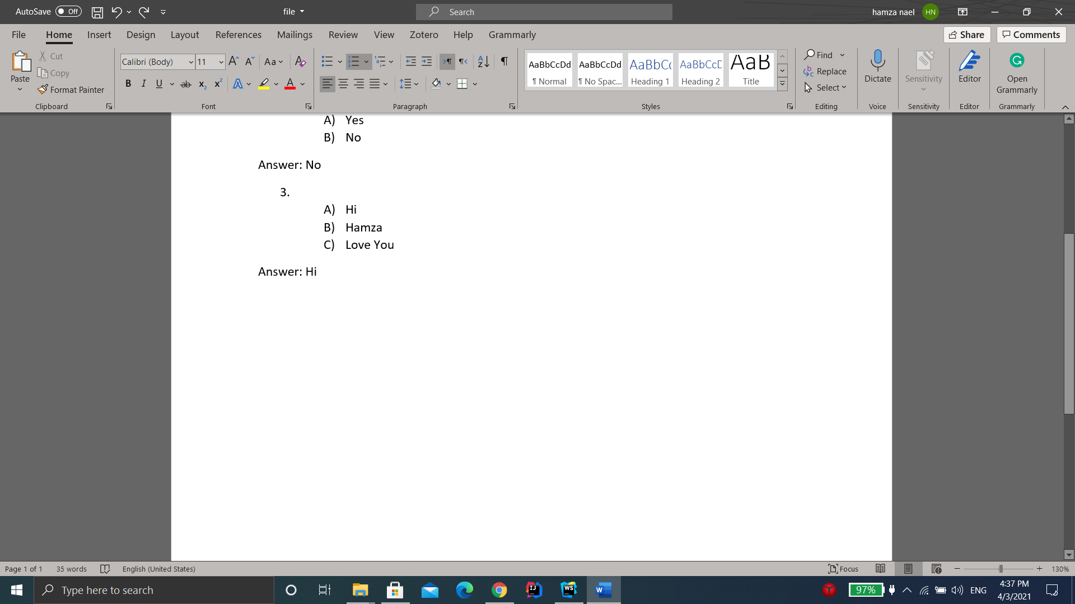

?

* 1. 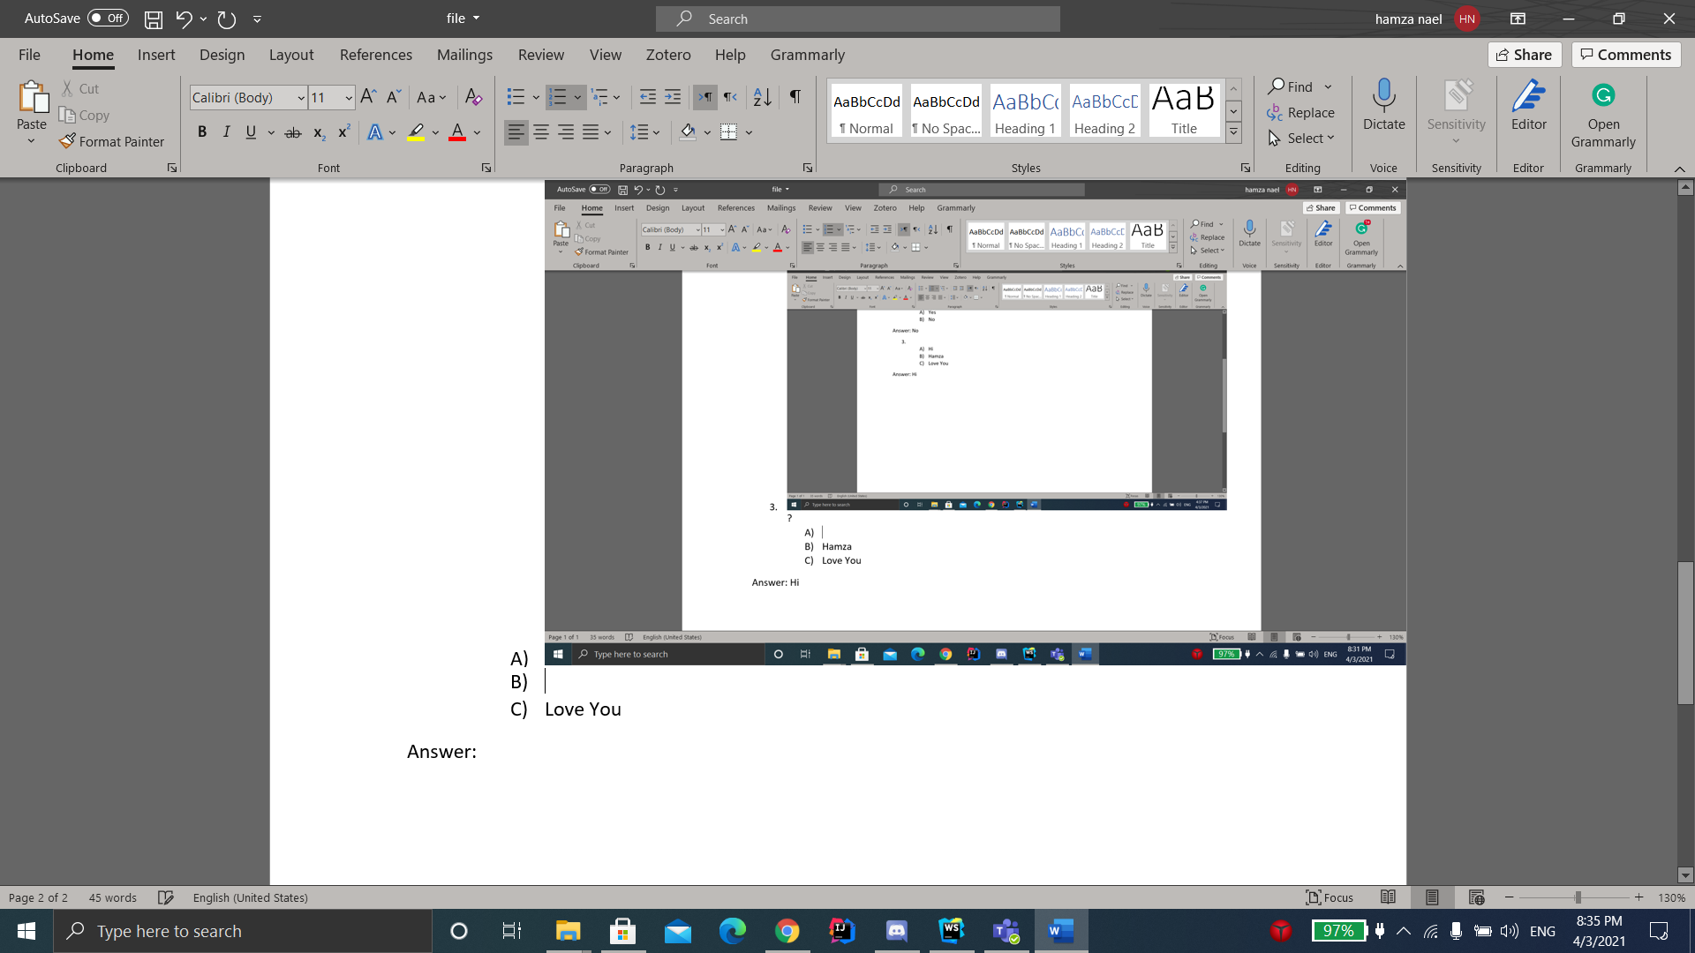
  2. Test
  3. Love You

Answer: 3

Mark: 10