# The First exam

1. Hi yehya ?
   1. Face
   2. Bro
   3. Test

Answer: 3

Mark: 1

1. How are you?
   1. Good
   2. Bad
   3. Perfect

Answer: 1

Mark: 1

1. Hi hamza Work?
   1. Yes
   2. No

Answer: 1

Mark: 1

1. 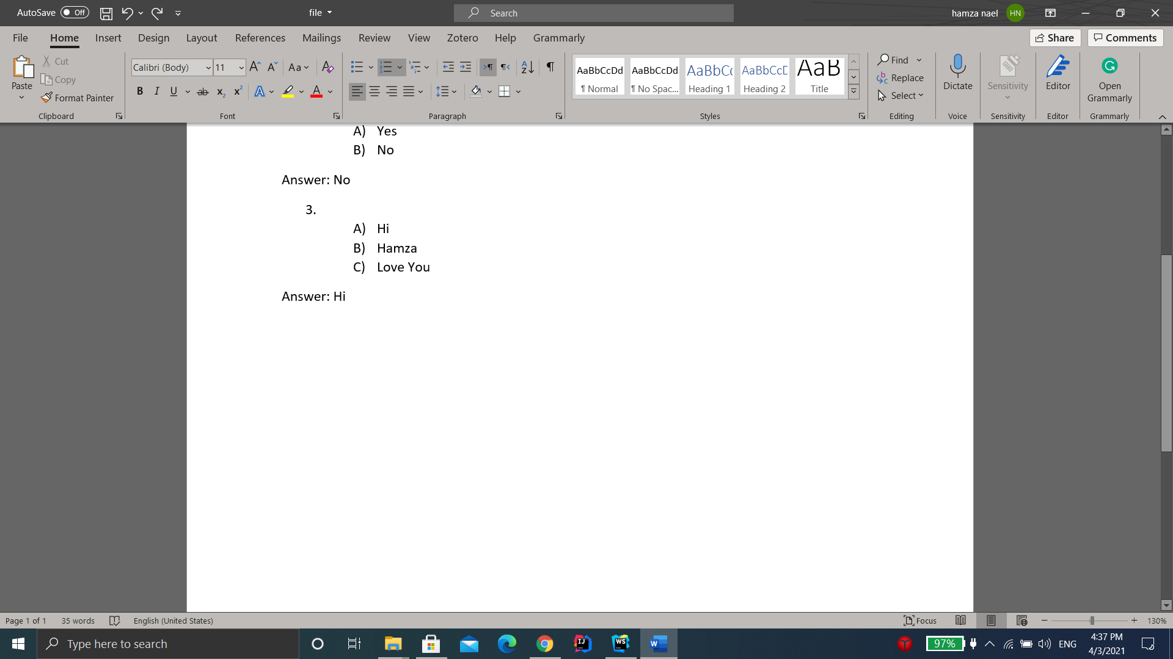?
   1. 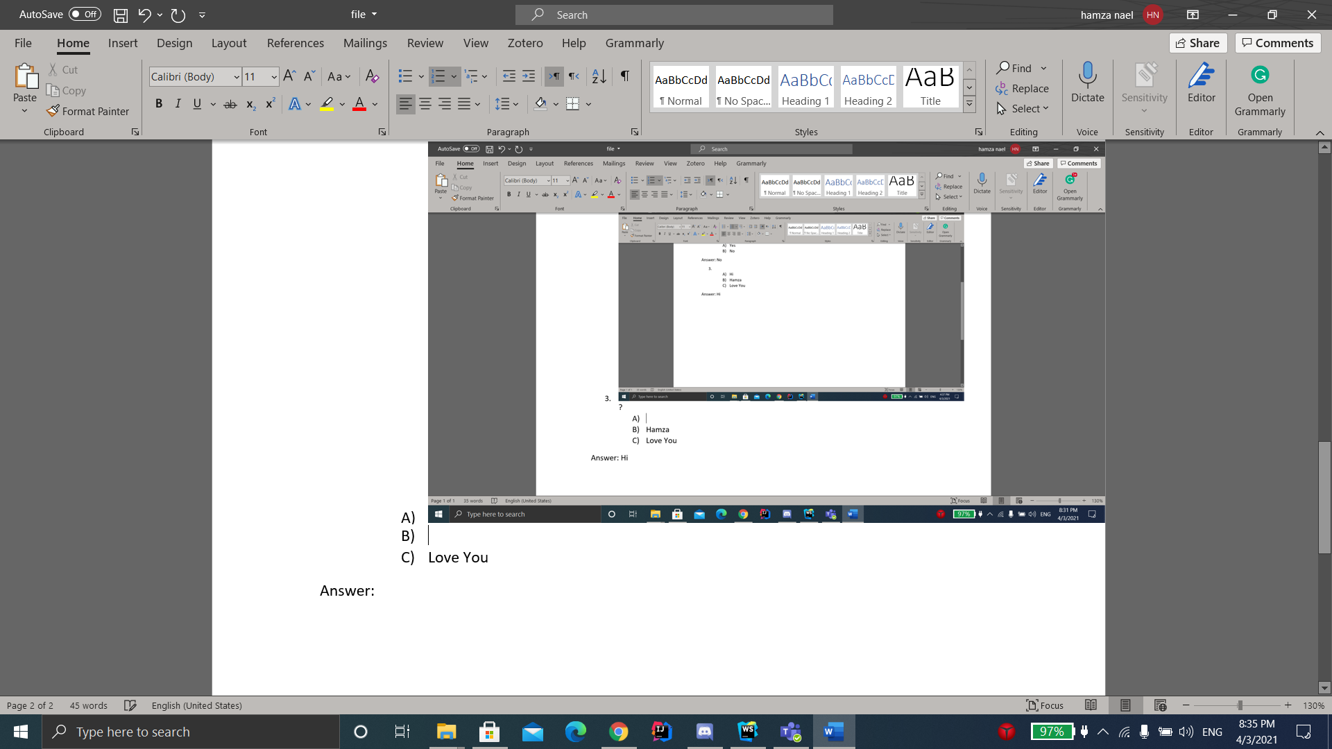
   2. Love You

Answer: 2

Mark: 1