# The First exam

1. Hi yehya (grad 1) ?
   1. Face
   2. Bro
   3. Test

Answer: 1

Mark: 5

1. How are you?
   1. Good
   2. Bad
   3. Perfect

Answer: 1

Mark: 5

1. Hi yahya Work?
   1. Yes
   2. No

Answer: 2

Mark: 5

1. 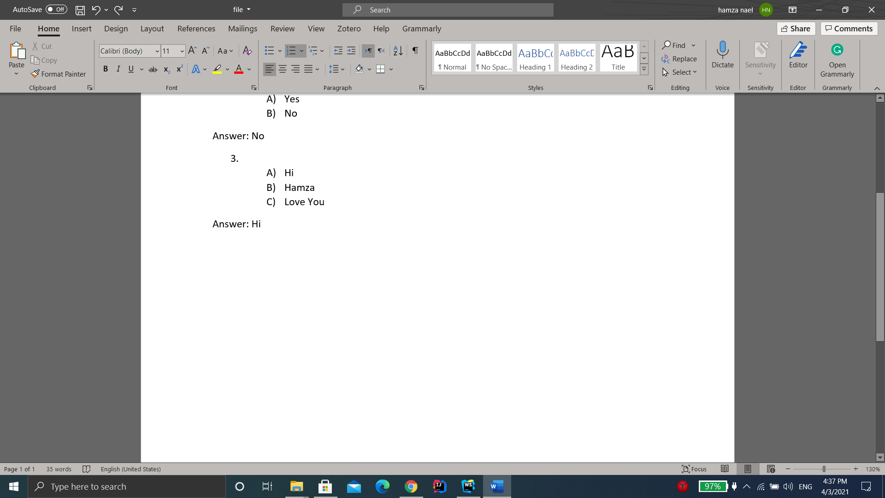?
   1. 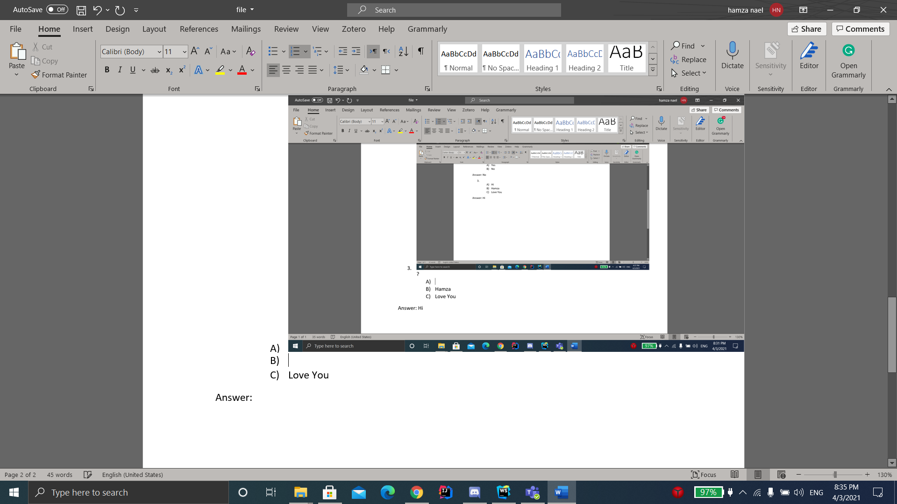
   2. Test
   3. Love You

Answer: 3

Mark: 5