# The First java exam

1. Which of the below is not a subinterface of Queue ?
   1. BlockingQueue
   2. BlockingEnque
   3. TransferQueue
   4. BlockingQueue

Answer: 2

Mark: 1

1. PriorityQueue is thread safe ?
   1. True
   2. False

Answer: 1

Mark: 1

1. Which data structure is used in Breadth First Traversal of a graph ?
   1. Stack
   2. Queue
   3. Array
   4. Tree

Answer: 2

Mark: 1

1. What should the return type of method where there is no return value ?
   1. Null
   2. Empty collection
   3. Singleton collection
   4. Empty String

Answer: 2

Mark: 1

1. **What is the output 6** Grads

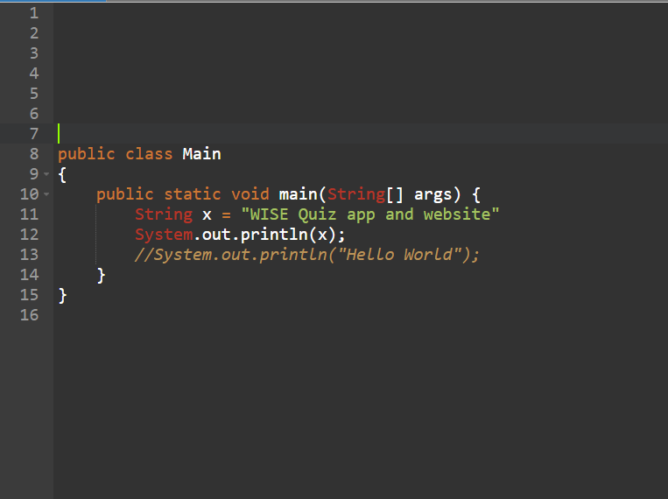

?

* 1. error
  2. Hello World
  3. WISE Quiz app and website
  4. Empty String

Answer: 1

Mark: 6