
Software Requirements Specification for<Captcha Solver>

Version 0.4 approved
Prepared by
Naveed Hakim(15026393)
Hamza Safdar(1506413)
Khizar Farooq(1506422)
Muhammad Nabeel(14031226)
Module Instructor: Dr.Adil Raja
Mentor: Mr.Faisal Zeshan
Client: Mr.Muhammad Saqib
Namal College, Mianwali

Date: 23/4/2018
Table of Contents
1. Introduction 1
1.1 Purpose 1
1.2 Document Conventions 1
1.3 Intended Audience and Reading Suggestions 1
1.4 Product Scope 2
1.5 Abbreviations 3
1.6 Overview 4
2. Overall Description 4
2.1 Product Perspective 4
2.2 Product Functions 4
2.2.1 Flow Diagram 4
2.2.2 Upload Image 6
2.2.3 Pre-Processing 6
2.2.4 Feature Extraction 6
2.2.5 Matching 6
2.2.6 Output 6
2.3 User Characteristic 6
2.4 Assumption and Dependencies 6
2.5 Apportioning of requirements 7
2.6 Operating Environment 7
3. External interface Requirements 8
3.1 User Interfaces 8
3.1.1 Graphical User Interface 8
3.1.2 Input Image: 9
3.1.3 Pre-processing 11
3.1.4 Editable text 11
3.2 Hardware Interfaces 11
3.3 Software Interfaces 12
3.4 Communication Interfaces 12
4. System Features 13
4.1 Use Case Model 13
4.1.1 Captcha Input 14
4.1.2 Pre-Processing 14
5. Other Non-Functional Requirements 19
5.1 Security Requirement 19
6. References 19
Appendix A: Glossary 19

Revision History
Name | Date | Reason For Changes | Version
Captcha Solver | 23 Feb, 2018 | Change in Interface | 0.1
Captcha Solver | 15^{h} March,2018 | Addition in features | 0.2
Captcha Solver | 10th april,2018 | Data Set enhancement | 0.3

Introduction

Purpose
Purpose of writing this document is to give a detailed and clear description of a system named as Captcha Solver. It will give a complete description of scope, use, Graphical User Interface, features, dependencies, assumptions taken, constraints under which system will operate, and all functional and non-functional requirements of the project as well as it will describe conventions, Glossary and abbreviations used in writing this document. This document is to help developers, testers and users of the software so that they may be able to use and improve this system by looking at initials provided in this document.

Document Conventions
This document is written on bases of template provided by IEEE for writing System Requirement Specification Document.

Intended Audience and Reading Suggestions
- General Purpose users who want to use this product for their ease to get textual form of any image. This document will act as user-manual for them and will help them using this software.
- Website owners who want to check Strength of their text based Captchas can use this software to do so.
- There is always a room for improvement in any product so this document can be used by those coders or developers who want to make further improvements in this product or want to fix bugs. They may take an overview of already done work so that their labor should be minimized.
- Analyzers who want to do some analysis on output.
- And finally, those who want to test this product can get description of system from this document.

Product Scope
The product named as Captcha Solver is a tool designed for those who want to take textual form of an image. Captcha’s are of many types. Text Based Captchas are common these days which are sequence of characters written in different fonts and styles and are used effectively to isolate human and robots.
Although Captcha plays an important role in maintenance of security of the system, but it is also necessary to check whether that captcha can be broken down using a program or not. Now a days, it is possible to make computer capable enough to read captcha using domain of Image Processing OCR. So this software can play an important role in checking strength of Captcha.
This software is a MATLAB program which is able to read captcha and give an output in textual form. Current Version of the system takes an image in input and returns its textual form regardless of the fact that images contains driftnet number of characters. This system is basically build upon methodologies of optical character recognition.
This project is actually a building block upon which many other systems can be build. For example, In future, an automatic software can be made which will auto detect the CAPTCHA in the website and will feed the CAPTCHA to the website automatically. In this way, labor for user will be less and he will like using this application which may also be available in form of browsers extension.
Moreover, transferring hand written books in to textual form is also a task in this era because old books are hand written and people need a typewritten version of them. Doing typing manually is a difficult task and acquires human efforts. This project can also be used as a building block for recognizing hand written books. Same goes for important data of users in National databases as that is also in hand written form in under developed countries. A basic unit for achieving that task is provided in form of this software.
This captcha solver can also give a sound bases for number plate readers .Purpose of number plate reader will be to work in live environment on roads and check if someone breaks traffic rules, his/her number plate will be given to system and system will return a textual form of it. That textual form can be used to search and penalize person in future.

Abbreviations
Abbreviation | Term
OCR | Optical Character Recognition
GUI | Graphical User Interface
User | The person viewing this document
OS | Operating System
PNG | Portable Network Graphics
JPEG | Joint Photographic Experts Group
BMP | Best Management Practice
NN | Neural Network

Overview
Document provides requirement specifications for Captcha Solver. Section 1 was mainly for giving an overview of document. It gave description of use, perspective, audience and glossary of this document.
Chapter 2 deals with overall description of this system which explains product perspective, overview of function using flow charts and use case Modals.

Overall Description

Product Perspective
Captcha Solver is not subpart of any other system. It is an independent software which is complete in its functionality. This product is not modified version of any already existing OCR System but some basic functions are having same features as already existing OCR’s possess. Software is mainly made for those who want to check capability of their captchas or build interesting software’s taking this captcha solver as base.

Product Functions

Flow Diagram
Captcha Solver mainly performs functions given below. (Figure 1)
Figure 1

Upload Image
User is able to upload image in graphical user interface of software. This accepts images (with extensions PNG and JPEG). GUI shows image after uploading an image in the system

Pre-Processing
Software performs some preprocessing steps on that image for example converts it into binary image and partitioning on bases of characters.

Feature Extraction
Preprocessed image is given to feature extractor which extracts useful information from that image. If user of system is analyzer or tester, provision of viewing all these steps is provided in this system.

Matching
These features are given to neural network that is rising domain of Artificial intelligence. Neural Network does analysis on these features and checks in its database that which character falls in which category. It matches features of image with already existing data and gives results.

Output
After performing all above given steps, system returns textual form of image which is the ultimate goal. Implementation of all these components is given in Section 3.

User Characteristic
User is expected to be capable enough of using basic windows command such as “upload file” or drag drop menus. As this software is built using MATLAB , user should be able to build and run a MATLAB program as well as he should know how to use Graphical User Interface that is also made using MATLAB.
If user is a developer who want to take this software as a building block or he an analyzer he is expected to be familiar with terms feature extraction as well as neural networks to get an understanding of Software .These terms are further explained in section 3.

Assumption and Dependencies
The system is built on taking the assumption that user will give an image by himself to be tested and this program can deal with capital 26 characters only.

Apportioning of requirements
The current version of system requires to take image as input. Future version may be able to recognize captcha from a website by itself and feed textual form of captcha into text box automatically
This captcha solver deals with texted based captchas only, future version of system may able to recognize other captchas for example captchas containing objects. This will also be done using Image processing.

Operating Environment
- Windows 7
- Windows 8
- Windows 10
- 64 bits system only as MATLAB does not support 32 bit windows
- Linux

External interface Requirements

User Interfaces

Graphical User Interface
Graphical User Interface of this software is easy to handle, efficient and can handle different kind of inputs. Figure gives overview of starting condition of graphical user interface.
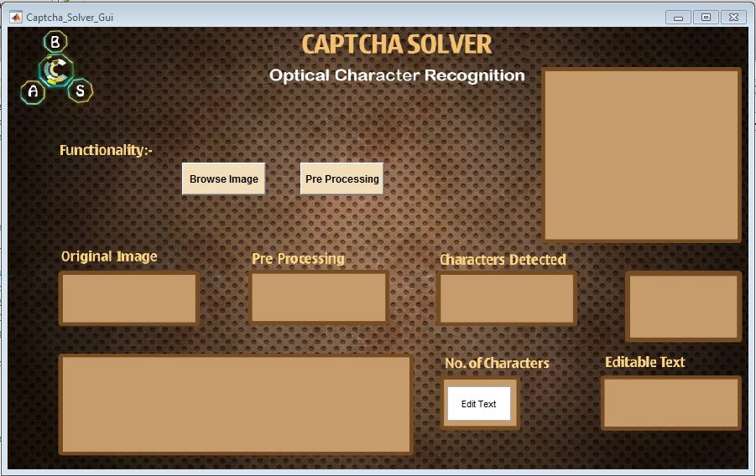
Figure 4.1

Input Image:
Software provides provision of uploading image on graphical user interface for detection of characters so that user can view input, preprocessing and output easily. (Figure 4.2.1)
Here is image for how to upload image in GUI. User can upload jpg , png, bmp and tiff files by clicking drop down menu.(Figure 4.2.2)

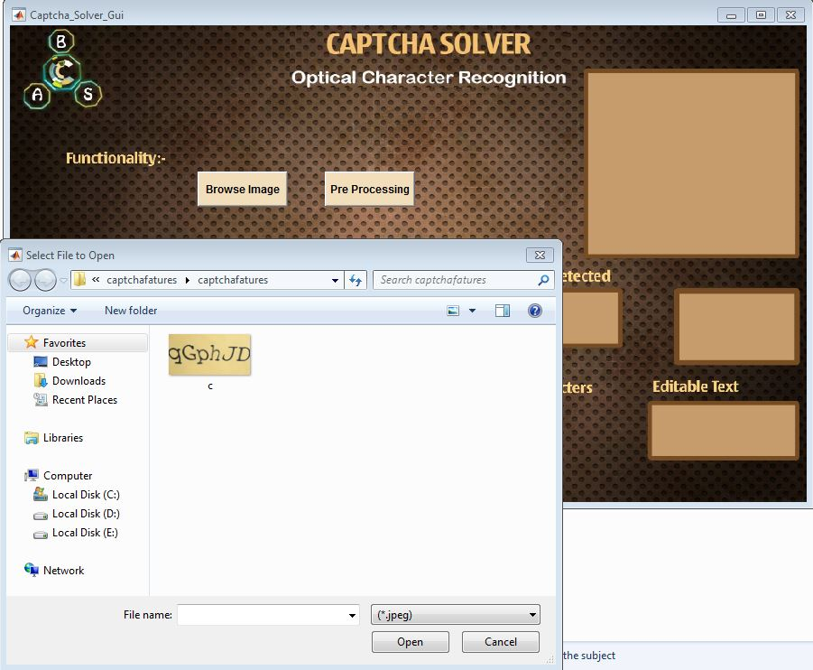
Figure 4.2.1
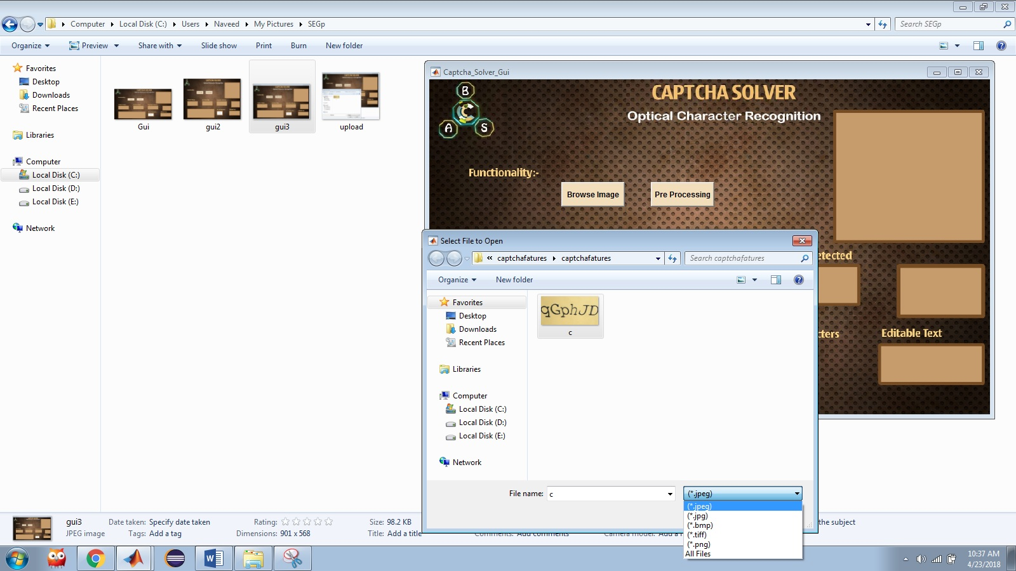
Figure 4.2.2
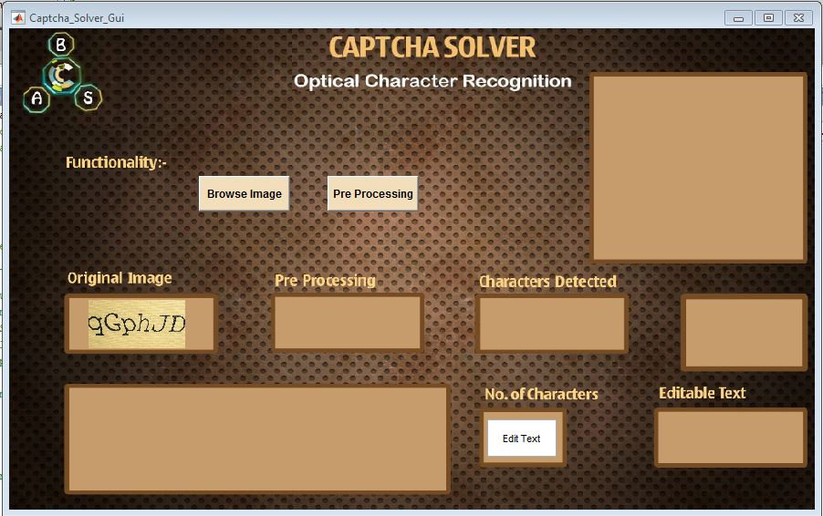
Figure 4.2.3

Pre-processing
Preprocessing button enables user to view some intermediate stages of translating image into text for example partitioning to string, characters identified, number of characters and neural network training. (Fig 4.3)

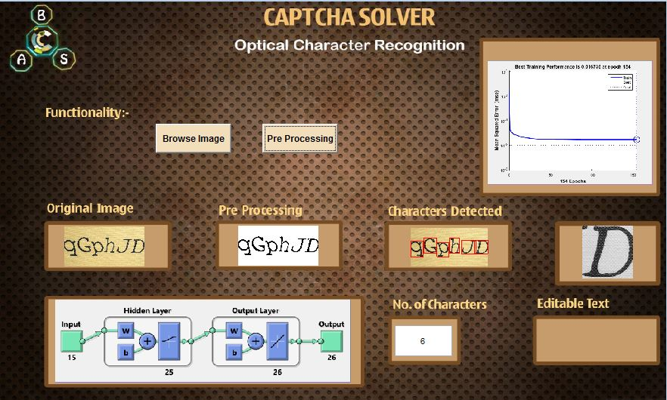
Figure 4.3

Editable text
Final output of Program is as given below:
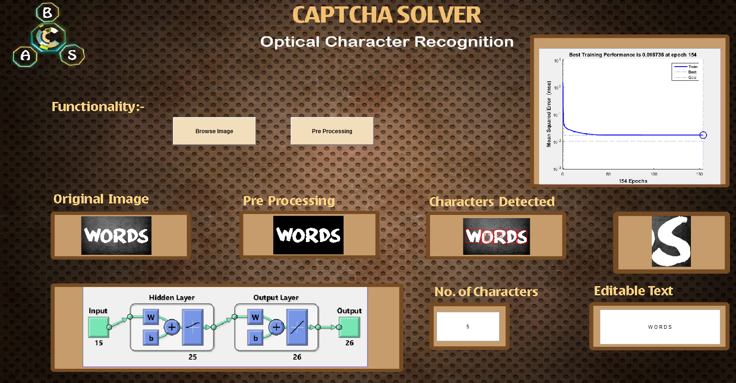
Figure 3.1.4

Hardware Interfaces
Captcha Solver itself requires 3MB (approx.) but an additional memory of 9GB is required for MATLAB installation.

Software Interfaces
As it is a Captcha Solver so there does not exist any login constraint on user. Common user have access to all features of the product. It requires MATLAB to run and compile on as it is a MATLAB program. System does not have any other software or hardware requirements rather than OS and a hardware that supports MATLAB R2015a .s

Communication Interfaces
Captcha Solver needs internet connection only once when user have to install MATLAB. After installation of current version System can work on its own without need of any communication interface.

System Features

Use Case Model
This system has one active user that can be analyzer, tester, common user or developer. All of them can view or access all parts of system as system doesn’t require any login credentials.

Figure 4

Captcha Input
Use case: Captcha Input
Diagram
Captcha Input

User
Brief Description
User runs the code in his/her machine after installation of MATLAB. And gives input to the software.
Description
This use case applies on user who has already run the program in MATLAB
GUI is appeared in front of user and he selects to upload an image to get its textual form by clicking on given option of “UPLOAD IMAGE”.

Use Case | Feed Input
Trigger | User runs Program
Pre-Condition | GUI interface is opened in front of user
Basic Path | {how GUI code is executed step by step}
Post Condition | Image is uploaded and shown on an axis of GUI
Exception Paths | User can drop uploading image any time during Performa of task.

Pre-Processing
This option for the user who is analyzer or developer who want to check each and every step.
Use case: character detection
Diagram
Detect Characters

User
Brief Description
User is able to detect characters in an image.
Step by Step Description
On click of preprocessing button user can see image divided into characters.
This task is done with help of bounding box. Each character is enclosed in an bounding box in this use case so that further processing should be done on this image.
Use Case | Character Detection
Reference
Trigger | Click on pre-processing button
Pre-Condition | Image must be converted into a binary image before this task
Basic Path | 1)User chooses to upload an image for character detection  2) Basic operations like noise removal , edge detection conversion into a binary image and holes filing is done before execution of this task  3) Click on preprocessing button enables software to detect characters from image.
Post Condition | Function returns image which has discrete characters detected in that.
Use case: String Partitioning
Diagram
String Partitioning

User
Brief Description
String is divided into parts on basis of characters to get each character’s image and identify text from that.
Step by Step Description
String of input will be passed to program. Program will do preprocessing on it, and will draw bounding box on bases of characters. Furthermore, it will crop image on basis of bounding box
Reference
Use Case | String Partitioning
Trigger | Click on Pre Processing button
Pre-Condition | Image uploaded
Basic Path | Input  Pre processing
Post Condition | Partitioned String
Use case: Feature extraction
Diagram
Feature Extraction

User
Brief Description
Different important features are extracted after getting string inform of characters.
Step by Step Description
On each character feature extractor is applied which extracts following features
- Finds black pixels in image
- width and height of written part of image
- centroid and area of image
- Line detection
- Rho and theta values for lines
Use Case | Feature Extraction
Trigger | Click on Pre Processing button
Pre-Condition | Segmented image
Basic Path | Input image  Pre processing  Partitioning
Post Condition | Extracted features stored in database

Use case: Neural Network Training
Diagram
NN’s Training

User
Brief Description
Neural Network is trained on basis of features extracted of image.
Step by Step Description
Extracted features are passed to neural network.

Use Case | Neural Network Training
Trigger | Features extracted
Pre-Condition | Extracted features stored in variable
Basic Path | Data Set  Conversions , filtrations , holes filling  Feature extraction  Training of NN’s
Post Condition | Trained Neural Network which is able to detect characters.

Use case: Matching and final out put
Diagram
Final Output

User
Description
To get final out put captchas features are sent to neural network and after comparison final output is returned.
Use Case | Matching Final Output
Trigger | Pre Processing button clicked
Pre-Condition | Trained neural network
Basic Path | Data Set  Conversions , filtrations , holes filling  Feature extraction  Training of NN’s  Final Out Put
Post Condition | Final out Put of program

Other Non-Functional Requirements

Security Requirement
Captcha Solver is open software which doesn’t need any login credentials as well as interface is easy to understand and error checking and resolving is done so there are no security requirements for this software.

References
IEEE. IEEE Std 830-1998 IEEE Recommended Practice for Software Requirements Specifications. IEEE Computer Society, 1998.
Meriem Guerar, Mauro Migliardi, Alessio Merlo, Mohamed Benmohammed, Belhadri Messabih, "A Completely Automatic Public Physical test to tell Computers and Humans Apart: A way to enhance authentication schemes in mobile devices", High Performance Computing & Simulation (HPCS) 2015 International Conference on, pp. 203-210, 2015.

Appendix A: Glossary
Captcha: A technique to separate human from machine
Image Processing: Making Computer able to read and analyze images
Feature Extraction: Extracting unique features of an image to identify it uniquely.
Neural Networks: A Try to make computer intelligent artificially using same model as used by
MATLAB: An environment which is allows to work with matrix manipulation and graph plotting, therefore, used for image processing widely
Data Set: Collection of data to train neural network.
<--------------------------------------------------------------------------------------------------------->

