
Testing Report for<Captcha Solver>

Version 0.4 approved
Prepared by
Naveed Hakim(15026393)
Hamza Safdar(15026413)
Khizar Farooq(15026422)
Muhammad Nabeel(14031226)
Module Instructor: Dr.Adil Raja
Mentor: Mr.Faisal Zeshan
Client: Mr.Muhammad Saqib
Namal College, Mianwali
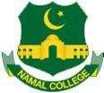
Date: 23/4/2018

Case1:

Task
System should be able to take input image of extension jpg, png, bmp and tiff.

Expected Output:
On Clicking browse image option, software should be able to open directory to select image.

Output by Program:
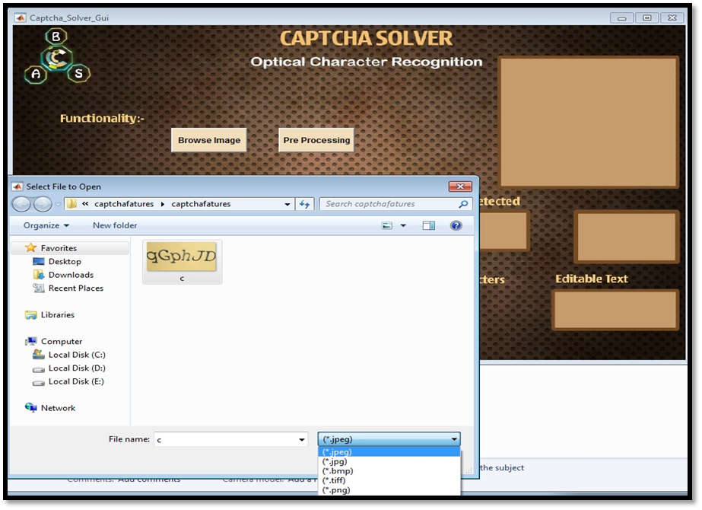

Case2:

Task
System should give user provision of viewing some intermediate steps like patriating of string, number of characters in string and training of neural network

Expected Output:
On Clicking preprocessing button, graphical user interface should show some steps of feature extraction.

Output by Program:

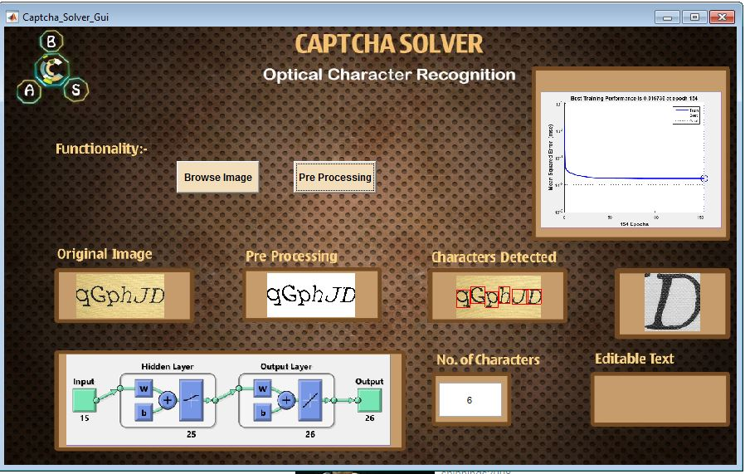

Case3:

Task
Final editable text from image should be visible to user.

Expected Output:
User should be able to get image from text as accurately as possible

Output by Program:
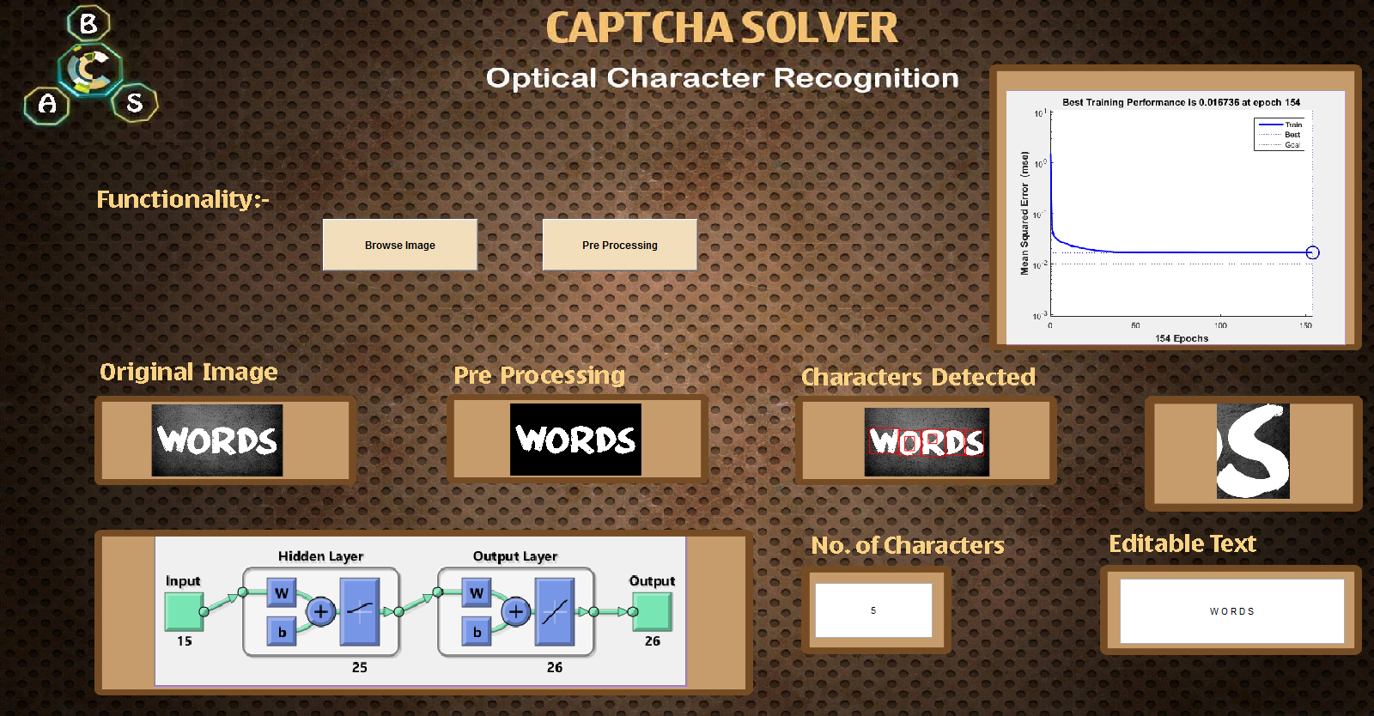

Error Testing

No | Case | Assumption | Results
1. | Insert anything other than image | It should give an error | It does nothing
2. | Try to put image of format which isn’t included in software | It Should not consider that image | It’s not considering
3. | Give image which don not include any alphabets | It Should display a message that there are no alphabets here. | It does nothing.

Case 1.
If user is going to insert anything else than image, our software should give an error that “this is not an image, kindly insert an image”. When we test this constraint in our software. Our software took that image but didn’t do anything.

Case 2.
We have defined limited formats of images, PNG, JPG, JPEG, BMP and TIFF are only the formats on which our software will do processing. If user gives an image of any other format our software should not consider it. It is doing exactly what we opt for.
Case 3.
Our project recognizes different alphabets written on an image and returns that alphabet’s in textual format. If there are not alphabets in given image, then software should indicate that there are no alphabet’s in this image. In our software it doesn’t do any processing on image which don’t include alphabet

