# **Project 3 - Deploying a Node Js Application on AWS EC2**

Step 1: Clone the repository to local system

> git clone url/of/node/js/application

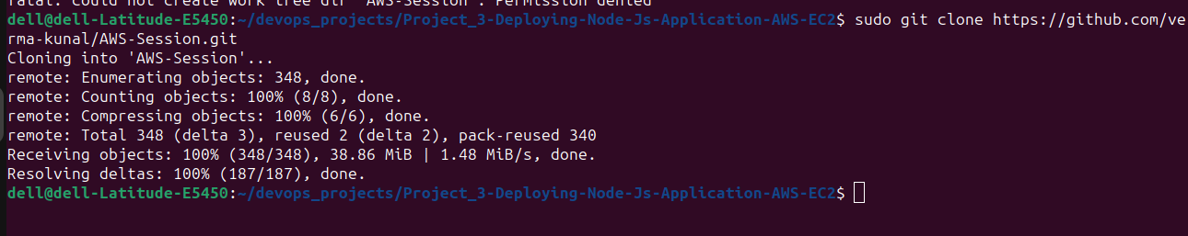

Step 2: Create a .env file for environment variables.

Q1: Why do we need .env ?

The .env file is used to store environment variables that your application needs to run. Here are some key reasons why using a .env file is beneficial:

1. **Separation of Configuration and Code**: Environment variables allow you to separate configuration from your code. This means you can deploy the same code in different environments (development, staging, production) with different configurations without changing the code.
2. **Security**: Storing sensitive information such as API keys, database passwords, and other credentials in environment variables keeps them out of your codebase. This reduces the risk of exposing these sensitive details if your code is shared or published to a public repository.
3. **Flexibility**: Using environment variables makes it easier to manage and change configurations without modifying the code. For example, if you need to change the port your application runs on, you can simply update the .env file instead of changing the source code.
4. **Consistency**: Using a .env file helps ensure that all developers on your team, as well as your deployment environments, use the same configuration values. This reduces the "it works on my machine" problem.
5. **Convenience**: Libraries like dotenv make it easy to load environment variables from a .env file into your Node.js application, providing a simple and consistent way to manage these variables.

> touch .env

>sudo vim .env

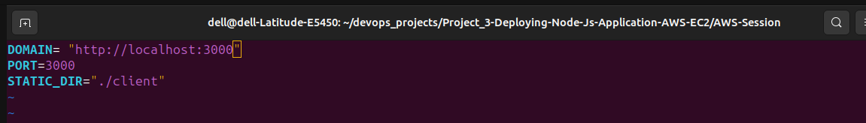

To install the necessary module and packages required

> sudo apt install npm

Now we will run it.

> npm run start

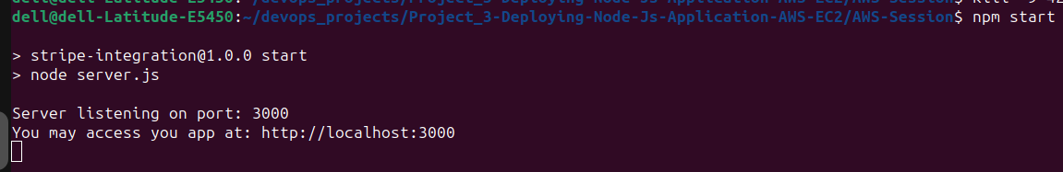

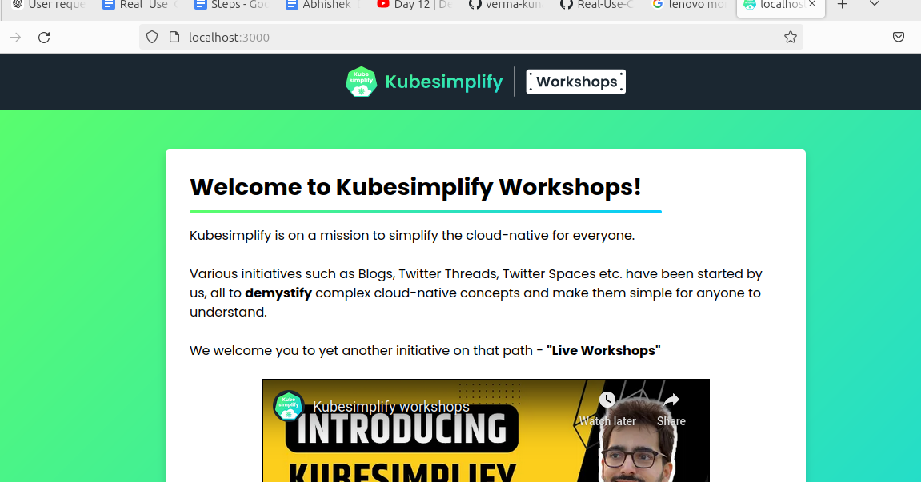

Till now we have deployed our site on our personal laptop and as we can see our site is working perfectly fine and from here we'll take it to the AWS Ec2 instance.

Step 3: Go to AWS console.

i) Create an IAM user.

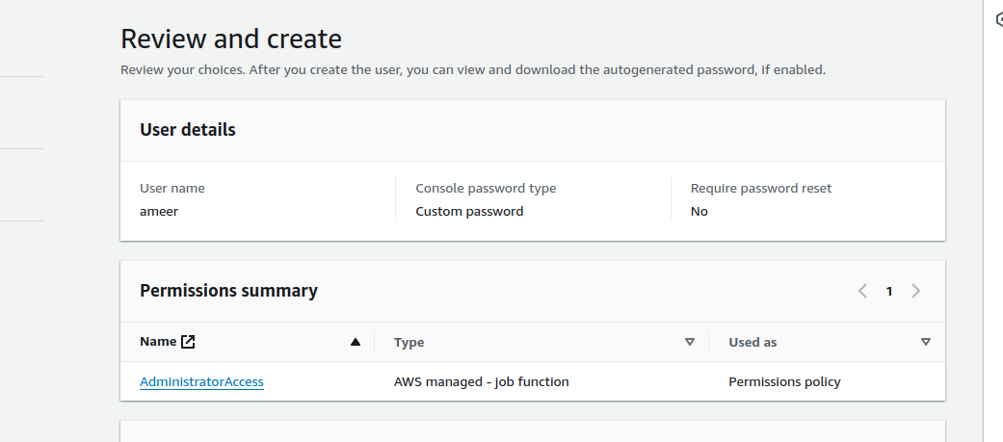

ii) Login as IAM user

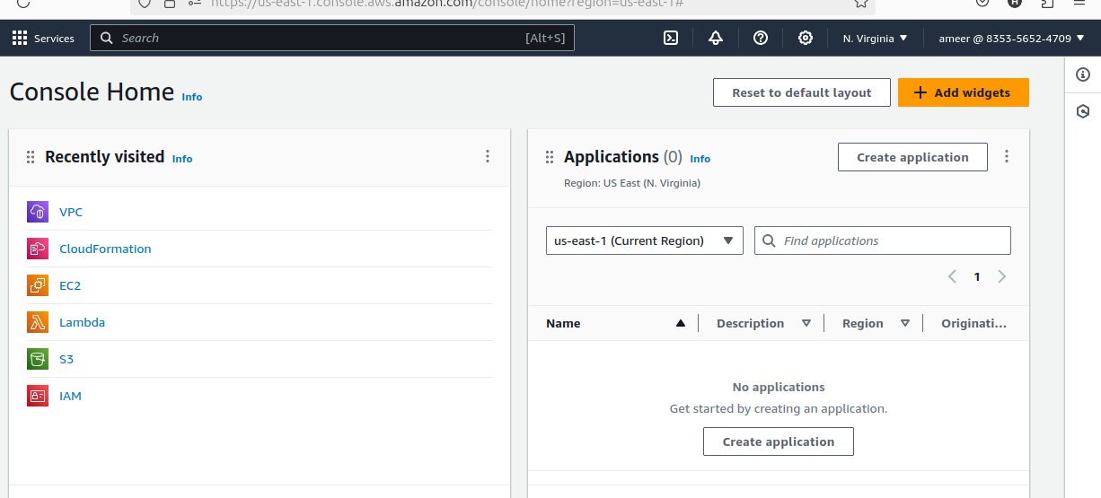

iii) Create EC2 instance and ssh into the remote server.



> ssh -i /home/dell/AWS_credentials/Test_server_1_key_pair.pem ubuntu@public_ip_address

iv) Install git on the server

> sudo apt install git

v) Install node js and npm

> sudo apt install nodejs

> sudo apt install npm

vi) Git clone

> git clone https://github.com/verma-kunal/AWS-Session.git

viii) Create .env file

> touch .env

> sudo vim .env



ix) To install the necessary module and packages required

> sudo apt install npm

x) Now we will run it.

> npm run start

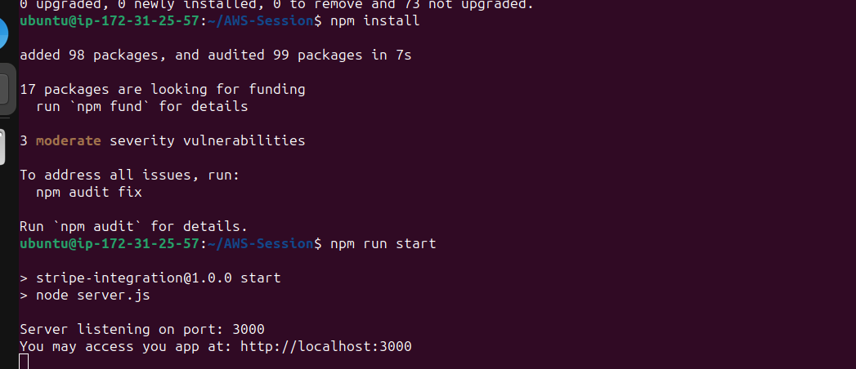

xii)

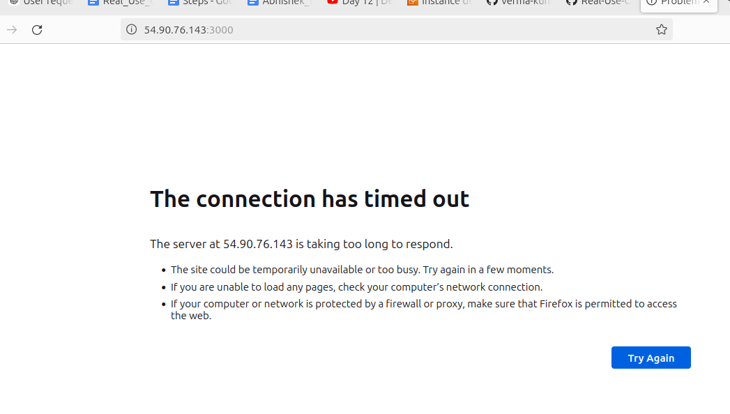

We can see that it's not working as our port is not exposed to the open internet.

So to solve this problem,

1. Select our instance ⇒ go to security groups 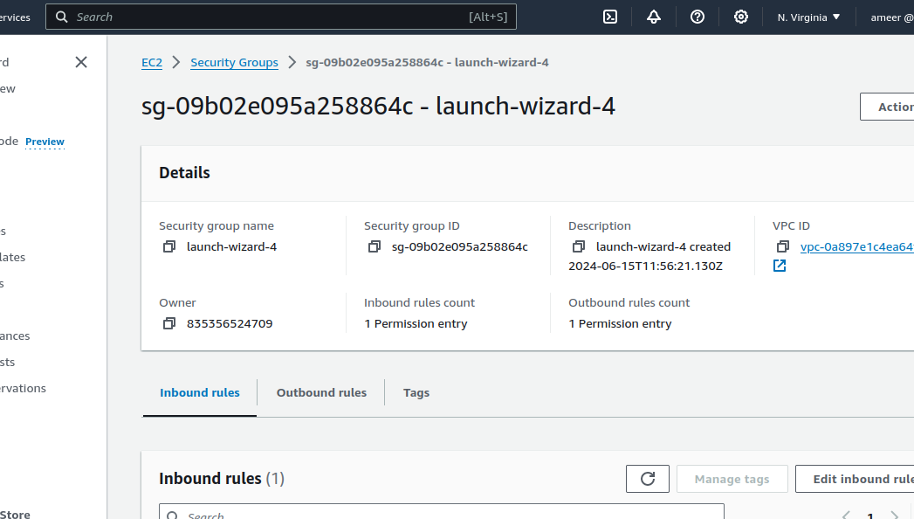
2. Add a rule to expose the application from port 3000

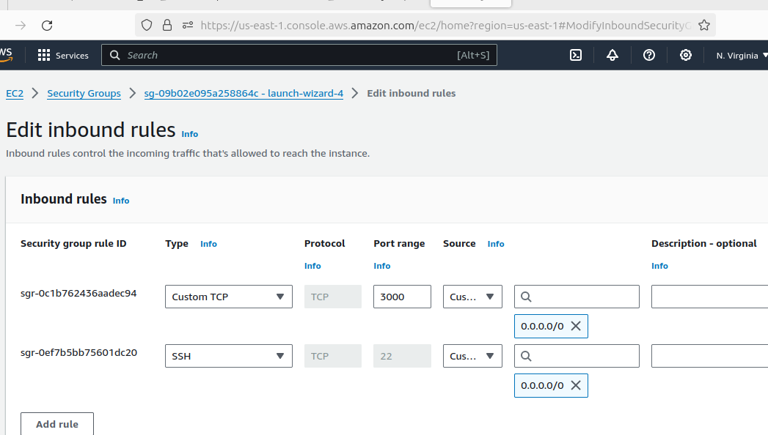

1. Now we try to enter <http://54.90.76.143:3000/> , it opens

