Q#1

“IS” is used. Which is error.

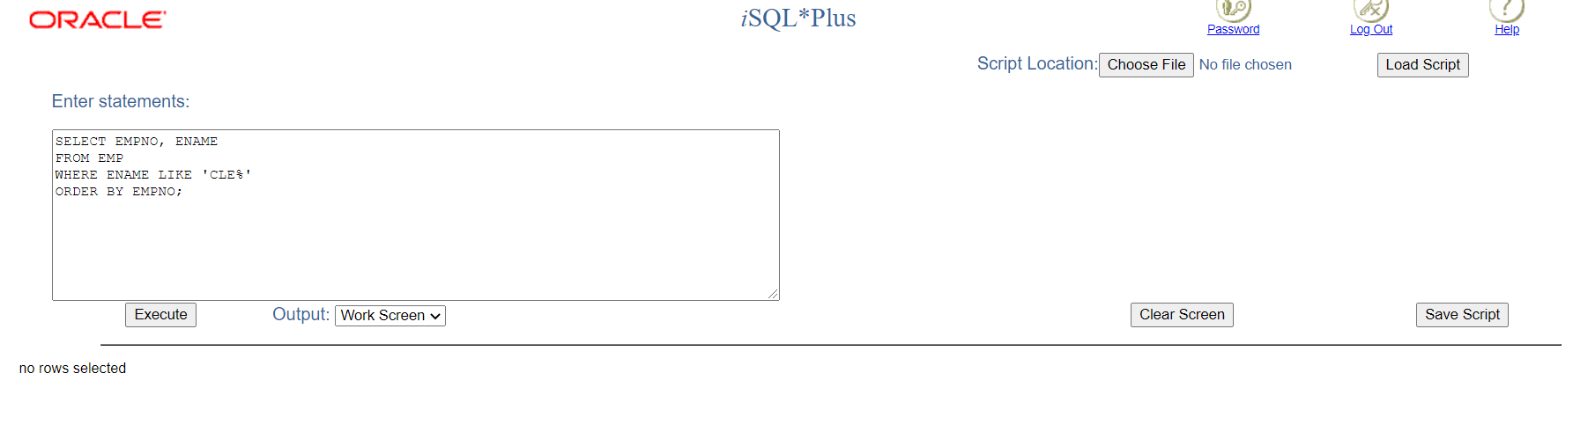

Q#2

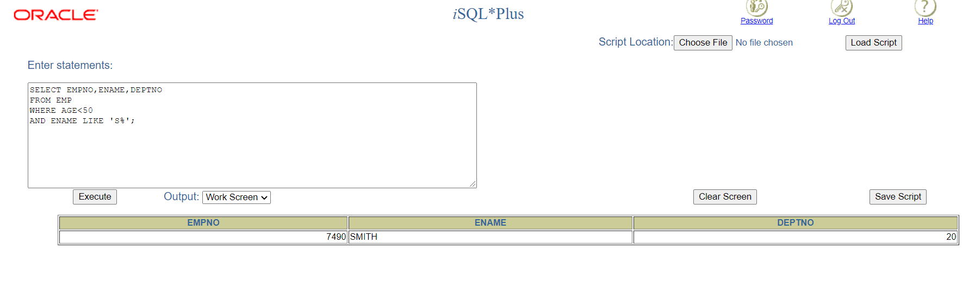

Q#3

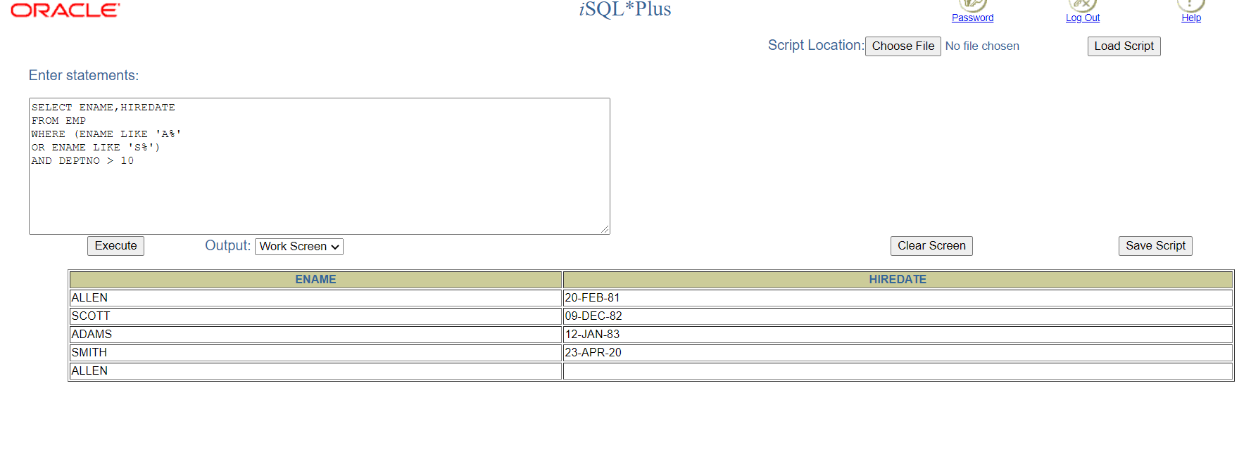

Q#4

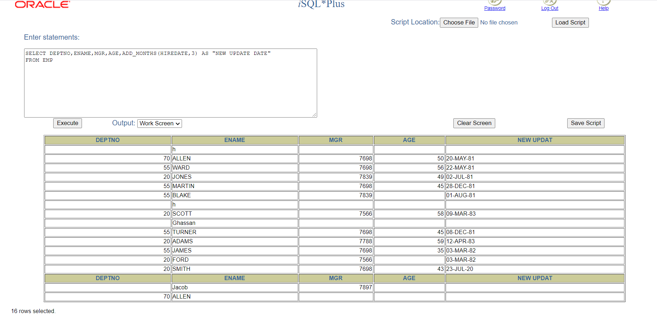

Q#5

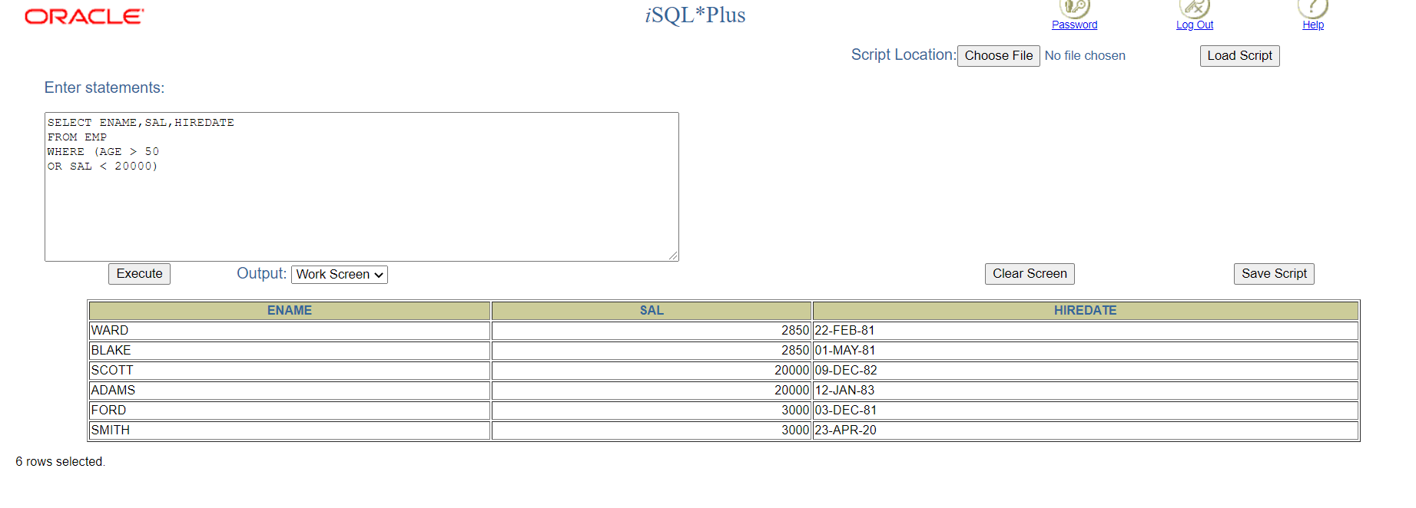

Q#6

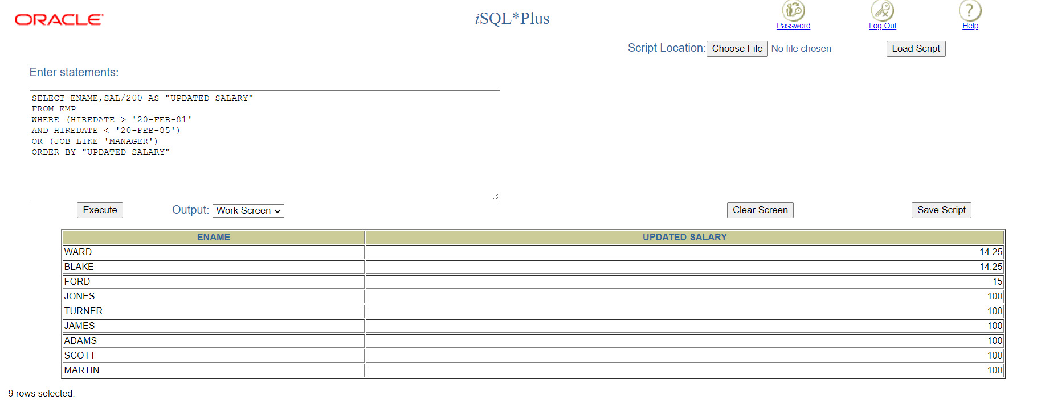

Q#7

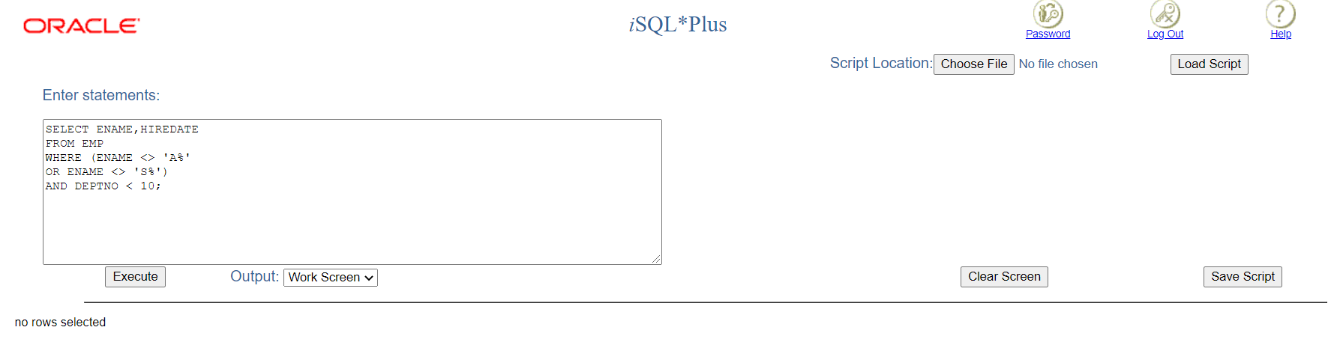

Q#8

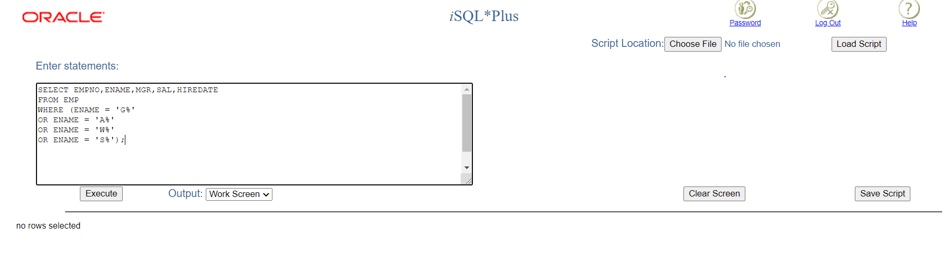

Q#9

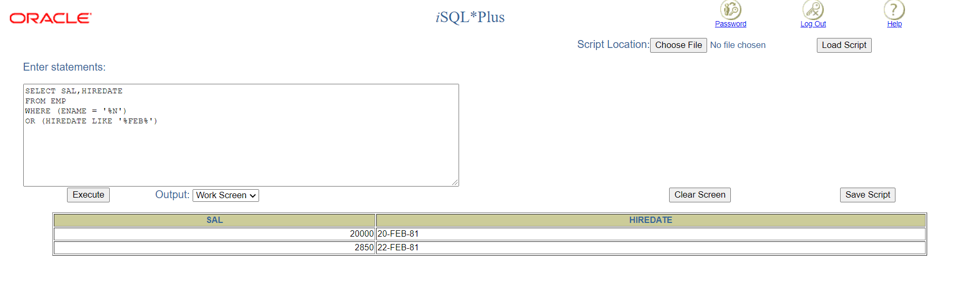

Q#10

