University of Central Punjab
Agent Based Modeling, Assignment 1 (group)

Smart Food Delivery Agent
Seven agent architectures for a rider delivering from
Cheezious, Johar Town to the University of Central Punjab

Member | Registration No.
Ch Hamza Younas | L1F23BSAI0089
Rida | L1F23BSAI0091
Muhammad Abdullah | L1F23BSAI0063

Section: ____________
Instructor: ____________
Date: October 2026

1. Introduction
Food delivery riders in Lahore make the same decision many times a day: which road to take from the restaurant to the customer. The fastest road depends on the time of day, the weather and things the rider cannot see from the restaurant door. This report models one such rider as an intelligent agent. An order is picked up at Cheezious, Johar Town and must be handed over at the main gate of the University of Central Punjab (UCP), Khayaban-e-Jinnah, within 20 minutes.
The same delivery problem is solved by seven single-agent architectures: Simple Reflex, Model-Based Reflex, Goal-Based, Utility-Based, Learning, Hierarchical and Contextual. Every agent receives exactly the same percept and is tested in the same three situations. A Python program produces the results, and an interactive 3D simulation shows each delivery as a rider riding through a model of Johar Town.

2. The Environment

2.1 Road map and routes
There are three ways from Cheezious to UCP. Destinations A, B and C are the three routes:
Route | Road | Distance | Free-flow time | Main risk
A | Khayaban-e-Jinnah Road | 3.00 km | 10.0 min | Jams at the Jinnah signal chowk in rush hour
B | Canal Bank Road (underpass) | 3.25 km | 10.4 min | The Canal underpass floods after about 30 minutes of rain
C | Johar Town inner streets | 4.20 km | 14.4 min | Longest route, but rarely blocked

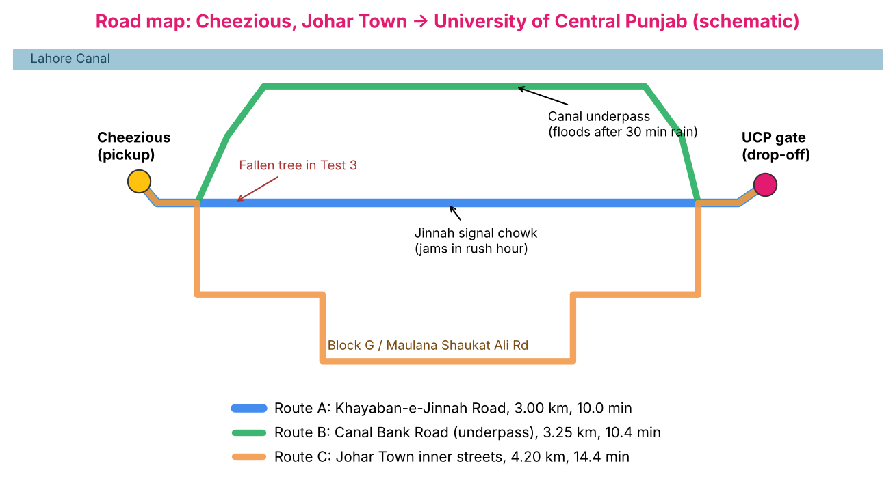
Figure 1. Schematic road map (not to scale).
The road map is a graph with 7 nodes (Cheezious, Jinnah signal chowk, Canal Bank Road entry, Canal underpass, Block G inner street, Maulana Shaukat Ali Road, UCP gate) and 8 road sections, each with a length in kilometres. Riding time is distance divided by the route's average speed. A jam adds a fixed delay (9.2 min on A), and a flooded underpass adds 14.1 min to B, where the rider has to push the bike through the water.

2.2 PEAS description
 | Description
Performance | Order handed over within 20 minutes; shortest delivery time; avoid unsafe (flooded) roads; arrive at all (do not choose a closed road).
Environment | Johar Town roads between Cheezious and UCP: routes A, B, C, traffic, rain, road closures, underpass flooding, time of day.
Actuators | Motorbike controls: choose and ride route A, B or C; speed and braking (used by the Hierarchical agent's operational layer).
Sensors | Eyes (closures and traffic right outside the restaurant, weather), the rider app (clock, live traffic on all routes, reported closures), memory of earlier percepts.

2.3 Properties of the task environment
Property | Value | Reason
Observable | Partially | Flooding of the underpass is 2 km away and is not reported by the app.
Agents | Single agent | Other traffic is part of the environment, not competing agents.
Deterministic | Stochastic (to the agent) | Whether the underpass is flooded is uncertain given the percept; the Learning agent's training trips have random noise.
Episodic | Episodic | Each delivery is independent; the Learning agent uses earlier episodes only for training.
Static | Static during the decision | The world does not change while the agent decides; the route is chosen once at the restaurant.
Discrete | Discrete | Three actions (A, B, C) and a finite set of road conditions.
Known | Known | The rider knows the road map and the rules of the environment.

2.4 Percept
Every agent receives the same percept. Example from Test 3:
time: "13:00"
weather: "rain"
traffic: {"A": "light", "B": "light", "C": "light"}
closed: {"A": true, "B": false, "C": false}
deadline: 20.0
history: [{"time": "12:00", "weather": "clear"}, {"time": "12:15", "weather": "rain"}, {"time": "12:30", "weather": "rain"}, {"time": "12:45", "weather": "rain"}]

3. Test situations
Test | Situation | Order time | What is true | What the rider can see
1 | Normal lunch hour | 13:00 | All roads clear | Everything
2 | Evening rush hour | 18:10 | A jammed at Jinnah chowk (+9.2 min) | A heavy on the traffic app
3 | Monsoon rain | 13:00 | Rain since 12:15; A closed by a fallen tree; B underpass flooded (+14.1 min) | Rain, A closed. Flooding is NOT visible

The best possible choice is A (10.0 min) in Test 1, B (10.4 min) in Test 2 and C (14.4 min) in Test 3.

4. Agent designs

4.1 Simple Reflex Agent
Uses condition-action rules on the current percept only. It has no memory and no model of the world.
IF A is closed THEN take B
IF A is jammed THEN take B
OTHERWISE take A
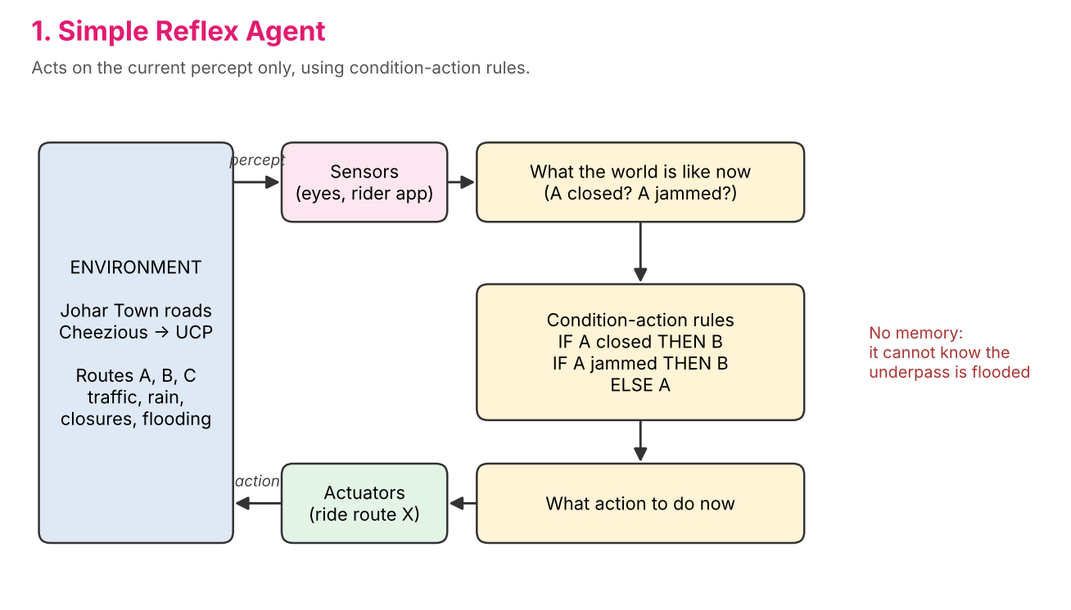
Figure: Simple Reflex Agent architecture.
Fast and simple. In Test 3 it cannot know that the underpass is flooded, so it sends the rider into the water.
Reasoning in Test 3: Rule fired: IF Khayaban-e-Jinnah is closed THEN take route B. No memory: earlier percepts are ignored.

4.2 Model-Based Reflex Agent
Keeps an internal state that it updates from the percept history, using a model of how the world works: the Canal underpass floods after 30 minutes of continuous rain.
state.rain_minutes = time since rain started (from percept history)
state.B_flooded = rain_minutes >= 30
IF A not blocked THEN A ELSE IF B not flooded THEN B ELSE C
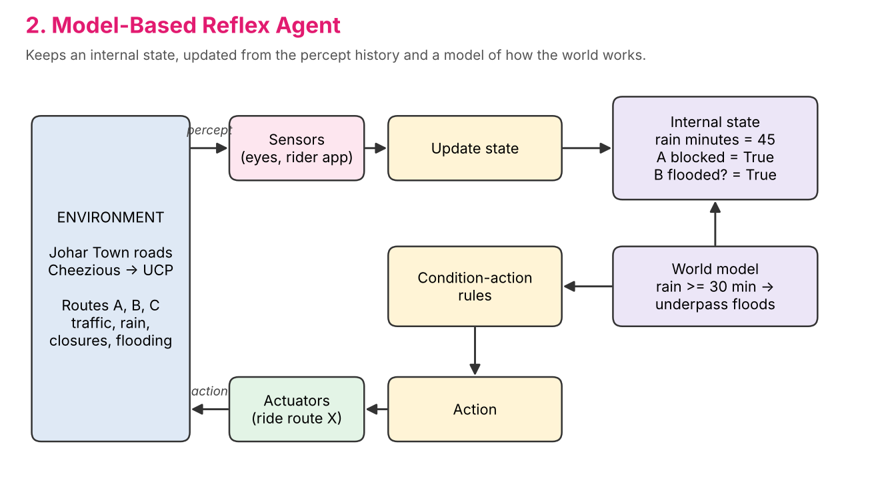
Figure: Model-Based Reflex Agent architecture.
Handles the partially observable flood by remembering how long it has been raining.
Reasoning in Test 3: Internal state: raining for 45 min, A blocked=True, underpass flooded (believed)=True. Rule: A blocked and underpass believed flooded -> take C.

4.3 Goal-Based Agent
Has an explicit goal (be at the UCP gate) and searches the road graph with uniform-cost search, using distance as the cost. Closed roads are removed from the graph.
graph = road map without closed roads
path = uniform_cost_search(graph, CHZ, UCP)
ride the route of path
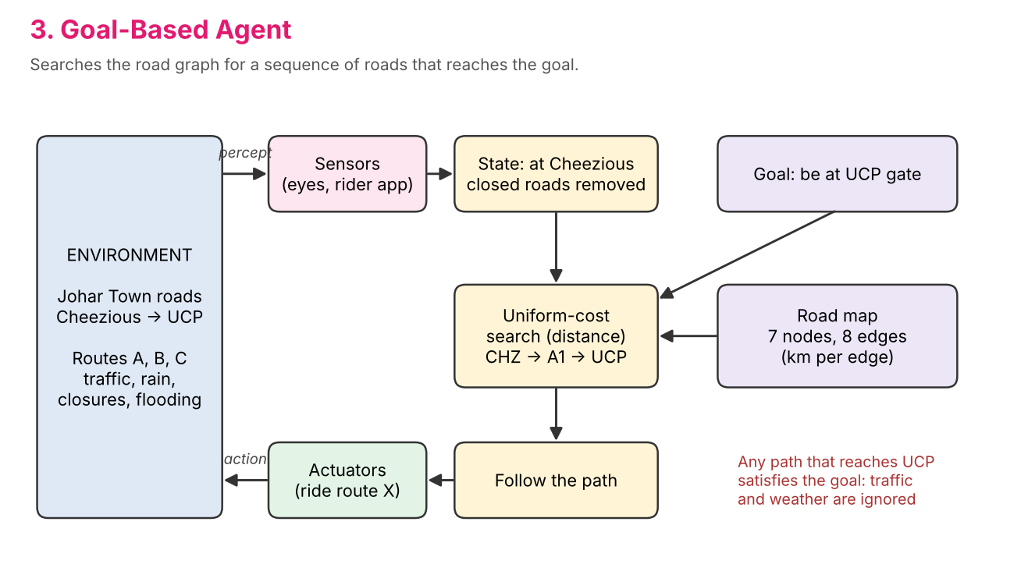
Figure: Goal-Based Agent architecture.
Always reaches the goal by the shortest road, but the goal test does not care about traffic or weather. This costs time in Test 2 and makes it late in Test 3.
Reasoning in Test 3: Goal: reach UCP. Closed roads removed from the map: A. Uniform-cost search found CHZ -> B1 -> B2 -> UCP (3.25 km) on route B. Traffic and weather are not part of the goal test, so they are ignored.

4.4 Utility-Based Agent
Predicts the possible outcomes of each route with probabilities, for example P(flood) = 0.85 after more than 30 minutes of rain, and scores them with a utility function:
U(route) = 100 x P(on time) - 2 x E[minutes] - 15 x P(flood)
choose the open route with the highest U
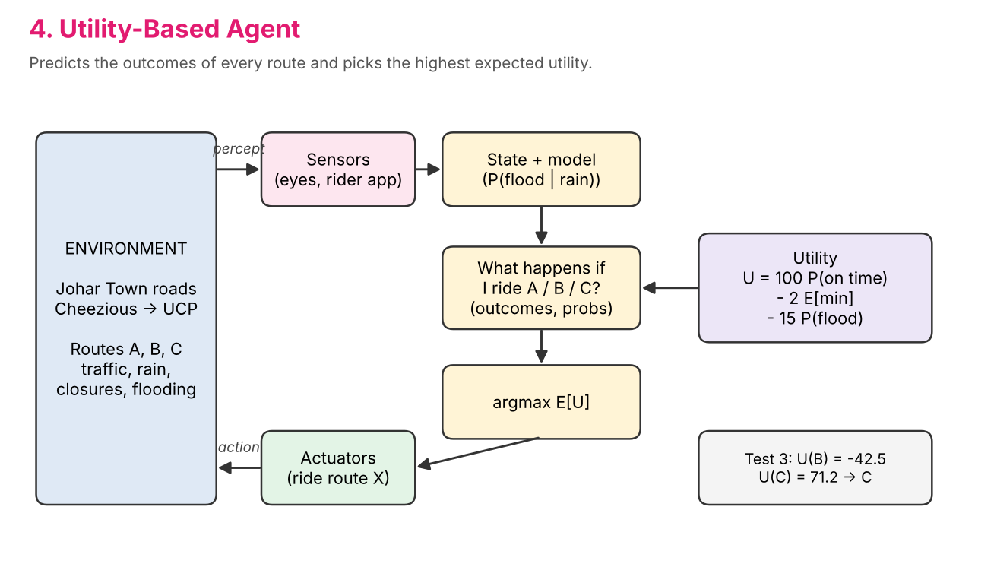
Figure: Utility-Based Agent architecture.
Trades off speed, punctuality and safety, and handles uncertainty explicitly.
Reasoning in Test 3: U = 100*P(on time) - 2*E[minutes] - 15*P(flood) Route B: E[t]=22.4 min, P(on time)=0.15, U=-42.5 Route C: E[t]=14.4 min, P(on time)=1.00, U=71.2 Highest utility -> route C.

4.5 Learning Agent
Learns a value Q(context, route) from experience. During training it rides every route on six practice days three times (54 trips, with a little random noise) and keeps the running average of -minutes. Contexts are normal, rush and rain.
Q(ctx, r) <- Q(ctx, r) + (reward - Q(ctx, r)) / n reward = -minutes
at test time: choose argmax_r Q(ctx, r) among open routes
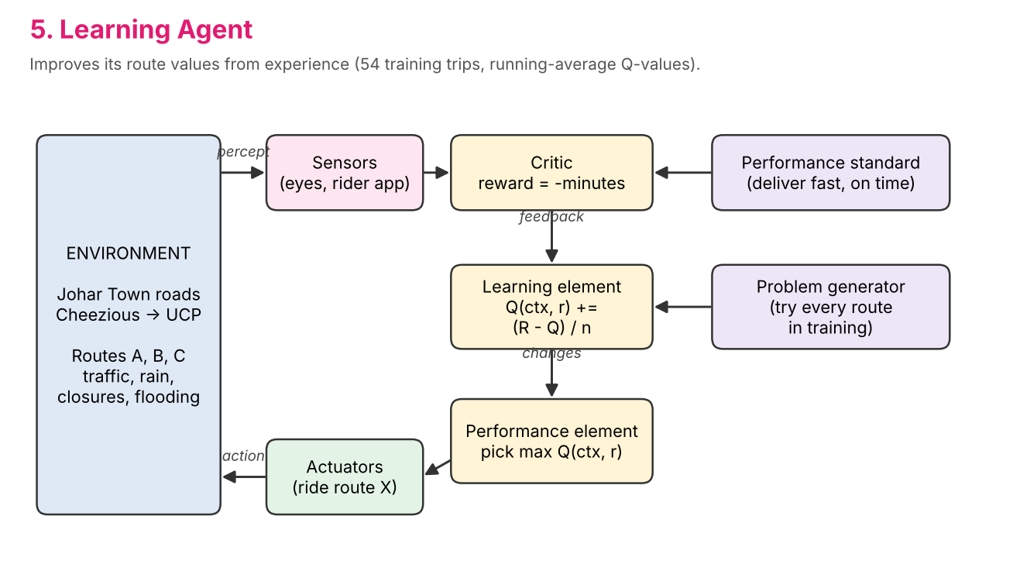
Figure: Learning Agent architecture.
Needs no hand-written rules, but it needs training data that covers each context.
Reasoning in Test 3: Context recognised: rain. Learned from 54 training trips. Q(rain, B) = -24.5 (about 24.5 min) Q(rain, C) = -14.3 (about 14.3 min) Exploit best learned value -> route C.

4.6 Hierarchical Agent
Splits the problem into three layers. The strategic layer sets the mode (fast or safe) and constraints (avoid congestion, avoid flood-prone roads after 30 minutes of rain). The tactical layer picks the fastest route that meets the constraints. The operational layer controls riding (speed limit, signals).
constraints = strategic(percept)
route = fastest route that satisfies constraints
operational(route): ride it
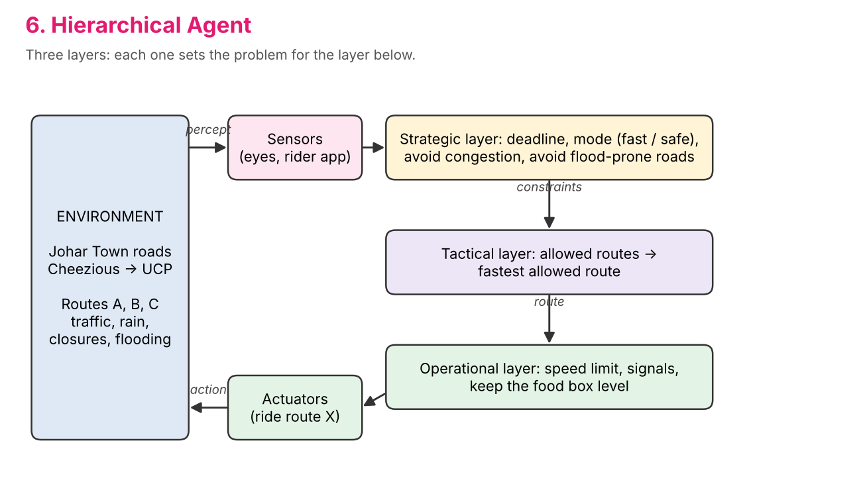
Figure: Hierarchical Agent architecture.
Easy to extend: a new concern (for example fuel) is added in one layer.
Reasoning in Test 3: Strategic layer: mode=safe, avoid congestion=True, avoid flood-prone=True. Tactical layer: allowed routes C, fastest of them is C. Operational layer: limit speed to 14 km/h on bad patches, stop at red signals, keep the food box level.

4.7 Contextual Agent
First recognises the context (normal, rush hour or monsoon) from the clock, weather and traffic, then applies the policy written for that context.
normal: A > B > C rush hour: B > C > A monsoon: C > A > B
choose the first open route in the policy
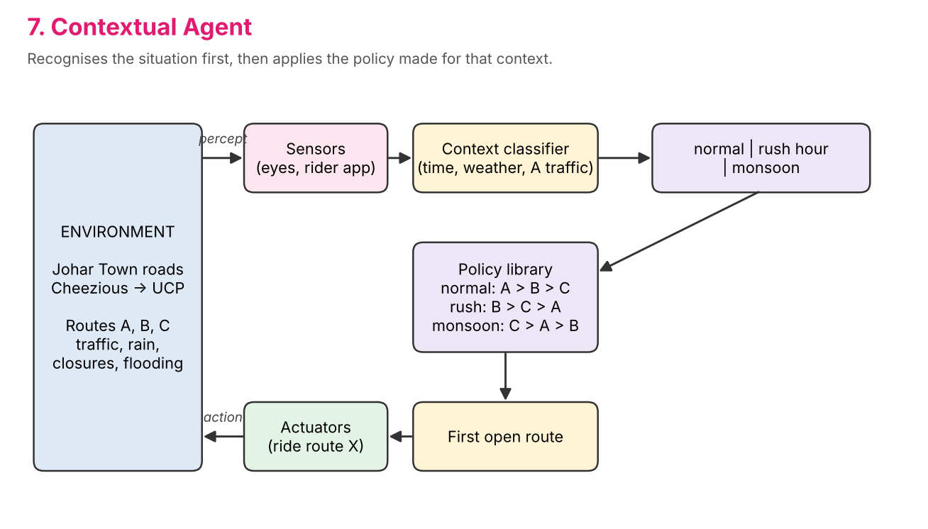
Figure: Contextual Agent architecture.
Very quick decisions, but every context and its policy has to be designed in advance.
Reasoning in Test 3: Context: monsoon (time 13:00, weather rain). Policy for monsoon: preference C > A > B. First open route in the policy -> C.

5. Implementation
File | Purpose
code/environment.py | Road map, routes, test situations, percept, trip-time model, training days
code/agents.py | The seven agent classes; each has decide(percept) -> (route, reasoning)
code/main.py | Runs every agent on every test, prints the tables, writes results/results.txt and .json
simulation/ | Interactive 3D simulation (Three.js): index.html, model.js, world.js, app.js
tools/check_parity.js | Checks that simulation/model.js makes exactly the same decisions, times and reasoning as the Python code
tools/export_diagrams.py | Draws the architecture diagrams
tools/build_report.py | Builds this report

Run the program with Python 3.8 or newer (no extra packages):
cd code
python main.py # result tables
python main.py --details # tables + every agent's reasoning

5.1 The 3D simulation
The simulation is a 3D model of the trip. A rider in a pink jacket on a motorbike with a delivery box leaves Cheezious and rides the chosen route to the UCP gate. The traffic keeps left, as in Pakistan. The scene shows Khayaban-e-Jinnah as a dual carriageway with a signal chowk, the Canal Bank Road along the Lahore Canal with its underpass, the inner streets of Block G, cars, rickshaws, buses and bikes, and lighting for the time of day. Test 2 has an evening sky and a traffic queue at the chowk. Test 3 has rain, a fallen tree across Khayaban-e-Jinnah and a flooded underpass with a stalled car.
- The decisions come from simulation/model.js, a line-by-line copy of the Python agents (verified by tools/check_parity.js).
- The rider's speed follows the model: free-flow speed on open road, crawling through the jam, pushing the bike through the flood. The total time equals the model's delivery time.
- The side panel shows the percept, the hidden truth (underpass flooded or dry) and the agent's reasoning line by line.
- Race mode sends all seven agents out at once. A custom mode lets you set the time, rain, jams, closures and flooding yourself.
- One simulated minute takes two seconds at 1x speed. Speeds of 2x, 4x and 8x and chase, map and orbit cameras are available.
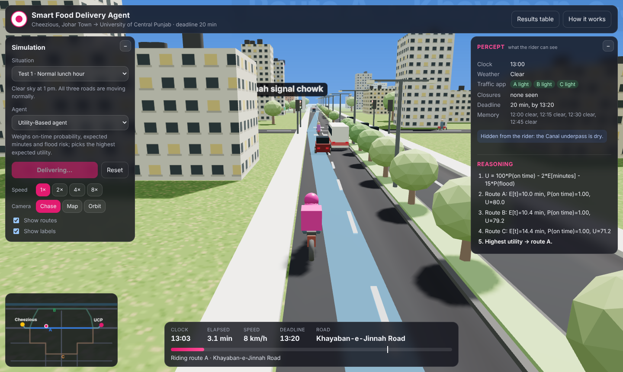
Figure: Test 1, the Utility-Based agent rides route A.
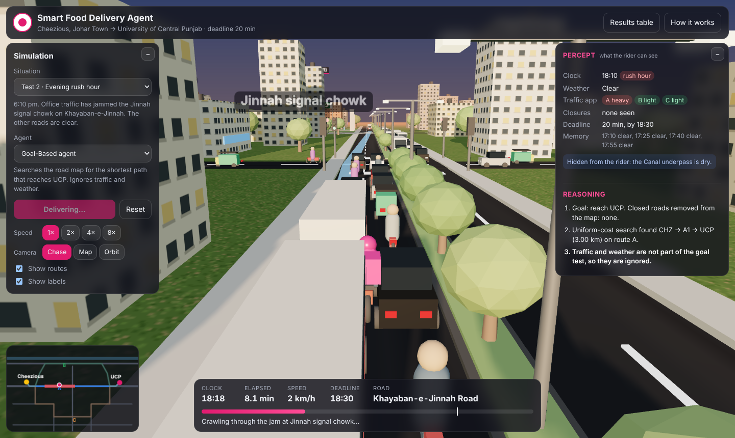
Figure: Test 2, the Goal-Based agent crawls through the jam at Jinnah chowk.
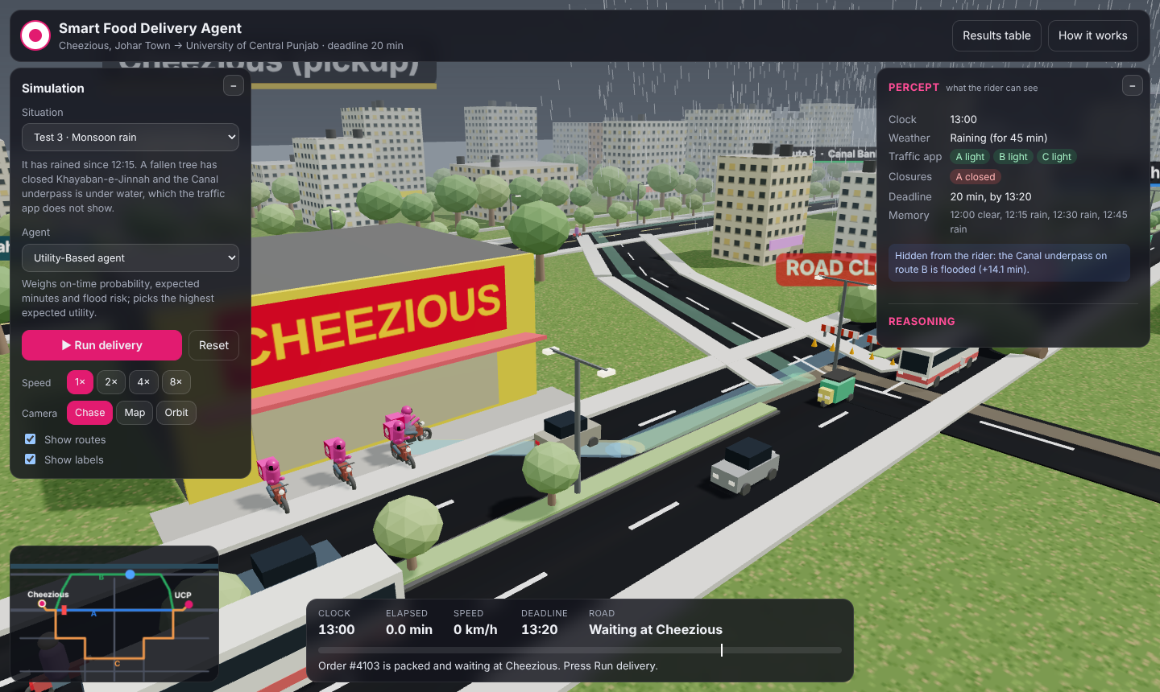
Figure: Test 3, rain, and Khayaban-e-Jinnah closed by a fallen tree.
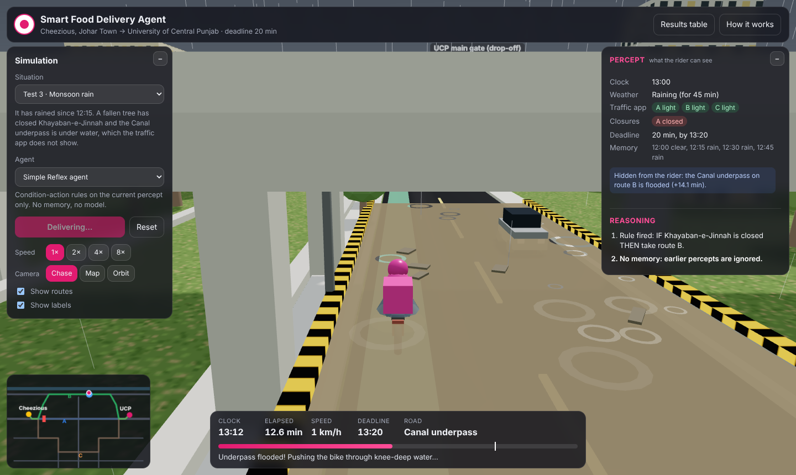
Figure: Test 3, the Simple Reflex agent is stuck in the flooded underpass.
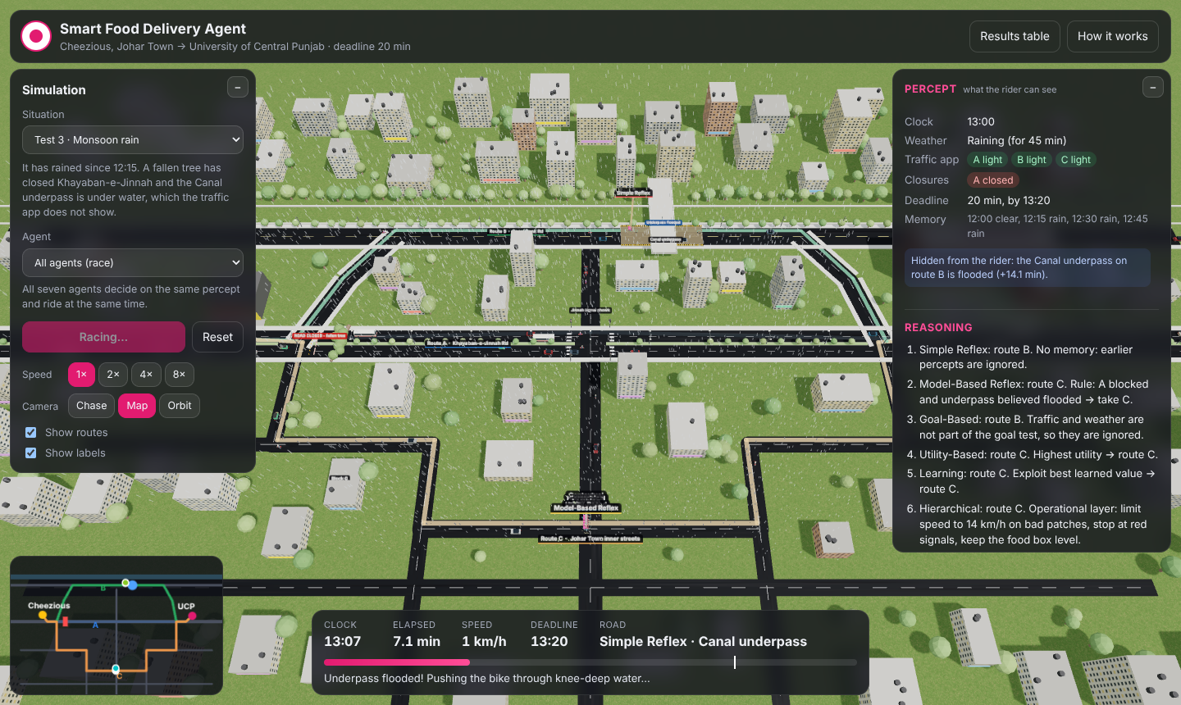
Figure: Test 3 race. Five agents take route C; Simple Reflex and Goal-Based take B.

6. Results
Agent | Test 1 | Test 2 | Test 3 | On time | Total min
Simple Reflex | A 10.0 | B 10.4 | B 24.5 (late) | 2/3 | 44.9
Model-Based Reflex | A 10.0 | B 10.4 | C 14.4 | 3/3 | 34.8
Goal-Based | A 10.0 | A 19.2 | B 24.5 (late) | 2/3 | 53.7
Utility-Based | A 10.0 | B 10.4 | C 14.4 | 3/3 | 34.8
Learning | A 10.0 | B 10.4 | C 14.4 | 3/3 | 34.8
Hierarchical | A 10.0 | B 10.4 | C 14.4 | 3/3 | 34.8
Contextual | A 10.0 | B 10.4 | C 14.4 | 3/3 | 34.8

Cell = chosen route and real delivery time in minutes. Deadline: 20 minutes.
- Test 1: every agent takes A (10.0 min). With nothing unusual, all architectures are equal.
- Test 2: the jam on A is visible on the app. Every agent except Goal-Based switches to B (10.4 min). Goal-Based still takes the shortest road A and needs 19.2 min. It is on time, but only just.
- Test 3: A is closed and the underpass on B is flooded, which cannot be seen. Simple Reflex (no memory) and Goal-Based (traffic and weather are not part of its goal) take B and arrive after 24.5 min, which is late. Every agent that keeps or learns a model of the rain (Model-Based, Utility, Learning, Hierarchical, Contextual) takes C and arrives in 14.4 min.

7. Comparison and the most suitable agent
Agent | Handles hidden flood | Handles traffic | Needs training | Design effort | Explains its choice
Simple Reflex | No | Yes (visible jam) | No | Very low | Rule that fired
Model-Based Reflex | Yes (rule) | Yes | No | Low | State + rule
Goal-Based | No | No | No | Low | Search path
Utility-Based | Yes (probability) | Yes | No | Medium | Utility of every route
Learning | Yes (learned) | Yes | Yes, 54 trips | Medium | Learned values
Hierarchical | Yes (constraint) | Yes | No | Medium | Each layer's decision
Contextual | Yes (context) | Yes | No | Medium | Context + policy

Five agents deliver all three orders on time in 34.8 minutes in total, so the results alone do not decide. We choose the Utility-Based agent as the most suitable for this problem, for these reasons:
- It deals with uncertainty directly. The flood cannot be observed, and the agent reasons with P(flood) instead of a yes/no rule. A rule that is wrong 15% of the time is still a rule; the utility agent knows how risky B is.
- It balances several goals at once: being on time, total minutes and rider safety. The weights can be changed (for example, a heavier penalty for lateness on a premium order) without rewriting the agent.
- It needs no training data, unlike the Learning agent, and does not depend on a fixed list of contexts, unlike the Contextual agent. A new mix of conditions (for example a jam on A and light rain together) is still scored correctly.
- Its reasoning is transparent: the utility of every route is shown, which makes each decision easy to explain to the rider or the dispatcher.
The Learning agent is a strong second choice for a real company with a lot of trip data, and the Hierarchical design is a good way to add riding control on top of the Utility-Based route choice.

8. Conclusion
The simple architectures do well while the world is fully visible (Tests 1 and 2), but they fail when an important fact is hidden (Test 3). Agents that keep a model of the world, learn from experience or reason about outcomes avoid the flooded underpass and deliver on time. The Utility-Based agent combines this with explicit handling of uncertainty and adjustable goals, so it is the most suitable architecture for the Smart Food Delivery Agent. The 3D simulation makes these differences visible: the same order, the same roads, and seven riders that think in seven different ways.

