**<<<A guideline for the system and how to use it>>>**

**The system permissions …..**

**Admin: (the ID :Admin)**

**Main Menu:**

1-**Display Information**

* **Display Patient Data (by ID)**

1. Display Personal Information
2. Display Specific Personal Information
3. Display a Summary about the Patient

* **Display Doctor Data (by ID)**

1. Display Doctor Information
2. Display ID's for All Patients Under Supervision
3. Display a Summary for All Patients Under Supervision

* **Display Nurse Data (by ID)**

1. Display Nurse Information
2. Display ID's for All Patients Under Supervision
3. Display a Summary for All Patients Under Supervision

* **Display Hospital Information**

1. Display Hospital Information
2. **Go to Emergency Room**

1-Display A Summary

3**) Go to Quarantine Room**

1-Display A Summary

2-**Edit Information**

* **Edit Patient Data (by ID)**

1. Edit Personal Information
2. Edit Patient ID

* **Edit Doctor Data (by ID)**

1. Edit Doctor Information
2. Edit Doctor ID
3. Add new Patients

* **Edit Nurse Data (by ID)**

1. Edit Doctor Information
2. Edit Doctor ID
3. Add new Patients

* **Edit Hospital Information**

1. Edit Hospital Name
2. Edit Hospital Location
3. Edit Hospital Contact Number

**Doctor:**

**Main Menu:**

**1-Display Information**

1. Display Doctor Information
2. Display A Summary about The Patients
3. Display Patients IDs
4. Display Information about a Specific patient (by ID)
5. Display Daily Check for a Specific patient (by ID)
6. Show All Symptoms for a Specific patient (by ID)

**2-Edit Information**

1. Edit Daily Check for a specific patient (by ID)
2. Edit Patient Condition for a specific patient (by ID)
3. Edit Symptoms for a specific patient (by ID)

**Nurse:**

**Main Menu:**

**1-Display Information**

1. Display Nurse Information
2. Display A Summary about The Patients
3. Display Patients IDs
4. Display Information about a Specific patient (by ID)
5. Display Daily Check for a Specific patient (by ID)
6. Show All Symptoms for a Specific patient (by ID)
7. Display Quarantine Information for a Specific patient (by ID)

**2-Edit Information**

1. Edit Daily Check for a specific patient (by ID)
2. Edit Quarantine Information for a specific patient (by ID)
3. Edit Symptoms for a specific patient (by ID)

**Patient:**

**Main Menu:**

1. Display Personal Information
2. Display a Summary
3. Display a specific information

How to use the system.

Important notes: the system only work with C++11 and above .

It’s preferred to use Codelite IDE to run the system (since the workspace will be provided)

Always the IDs should start with a upper case letter and you have three type of IDs (N,D,P)

1. N=nurse
2. D=doctor
3. P=patient
4. And always the admin id is (Admin)

So, if you change on the Patient or Doctors or Nurses always make sure that the first letter start base of the given instructions.

**Running the system for the first time !!...**

You might face this issue when you run the system

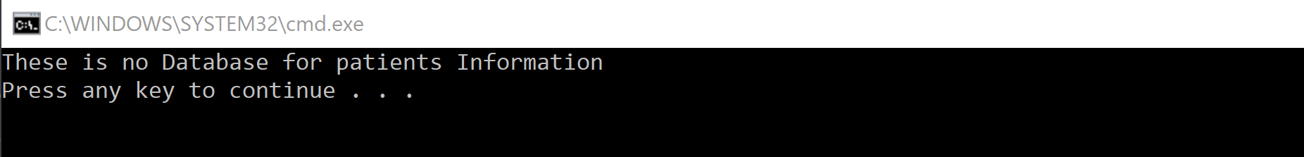

This problem appears when you don’t write the databases location in the int main

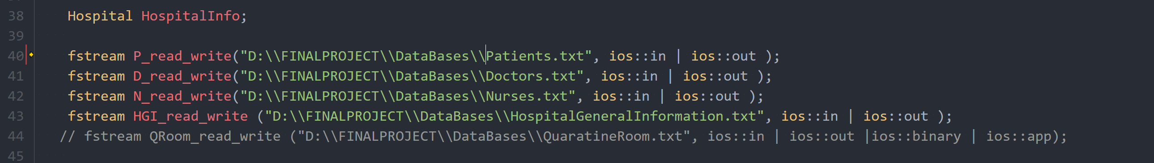

So, first thing you have to do is to write the location of the files.

Keep in mind that the first line is for the Patients database

Whereas the second line for the Doctors database, and the third line for the Nurses database, finally the fourth line is for the HospitalInformation database.

Setting up the system:

If the databases are empty you have to set up the system and insert initial data, (like how many patient, doctor…etc)

Always keep in mind if the patient file is empty you have to set up again the nurse and doctor files, since you have to connect the doctor and nurses with their patients.

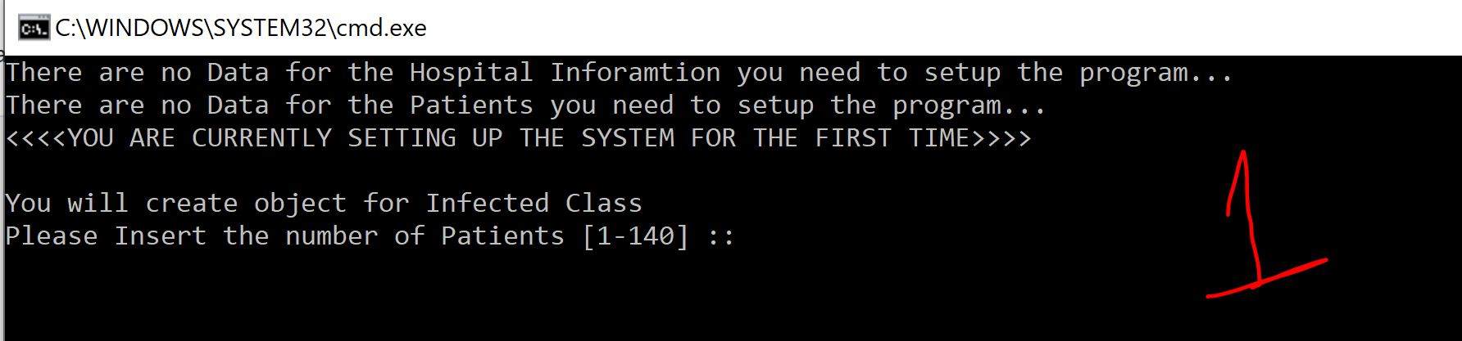

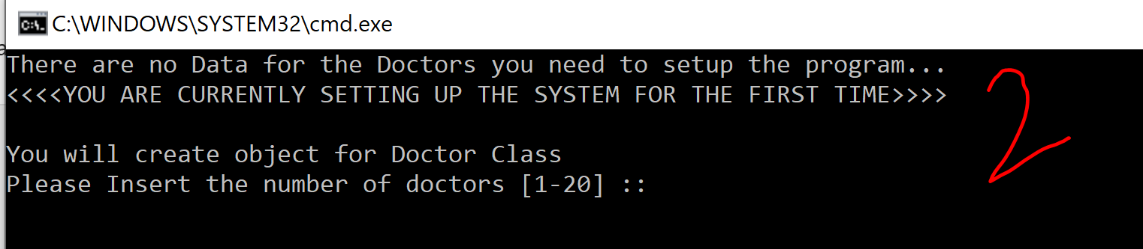

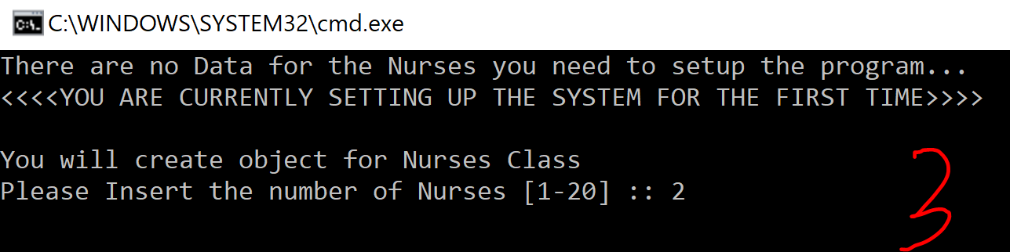

You have to keep in mind that each doctor and nurse can be responsible for 7 patients so if you have to doctors in the system you are only allowed to insert 14 patient maximum.

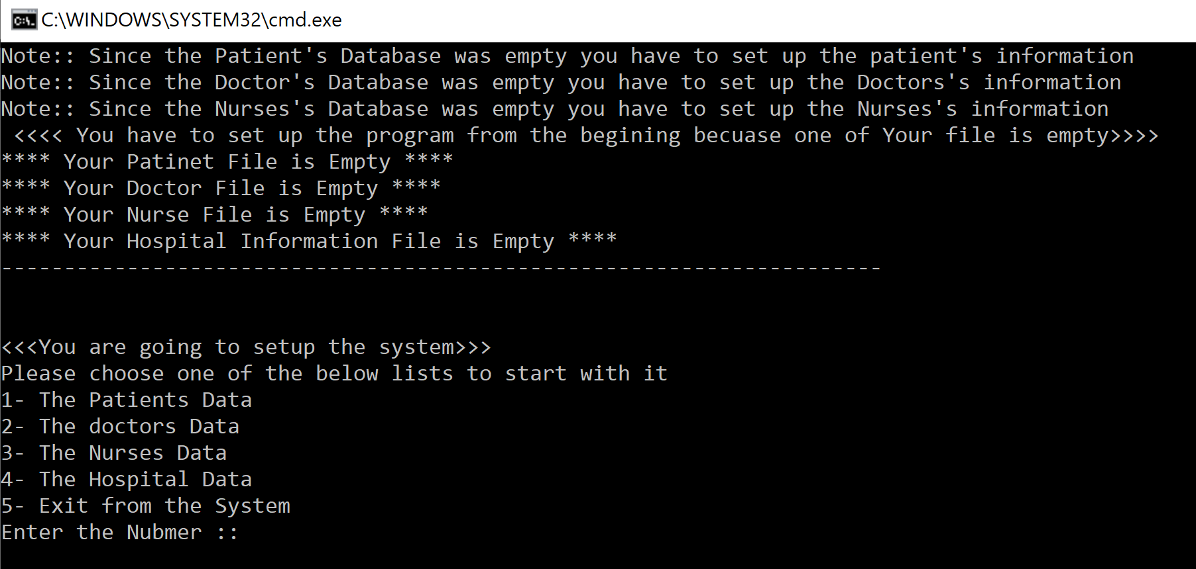

Here you will be informed what are the files that are empty.

Always start with the patient Data

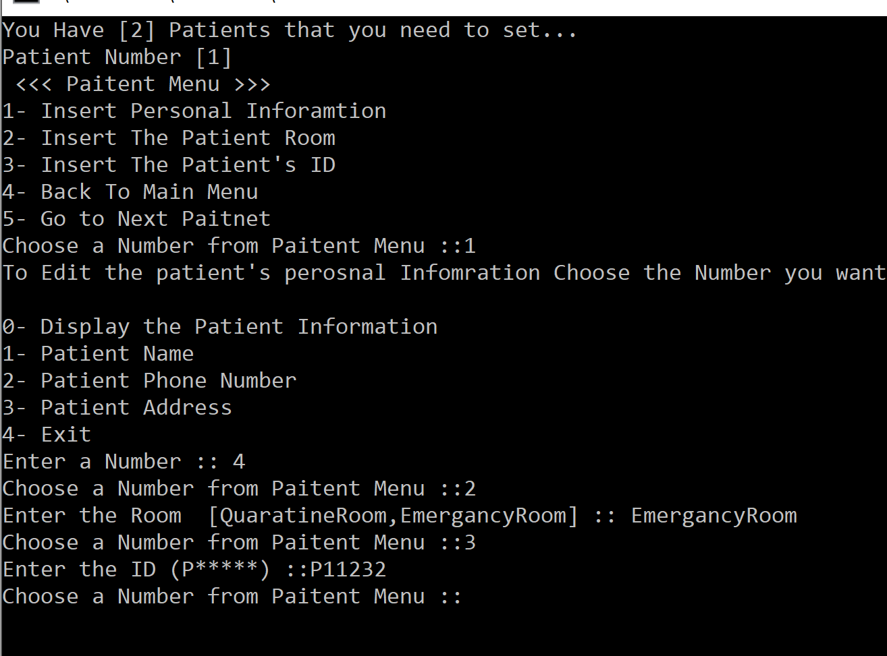

Always the id starts with (P)

You have to copy and paste the room the patients is in it (from the two choices )

If you chose to go to the main menu (the counter will be set to zero , which means you have to re-enter all the data again)

In the above part it shows how many patients that you need to enter their data , as well as the number of the patients that you are entering his\her data.

After finishing from inserting the data choose 5 (go to next patient).then a mess will be displayed saying that you have set up all the patients data. Then you will go back to the main menu again.

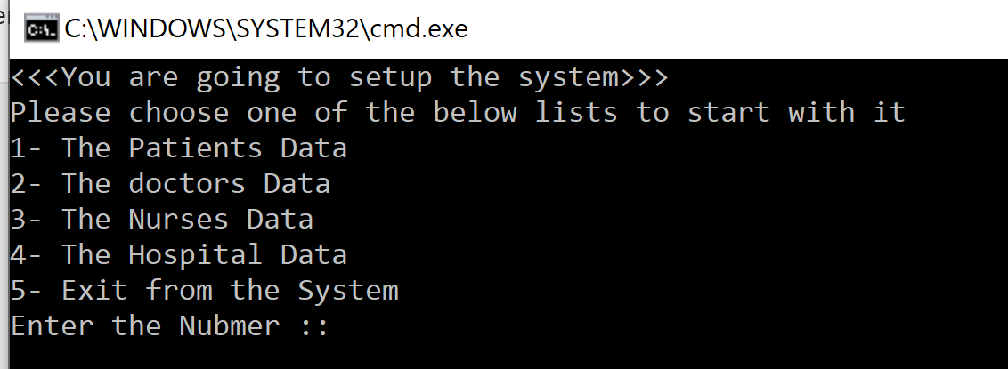

After choosing the second option

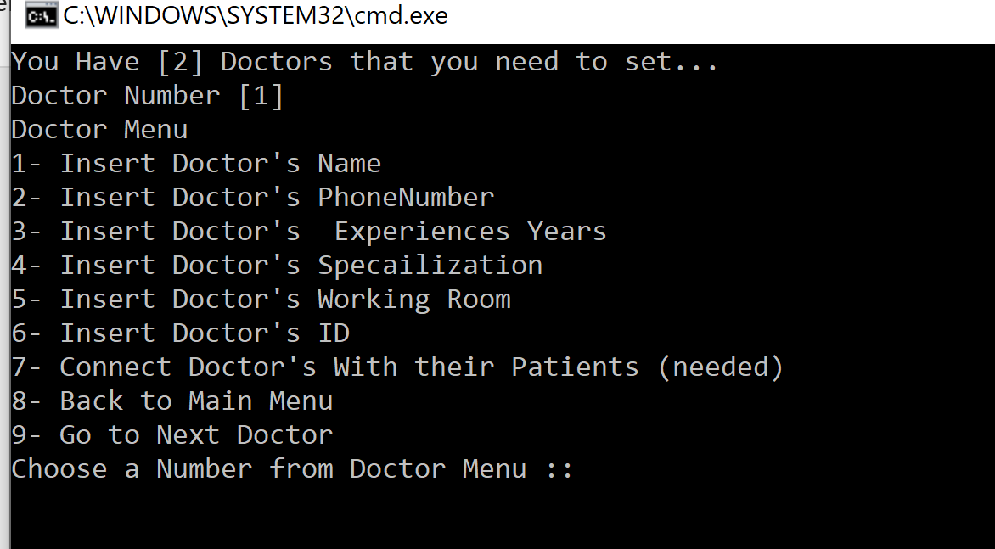

The important thing here is to set up (working room , ID, as well to connect the doctor with his patients)

You can only connect the doctor with the patient they have the same (Room)

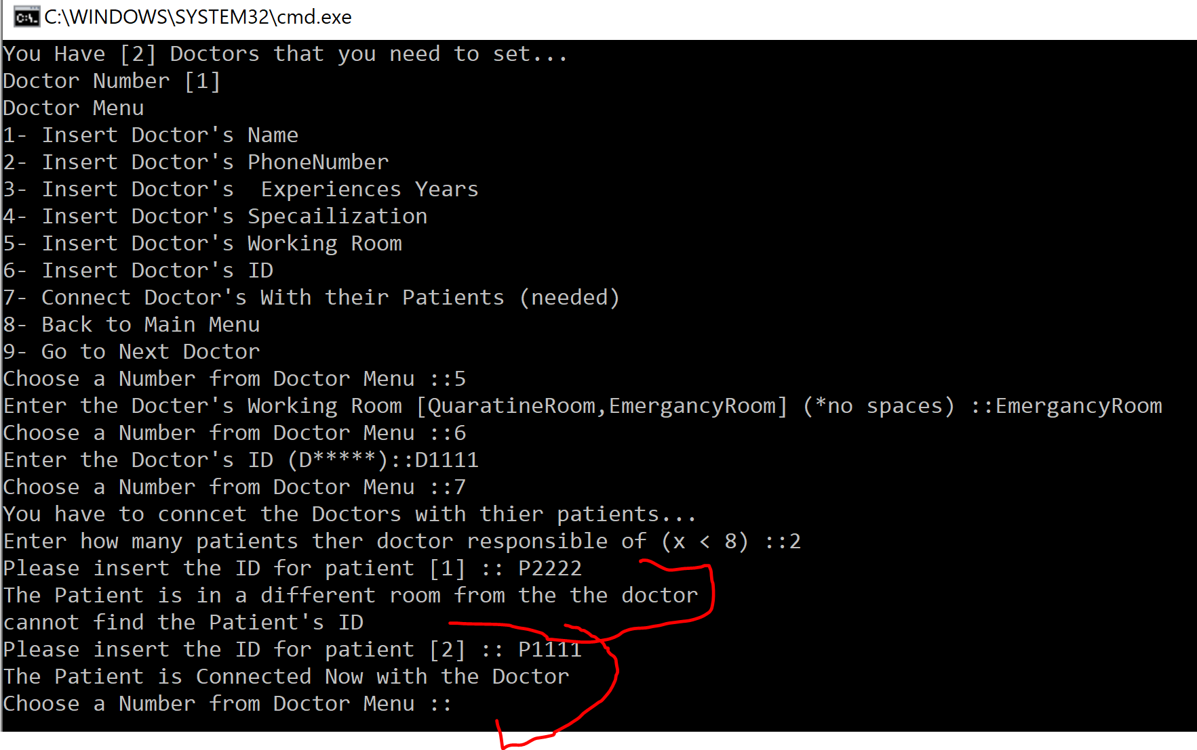

YOU ARE NOT ALLOWED TO CONNECT THE DOCTOR WITH MORE THAN 7 PATIENTS.

If you inserted a wrong ID

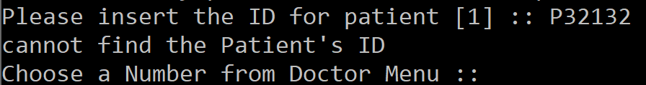

After finishing choose (9)

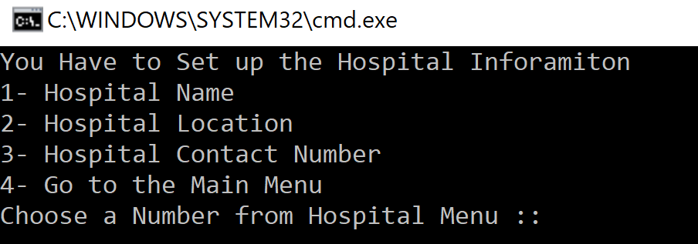Same conditions with patients if you chose (8).

All the above step work the same with the Nurse.

Setting up the hospital information

After finishing choose (exit from the system)

**Database check step…**

Always make sure after you enter the data from these things.

1. if you find the database for the doctor and nurses like this 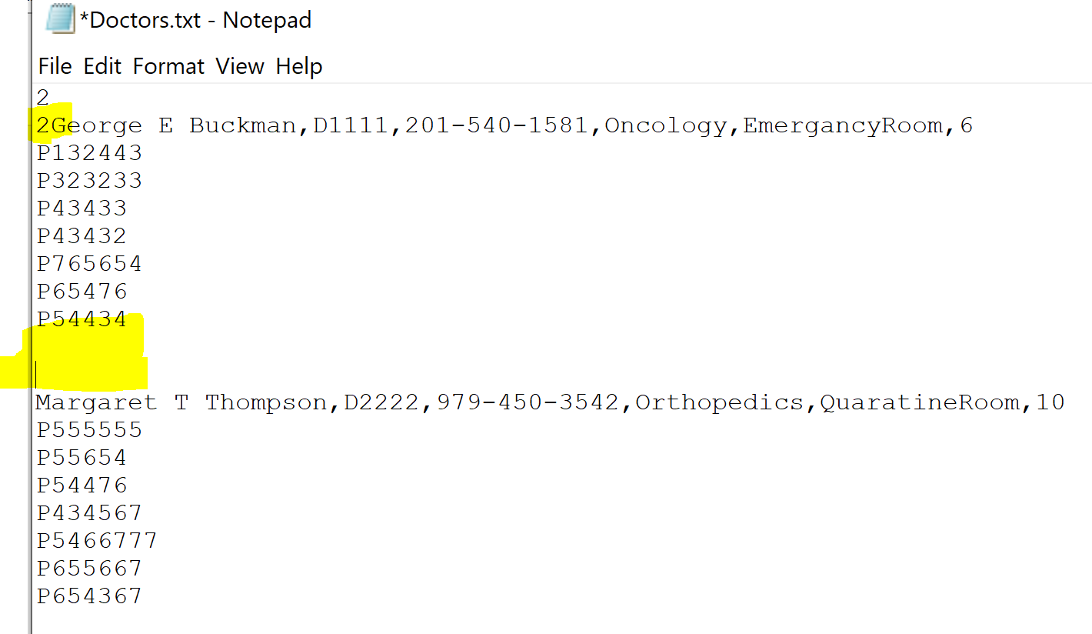

Always delete the empty lines , as well separate the second number from the words. The correct database should be like this

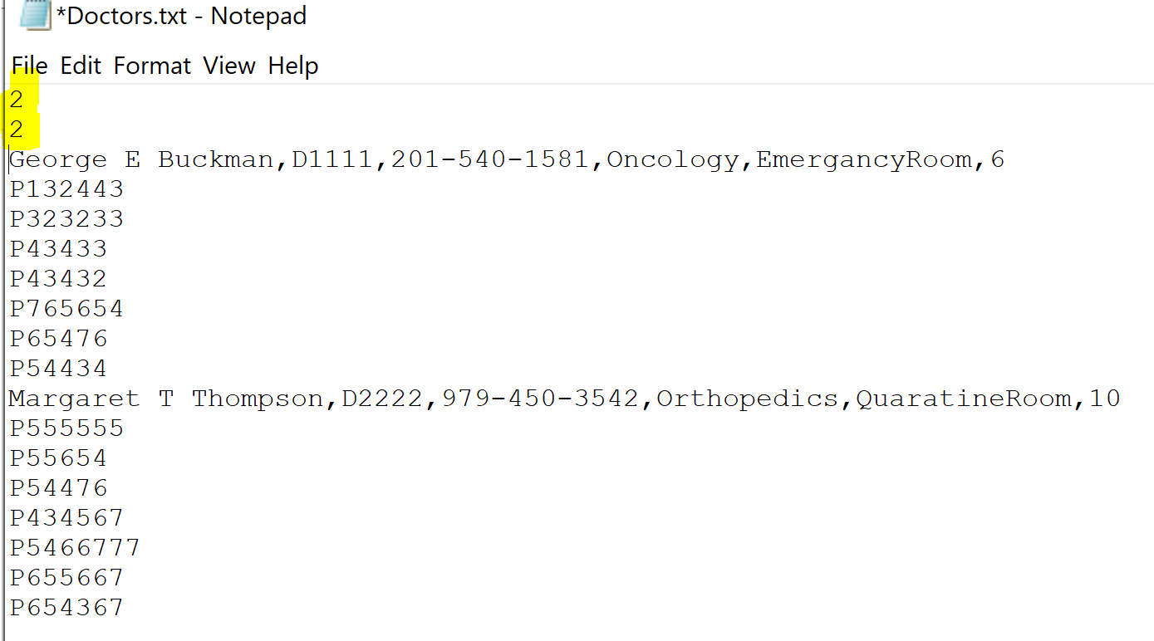

The same thing goes with the patient’s database.

**Starting the program…..**

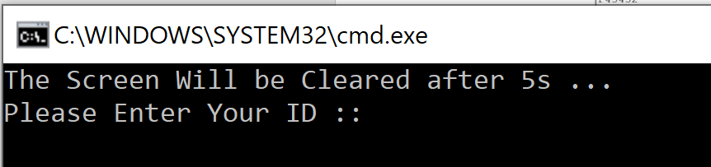

After setting the data you can start the program

Note: a virtual data set will be provided in the files.

Here you can enter the ID and based on the id the permissions will be displayed.

If you don’t know any IDs (check part *understanding the databases*), keep in you mind that the admin ID is always (Admin).

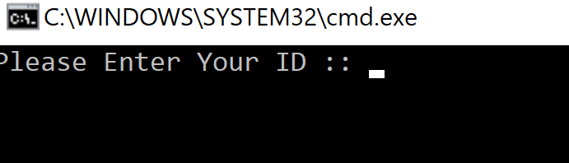 **Logging out from the system….**

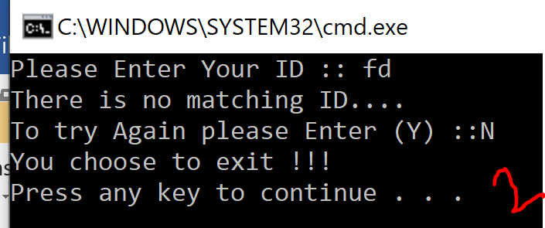Always after you finish your work choose log out option then you will move to this page again.

If you want to continue enter any existed ID in the system , and if you want to log out enter any random ID. Then the data will be stored in the databases. Always do (databases check step) after finishing using the system.

**Understanding the databases…**

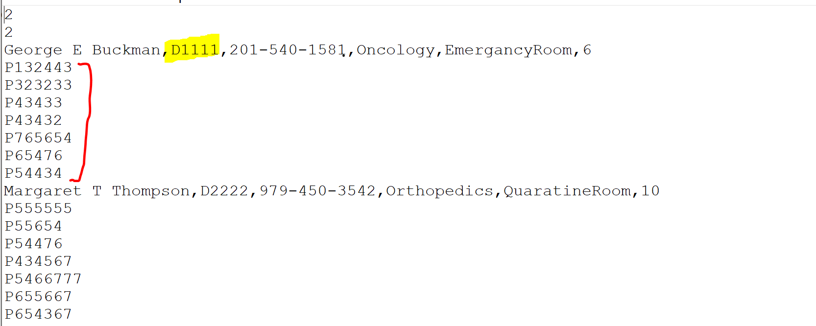

The marked part is the doctor’s ID , whereas the red part is the patients that the doctor responsible of. First and second numbers are very important since they indicates for the number of doctors and the doctor counter.

Same thing goes with the Nurses database, the only difference that it doesn’t contain the specialization name.

HospitalInformation database

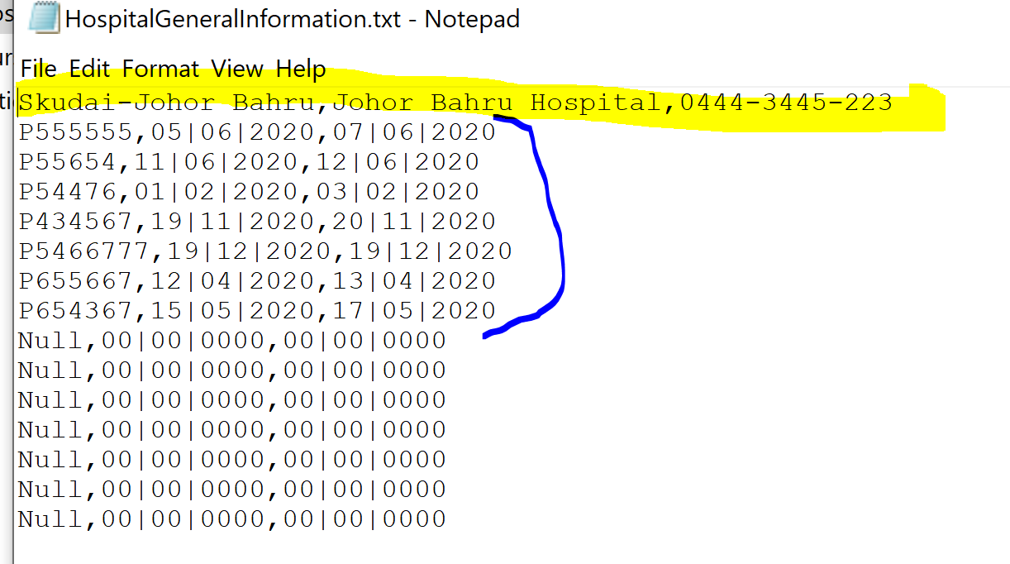

The marked part is the general information, where as the blue part is the data that belongs to the quarantine room.

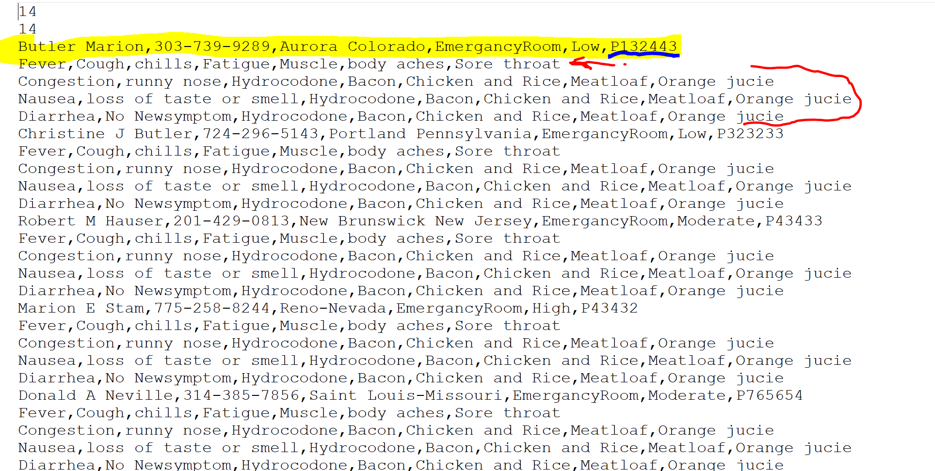

For the Patients database, the first line is for the patient information, notice that the last data is the patients ID, the second line contains all the patient’s symptoms, whereas the next three line are for the daily-check class.

**Other important notices….**

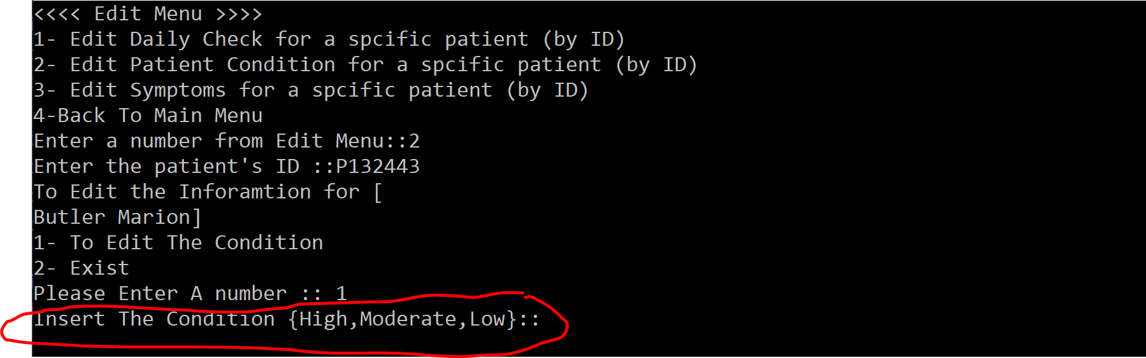

When ever you face this kind of inputs (please copy and past) from the provided choices and don’t insert any addition characters (even a space).

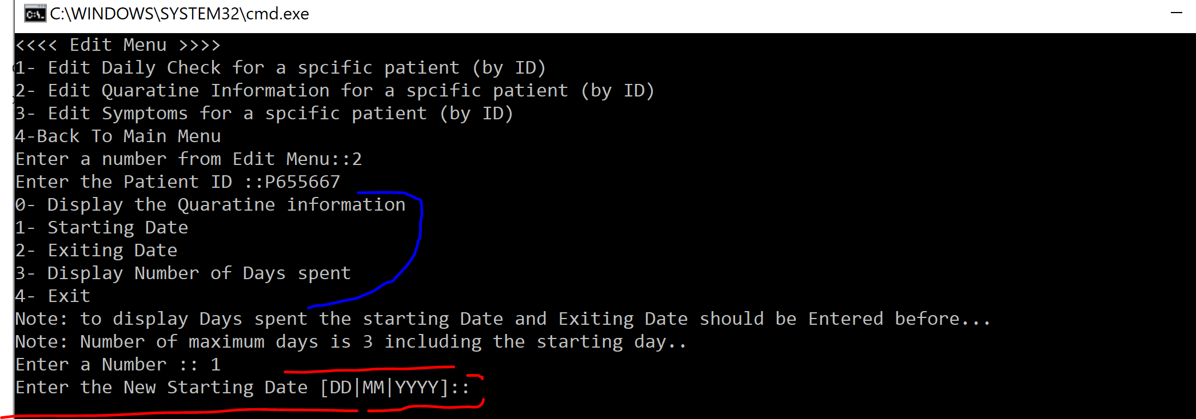

When you want to edit the Patients information room, always start with the first choice

And then continue with the rest of the choices, for the red part , insert the input as it’s shown in the screen 07|12|2020.

When you log