Supplements for
User-Centered Design Metrics and
Motivational Aspects for Basic Study Design
Philipp Ziebell – University of Würzburg – Institute for Psychology
Psychological Intervention, Behavior Analysis, and Regulation of Behavior (Prof. Dr. Andrea Kübler)
Differential Psychology, Personality Psychology, and Psychological Diagnostics (Prof. Dr. Johannes Hewig)

User-Centered Design (UCD): Objective Measures

Effectiveness: Accuracy

A measure of how accurate and complete a user can accomplish a BCI-controlled application is how often the intended output can be achieved. Accuracy relates successful selections to the total number of attempted selections and can be expressed in percentage of correct responses, preferably online (vs. offline) [1, 2].

Efficiency: Information transfer rate (ITR) – utility metric

Efficiency relates the costs, i.e. effort and time, invested by the user to effectiveness. An objective measure of efficiency is the ITR and its modifications with regards to error probability, accuracy, and practicality. A common phenomenon in a BCI-controlled application is that high ITR can be achieved despite numerous miss-selections if the number of possible selections is high. However, such a BCI would be of no practical value as no meaningful communication would be possible. Thus, the utility metric was introduced and takes into account, that with an accuracy below 50%, no reliable communication can be achieved, i.e. ITR is 0 bits/minute for all accuracies below 50% [1, 2], see also following figure [3] and example [4].
Example

UCD: Subjective Measures

Efficiency: Workload

Workload constitutes a subjective measure of efficiency and is classically measured by the NASA-TLX. Workload in the NASA-TLX is defined as a ‘‘hypothetical construct that represents the cost incurred by a human operator to achieve a particular level of performance’’. The NASA-TLX measures the overall workload experienced while operating a specific application and identifies main sources of workload, which is estimated across the dimensions mental, physical, and temporal demand, and performance, effort, and frustration. Subjective workload for each dimension has to be rated on twenty step bipolar scales with scores from 0 to 100. A weighting procedure combines the individual scores for each dimension into one total score. It has previously been used to assess workload of healthy subjects during BCI operation [1, 2].
Details and example see following figures [5, 6].
Example

Satisfaction: Overall satisfaction – BCI-related aspects – interview

User satisfaction refers to the perceived comfort and acceptability while using the product. We suggest several measures to assess device satisfaction. The Extended QUEST 2.0 (see following page) is not suitable to be applied after every BCI session as it requires time and it is unlikely that basic aspects contributing to satisfaction change substantially across sessions with the same BCI-controlled application. However, we consider it valuable to obtain a coarse rating of overall satisfaction at the end of each BCI session. Visual analogue scales (VAS) can provide such a measure. Users can be easily asked after each session to indicate their overall satisfaction on a VAS ranging from 0 (not at all satisfied) to 10 (maximally satisfied). Such a rating does not provide any in depth information about sources of satisfaction/dissatisfaction, but it allows for easy monitoring specifically in long-term studies [1, 2].
Concrete examples from a relatively basic study design see subsequently [4].
Example
Dear participant,

Please complete the following questions:

Please use the line below to rate how difficult it has been for you to control the BCI. The number 0 means that it was not difficult at all and the number 10 means that it was extremely difficult. As a marker, please put a cross in the area that you think best represents your experience.

0 = not difficult at all 10 = extremely difficult

Please use the line below to rate how satisfied you are with the BCI system.

0 = not satisfied at all 10 = extremely satisfied

Could you imagine using a BCI for communication? What problems would need to be addressed? What would be major improvements? Did you notice anything else?

__________________________________________________________________________________________

__________________________________________________________________________________________

__________________________________________________________________________________________

Satisfaction: General aspects of assistive technology

The Quebec User Evaluation of Satisfaction with assistive technology (QUEST 2.0), allows for quantifying satisfaction with general aspects of a product. The questionnaire consists of items that cover 12 aspects. The QUEST 2.0 is considered invalid if scores for more than six (of 12) satisfaction items are missing; thus, it is important to check whether the items are adequate to assess a specific application. We considered the items ‘‘durability, service delivery, repairs/servicing, and follow-up services’’ inadequate for the evaluation of a BCI-controlled application during development and removed those from the questionnaire. ‘‘Durability’’ was removed also because EEG amplifiers have already demonstrated their long-term functionality, electrodes have to be replaced depending on the frequency of use, and our evaluation procedure did not span a time frame of years such that durability could become an issue. Items are rated on a Likert-type scale from 1 to 5. Whenever users are not ‘‘very satisfied’’ they are invited to comment. The arithmetic mean across all items provides the total satisfaction score. Demers and colleagues explicitly invite researchers to add few items to render the questionnaire more suitable for a specific piece of technology. Concrete example see below [1, 2, 7, 8, https://www.midss.org/sites/default/files/questeng.scoring_sheetpdf_0.pdf].
Example

Usage: Match between product and user – overall usability – use in daily life

For a detailed description with a focus on hearing the needs of clinical users see [2].

Motivational Aspects

See overview in following figure [9] and concrete examples on following page [4].

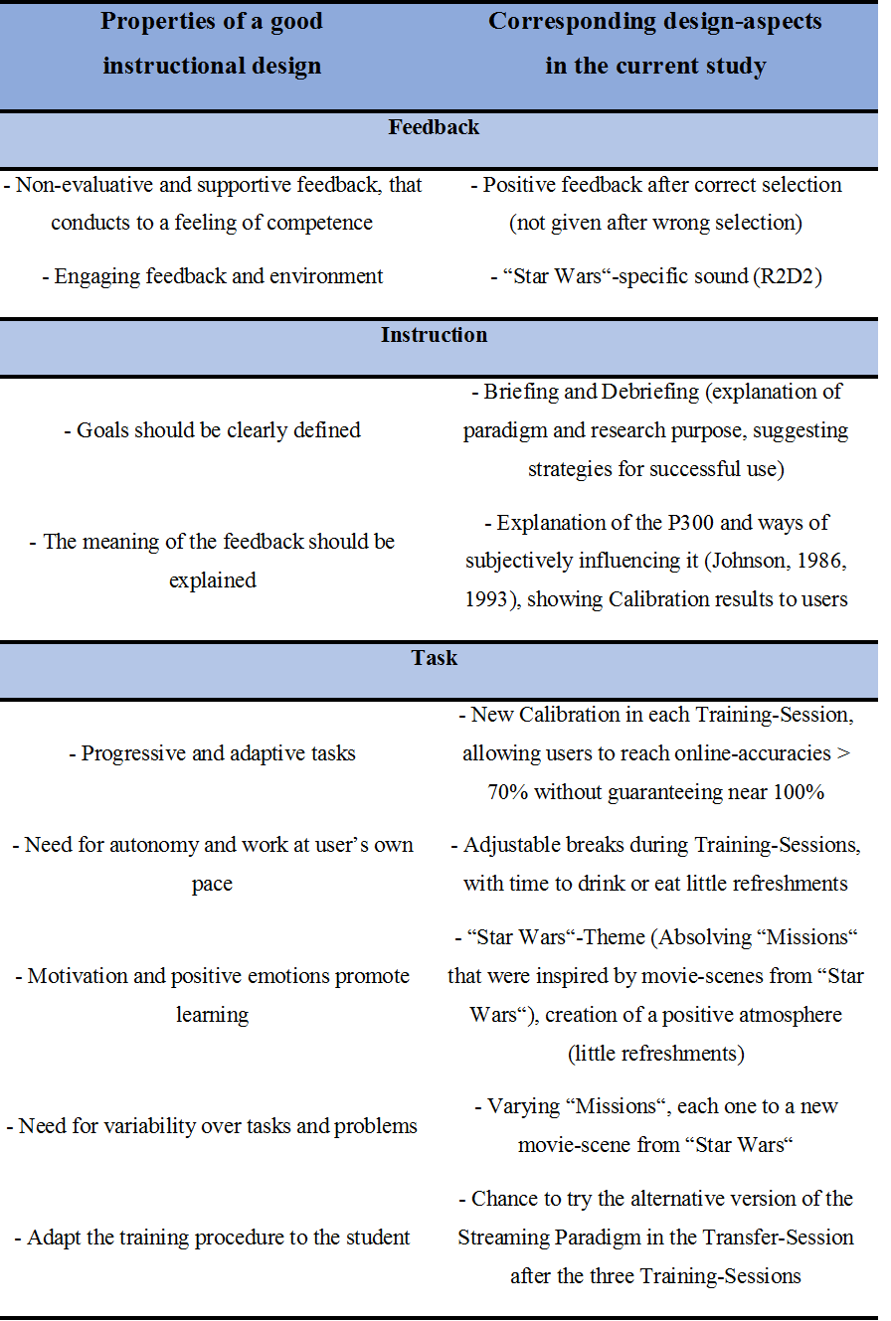
Example

In addition to considering the listed motivational aspects, motivation can be assessed via relatively global measures (e.g. VAS) or via more specific measures (e.g. QCM-BCI) [4, 10, 11].

Literature

[1] Kübler, A., Holz, E. M., Riccio, A., Zickler, C., Kaufmann, T., Kleih, S. C., …, & Mattia, D. (2014). The user-centered design as novel perspective for evaluating the usability of BCI-controlled applications. PLoS ONE, 9(12), doi: 10.1371/journal.pone.0112392.
[2] Kübler, A., Nijboer, F., & Kleih, S. (2020). Hearing the needs of clinical users. In Ramsey, N. F. & Millán, J. R. (Eds.), Handbook of Clinical Neurology. Amsterdam: Elsevier.
[3] Wolpaw, J. R., Birbaumer, N., McFarland, D. J., Pfurtscheller, G., & Vaughan, T. M. (2002). Brain–computer interfaces for communication and control. Clinical Neurophysiology, 113(6), 767-791.
[4] Ziebell, P., Stümpfig, J., Eidel, M., Kleih, S. C., Kübler, A., Latoschik, M. E., & Halder, S. (2020). Stimulus modality influences session-to-session transfer of training effects in auditory and tactile streaming-based P300 brain–computer interfaces. Scientific Reports, 10(1), doi: 10.1038/s41598-020-67887-6.
[5] Hart, S. G. (2006). NASA-task load index (NASA-TLX); 20 years later. Proceedings of the Human Factors and Ergonomics Society Annual Meeting, 50(9), 904-908.
[6] Grier, R. A. (2015). How high is high? A meta-analysis of NASA-TLX global workload scores. Proceedings of the Human Factors and Ergonomics Society Annual Meeting, 59(1), 1727-1731.
[7] Demers, L., Weiss-Lambrou, R., & Ska, B. (2002). The Quebec User Evaluation of Satisfaction with Assistive Technology (QUEST 2.0): an overview and recent progress. Technology and Disability, 14(3), 101-105.
[8] Zickler, C., Riccio, A., Leotta, F., Hillian-Tress, S., Halder, S., Holz, E., … & Kübler, A. (2011). A brain-computer interface as input channel for a standard assistive technology software. Clinical EEG and Neuroscience, 42(4), 236-244.
[9] Lotte, F., Larrue, F., & Mühl, C. (2013). Flaws in current human training protocols for spontaneous Brain-Computer Interfaces: lessons learned from instructional design. Frontiers in Human Neuroscience, 7, doi: 10.3389/fnhum.2013.00568.
[10] Nijboer, F., Furdea, A., Gunst, I., Mellinger, J., McFarland, D. J., Birbaumer, N., & Kübler, A. (2008). An auditory brain–computer interface (BCI). Journal of Neuroscience Methods, 167(1), 43-50.
[11] Rheinberg, F., Vollmeyer, R., & Burns, B. D. (2001). QCM: A questionnaire to assess current motivation in learning situations. Diagnostica, 47(2), 57-66.

Examples for Further Reading

Chavarriaga, R., Fried-Oken, M., Kleih, S., Lotte, F., & Scherer, R. (2017). Heading for new shores! Overcoming pitfalls in BCI design. Brain-Computer Interfaces, 4, doi: 10.1080/2326263X.2016.1263916.
Choi, I., Rhiu, I., Lee, Y., Yun, M. H. & Nam, C. S. (2017). A systematic review of hybrid brain-computer interfaces: Taxonomy and usability perspectives. PLoS ONE, 12(4), doi: 10.1371/journal.pone.0176674.
Mladenović, J. (2021). Standardization of protocol design for user training in EEG-based brain–computer interface. Journal of Neural Engineering, 18(1), 011003.

