2021-1-31

The manifest file
Before the Android system can start an app component, the system must know that the component exists by reading the app's manifest file, AndroidManifest.xml. Your app must declare all its components in this file, which must be at the root of the app project directory.
The manifest does a number of things in addition to declaring the app's components, such as the following:
- Identifies any user permissions the app requires, such as Internet access or read-access to the user's contacts.
- Declares the minimum API Level required by the app, based on which APIs the app uses.
- Declares hardware and software features used or required by the app, such as a camera, bluetooth services, or a multitouch screen.
- Declares API libraries the app needs to be linked against (other than the Android framework APIs), such as the Google Maps library.

1.Declaring components
The primary task of the manifest is to inform the system about the app's components. For example, a manifest file can declare an activity as follows:
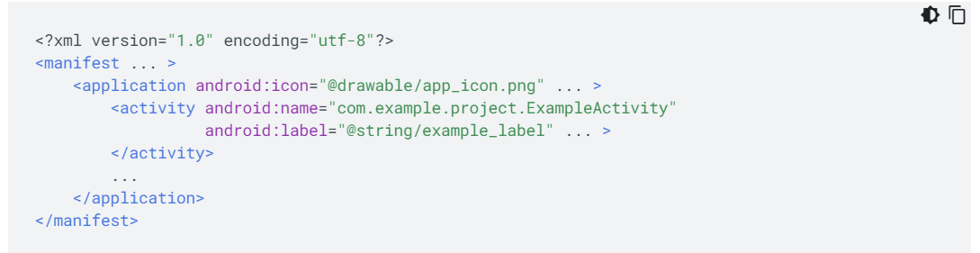
In the <application> element, the android:icon attribute(특성) points to resources for an icon that identifies the app.
In the <activity> element, the android:name attribute specifies the fully qualified class name of the Activity subclass and the android:label attribute specifies a string to use as the user-visible label for the activity.

You must declare all app components using the following elements:
- <activity> elements for activities.
- <service> elements for services.
- <receiver> elements for broadcast receivers.
- <provider> elements for content providers.
Activities, services, and content providers that you include in your source but do not declare in the manifest are not visible to the system and, consequently, can never run. However, broadcast receivers can be either declared in the manifest or created dynamically in code as BroadcastReceiver objects and registered with the system by calling registerReceiver().

2.Declaring component capabilities
As discussed above, in Activating components, you can use an Intent to start activities, services, and broadcast receivers. You can use an Intent by explicitly naming the target component (using the component class name) in the intent. You can also use an implicit intent, which describes the type of action to perform and, optionally, the data upon which you’d like to perform the action. The implicit intent allows the system to find a component on the device that can perform the action and start it. If there are multiple components that can perform the action described by the intent, the user selects which one to use.
Caution: If you use an intent to start a Service, ensure that your app is secure by using an explicit intent. Using an implicit intent to start a service is a security hazard because you cannot be certain what service will respond to the intent, and the user cannot see which service starts. Beginning with Android 5.0 (API level 21), the system throws an exception if you call bindService() with an implicit intent. Do not declare intent filters for your services.

The system identifies the components that can respond to an intent by comparing the intent received to the intent filters provided in the manifest file of other apps on the device.
When you declare an activity in your app's manifest, you can optionally include intent filters that declare the capabilities of the activity so it can respond to intents from other apps. You can declare an intent filter for your component by adding an <intent-filter> element as a child of the component's declaration element.
For example, if you build an email app with an activity for composing a new email, you can declare an intent filter to respond to "send" intents (in order to send a new email), as shown in the following example:
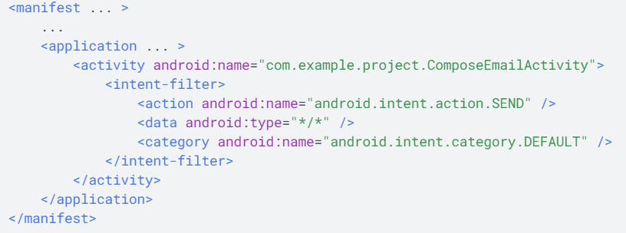
If another app creates an intent with the ACTION_SEND action and passes it to startActivity(), the system may start your activity so the user can draft and send an email.

3.Declaring app requirements
There are a variety of devices powered by Android and not all of them provide the same features and capabilities. To prevent your app from being installed on devices that lack features needed by your app, it's important that you clearly define a profile for the types of devices your app supports by declaring device and software requirements in your manifest file. Most of these declarations are informational only and the system does not read them, but external services such as Google Play do read them in order to provide filtering for users when they search for apps from their device.
For example, if your app requires a camera and uses APIs introduced in Android 8.0 (API Level 26), you must declare these requirements.
The values for minSdkVersion and targetSdkVersion are set in your app module's build.gradle file:
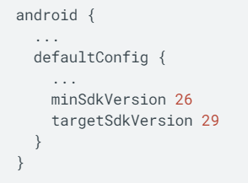
Note: Don't set minSdkVersion and targetSdkVersion directly in the manifest file, since they will be overwritten by Gradle during the build process.

Declare the camera feature directly in your app's manifest file:
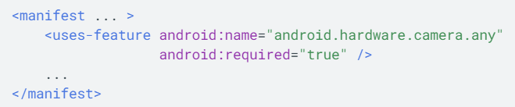
With the declarations shown in these examples, devices that do not have a camera or have an Android version lower than 8.0 cannot install your app from Google Play. However, you can declare that your app uses the camera, but does not require it. In that case, your app must set the required attribute to false and check at runtime whether the device has a camera and disable any camera features as appropriate.

