2020-1-25 !!

Build your first app

Apps provide multiple entry points
Android apps are built as a combination of components that can be invoked individually.
activity is a type of app component that provides a user interface (UI).
The "main" activity starts when the user taps your app's icon. You can also direct the user to an activity from elsewhere, such as from a notification or even from a different app.

Apps adapt to different devices
Android allows you to provide different resources for different devices.
The system determines which layout to use based on the screen size of the current device.

app > java > com.example.myfirstapp > MainActivity
This is the main activity. It's the entry point for your app. When you build and run your app, the system launches an instance of this Activity and loads its layout.
app > res > layout > activity_main.xml
This XML file defines the layout for the activity's user interface (UI).
Gradle Scripts > build.gradle
There are two files with this name: one for the project, "Project: My First App," and one for the app module, "Module: app." Each module has its own build.gradle file, but this project currently has just one module.

Android 4 Generations component:
- Activity
- Service
- Content Provider
- Broadcast Receiver

Build a simple user interface
PlainText = EditText => PlainText Input
The user interface (UI) for an Android app is built as a hierarchy of layouts and widgets. The layouts are ViewGroup objects, containers that control how their child views are positioned on the screen. Widgets are View objects, UI components such as buttons and text boxes.

The Component Tree panel on the bottom left shows the layout's hierarchy of views.

ConstraintLayout is a layout that defines the position for each view based on constraints to sibling views and the parent layout.

Add a button
select Show Baseline 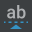. The baseline anchor appears inside the button. Click and hold this anchor, and then drag it to the baseline anchor that appears in the adjacent text box.
You can also use the top or bottom edges to create a horizontal alignment. However, the button image includes padding around it, so the visual alignment is wrong if created that way.

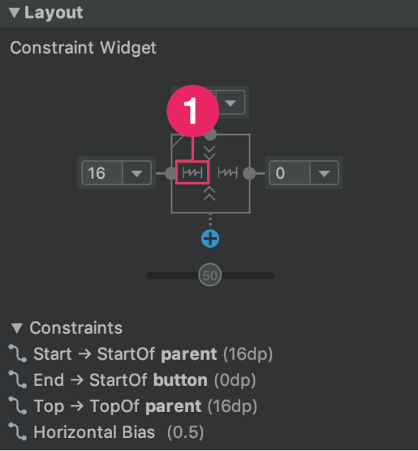
it's layout is set to Match Constraints, as indicated by callout in figure 9.

Make the text box size flexible
click the other, and then right-click either one and select Chains > Create Horizontal Chain
A chain is a bidirectional constraint between two or more views that allows you to lay out the chained views in unison.
Match constraints means that the width expands to meet the definition of the horizontal constraints and margins. Therefore, the text box stretches to fill the horizontal space that remains after the button and all the margins are accounted for.

