2020-1-26

Start another activity
Return to the activity_main.xml file to call the method from the button:
- Select the button in the Layout Editor.
- In the Attributes window, locate the onClick property and select sendMessage [MainActivity] from its drop-down list.
Now when the button is tapped, the system calls the sendMessage() method

Build an intent
An Intent is an object that provides runtime binding between separate components, such as two activities. The Intent represents an app’s intent to do something. You can use intents for a wide variety of tasks, but in this lesson, your intent starts another activity.
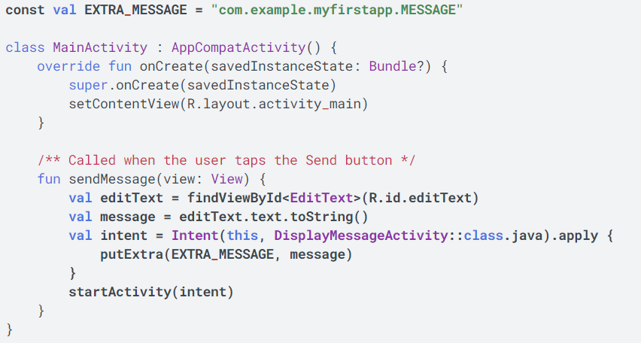

The Intent constructor takes two parameters, a Context and a Class.
The Context parameter is used first because the Activity class is a subclass of Context.
//context is parent. And the activity class is child of context.
// Context:
- 자신이 어떤 어플리케이션을 나타내고 있는지 알려주는 ID 역할
- ActivityManagerService 에 접근할 수 있도록 하는 통로 역할
• 어플리케이션에 관하여 시스템이 관리하고 있는 정보에 접근하기
• 안드로이드 시스템 서비스에서 제공하는 API 를 호출 할 수 있는 기능

The Class parameter of the app component, to which the system delivers the Intent, is, in this case, the activity to start.
The putExtra() method adds the value of EditText to the intent. An Intent can carry data types as key-value pairs called extras.
- Your key is a public constant EXTRA_MESSAGE because the next activity uses the key to retrieve the text value. It's a good practice to define keys for intent extras with your app's package name as a prefix. This ensures that the keys are unique, in case your app interacts with other apps.
The startActivity() method starts an instance of the DisplayMessageActivity that's specified by the Intent.
The Navigation Architecture Component allows you to use the Navigation Editor to associate one activity with another. Once the relationship is made, you can use the API to start the second activity when the user triggers the associated action

Create the second activity

Display the message
In this step, you modify the second activity to display the message that was passed by the first activity. 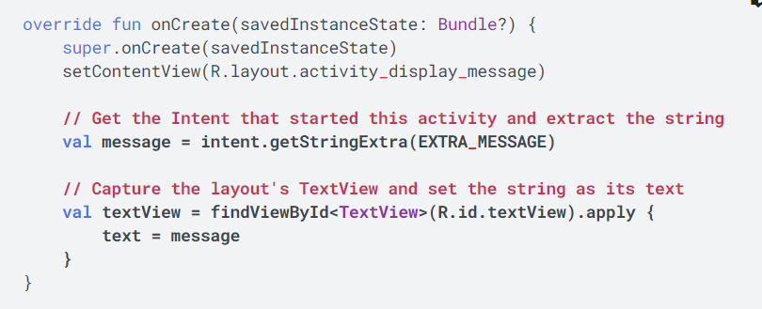

Add upward navigation
Each screen in your app that's not the main entry point, which are all the screens that aren't the home screen, must provide navigation that directs the user to the logical parent screen in the app's hierarchy. To do this, add an Up button in the app bar.
To add an Up button, you need to declare which activity is the logical parent in the AndroidManifest.xml file.
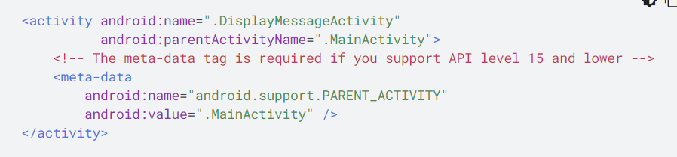
The Android system now automatically adds the Up button to the app bar.

Run the app

API(Application Programming Interface, 응용 프로그램 프로그래밍 인터페이스)는 응용 프로그램에서 사용할 수 있도록, 운영 체제나 프로그래밍 언어가 제공하는 기능을 제어할 수 있게 만든 인터페이스를 뜻한다

Application Fundamentals
Android apps can be written using Kotlin, Java, and C++ languages. The Android SDK(Software Development Kit) tools compile your code along with any data and resource files into an APK, an Android package, which is an archive file with an .apk suffix. One APK file contains all the contents of an Android app and is the file that Android-powered devices use to install the app.
Each Android app lives in its own security sandbox, protected by the following Android security features:
- The Android operating system is a multi-user Linux system in which each app is a different user.
- By default, the system assigns each app a unique Linux user ID (the ID is used only by the system and is unknown to the app). The system sets permissions for all the files in an app so that only the user ID assigned to that app can access them.
- Each process has its own virtual machine (VM), so an app's code runs in isolation from other apps.
- By default, every app runs in its own Linux process. The Android system starts the process when any of the app's components need to be executed, and then shuts down the process when it's no longer needed or when the system must recover memory for other apps.
The Android system implements the principle of least privilege. That is, each app, by default, has access only to the components that it requires to do its work and no more. This creates a very secure environment in which an app cannot access parts of the system for which it is not given permission. However, there are ways for an app to share data with other apps and for an app to access system services:
- It's possible to arrange for two apps to share the same Linux user ID, in which case they are able to access each other's files. To conserve system resources, apps with the same user ID can also arrange to run in the same Linux process and share the same VM. The apps must also be signed with the same certificate.
- An app can request permission to access device data such as the device's location, camera, and Bluetooth connection. The user has to explicitly grant these permissions.

