Finlogix front-end coding question

UI design: <https://www.figma.com/file/bNIQodJBKsOnoMof8msEzR/Education?node-id=7%3A257>

If you have no figma account, register it.

1. Please implement the webinar page
2. You can create the project with **create-react-app** or build a react project with **webpack**
3. Only implement PC and mobile version
4. Do not use any UI framework.
5. Do not use any third part library for form.
6. Use typescript if you can.
7. The following two parts no need to implement.



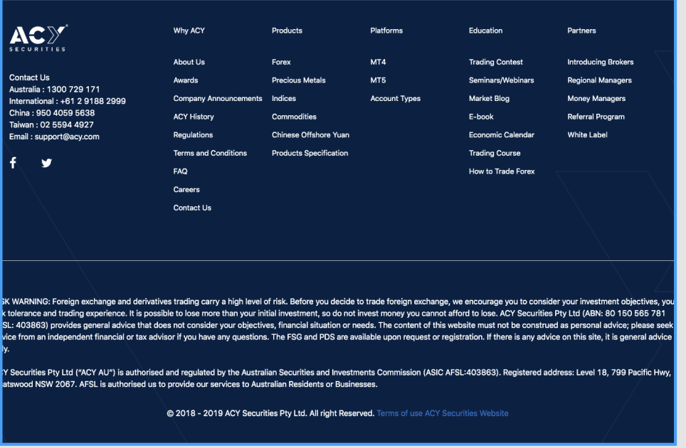

|  |  |  |
| --- | --- | --- |
| url: https://g1api.finlogix.com/v1 | | |
| Descriptions | API | Authorization Bearer Token |
| Get post list | GET {{url}}/ post/analysis?per_page=12&page=1 | Not required |
| Favourite a post | POST  {{url}}/me/user/favourite/post-analysis/{{postId}} | Need |
| Unfavourite a post | DELETE  {{url}}/me/user/favourite/post-analysis/{{postId}} | Need |
| Get favourite post list | GET  {{url}}/me/user/favourite/post-analysis | Need |
| User login | POST  {{url}}/auth/login/email  email: yuntest@mailinator.com  password: A123456 | No |
| User logout | POST  {{url}}/me/user/logout | Need |
| Check user by token | GET  {{url}}/me/user/info | Need |

1. Header

* Change register button to logout.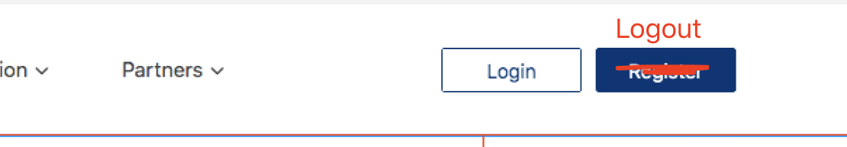
* When click Login button, go to login page, on this page implement a simple form to login. Dispatch login action. Save user info on redux.
* When click Logout button, dispatch logout action, user logout.
* If user already login, save token. When refresh page, get user info by saved token.
* Header should be appeared on every page.

1. Webinar list:

* Webinar prosperities: id, created_at, title, content, course start time, favourited.

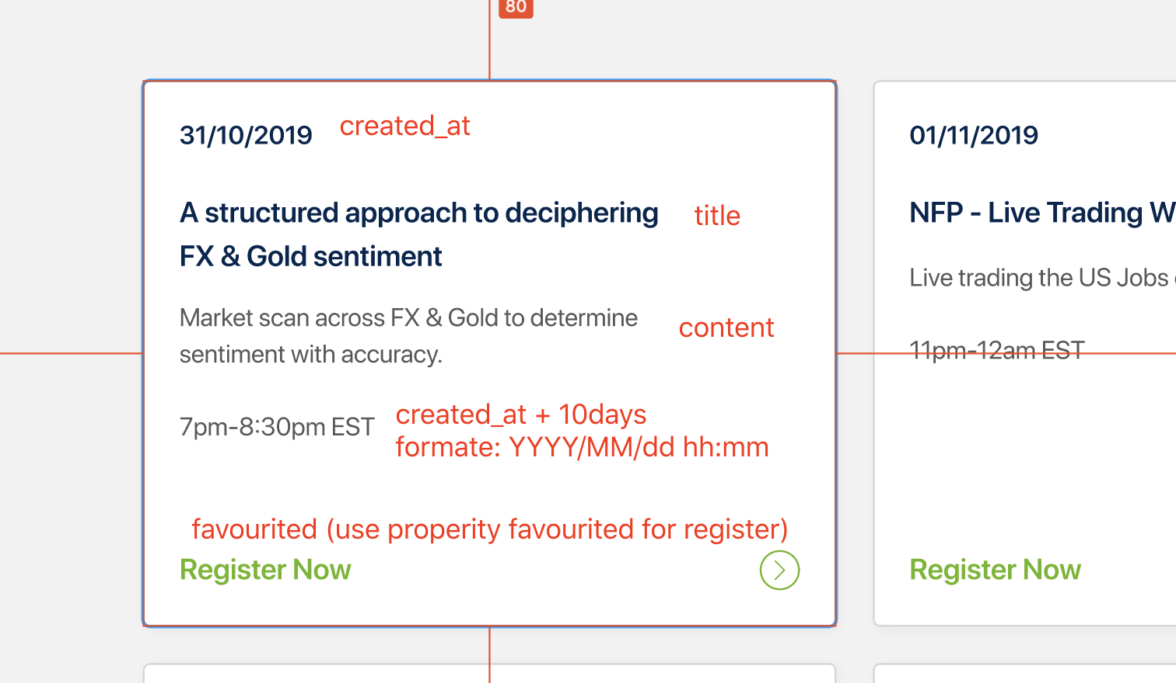

* Fetch data from post list api, set per_page to 12. Save webinar list in redux store.
* Webinar list only show unregistered courses. (Use property favourited)
* The webinar list can be scroll horizontally, when no more data to show, fetch more data, until to the last page.
* When click **register now**, if user login, scroll down to the **register form** part; if user not login, redirect to the login page.
* When click webinar button, go to webinar detail page. Only show webinar info. Url: /webinar/:id
* Add a registered course link, url: /registered, show a list of registered courses (use property favourited), same style with registered list; change **register now** button to **unregister,**when click unregister, trigger **unregister action,** change this webinar to unregistered. (Use unfavourite a post api)

1. Register form

* No need to implement the **phone and mobile authentication** part.
* The **topic** content should be webinar title. When dropdown list open, click any place to close the dropdown list.
* Verification: First name, last name and email are all required. Show red error message after label.
* User can not click the register button until pass all verification.
* When chick **register button**, trigger **register action**, change webinar to enrolled. (Use favourite a post api)

1. YouTube video: You can use any YouTube video you like.