**Establishment of a  
Consumer-Production Chain  
Using Left Foods of Hotel Buffets**

***“Left Foods, Right Foods”***

Seong Jin Kang, Seung Ho Seol, Ji Woong Shin, Woo Hyuk Kim, Ju Eun Park, Kyu On Han

**Net Impact Food Solutions Challenge**

**Contents**

**Why?** *Solution proposal*

**-** Project Summary

- Problem recognition & Current Situation

**What?** *Solution description*

- Execution direction

- Execution method

**How?** *Action plan*

- Storytelling for naming

- Future goals

- Expectation effectiveness

**Citation**

**Why?**

**Project Summary**

**Project Name**: Left Foods, Right Foods

**Project Concept**: Reuse leftovers at hotel buffets to provide edible food for pets and return the profits to low-income bracket.

**Target Consumer Base**: Animal lovers who want to give delicious and safe food to their pets.

**Problem Recognition & Current Situation**

**- The reason leftovers at hotel buffets can be effective to consumption-production chain**

**:** Our team focused on constructing a ‘consumption-production chain’ for the problem of food loss. To construct this chain, we first need to get the leftovers from the primary consumption and put them into the production process. To do so, these 3 standards must be satisfied – quality, supply, and reliability. To uphold these standards, we suggested ‘hotel buffet leftovers’ are the best resource. In the hotel buffet systems, where people scoop food onto their plates, the leftovers are usually untouched and sanitary. Huge portion of the food is wasted every day after closing, which means abundant supply for us. This source of food will be more reliable and trustworthy to the consumers because of the famous hotel brands and their name values.

In conclusion, we decided that leftovers at hotel buffets will be effective in constructing the ‘consumption-production chain’.

-------------------------(Numerical statistics will be applied in February feedback) -------------------------

During the Rio Olympics in 2016, Michelin 3 star chef cooked the leftover food from the Olympic Athlete Village for free meals to the people in the low-income bracket. Through this, we realized that the provision to people is a step away from generalization. Hence, we tried to find other target for the solution.

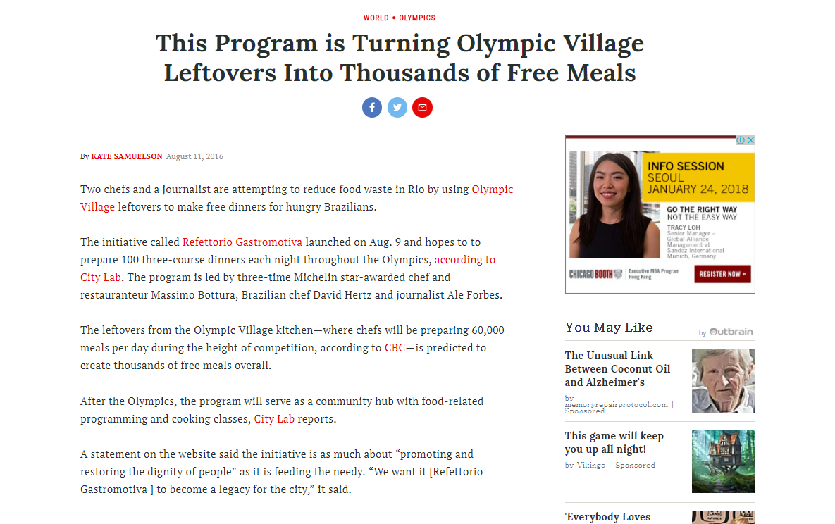

**- There are people who want to feed delicious and safe food to their pets.**

: Pets are recognized as members of families nowadays. In this cultural setting, some people want to feed appetizing and highly nutritional food to their pets. You can refer to the pictures below of some pet foods on sale.

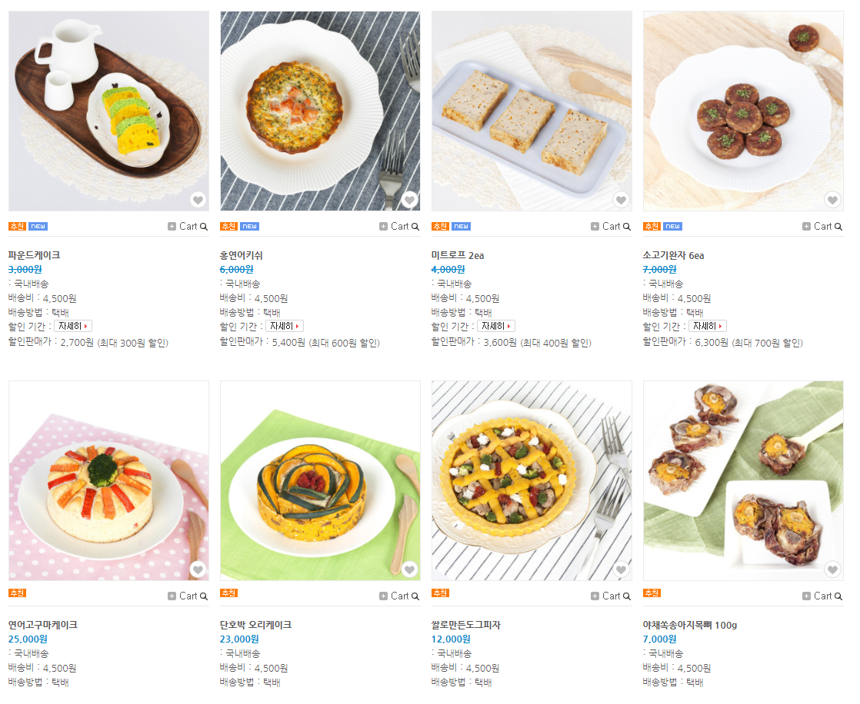

In response to the pet food boom in Korea, there is a cooking TV show that the broadcaster and chef cook for pets.

|  |  |
| --- | --- |
|  |  |
|  |  |

However, it is challenging for ordinary people to cook for pets often. The snacks sold at pet stores are too expensive, difficult to choose, and unreliable. These problems can be solved by putting our solution into practice.

-------------------------- (Actual pet owners will be surveyed with Google Forms) -------------------------

**- Number of pet raising households (Korea)**

**((Unit: Household)**

|  |  |  |
| --- | --- | --- |
| **Year** | **Dogs** | **Cats** |
| **2012** | 3,200,000**(16.0%)** | 680,000**(3.4%)** |
| **2015** | 4,000,000**(19.1%)** | 1,100,000**(5.2%)** |
| **2017** | 5,090,000**(24.1%)** | 1,330,000**(6.3%)** |

We observe that the pet owning households are on an increase.

--------------------------- (United States and worldwide statistics will be added) ---------------------------

**What?**

**Execution direction**

**- The focus of this project is to reduce food waste through our solution and use the profit to help people in the low-income bracket recover from poverty.**



As the success story of “The Big Issue Foundation,” who have gave second chances to homeless people by giving them magazine sales jobs, we pursue a solution that satisfies the following: construction of consumption-production chain, satisfaction of pet owners, and supporting the people of low-income bracket.

**Execution method**

**Process**

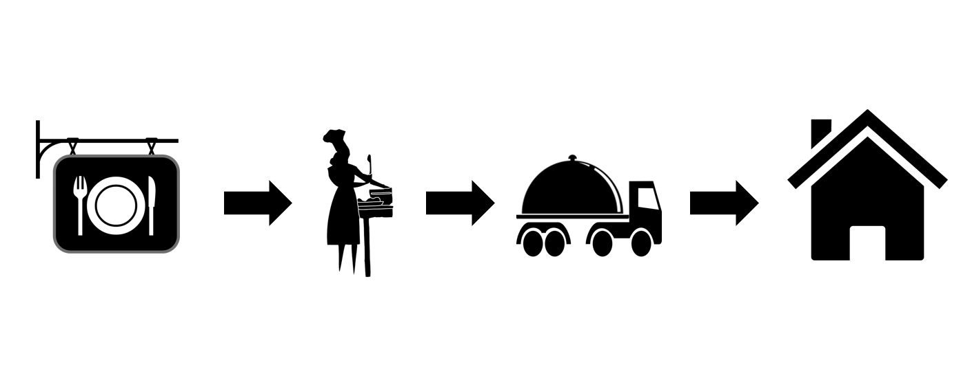

The process starts at the closing hour of hotel buffets. The leftovers will be collected and manufactured into pet food through the night. The products will be delivered to the consumers in the morning.

**Products**

|  |  |
| --- | --- |
| **Products** | |
| **Category** | **Ingredient** |
| Dried Food | Leftovers |
| Healthy Cooked Food | Leftovers |

Selling healthy food on top of dried food will increase the demand and variety of consumers.

**Using Application**

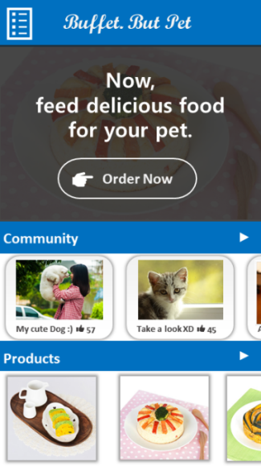

**App Mockup**

The customers will be able to purchase food without the inconvenience of physically going to a store, build communities, and share stories through a smartphone application. Also, we are planning to have one-time payment service for everyday delivery.

**Social Contribution**

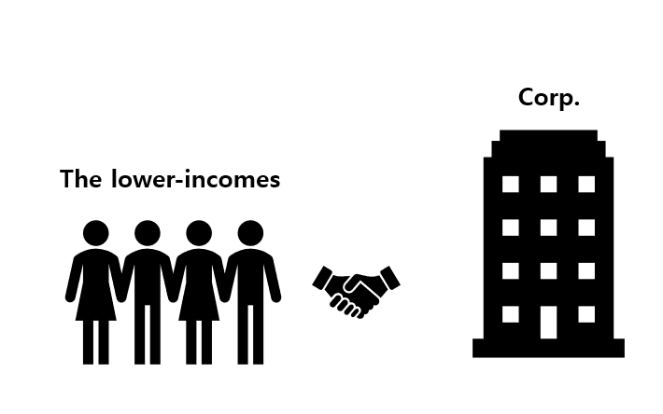

We will hire people from the low-income group first to give opportunities of technology education and employment.

**How?**

**Storytelling for Naming**

Our production process is very unique. Thereby, we wanted to appeal this to the consumers in the name. After much of the consideration, we came out with a name,

**Buffet. But pet**

**Future goals**

**5 years:** Globalize our production process and establish offline stores.

**10 years:** Develop this business into a multinational enterprise.

**Expectation Effectiveness**

**SWOT analysis**

|  |  |
| --- | --- |
| **Strength**  - Reduce costs by recycling leftovers.  - Social impact on supporting low-income group.  - Consumers can easily order by using application (without visit or call)  - There is a case applied to people. | **Weakness**  - Hard to expect the amount of supply and demand of pet food.  - There are still negative view on food recycling |
| **Opportunity**  - This is totally a new concept  - Winning the competition and improved social image by hiring low-income brackets. | **Threat**  - Existence of a large pet food franchises  - Hotels must cooperate  - Hard to expect the demand of high-income group. |

**Citation**

**News**

http://time.com/4448543/rio-2016-olympics-michelin-star-chef-free-meals/

**Photographs**

http://www.wooucaca.com

https://www.youtube.com/watch?v=03wSDG3Iu7s

**Measure**

http://www.dailyvet.co.kr/news/industry/88271

**The Big issues**

https://www.bigissue.com/