**Traction force microscopy package**

***Materials***

Computer with 64-bit processing capabilities and at least 4GB RAM.

Matlab (Mathworks, version R2010b and above) with the following toolboxes: Image Processing, Curve Fitting, Statistics and Symbolic Math toolbox.

**Obtain the TFM Software**

1. Download the TFM package from lccb.hms.harvard.edu/software or Nature Methods paper webpage.
2. Start Matlab and add the directory containing the code to the Matlab path (see installation  instructions)*.*

**Setup a Database for the Movie and Load it for Processing**

The first step in any analysis is to set up a database for the movie. This database contains links to the directories with the raw image files, links to all the processed and stored result files, and the parameters used for image processing. Prepare the image files for the database by storing each channel (wavelength) of each time-series in a separate directory (folder), with one file per frame (time point) of the movie. To indicate the time point, the software package expects the following filename convention: MyMovieXXX.tif. MyMovie is a placeholder for any string, including underscores and dashes that specifies the generic name of the movie. XXX is a placeholder for a numeric value identifying the time point of that particular frame, e.g. 007, 008, 009, etc. In addition to organizing the raw image sequences, gather information on the camera (pixel size, acquisition time, bit depth), the objective lens (numerical aperture), and the fluorescent channels (emission wavelength) before launching the software.

IMPORTANT: the emission wavelength of the channels containing the beads as well as the pixel size and time interval of the movie needs to be filled.

1. From the Matlab command prompt, launch the movie selector interface by typing **movieSelectorGUI** or **tfmPackageGUI**. *This command will bring up the movie selection panel (***Figure 1***). The left panel displays all of the movies to be processed. The buttons next to the list allow the user to modify the list by creating, opening, and removing movies. The right panel displays the available software packages that can be used to process the movies.*

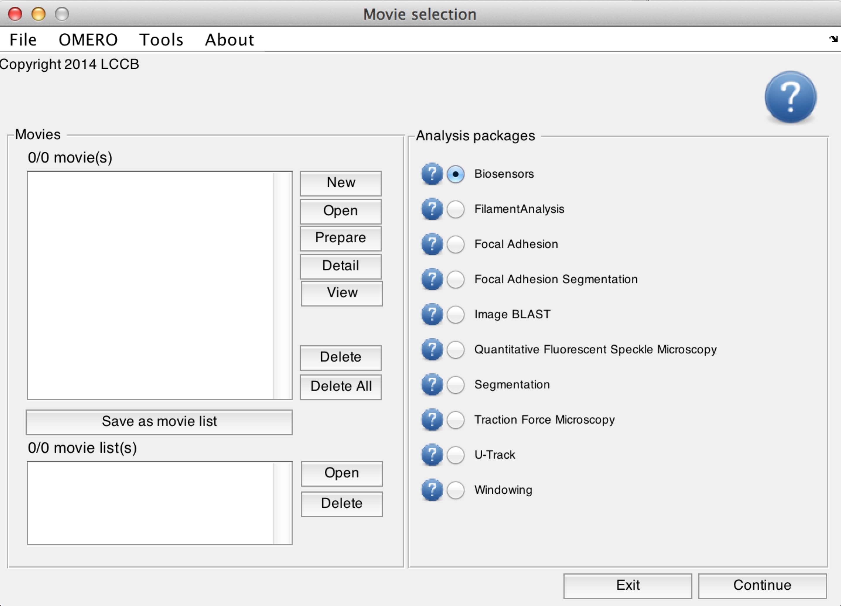

Figure 1. Movie selection window, launched by a command ‘MovieSelectorGUI’ or “tfmPackageGUI’.

1. Create a new movie database by clicking on **New**. *This will bring up the movie edition interface (***Figure 2***).*

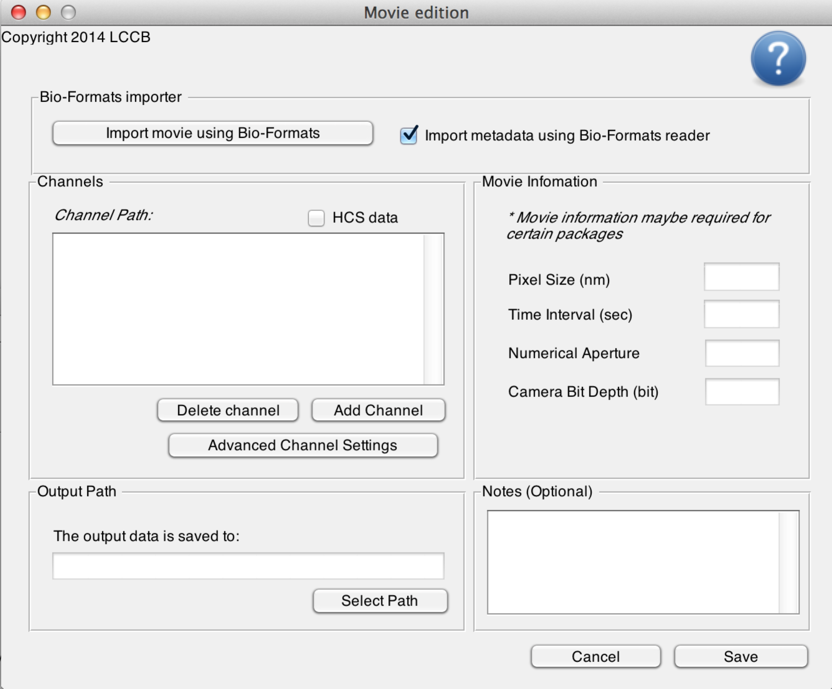

Figure 2. Movie edition window

1. Click on **Add Channel**. Select the folder containing the images to be analyzed. Repeat the **Add Channel** operation for all of the speckle channels of your FSM movie that you want to analyze.
2. Click on **Advanced Channel Settings**. In the new window, fill out the emission wavelength (in nm) for each channel.
3. In the movie edition interface, fill in the pixel size (in nm), time interval (in s), numerical aperture and camera bit depth of the movie. *Note: once saved, these fields cannot be further modified. In case of an erroneous input a new movie database has to be generated by repeating steps 2 – 5.*
4. Optionally, enter additional notes specific to your movie.
5. In the output directory panel, click **Select Path** and choose a location on the disk where all results of the analysis should be saved.
6. Click on **Save**. *This will open a pop-up window asking where to save the movie database. The operation will save a MAT file (Matlab format) containing all the movie information including all results from the processing. This MAT file can be later reused for loading the movie database (see next section).*
7. In the movie selection panel (**Figure 1 *left***), load the new movie by clicking **Open**. Select the MAT file saved when creating the movie database.  *If the movie database file has been relocated on the disk, the software will ask for relocation of all its components by comparing the new path of the movie database file to the old path.*
8. Repeat steps 2-8 until all of the TFM movies you want to process are listed in the left panel.  *A list of movie databases can be saved as a list using the* ***Save as Movie List*** *button. The resulting movie list is also saved as a MAT file on the disk. To load all of the movies in a list, repeat step 9 and select the MAT file containing the movie list.*
9. Select TFM package on the right panel and click **Continue** at the bottom right of the movie selection window.

**Run the TFM software**

The TFM analysis follows a series of steps illustrated in **Figure 3**.



Figure 3. TFM analysis steps

Two steps are optional: the Stage Drift Correction and the Displacement Field Correction. In accordance with this workflow, the main panel of the TFM analysis software (**Figure 4**) consists of the following components:

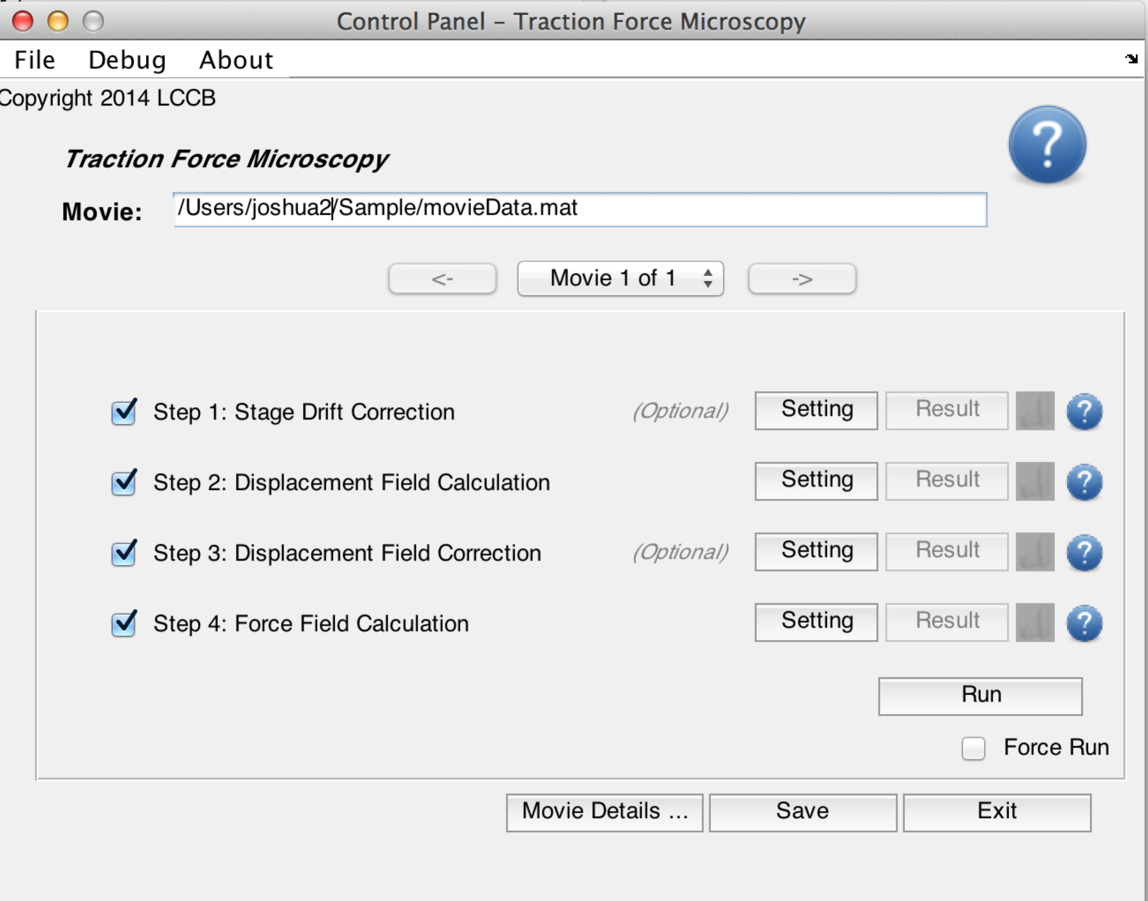

Figure 4. TFM package software interface

* A top panel that displays the current processed movie. If you are processing multiple movies, use the drop-down menu/arrows to switch between movies.
* A sequence of processes that can be run either individually or in a complete flow. Each process needs to be setup before it can be run. To setup a process, click on its associated **Setting** button. For all process setting interfaces, a help button is located in the top right corner of the window. Once setup, processes appear in bold characters.
* A checkbox next to each process marks it as scheduled for processing. To run a process, check the respective box and click **Run.** Once successfully run, the output of the process can be visualized by clicking the **Result** button.
* Icons next to each process indicate the current processing status. Only processes that have been run at least once successfully have an associated icon. To get more information, click on an icon.
* A **Run** button. Only checked processes with non-green icons will be run when hitting **Run**. If you want to re-run a process that has been run before, check the **Force Run** checkbox.  In the case of processing multiple movies through multiple steps, the processes that are to be run need to be individually set up and checked. In each setting interface, check the **Apply to all movies** checkbox to set up processes in batch. Check **Apply Check/Uncheck to All Movies** to schedule processes to run for all movies. Finally, click **Run All Movies** to run scheduled processes of all movies in the list.

When running TFM processes, all results will be saved in a subfolder of the movie database output directory called `TFMPackage`. All paths described below are relative to this main path. In addition, each process generates a log-file summarizing specific numerical values related to the process.