Process Description:
This step sub-divides the cell interior into small polygonal “sampling windows” which allow the fluorescence or other intracellular signals to be sampled locally within the cell. These sampling windows are constructed in a way which places each window at a user-defined distance from the cell edge, and associates each window with a region of the cell edge based on proximity.
These sampling windows are then propagated from one frame of the move to the next using a user-specified propagation method (described in more detail below).
The user can specify the size of the windows in the direction moving away from the cell edge (perpendicular size) and moving along it (parallel size), but due to the complex geometry of most cells these sampling windows will not all have the same geometry. They will always perfectly maintain the same size in the direction moving away from the cell edge (perpendicular size), but they will only have the exact size specified in the direction moving along the cell at one user-specified distance from the edge (StartContour). In other locations in the cell the size and shape of the windows in the direction parallel to the cell edge is determined by the local geometry of the cell, so as to fully sample the cell interior while still associating each window with a region of the cell edge. (See Figure 1 for illustrations of these parameters).

Important Note: The location and geometry of the windows is determined by the cell outline, which is determined by the masks produced by segmentation. It is therefore important that an accurate segmentation be completed prior to running the windowing process.

Brief Description of Algorithm: The cell interior is subdivided in the direction moving away from the cell edge by first calculating the distance transform of the cell interior, and then finding isocontours of this distance transform which are multiples of the user-specified perpendicular window size. Then, the contour specified by the StartContour parameter is divided into segments whose is the user-specified parallel window size. Then, maximal-gradient-ascent of the distance transform from these segments divides the cell up in the direction parallel to the cell edge. The intersections of these iscontours and gradient ascent lines determines the window geometry.
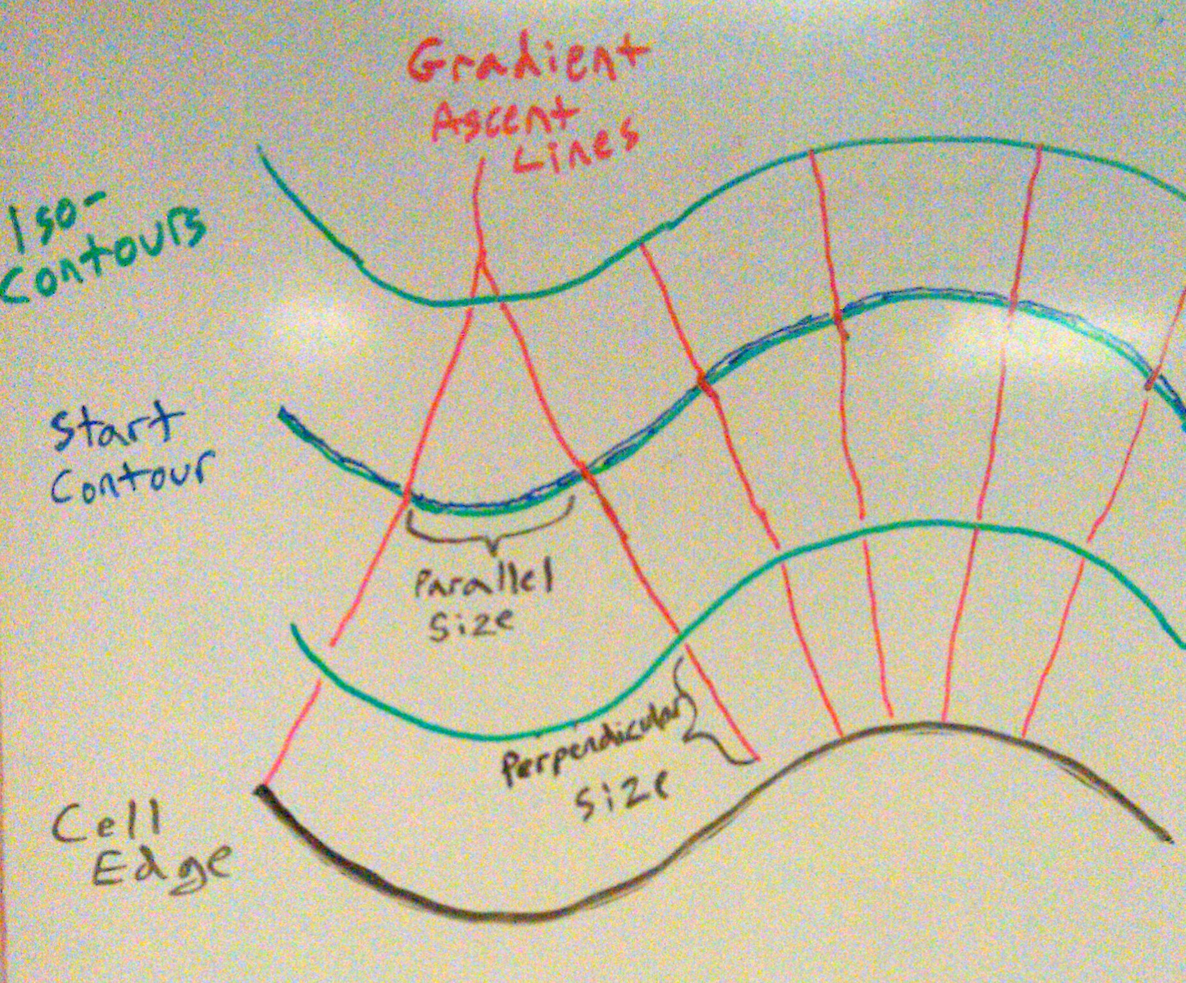
Figure 1 – Parameters determining window geometry. The cell is divided up in the direction perpendicular to the cell edge (black) by the isocontours (green). The spacing of these isocontours is determined by the “perpendicular size”, and is the same everywhere in the cell. The cell interior is then divided in the direction parallel to the cell edge by the gradient ascent lines (red), and the spacing of these gradient ascent lines is determined by the “parallel size” at the isocontour specified by the “StartContour” parameter. The size of the windows parallel to the cell edge at locations other than the StartContour is determined by the local cell geometry, as you can see by comparing the windows adjacent to the concave and convex regions of the cell edge in this illustration.
Parameter Descriptions:
Input Channels:
This allows you to select which mask channels you want to use for windowing. If multiple channels are selected, the intersection of the masks will be used (only pixels which are masked in all selected channels). Select the channels by clicking on them in the "Available Input Channels" box and then clicking "Select>" to move them to the "Selected Channels" box. You can unselect a channel by clicking the "Delete" button

Mask process to be used for windowing:
This allows you to select a mask process from the drop-down menu for windowing. If choosing “Select later” and more than one process exists, you will be asked at runtime which mask process to use. It is highly recommended that the Mask Refinement process be run after any initial segmentation, and that the masks from this process be used in windowing.
Note: The windowing requires that there be a single cell or cell region in each image of the movie, and that if this cell touches the image border it does so in all frames, and if not it does not in all frames.

Minimum size of objects to window:
Objects in the mask which are smaller than this size (in pixels) will be ignored during windowing. This is useful for ignoring small background specks which were detected in segmentation, or for avoiding small isolated pixels which are created when the intersection of multiple mask channels is used for windowing.

Window size:
Theses two edit boxes allow you to specify the size in pixels of the windows parallel to the mask edge and perpendicular to the mask edge. If the pixel size of the movie has been entered, the size of the window in microns will be displayed in the corresponding gray box. (See Figure 1 for illustrations of these sizes).
Important note: While the size in the direction perpendicular to the cell edge will always be maintained and is constant throughout the cell interior, the windows will only have the exact specified size in the direction parallel to the cell edge at the distance specified by the StartContour parameter (see below). Given the need to associate windows with the cell edge, and the complex geometries of cells, it is impossible for them to have this same width throughout the cell. Furthermore, depending on the method used to propagate the windows from one frame to another, the windows may change size in the direction parallel to the cell edge depending on how the cell moves and changes shape. See the methods description below for details.

Window origin:
This parameter only applies to movies where the entire cell is contained in the image and does not touch the image border. This parameter allows you to specify where the windows origin is, that is the location of window window(1,1), by clicking on the cell image.
After clicking on Select a position for the origin of the windows, a window will pop-up with a cursor allowing to select a position on the image. The coordinates of the cursor will be displayed in the edit box. Check Use this location as the origin of the windows if you want to use this position as the origin of windows, i.e. the coordinates of window (1,1).

Method to use to propagate the windows from one frame to another
Use the drop-down menu to select a propagation method. The propagation method determines how the windows which the user specifies at the first time-point are adapted to changes in the cell size and shape at subsequent time points. Currently available methods include
- Constant width: These windows are drawn with the same width (size parallel to cell edge) at each time point. Therefore, the width of the windows at the depth specified by the StartContour parameter will always be equal to the user-specified window size parallel to the mask edge (see above). To maintain this constant width and still cover the entire cell, the number of windows may vary if the size and shape of the cell changes in subsequent frames. That is, if the cell edge length increases, the number of windows will increase. The windows will always occupy a constant distance from the mask edge (and their perpendicular size will be constant).

- Constant number: The windows are drawn time-independently in each frame by dividing the mask up into a constant number of segments parallel to the cell edge. For the first frame, the number of windows will be determined by dividing the StartContour up into segments with the user specified parallel size. In subsequent frames the number of windows will be kept constant. Therefore, their size in the direction parallel to the mask edge will change as the cell changes shape and or size. That is, if the length of the cell edge increases, the size of the windows in the direction parallel to the cell edge will increase, while the number of windows will be constant. The windows will always occupy a constant distance from the mask edge (and their perpendicular size will be constant).

- Protrusion based: The outermost band of windows will follow the protrusion vectors for the mask edge. The protrusion calculations must already have been run. The inner bands of windows will still be based on maximal gradient ascent of the distance transform, using the outermost windows for start points. Because these windows follow the cell edge motion, they may change size as the cell moves and protrudes and retracts. That is, in an area which is protruding or expanding, the size of the windows in the direction parallel to the cell edge will increase near this protrusion, and near retraction their parallel size may decrease and they may even collapse completely into a line. However, the windows will still always occupy a constant distance from the mask edge (their perpendicular size will be constant).

If Periodically re-initialize windows to their starting size is checked, you can specify the Number of frames to propagate windows before re-initializing them to their starting sizes, just as they were initialized at the first frame of the movie. This applies only to the protrusion-based windows (see above).
StartContour:
This parameter specifies the distance from the cell edge at which the windows will have the exact width specified by the parallel size parameter. At distances closer to the edge or further from the edge, the size of the windows parallel to the edge will be determined by the local cell geometry. This is done by specifying the number of the contour which is the “StartContour.” The contours (see above for more details) divide the cell up in the direction moving away from the edge. So each window is bounded by two contours, one closer to the edge and one further away. For example, the cell edge is contour 1, and the first “band” of windows along the cell edge is bounded by contours 1 and 2. Therefore, specifying a start-contour of 2 would mean that, for the first band of windows, the side which is away from the cell edge would have exactly the size specified in the direction parallel to the cell edge. (See Figure 1 for an illustration of this parameter).
References
A methods paper describing this software is currently in preparation, and a final publicly available version of this software will be released on our lab website coincident with its publication. Stay tuned!

