Process Description:

The flow tracking process use multi-frame cross-correlation to calculate the flow velocity at any speckle position. The correlation score of a template consisting of a square box of specified size is integrated of multiple consecutive frame pairs in a time window at each point. The output is a calculated flow velocity representing the average flow velocity within the time window.

Parameter Descriptions:
Input Channels:

This allows you to select which channels you want to perform noise estimation on. This should be applied to all channels that are going to be used for calculating the noise parameters. Select the channels by clicking on them in the "Available Input Channels" box and then clicking "Select>" to move them to the "Selected Channels" box. You can unselect a channel by clicking the "Delete" button

Dynamic parameters
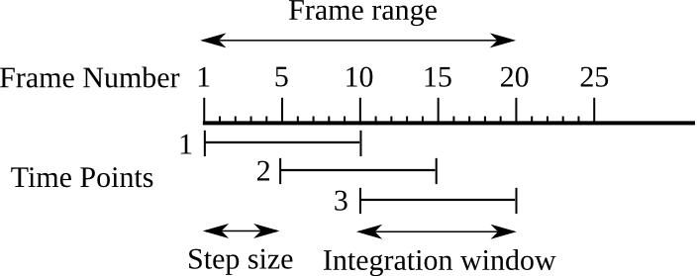
Frame range:
These two values determine the first and the last frame over which the integration window can be moved for the calculating the flow velocities.

Integration window (frames):
This is the timelength of the window used for the calculating the flow velocities.

Step size (frames):
This is the interval used to move time window used for the calculating the flow velocities.

Correlation parameters
Template size range (pixels):
These values specify the minimum and maximum sizes of the template used to calculate correlation scores. If using a range of sizes, the algorithm will automatically adapt the template size required for a stable flow tracking at each point within the specified range.

Maximum flow speed (pixels/frame):
This determines the maximum speed that is expected of the flow. It should be high enough so that flow of high speed will not be missed in tracking. However, high values will increase computational tracking time.

Minimum feature size (pixels):
This specifies the minimum size of features that can be detected by the flow tracking.

Background parameters
Edge erosion width (pixels):
This value specifies the distance over which the edge will be shifted towards the cellular domain. This shift reduces the potential error of tracking speckles that are close to the edge due to high intensity gradient across the edge. The amount of shift depends on the quality of edge detection

Stationary background
If Substract stationary background is selected, the correlation will be calculated after averaging a range of stationary frames. If Use all images from the frame range is selected, background will be computed using all the images in the frame range. Else, the algorithm uses the Number of stationary frames to average.

References
Li, J. and Danuser, G. 2005. Tracking quasi-stationary flow of weak fluorescent signals by adaptive multi-frame correlation. Journal of microscopy. 220:150-167.

