Package Description:
This package is for processing fluorescent speckle microscopy movies into speed maps and kinetic maps.
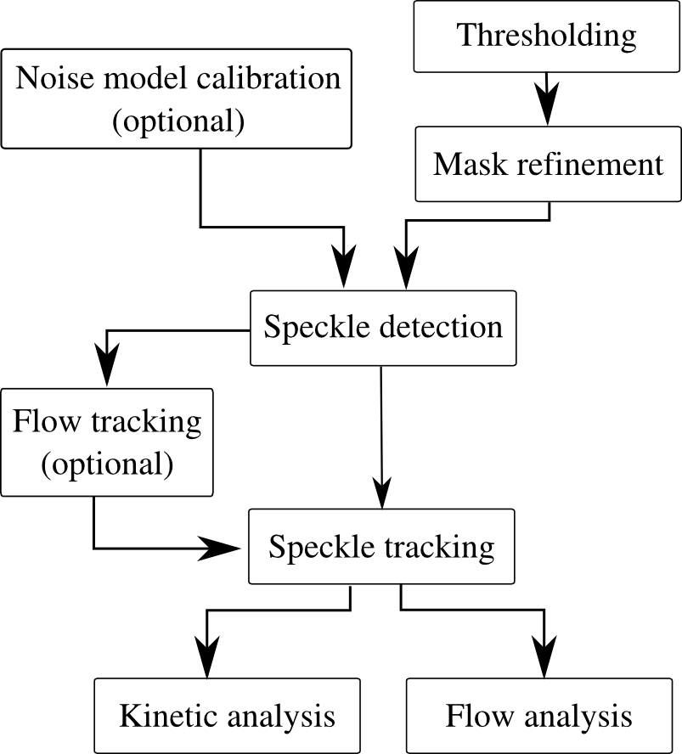

References
Ponti, A., P. Vallotton, et al. (2003). "Computational analysis of F-actin turnover in cortical actin meshworks using fluorescent speckle microscopy." Biophys J 84(5): 3336-3352.
Ponti, A., A. Matov, et al. (2005). "Periodic patterns of actin turnover in lamellipodia and lamellae of migrating epithelial cells analyzed by quantitative Fluorescent Speckle Microscopy." Biophys J 89(5): 3456-3469.
Li, J. and Danuser, G. 2005. Tracking quasi-stationary flow of weak fluorescent signals by adaptive multi-frame correlation. Journal of microscopy. 220:150-167.

