speckleArray

.timepoint : [uint16 (n x 1)] Frame number
.spPos : [uint16 (n x 2)] Speckle coordinates [y x]
.bgPos1 : [uint16 (n x 2)] Loc min 1 coordinates [y x]
.bgPos2 : [uint16 (n x 2)] Loc min 2 coordinates [y x]
.bgPos3 : [uint16 (n x 2)] Loc min 3 coordinates [y x]
.intensity : [double (n x 1)] Speckle intensity
.background : [double (n x 1)] Local background intensity
.deltaI : [double (n x 1)] Intensity difference speckle-background
.deltaICrit : [double (n x 1)] Critical intensity difference
.sigmaSp : [double (n x 1)] Calculated uncertainty on speckle intensity
.sigmaBg : [double (n x 1)] Calculated uncertainty on background intensity
.status : [char (n x 1)] One of: ‘b’, ‘d’, ‘s’, ‘g’, ‘f’, ‘l’ (see below)
.speckleType : [uint8 (n x 1)] Speckle order [1|2|3|…], corresponding to the iteration number in speckle extraction
.score : [double (n x 1)] Kinetic score associated to a ‘b’ or ‘d’ event
.activity : [int8 (n x 1)] Kinetic activity associated to a ‘b or ‘d’ event
.lmEvent : [logical (n x 1)] [0|1] ‘b’ or ‘d’ event associated to weak local max

status

‘b’ : pre-birth speckle (a real or virtual¹ weak local maximum before actual speckle appearance – needed for kinetic analysis of speckle appearance)
‘d’ : post-death speckle (a real or virtual¹ weak local maximum after actual speckle appearance – needed for kinetic analysis of speckle disappearance)
‘s’ : speckle
‘f’ : speckle already alive in frame 1
‘l’ : speckle still alive in last frame
‘g’ : gap

Complete speckle trajectories are stored sequentially in speckleArray. Each speckle begins with a ‘b’ or ‘f’ speckle and ends with a ‘d’ or ‘l’ speckle. Speckles can contain closed gaps ‘g’, which are to be considered full-rank speckles.

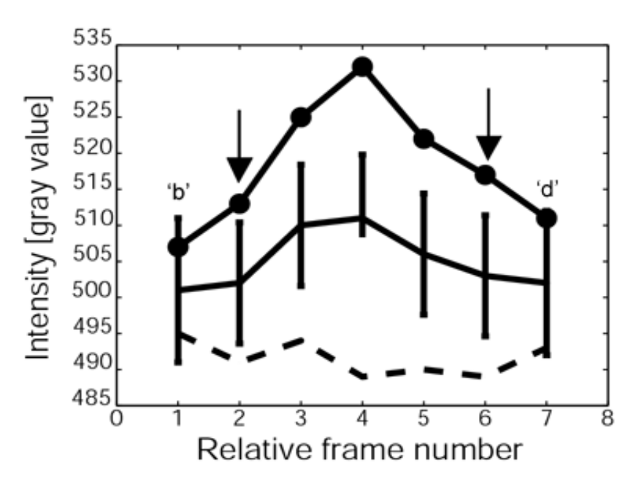
appearance
disappearance

(1) Very often, the formation of a speckle is so fast, that our sampling rate fails to capture its development from nothing, through a non-significant local maximum, into a speckle. For this reason, we create a “virtual” local maximum at the time point before actual speckle appearance located at position of speckle appearance. These virtual local maxima (with status ‘b’) have .lmEvent=0; actual weak local maxima have .lmEvent=1. Their intensities are extracted from the image at the position of the real speckle, and then processed as usual.

speckleClasses

.bTime : [uint16 (n x 1)] Frame of actual birth (not of the ‘b’ speckle)
In case of an ‘f’ speckle, the time of birth is 1 and corresponds to the time of the ‘f’ speckle.
.dTime : [uint16 (n x 1)] Frame of actual death (not of the ‘d’ speckle)
In case of an ‘l’ speckle, the time of death is the last frame in the movie and corresponds to the time of the ‘l’ speckle.
.first : [uint16 (n x 1)] Index of the beginning of the speckle in
speckleArray (of the ‘b’ or ‘f’ speckle)
.last : [uint16 (n x 1)] Index of the end of the speckle in speckleArray
(of the ‘d’ or ‘l’ speckle)
.pos : [uint16 (2 x 2 x n] Positions [y x; y x] at birth and death
First row, birth; second row, death.
.class : [uint8 (n x 1)] Speckle class: 1 – 13 (see below)
.network : [uint8 (n x 1)] Network to which the speckle belongs:
1 – lamellipodium
2 – transition
3 – lamellum

Speckle classes

1 : significant BIRTH due to POLYMERIZATION, significant DEATH due to DEPOLYMERIZATION
2 : significant BIRTH due to POLYMERIZATION, significant DEATH due to POLYMERIZATION
3 : significant BIRTH due to DEPOLYMERIZATION, significant DEATH due to DEPOLYMERIZATION
4 : significant BIRTH due to DEPOLYMERIZATION, significant DEATH due to POLYMERIZATION
5 : significant BIRTH due to POLYMERIZATION, non significant DEATH
6 : significant BIRTH due to DEPOLYMERIZATION, non significant DEATH
7 : non significant BIRTH, significant DEATH due to DEPOLYMERIZATION
8 : non significant BIRTH, significant DEATH due to POLYMERIZATION
9 : non significant BIRTH, non significant DEATH
10 : ghost speckle, a subset of class 9.
11 : speckle already present in frame 1 which dies within the movie
12 : speckle born within the movie and still present at movie end
13 : speckle which lives for the whole movie

