Abstract
An important in vitro model system for cancer metastasis is the scattering of cultured MDCK cells in response to growth factor treatment. Upon treatment, MDCK cells lose epithelial cell-cell junctions and acquire a motile phenotype, capturing the key aspects of the transformation of human epithelial cells into metastasizing tumor cells in vivo. Since MDCK cell scattering typically occurs within 24 hours, this system has the advantage of being easily accessible to studies with live-cell microscopy. However, while the disruption of cell-cell adhesions is an essential requirement for scattering, the quantitative analysis of cell adhesion properties is far from trivial. As a consequence, previous live-cell studies have focused on the more convenient assay of cell motility and the increase in velocity stimulated by the growth factor. We have developed a customized analysis software package, ScatterTrack, to overcome this limitation. On the one hand, ScatterTrack provides an automated detection and tracking of cells in phase-contrast time-lapse image series, allowing us to avoid the experimental pitfalls associated with fluorescence dyes, and thus reliable observation over long time periods. Secondly, ScatterTrack utilizes statistical descriptors of spatial clustering - based on Ripley’s K-function – to quantify spatial dispersal of clusters. This two-tier approach allows us to independently evaluate the changes in motility and cell-cell adhesion, separating these two distinct components of the scattering process. In a small scale drug screen, we have used this software to characterize several pharmacological inhibitors in terms of their capacity to modify either of these components specifically. We find that many known scattering inhibitors (such as xx) primarily affect cell motility rather than cell-cell adhesion, while others xxx. We conclude that our novel live-cell microscopy-based assay allows the quantitative characterization of distinct aspects of MDCK cell scattering, and is a promising tool for screening potential pharmacological inhibitors of tumor invasion. Additionally, we propose that pathway x is involved in regulating cell-cell adhesion, while pathway z signals both into adhesion and motility pathways.

Introduction
A central topic in biomedical research is the transformation of benign, locally restricted tumors into invasive ones. In epithelial cell tumors, which produce >90% of human cancers, this transformation is known as the epithelial-mesenchymal transition (EMT): In response to external signals, cells convert from an epithelial morphology to a mesenchymal fibroblastic phenotype. This phenotypic transition is accompanied by the loss of cell-cell adhesions and increased cell motility. In healthy tissue, EMT is an essential requirement for some normal physiological processes such as wound healing or development; however, in tumors it is the central requirement for cancer metastasis. Several intracellular signaling mechanisms, like TGFb/smad, NfkB and MapKinase pathways, have been shown to influence EMT and tumor formation, but because of the complexity of the process, much remains unknown about their roles at specific stages.
A well-established in vitro model system for the study of the mechanisms underlying EMT is the scattering of MDCK cells in response to treatment with hepatocyte growth factor (HGF) ({Thiery, 2002 #6774}, {Trybus, 2005 #6962}, {Weidner, 1993 #7231}), which is thought to capture the key aspects of EMT in metastatic cancer. HGF and its receptor c-met have been shown to promote the invasion and metastasis of human cancer ({Belmont, 1994 #6296},{Bellusci, 1994 #160}). In cultured MDCK cells, HGF treatment causes cells to spread, lose their epithelial cell-cell adhesions and acquire a migratory phenotype ({Stoker, 1985 #151},{Ridley, 1995 #6765}). The specific advantage of MDCK cells as a model system is the fact that HGF-induced scattering takes place within 24 hours, which allows investigation of the complete process in a simple tissue-culture environment. Therefore, MDCK cells are a convenient model system to investigate the signaling pathways controlling EMT, and on which to test and evaluate drugs that have potential as inhibitors of metastasis.
In terms of cellular dynamics, HGF-induced scattering of MDCK cells can be considered to be the effect of two separate and independent processes: an increase of motility, and a breakdown of the cell-cell adhesion. Although loss of adhesion and the increased motility are intimately linked through the remodeling of the cytoskeleton that is essential for both cell-cell adhesion and cell migration, these processes are mechanically and functionally distinct. It has been shown that modulations of the cell-substratum adhesion through the composition of the substratum can inhibit MDCK scattering, in which case prolonged HGF treatment causes cells at the periphery of colonies to produce long protrusions ({Clark, 1994 #7227}). This effect has been interpreted to indicate that the motility of these cells is stimulated, but 'frustrated' by the lack of breakdown of cell-cell adhesion, which means that the stimulation of motility alone is not sufficient for scattering. Additionally, this result indicates that the breakdown of cell-cell contacts is mediated by signals downstream of extracellular matrix receptors.
The breakdown of cell-cell adhesions and their dissociation is typically preceded by centrifugal spreading, as indicated by an increase of the area of cell colonies {Ridley, 1995 #6765}. It has been shown that cell spreading is characterized by the loss of adherens junctions, which is not in itself sufficient for cells to detach from each other; rather, only the subsequent breakdown of desosomes and tight junctions leads cell-cell detachment {Potempa, 1998 #6769}. These two phases – spreading and detachment - may be regulated independently.
In terms of the molecular signaling machinery, HGF-induced signaling pathways are known to be involved in the migratory response, and there are some that are believed to be potentially involved in regulating cell-cell adhesion (see schematic figure 1). Binding of HGF to the receptor tyrosine kinase (RTK) c-met results in its phosphorylation, and in the recruitment of several adaptor and signaling proteins, most notably GAB1, grb2 and Src {Birchmeier, 2003 #6773}. GAB1, in turn, recruits a number of signaling enzymes including PI3-kinase (PI3K) and Phospholipase C (PLC) {Birchmeier, 2003 #6773}. Phospholipase C activity results in the activation of the classical Protein Kinase C family members, whose large number of downstream targets has implicated them in many processes including cell migration. PI3K activation results in the production of Phospho-Inositol-Phosphates (mainly PIP2 and 3), which bind and activate PH-domain containing proteins {Divecha, 1995 #7266}. Notable targets are the PKB/Akt kinase, which is involved in cell survival {Lawlor, 2001 #7267}, and guanine-nucleotide exchange factors (GEFs) for the small GTPase Rac {Burridge, 2004 #7013;Cantrell, 2001 #7269}. Rac regulates cytoskeletal re-organization, and signals to downstream molecules involved in migration, such as jun N-terminal Kinase (JNK), which is involved in the turnover of integrin-mediated adhesion complexes {Huang, 2004 #7270;Huang, 2004 #7271}.
Src family kinases are directly recruited and activated by c-met and phosphorylate a number of downstream targets, including members of the focal adhesion complex such as Focal Adhesion Kinase (FAK), p130CAS and Paxillin {Playford, 2004 #7272}. Furthermore, the abl family kinases involved in actin organization are activated by Src {Plattner, 1999 #7273}.
Grb2 recruited together with Shc causes activation of Ras and downstream signaling, which includes the classical MAPKinase (mitogen activate protein kinase) cascade. The MAPKinase family presents an interesting group of proteins for this study: Some of its members, p38MAPKinase and JNK, have been implicated in tumor invasion and as the direct downstream targets of the invasion suppressor MKK4 {Steeg, 2003 #6772}. Another member, ERK2 (or p42MAPKinase), has been shown to regulate cell migration through effects on cytoskeletal contraction {Klemke, 1997 #7037}; however, in light of our recent findings regarding the role of cytoskeletal contraction in the breakdown of cell-cell adhesion {deRooij, 2005 #6969}, we speculate that it may also play a role in the regulation of adhesion.
In this study, we ask the question whether live-cell microscopy can provide us with direct evidence to point to a specific involvement of these pathways in either downregulating cell-cell adhesion or in upregulating cell-migration response. For this purpose, we use pharmacological inhibitors of signaling intermediates in these pathways, and assess their specific and distinct effects on migration and scattering independently and simultaneously from live-cell imaging. In previous studies on the subject, only cell cluster area or average cell velocity were usually accessible to direct and dynamic live-cell analysis, and were supplemented by the analysis of cell adhesion properties with immunocytochemistry (e.g. {Athman, 2003 #7281}, {Cozzolino, 2003 #7280}, {Potempa, 1998 #6769},{Guasch, 1998 #6766}, {Ridley, 1995 #6765}). This may seem surprising since cell detachment and scattering are very striking features for the viewer of live-cell movies; however, compared to cell velocity, both the measurement and the quantitative analysis of cell-cell attachment are far from trivial. Only a few studies attempted to directly address the analysis of adhesion properties through a quantitative description of cell clusters (such as {Kort, 2003 #6661}).
Recent technical advancements combining robotics and microscopy have made it possible to perform automated live-cell microscopy in multi-well-plates. This allows us to study the process of scattering in living cells under a range of conditions simultaneously. Phase contrast imaging is an ideal technique for this purpose; as it requires no fluorescence probes, it is minimally invasive, and since there are no concerns about photobleaching or photodamage, it permits long observation times. As a technique, it is simple enough to allow a high throughput of experiments, and robust against the natural variability of experimental material and observations in our system. However, the automated quantitative analysis of phase-contrast movies is a non-trivial problem, and the amount and complexity of the data generated by such experiments requires a completely new and systematic approach to make the analyses possible and useful.
In this study, we describe a combination of
(1) a new software for the reliable automated analysis (cell detection and tracking) of phase-contrast time-lapse movies of scattering MDCK cells, and
(2) a novel approach for the subsequent quantitative analysis of cell clustering/scattering in time-lapse data, based on Ripley’s K-function, a statistical assay of spatial clustering.
This assay allows us to quantify changes and velocity and clustering separately, and thus to detect differential effects of drugs on the migration and adhesion machinery. We use this package in a small-scale drug screen, which allows us on the one hand to evaluate the relative efficiency of known scattering inhibitors, and on the other hand to dissect the specific involvement of the signaling pathways targeted by these drugs in the regulation of either cell-cell adhesion or cell motility.
We find that the increase in cell motility, cell spreading, and spatial dispersal follow distinct time courses, and that changes in the spatial distribution of cells can serve as an indicator for a significant time period before any measurable increase in speed or visible detachment. We can detect quantitative differences in the efficiency of different drugs (and of different concentrations) in their ability to inhibit scattering. Most notably, we find that different drugs can specifically inhibit cell-cell disruption or motility. In conclusion, this work provides the basis for a reliable and conclusive cell-based assay for metastasis in vitro. *Here, we can write more about the biological conclusions of the paper when we have the final results*

Material & Methods
*here, we probably just need a brief description of the microscope, reagents, and cell stuff, as the technical details of the analysis are handled in the supplementary material – or should we put some of it into an appendix at the end of the paper??*

Results
Quantitative phase-contrast imaging
Phase-contrast imaging is an ideal technique for high-throughput, non-invasive imaging of cellular dynamics; however, phase-contrast movies pose some challenges for automated quantitative image analysis. In phase-contrast, cells have associated halos and badly defined edges, so that the reliable segmentation of entire cell in multi-cell clusters is a largely unsolved problem and requires extreme computational effort. However, a convenient and relatively stable element of phase-contrast cell images is the cell nucleus, so that our assay detects cells with good reliability via their nuclei (see Supplementary Material for details on segmentation and detection accuracy). We consider the nucleus to be a reasonable representative the cell position, in lieu of a standard measure such as the center of gravity of the cell footprint area, which is not always accessible. This approach has the added advantage that the movement of the nucleus in the cell is sensitive to cytoskeletal contractions, so that nuclei positions are in fact more sensitive to dynamic changes in the cellular migration machinery than the geometrical center of gravity.
Ripley’s K-function
Lacking reliable cell edge segmentation, cell positions do not contain direct information on whether neighboring cells are physically attached or detached. However, the relative positions of all cells in a population do contain relevant information about the characteristics of cell clusters, which may be analyzed with statistical tools. Even lacking direct contact information, mathematical descriptors of spatial clustering are reliable in distinguishing spatially random patterns from clustered distributions. Thus, the time-course of changing cluster properties may be used to study the modification of cell-cell adhesion over time, as cells that lose adhesion detach from clusters and disperse in space.
This description of cell clustering in this study is based on Ripley’s K-function {Ripley, 1976 #158}, which is a statistical descriptor of spatial clustering widely used in ecology and astronomy. Statistical analysis of point processes can also be applied to microscopy {Mattfeldt, 2005 #161}, and it has been used to study the distribution of specific cell types in tissue {Reilly, 2002 #6997}, and the distribution of subcellular structures, using proteins labeled with fluorescence markers or immunogold particles {Beil, 2005 #156;Ehrlich, 2004 #27},{van Rheenen, 2005 #157},{Hess, 2005 #6994},{Prior, 2003 #6993},{Philimonenko, 2000 #6992}.
In a population of cells, Ripley’s K-function denotes how many neighbors are found within a certain distance r of a given point (see fig 1A), averaged over all points in the image.
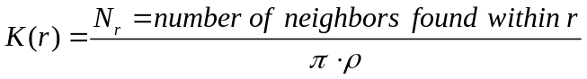
Normalized by the total cell density (in units of 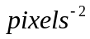) in the image, Ripley’s K-function corresponds to an average cumulative probability of finding a neighbor within this distance (fig 1B). In a completely random spatial distribution, the average probability of finding a neighbor at a certain distance is independent of all other objects’ positions, so that the average number of neighbors found in a circle of radius r depends only on the area of the circle and the density, 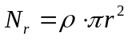. Thus, for a spatially random distribution, 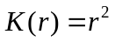 (fig 1B, dashed black line). Deviations from this r² increase denote deviations from spatial randomness in the analyzed distribution - if the probability is systematically increased (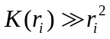), more neighbors are found at this distance than would be expected for spatial randomness, which represents clustering. Conversely, if the probability is systematically decreased (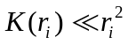), less neighbors are found at this distance than would be expected for spatial randomness, which represents exclusion or repulsion of points. To analyze (and visualize) deviations from spatial randomness in more detail, it is common to use a linearized version of the K-function 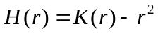 (or the more commonly used 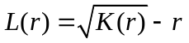) (*this will be decided as we work on the details of the ripley analysis*), in which spatial randomness corresponds to a zero-value function, so that positive values represent clustering, and negative values exclusion (more details in supplementary material). To represent the varying degree of clustering in a single parameter, which should be both well-defined for all time points, and robust to variations from one coverslip to the next, we chose the partial integral of H(r) (see fig 1C – more details on the rationale for choosing a cumulative parameter the supplementary material *this will also be rewritten and improved*). This parameter (in the following referred to as the ‘cluster parameter’) is positive for clustered distributions; when cells scatter, the H(r) function flattens out progressively as cells disperse in space, so that the integral and thus the cluster parameter decays to values around zero. When the cluster parameter takes on values of around or under zero, the corresponding cell distribution is considered to be completely scattered, as to be undistinguishable from a spatially random distribution. This descriptor of clustering is only sensitive to cells moving apart from each other as a whole, and can distinguish between cell spreading (cells remain clustered, although their average distance is changed) and complete spatial dispersal. Since we are not interested in the absolute degree of clustering in any given experiment or its variations between individual coverslips, but rather in its change in response to growth-factor stimulation, the cluster parameter is normalized to its pre-scattering value for each movie, to yield parameter values typically between one (clustered) and zero (fully dispersed).
Growth correction
Calculating the cluster parameter for long time series of cell distributions revealed a problem specific to live-cell microscopy: Cumulative cluster parameters such as the one used in this study are not only modified through scattering, but also through cell division. Although the Ripley function is normalized by the cell density in the image, and thus theoretically independent of the total number of cells, in the case of cell division the new ‘points’ are not added to random positions in the image, but rather in a systematic fashion to the middle or edge of existing clusters. This growth of the clusters causes a decay artifact in the cluster parameter. In order to separate our effect of interest, i.e. the decay caused by scattering, from the cluster growth decay artifact, we perform a mathematical simulation of cluster growth using the original unscattered (i.e. pre-treatment) cell distribution (figure 1D). The analysis of the simulated time series yields the typical contribution of cell division to the cluster parameter decay (3 simulations are performed and averaged for each experiment). After subtraction of this growth contribution, the growth-corrected cluster parameter depends only on changes of the cell adhesion properties (more details in supplementary material).
Descriptors
This strategy yields two independent descriptors of cell dynamics (fig 1E): The normalized cluster parameter, which typically decays from one to around zero during scattering, and the velocity provided by cell tracking. For analysis purposes, we normalize the average velocity to range between zero and one, to allow for comparison across different conditions and to account for day-to-day variations in cell velocity. For this purpose, every typical experiment (cells treated with HGF plus a putative scattering inhibitor x) is accompanied by a control experiment in the same multiwell-plate, where cells are treated only with HGF. The plateau velocity in the inhibitor experiment is normalized to the plateau velocity of HGF-only cells, and the pre-stimulus velocity is set to zero. This means that in absence of inhibitors, the normalized velocity value rises from zero to one in response to HGF stimulation, while in presence of an effective inhibitor, the increase might be less or none at all.
For each condition (inhibitor x at concentration m), the stimulation response time courses of the normalized cluster parameter and velocity are summarized as a set of time constants. The time constants represent the amount of time it takes the function to decrease/increase by 10% of its possible maximum (defined as the effect achieved by treatment with HGF alone). For this purpose, the parameter time courses are smoothed (1F, grey traces) and subsequently thresholded to ten levels (black traces), each representing 10% of the maximum. Thus, the time constants are the lengths of the thresholded function at each level; as the function doesn’t change after it has reached the final plateau value, the length of the final level itself is not counted; thus, full scattering or full velocity increase is represented by the maximum of ten, rather than eleven, bins. In the following, the set of time constants is represented as stacked bins in a bargraph (green-blue for the cluster parameter, yellow-red for the velocity). The number of bins denotes the number of available time constants, and thus the final value reached by the parameter. The length of a single bin represents the time the parameter value resides at the given thresholded level, so that the bin length contains information on the time course of parameter change. As seen in fig 1 f, the bargraphs show that both scattering and velocity change are complete in the observed time interval and that full scattering and velocity change take place at the same time; however the length of the individual bins shows that the cluster parameter initially reacts much faster than the velocity to hgf treatment, and that tau50 is reached much sooner. As a results, some 20-30 frames become accessible for comparative drug analysis before any measurable changes in motility can be detected.
Drug screen
The assay described above permits us to quantify the time course of velocity increase and of spatial dispersal independently. In a small drug screen, we tested several drugs implicated as potential inhibitors of HGF-induced scattering, and evaluate their potential reduce scattering and/or inhibit the increase in migration velocity separately. For each condition, we quantified the time course of the velocity and cluster parameter as described above; the results are summarized in figure 3. Each condition yields 3 time constant bargraphs: one for the cluster parameter (green-blue), and two for the velocity (yellow-red) – we considered the relative all-cell velocity (averaged over all cells in the image), and the relative single-cell velocity (averaged over all isolated cells in the image).
For control cells (cells without any treatment), there is no cluster parameter bargraph, since these cells do not scatter at all and thus don’t yield decay time constants. The decay time course in cells treated only with HGF reveals a clear difference in time course: The cluster parameter initially decays quickly, which is reflected in the short length of the first x bars; the decay of the cluster parameter has a half-time t50 of x minutes, reaching complete scattering within xx minutes. In contrast, the velocity increase is slower to start, it has a half-time on the order of xx and reaches its plateau value only after xx. *here a description of the main findings of the bargraph figure*
If a specific drug slows down the change of one or more of the descriptors (e.g. xx), the bargraph typically becomes stretched for increasing concentrations of the inhibitor, as time constants and the individual bars become longer. For efficient inhibitors, which prevent the descriptors from changing by as much as they do under HGF treatment, the bars are also “capped” at the right end, as the number of bars decreases. The drugs in the graph are put in an approximate order on the basis of their efficiency of inhibiting scattering. Drugs such as xx display both a stretching of the bars and capping for higher concentrations. We also found differential effects on velocity and adhesion – some drugs such as xx are effective inhibitors for the velocity (which shows both stretching and capping for higher temperatures), but have little effect on the change of the cluster parameter, which is similar to the HGF time course – so that, in spite of the blocked acceleration, the cells disperse spatially just as quickly as those treated with HGF alone.
Interestingly, we find in several instances that although the increase in velocity is inhibited by a drug, scattering is not just intact, but its time course is just as fast as in HGF-treated cells. Since the unchanged motility apparently doesn’t alter the scattering time-course, we conclude that the spatial dispersal on the length scales of our experiments is not rate-limited by the cells’ velocity, even though the increased motility may be a critical factor for the efficiency of invading surrounding tissues in vivo.
In order to evaluate the effects of different drugs in detail, the results of a number of the utilized drugs were extracted form the screen (figure 4): The upper panel denotes the relative efficiency of the inhibitor for velocity and clustering, defined as one minus the maximum change of the descriptor (normalized to the absolute change of the corresponding parameter in HGF treatment). The maximum change of a descriptor corresponds to the number of bars/number of time constants, so that capped bargraphs in figure 3 represent smaller changes, and thus higher efficiency values. The lower panel shows the change of the time constant with concentration. In order to compare time constants between concentrations of the same drug and between drugs that have different efficiencies, a normalized relative time constant is calculated for all conditions: For a given drug, this time constant is the cumulative length of the maximum number of bars that are available for all parameters at all concentrations. For example, for an inhibitor that is 90% efficient at its highest concentration, the maximum number of bars is 1, so that the time constant represent t10%, for a less efficient one, this may be the sum of the length of t10% up to t40%. This time constant (in units of minutes) is then normalized to the value of this time constant in the HGF-treated case (*this explanation still seems rather convoluted to me; and maybe we can find a simpler time constant to use here*).
*here a summary of the effects of specific inhibitors in figure 4; in conclusion, depending on the results, we can question the efficacy of known inhibitors if their effect on dispersal is low, and we can propose other drugs as potential candidates for metastasis inhibitors based on their efficiency in inhibiting dispersal. *
Discussion
Our novel live-cell analysis assay measures cell velocity and scattering simultaneously and independently. Thus, it reveals the dynamic time course of scattering behavior of MDCK cells in response to HGF, which has several mechanically distinct stages with specific properties of these parameters. As a result, we were able to demonstrate that inhibitors of metastasis not only target the regulation of cell motility, but that some drugs also selectively target the pathway governing the disruption of cell-cell adhesions. Therefore, this assay can serve as a useful drug screen to test effects of metastasis inhibitors drugs, both to elucidate their regulatory target and to quantify their efficiency in relation to concentration and to other drugs.
*discuss the biological results here, and what conclusions we draw about the different reghulatory pathways and their involvement in different stages*

*then discuss issues of possible technical improvements; it might e.g. be possible in the future to develop a direct assay of cell attachment, using more sophisticated image analysis, which might expand the live-cell study of scattering even further {Debeir, 2004 #7277}*

Reference List

Figure 1

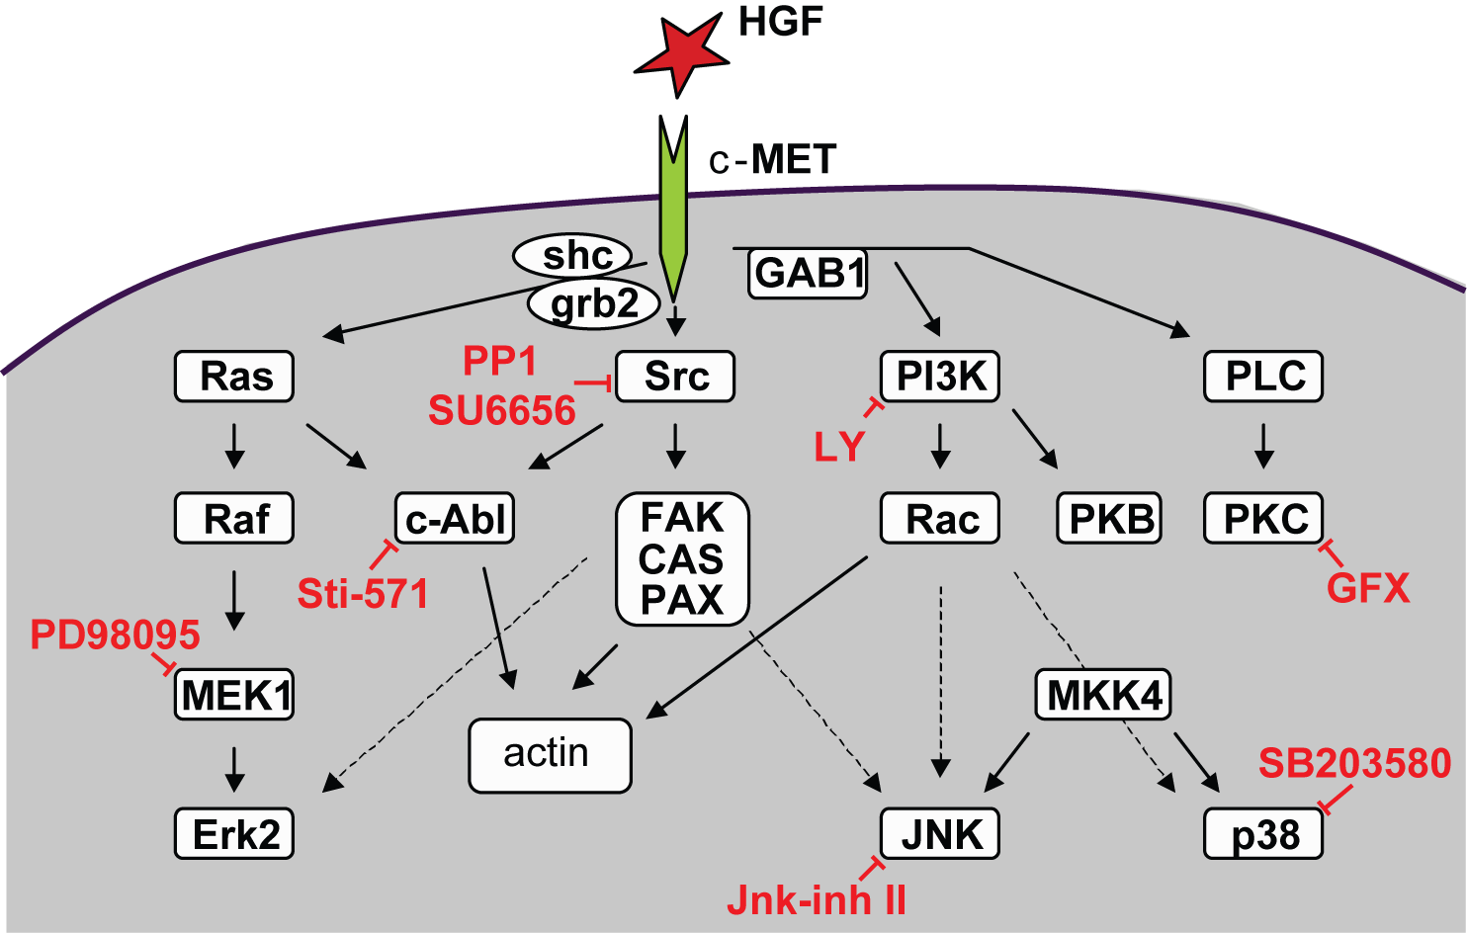

Figure caption:
*small summary of the different pathways, Johan, could you take care of this?*
Figure 2

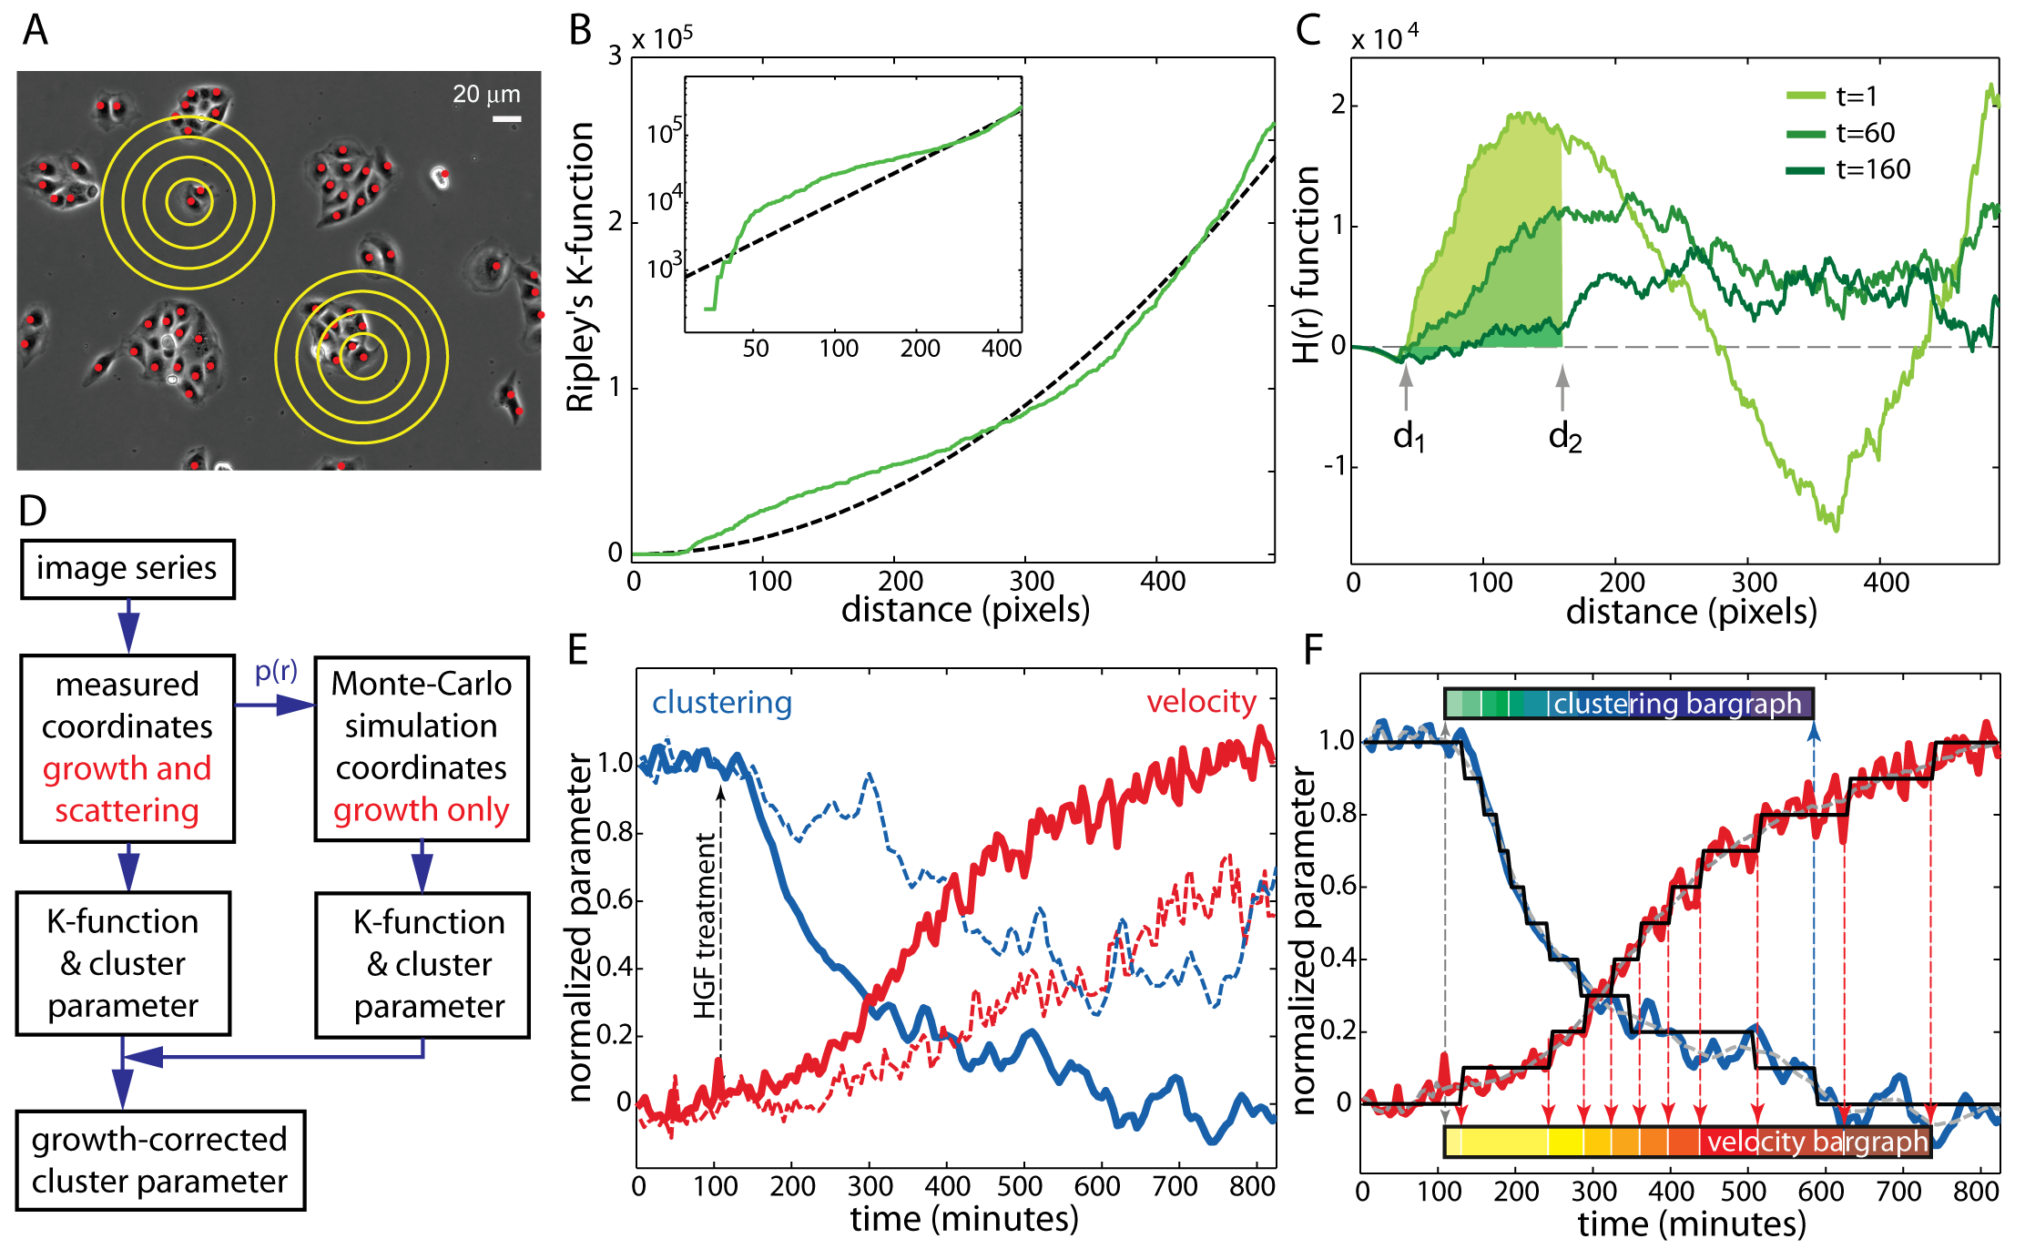

Figure caption:
*Dinah will write the figure caption here and update the figure as necessary when we change the ripley quantification*

Figure 3

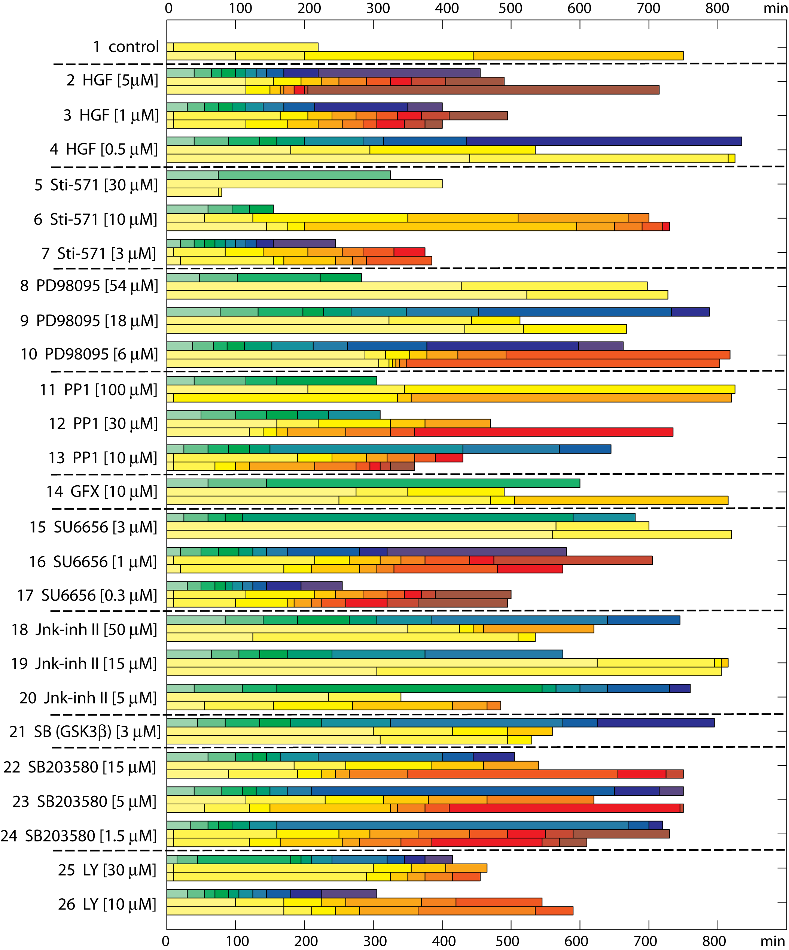

Figure caption:
*This figure will change with the new results; the figure caption won’t need to summarize the individual results, just delineate what the bargraphs mean in terms of time constants and final level of change*.

Figure 4

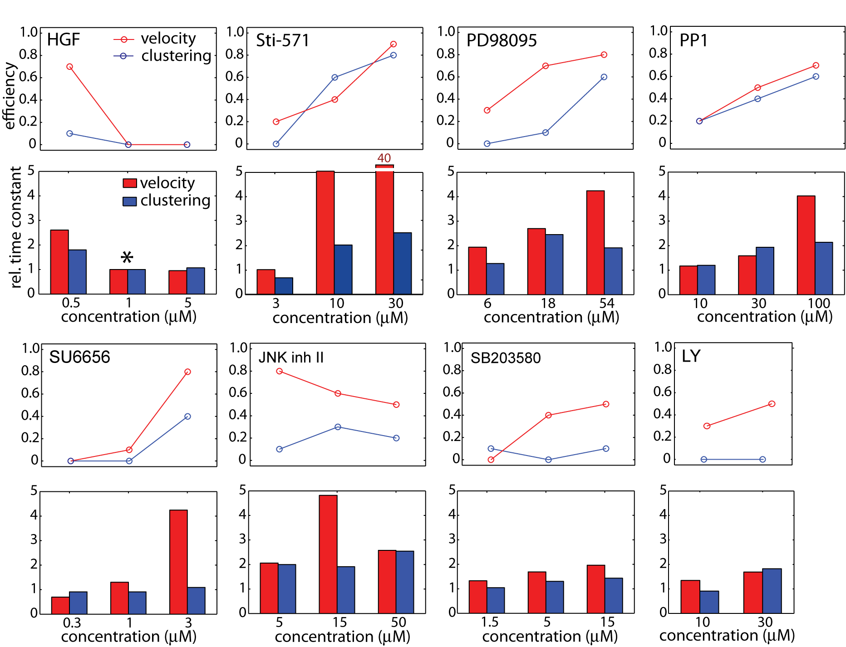

Figure caption:
*This figure will also change with the new results; tell me how many drugs you think would be appropriate to put into one figure like this*

Supplementary Material
Phase-contrast image analysis (*this is your, Andre*)
The image-analysis software is developed under the aspect that large data sets of experiments can be processed in an automated way without significant user interaction. The image processing basically consists of an image segmentation to detect the cell locations and cell clusters, followed by a tracking of individual cells in time. The segmentation is done with a clustering method applied on the intensity distribution of the images. For the tracking, we apply a nearest neighbor criteria supported by a neuronal net to resolve possible conflicts. The segmentation and tracking steps are combined with a template matching method to handle cells initially not detected. The backup mechanism is intended to significantly increase the number of detected and tracked cells.
To be able to retrieve relevant information from cell images, cell positions need to be found for every frame and to be tracked throughout the image series. In ScatterTrack this is achieved in 2 phases, a cell detection phase and a cell tracking phase. Many other applications perform these phases separately: first all cells are detected in all frames, followed by a cell tracking phase where cell positions are correlated from one frame to the next. For practical reasons, ScatterTrack merges these two phases: starting from the second frame, first the cell positions are detected in the frame, followed by a tracking step where the current positions are correlated to the positions in the previous frame. This procedure immediately yields a list of cell positions that could not be correlated to previous positions (so-called new cells), as well as a list of previous frame cell positions that could not be correlated to positions in the current frame (so-called lost cells). This information can be used in later frames to close gaps in tracks.
The algorithm we use works as follows: (*can you maybe make a little flow chart with boxes for the code outline, and something similar for the matrices?*)
FOR image_nr = first_image TO last_image
image = read (image_nr)
quality = check_quality (image)
IF quality is good
calculate_frame_time (image)
image_no_bg = subtract_background_from (image)
segmented_image = segment_image (image_no_bg)
nuclei_coord = find_nuclei (segmented_image)
IF image > first_image
matched_cells, lost_cells = track_cells (previous_nuclei_coord, nuclei_coord)
M = store_matched_cells (matched_cells)
M = close_gaps_in_tracks (lost_cells, M)
ELSE
previous_nuclei_coord = nuclei_coord
END
cell_props, cluster_props, frame_props = generate_properties (segmented_image, nuclei_coord)
ELSE
bad_frame_list = mark_as_bad (image)
END
END
MPM = generate_MPM (M)
MPM = minimal_track (MPM)
cell_props, cluster_props, frame_props = update_properties (MPM, bad_frame_list)
One of the first steps in the algorithm is to check whether the image is of sufficiently high quality to be segmented. This is done by a very simple test where the variance of the complete image is determined. If the variance is close to 0, this means that there are hardly any objects in the image that we would be able to use in the segmentation algorithm. If this is the case, the image is rejected and stored in a list (bad_frame_list). If the image is of good quality, the frame time is calculated, and it will be corrected for background inequality. The background is determined based on variance of the image and an automatically calculated optimal threshold value {Kittler, 1986 #163} and subtracted from the original image. After the subtraction step, the processed image pixels are segmented into three values: nuclei (black), halos (white) and background (grey), using the K-Means clustering algorithm {MacQueen, 1967 #164}. This iterative partitioning minimizes the sum, over all clusters, of the within-cluster sums of point-to-cluster-centroid absolute differences, i.e., L1. Each centroid is the component-wise median of the points in that cluster*. After the segmentation step the cell nuclei coordinates are calculated as the centroids of the nuclei clusters (black values) found in the segmented image. This step also includes finding more nuclei coordinates by fitting nuclei into larger clusters based on average single cell nucleus size.

After finding the nuclei coordinates in the first frame of the images series, the same procedure is performed on the second frame, from which point on the tracking of cells can commence. Correlation of cell coordinates from one frame to the previous frame is done by using a nearest neighbor algorithm resolving topological conflicts with a Labonte neural network {Labonte, 1999 #162} (REF ponti?). Cell coordinates from the previous frame that could not be correlated to coordinates in the current frame are stored in a lost cells list together with the frame number where the track was lost; e.g. (123 456 4) means that cell coordinate pair (123,456) was last seen in frame 4. Matched cells are stored in a matched cells list and accumulated into a so-called magic (M) matrix. This matrix is three-dimensional and contains 4 columns for every frame: columns 3 and 4 contain the y-coordinates and x-coordinates from frame 'a' while columns 1 and 2 contain the matching y-coordinates and x-coordinates from frame 'a-1'. The size of the third dimension is the number of frames in the series minus one. An example M matrix looks as follows:

1 ---- 1 2 3 4
-----------------------------------------
1 | 12 34 13 36
2 | 44 139 45 140
3 | 25 4 23 6
4 | 47 234 44 230

2 ---- 1 2 3 4
-----------------------------------------
1 13 36 0 0
2 45 140 44 142
3 23 6 21 8
4 44 230 0 0
5 0 0 25 27

Every time a pair of cell coordinates in the previous frame can not be matched to a pair in the current frame, a pair of zeros is shown in column 3 and 4 and in the next frame this row will not be present anymore. If a new pair of coordinates is found, these will be added at the end of the list in columns 3 and 4 and preceded by a pair of zeros. Using the lost cells list, an attempt can be made to close a gap in between two tracks if these tracks fit together statistically. Currently this is done for frames that are less than 5 apart, but in future work this could be extended to a dynamical scheme which takes into account velocity and direction of the cells. If a gap can be closed, the M matrix will be modified to show this fact. The cell coordinates with which the gap is filled, are calculated using a linear interpolation scheme. The last step in the for loop is a calculation if cell, cluster and frame properties. These values are calculated based on the coordinates of cells in the segmented image. Cell properties contains the cell coordinates and the cluster number the cell belongs to (this could be a cluster of one cell or a single cell). Cluster properties contains the cluster number, the number of cells in the cluster, the cluster area, the cluster perimeter length and the number of perimeter elements the cluster consists of. Last but not least, the frame properties contains the average area of clusters (including single cells), the average area of the convex hull around a cluster and the average ratio of cluster area divided by convex hull area.

After all frames in the series have been processed, the M matrix is converted in a so-called MPM matrix: a matrix that contains one cell coordinate track per row. Every frame is represented by 2 columns. An example MPM matrix based on the M matrix above looks as follows:

1 2 3 4 5 6
----------------------------------------------------------
1 | 12 34 13 36 0 0
2 | 44 139 45 140 44 142
3 | 25 4 23 6 21 8
4 | 47 234 44 230 0 0
5 | 0 0 0 0 25 27

In this example tracks 1 and 4 are lost in frame 3 (column 5 and 6) while a new track is started in that same frame. In this way it is easy to give every cell track its own unique number which can be graphically shown on an image series. This step is followed by ine where the MPM matrix is cleaned up to only show cell tracks that are at least present in two frames. Cells that are only seen in one frame will be disregarded. The last step in the algorithm is a renewed generation of cell, cluster and frame properties based on the information in the MPM matrix and the bad frame list. This is necessary because the gap closing and minimal track functions will have generated new cells or disregarded short tracks which have an impact on these generated properties.

The MPM matrix and properties are saved on disk and can subsequently be used for further research into migration and scatter patterns of cells.
References:
[*] Definition from Mathworks K-Means web page "http://www.mathworks.com/access/helpdesk/help/toolbox/stats/kmeans.html"

Cell Detection and Tracking (*Dinah will finalize this paragraph*)
To quantitate the efficiency of our automated detection algorithm, the automatic detection results were directly compared to manual detection in a small number of representative images. In a total of 8 image series - 4 image series of hgf-treated cells, 4 series of untreated control cells - cells were identified manually and automatically at seven different time points (frames 1, 30, 60, 90, 120, 150 and 180).
The fact that a sharp drop in the percentage of true positives occurs already between the first and the second point – i.e. before the velocity has increased significantly beyond the range of variation seen in the untreated cells – is an indication that the loss of detection efficiency depends primarily on the changes in morphology preceding the increase in velocity.
The initial drop of efficiency is caused by an increase in the percentage of false negatives (cells that aren’t found), while the later gradual decrease over the course of the movie reflects more an increase in the percentage of false positives (points that are incorrectly identified as cells).
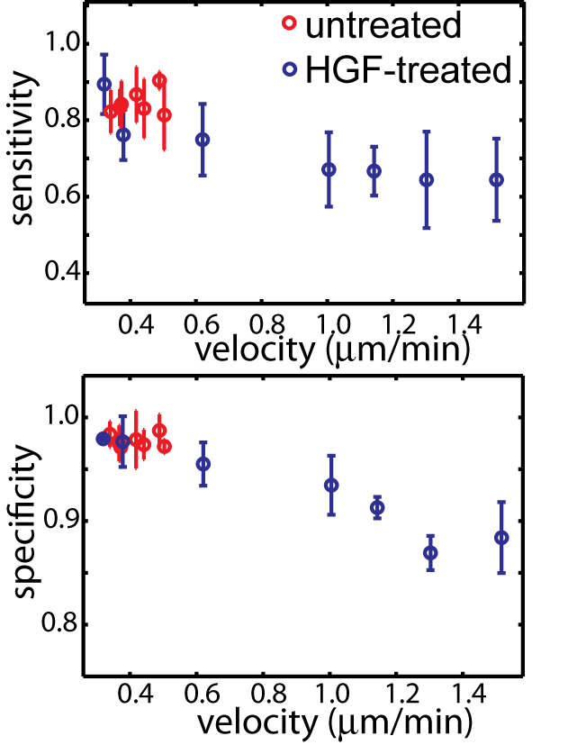
Figure S1: Detection Efficiency. Example image of hgf-treated cells with results of manual (red) and automatic (blue) tracking. Automatically detected points with matching manually detected points (filled circles) in the vicinity are considered correct identifications, i.e. true positives. Automatically detected points without a match are false positives (open blue circles), while manually detected points without a match are false negatives (open red circles).
B: Detection efficiency for hgf-treated (dashed lines) and untreated cells (solid lines). The lower limit of the detection efficiency (percentage of true positives) is on the order of ~80-90% for untreated cells, and in hgf-treated cell decays to ~50% as cells change their morphology (and increase their velocity) over the time course of the movie. The upper limit of the detection efficiency – the total fraction of points found by automatic tracking – is slightly above 70%.

Quantitation of clustering/scattering with Ripley’s K-function (*Dinah will also finalize this when the new Ripley is finished*)

Paragraph about Ripley: how to calculate ripley, what do the different parameters signify, rationale for cell division simulation correction.
Validation 1: behavior of cluster parameter in benchmark simulations (with pre-determined velocity and adhesion and spreading properties).
motility is increased and adhesions are disrupted; cells scatter
motility is increased but adhesions are intact; cells move around faster within and with their cluster, but do not – on the whole – move significantly away from their neighbors
motility does not increase, but adhesions are lost; although not faster than before, cells slowly ‘diffuse’ and thus move away from their neighbors in the cluster
cells spread only, while no scattering occurs

Validation 2: Cluster parameter is insensitive to removal of points, and thus isn’t bothered by the fact that our detection efficiency is not 100%

Growth correction (*Dinah will do this*)
*Here follows a paragraph about the growth correction, how we quantify the nearest neighbor distance probability, and how cells are added to the edge of clusters in a monte-carlo simulation; the descriptors are calculated for growing distributions, and subtracted in measured distribution*

