Process Description:

The flow tracking process uses multi-frame cross-correlation to calculate the flow velocity at any speckle position. The correlation score of a template consisting of a square box of specified size is integrated of multiple consecutive frame pairs in a time window at each point. This allows the tracking of very weak speckle patterns. The fundamental assumption of the algorithm is that the speckle flows are quasi-stationary, i.e. the flow field does not significantly change over the duration of the integration window. The output is a calculated flow velocity representing the average flow velocity within the time window.

Parameter Descriptions:

Input Channels:
This allows you to select which channels you want to perform noise estimation on. This should be applied to all channels that are going to be used for calculating the noise parameters. Select the channels by clicking on them in the "Available Input Channels" box and then clicking "Select>" to move them to the "Selected Channels" box. You can unselect a channel by clicking the "Delete" button

Dynamic parameters

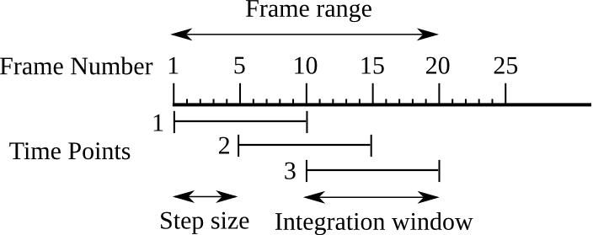
Frame range:
These two values determine the first and the last frame over which the integration window can be moved for calculating the flow velocities.

Integration window (frames):
This is the duration of the window used for integration of cross-correlations values between consecutive frames. The final velocity in one location is calculated from the peak of the integrated correlation function.

Step size (frames):
This is the interval used to move the integration window.

Correlation parameters
Template size range (pixels):
These values specify the minimum and maximum sizes of the template used to calculate correlation scores. If both values are equal, the algorithm will use a single template size to track a stable flow. Else, it will automatically adapt the template size required for a stable flow tracking at each point within the specified size range.
Practically, the function will start correlating images with the lowest template size in the given range. If no unambiguous global correlation maximum is found, the template size will be increased by a factor 1.5 and the correlation repeated until a valid correlation maximum is found. For instance, if the user inputs 5-21 pixels as the template size range, the following template sizes: (5, 7, 10, 21) will be tested for each speckle position until a satisfying correlation maximum is found.

Maximum flow speed (pixels/frame):
This determines the maximum expected flow speed. It should be high enough so that flow of high speed will not be missed in tracking. However, high values will increase computational tracking time.

Background parameters
Edge erosion width (pixels):
This value specifies the distance over which the edge will be shifted towards the cellular domain. This shift reduces the potential error of tracking speckles that are close to the edge due to high intensity gradient across the edge.

Stationary background
If Subtract stationary background is selected, the correlation will be calculated after averaging a range of stationary frames. If Use all images from the frame range is selected, background will be computed using all the images in the frame range. Else, the algorithm uses the Number of stationary frames to average.

Outlier detection parameters
Once the flow has been determined at each position, if Filter vector outliers is checked, outliers are detected using a normalized median test (Westerweel and Scarano 2006). For each stable tracked flow, the residual of the flow displacement with respect to the local neighborhood flow is computed and normalized. Normalized residuals exceeding the Threshold for normalized residual are marked as outliers.

References
Li, J. and Danuser, G. 2005. Tracking quasi-stationary flow of weak fluorescent signals by adaptive multi-frame correlation. Journal of Microscopy. 220:150-167.
Westerweel, J. and Scarano, F. 2005 Universal outlier detection for PIV data. Experiments in Fluids 39:10096-1100

