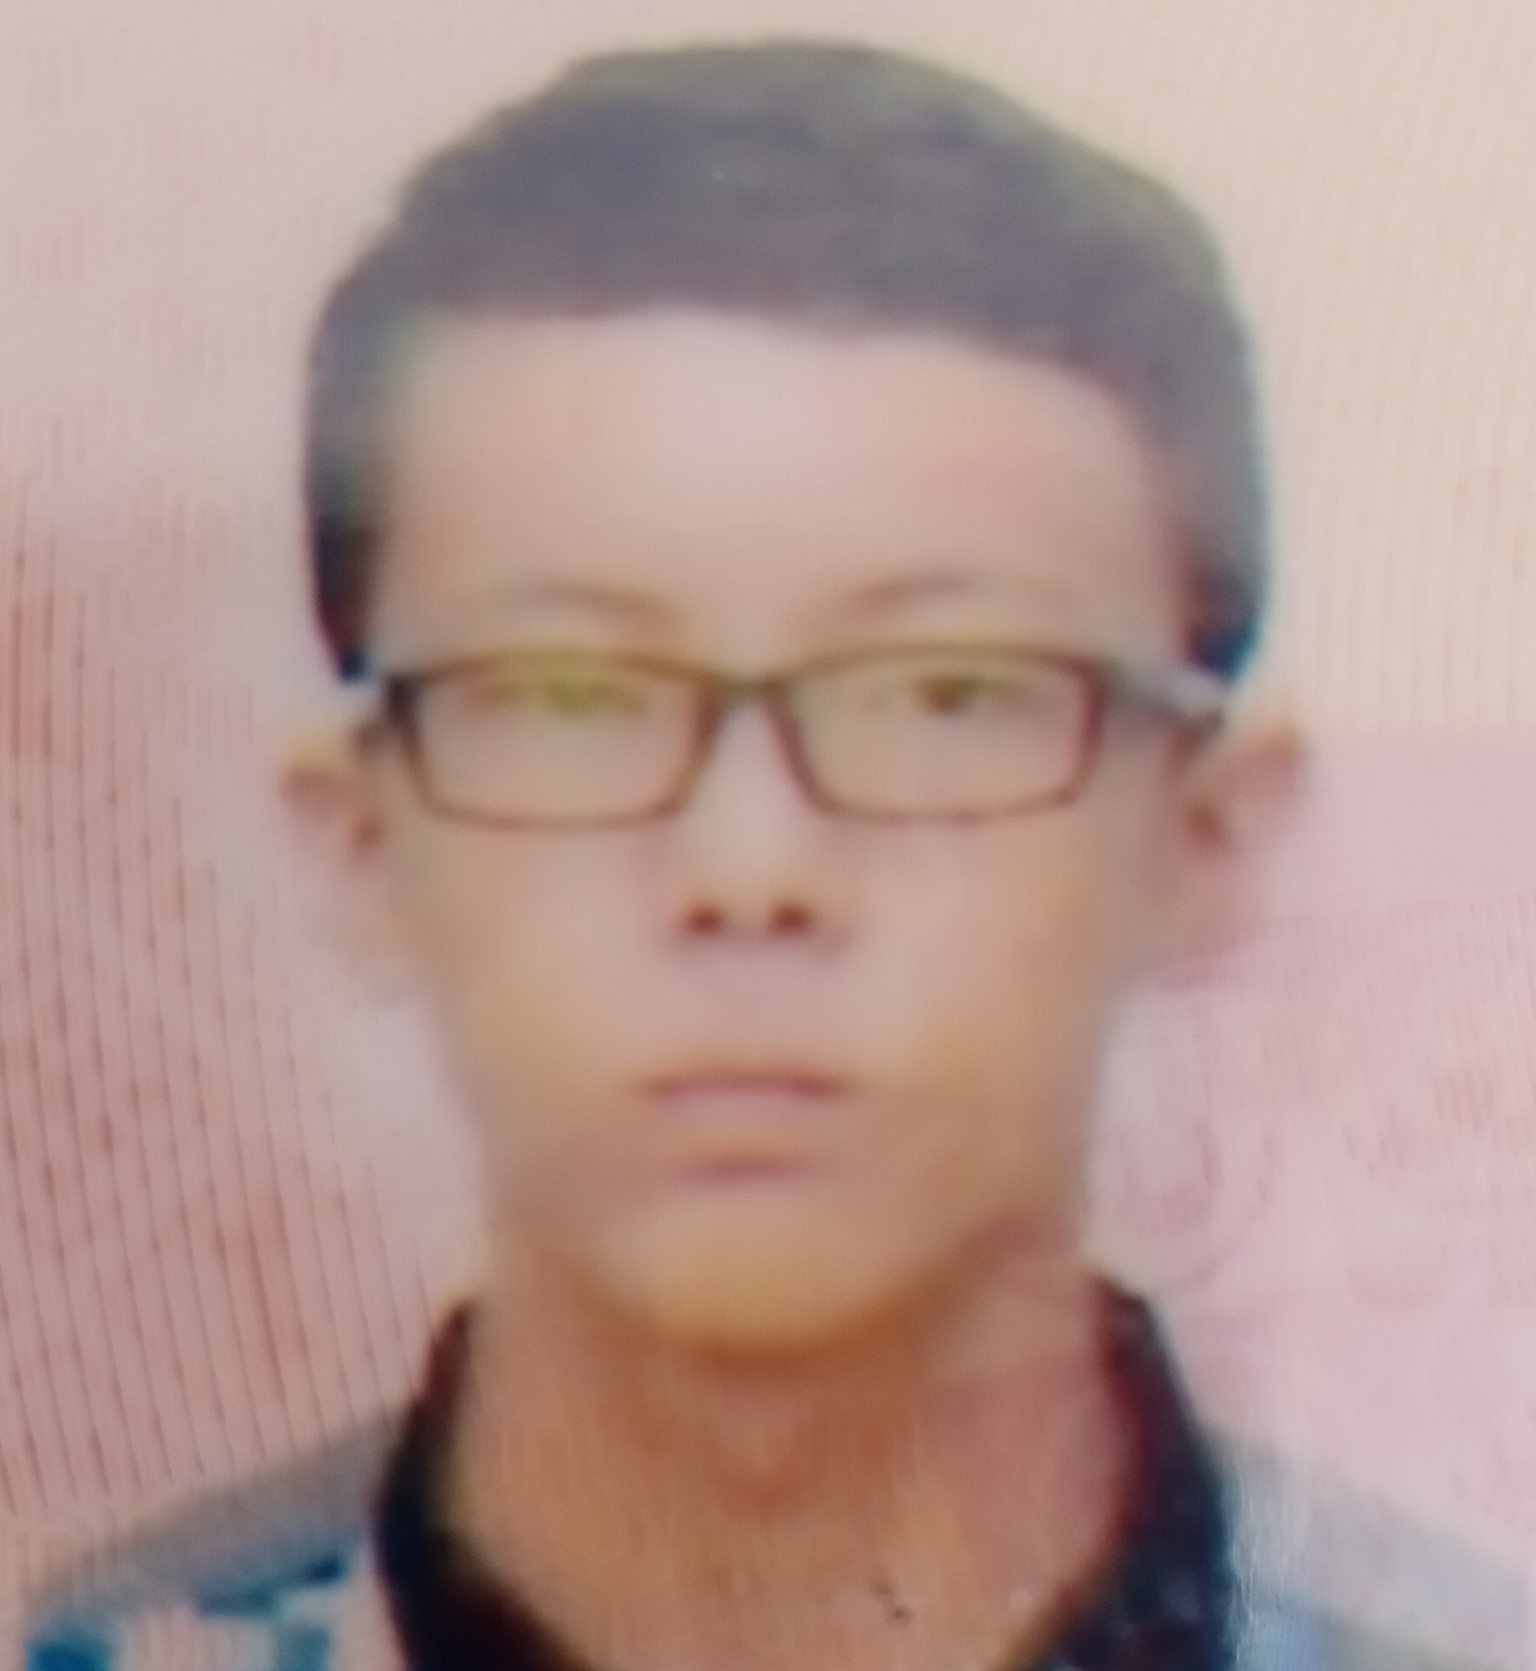 |  |  |  | TEA HAN QIN

Experience
1-1-2019 – 1-3-2019
Sales Department• Salesman • 100 Plus company
2-3-2019 – 1-9-2019
Sales Department• Salesman • Coca’Cola Company

Education
XIAMEN UNIVERSITY MALAYSIA, Jalan Sunsuria, Bandar Sunsuria, 43900 Sepang, Selangor
- GPA 2.5
- Kangaroo Math Competition (Gold Medal)

Communication
I can communicate well with other people and make people know my presentation well using different language;
- English
- Chinese
- Malays
- Other dialect
I am also good in pursue other people to buy the thing that I sell.

Leadership
I have become the vice president of Science and Mathematics Club in secondary school.
I also become the secretary in Rowing Workshop held by the Rowing Club in university.

References
Haji Rahman bin Musa, principal of SMK Tunku Putra.

232, Kampung Bindu, Tongkang Pechah
83000 Batu Pahat, Johor.
 |  | 0177377064
 |  | teahanqin@gmail.com

