**Numerical Optimization Homework #2**

**20161216 HAN SANGJUN**

**Problem 1) Find local minimum of f(x) = 3x^2 - 6x +7**

- The local minimum of f(x) is 4 when x =1

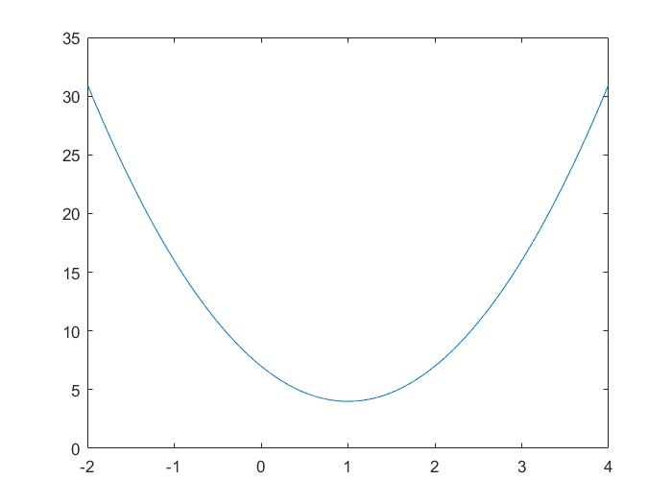

- Performance

|  |  |  |
| --- | --- | --- |
| Method | Optimal point | Speed(sec) |
| Bisection | 0.999754 | 0.234696 |
| Newton | 1 | 0.025877 |
| Secant | 1 | 0.030876 |
| Regula falsi | 1 | 0.026448 |

- Discussion

a. Newton’s method shows good speed, but not significantly

b. I add a new condition to initial guess of bisection a < b, because terminating condition which is b - a < epsilon confuses the optimizer not to find optimal point

**Problem 2) Find local minimum of f(x) = x^3 - 3x^2 + 2**

- The local minimum of f(x) is -2 when x = 2

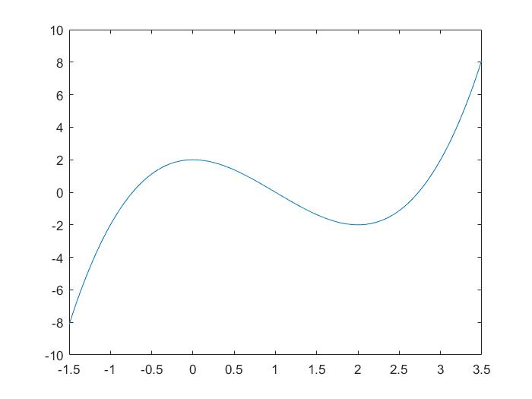

- Performance

|  |  |  |
| --- | --- | --- |
| Method | Optimal point | Speed(sec) |
| Bisection | 1.999864 | 0.226591 |
| Newton | 2.000044 | 0.209376 |
| Secant | 2.000080 | 0.241034 |
| Regula falsi | 1.999180 | 10.353901 |

- Discussion

a. It is hard to find local(or global) minimum because generally in cubic(or high-order) function, there could be many points which make f’(x) = 0

b. In the reason, I constrained the initial guess (a, b) to be f’(a) < 0, f’(b) > 0, a < b in Bisection, f’’ > 0 in Newton, a > 0, f’(a) > 0, a < b in Secant, and f’(a) < 0, f’(b) > 0, a < b in Regula falsi

c. The reason that Regula falsi has difficulty to converge is new generated points on x-axis are always in same sign with point ‘a’ in this case. We need more general cases

**Problem 3) Find local minimum of f(x) = (1/3)x^3 - 2x^2 + 3x + 3**

- The local minimum of f(x) is 3 when x = 3

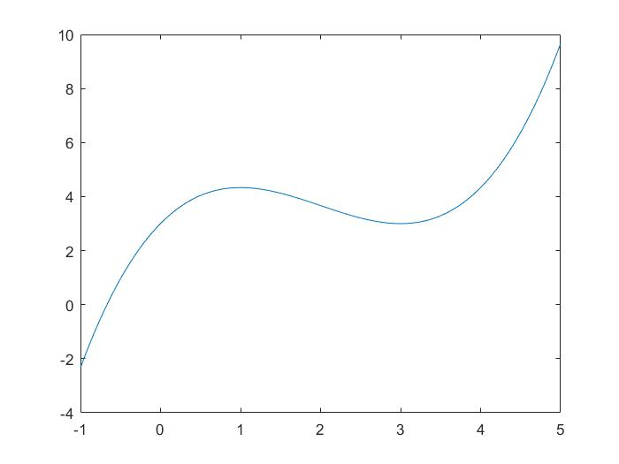

- Performance

|  |  |  |
| --- | --- | --- |
| Method | Optimal point | Speed(sec) |
| Bisection | 3.000005 | 0.183557 |
| Newton | 3.000002 | 0.150701 |
| Secant | 3.000000 | 0.249130 |
| Regula falsi | 3.000006 | 3.436841 |

- Discussion

a. Newton’s method converges fast, but if f(x) is not differentiable, it cannot be used

b. The initial points are constrained according to Problem 2

c. Secant method is slower than Bisection, as not expected. In problem 4, I’ll compare the performance, setting manually the initial points

d. Regula falsi is in same issue in compliance to Problem 2

**Problem 4) Find local minimum of f(x) = (3/4)x^4 - 3x^3 + (27/2)x^2 - 15x + 2 [3, 8]**

- The local minimum of f(x) is -316.75 when x = 5

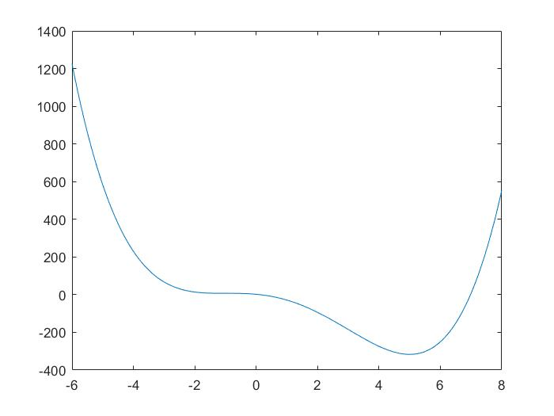

- Performance

|  |  |  |
| --- | --- | --- |
| Method | Optimal point | Speed(sec) |
| Bisection | 4.999817 | 0.215659 |
| Newton | 5.000000 | 0.084982 |
| Secant | 4.999999 | 0.174837 |
| Regula falsi | 4.999999 | 0.598721 |

- Discussion

a. I set manually the starting point as [3, 8], and 8 is used on Secant method

b. Despite of setting the initial point, Regula falsi are still in trouble. The only one side of interval is swapped including all previous cases. In Problem 5, I try to find a case well-fitted to Regula falsi.

**Problem 5) Find local maximum of f(x) = x^3 - 6x^2 + 9x +7**

- The local maximum of f(x) is 11 when x = 1

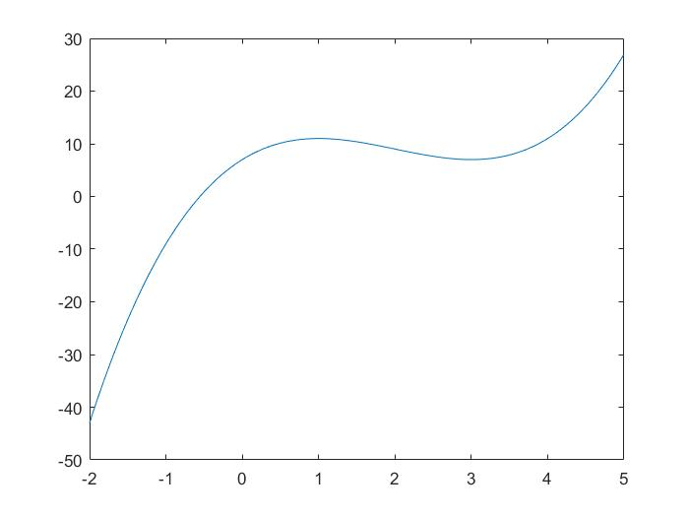

- Performance

|  |  |  |
| --- | --- | --- |
| Method | Optimal point | Speed(sec) |
| Bisection | 10.999998 | 0.133676 |
| Newton | 11 | 0.040795 |
| Secant | 11 | 0.112301 |
| Regula falsi | 11 | 0.115344 |

- Discussion

a. In this case, Regula falsi is reasonably converging to optimal point. In special case, Regula falsi is not working well

b. Bisection method have difficulty to converge to optimal point precisely including previous problems