**Numerical Optimization Homework #3**

**20161216 HAN SANGJUN**

**장세현, 원경호 조교님**

**Problem 1) Find local minimum of f(x) = x^2 - 4*x + 7**

- The local minimum of f(x) is 3 when x = 2

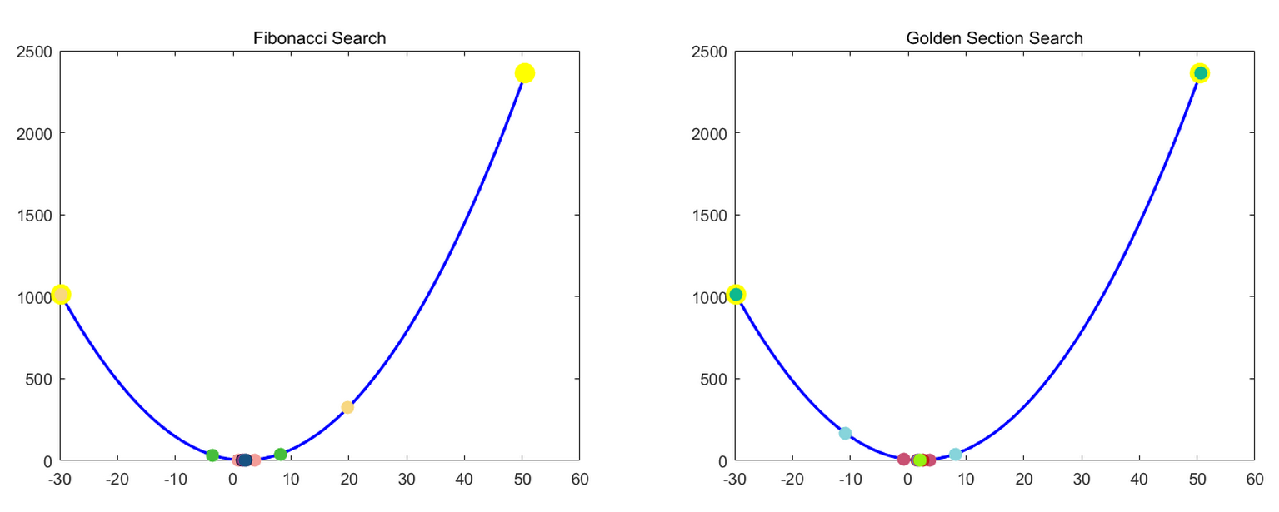

*\* The left/rightmost yellow points indicate initial search boundary which was found referring to unimodality of the function, range[-100 100]*

*\* The figure was captured at each iteration which satisfies (iter mod 3 == 1)*

*\* We generate N which satisfies the final interval length within epsilon 0.001*

*\* One function evaluation is used*

- Performance

|  |  |  |  |  |
| --- | --- | --- | --- | --- |
| Method | Optimal interval | Speed (sec) | Iterations | Interval/Iterations |
| Fibonacci search | 6.62 * 10^-4 | 0.445668 | 24 | 2.75 * 10^-5 |
| Golden section search | 4.79 * 10^-4 | 0.457492 | 25 | 1.96 * 10^-5 |

- Discussion

a. It seems that Fibonacci search converges a little faster than Golden section search, but in terms of ratio with interval/iteration, Golden section search is better. The reason can be inferred as below;

The interval length shrinks at the ratio of fibonacci_array(N-2) / fibonacci_array(N) (at most tau ratio) when Fibonacci search is applied. It means that it cannot be faster than Gold section search which shrinks the interval at the ratio of tau). The term interval/iteration can be used for performance metric.

**Problem 2) Find local minimum of f(x) = abs(x - 3) + 1**

- The local minimum of f(x) is 1 when x = 3

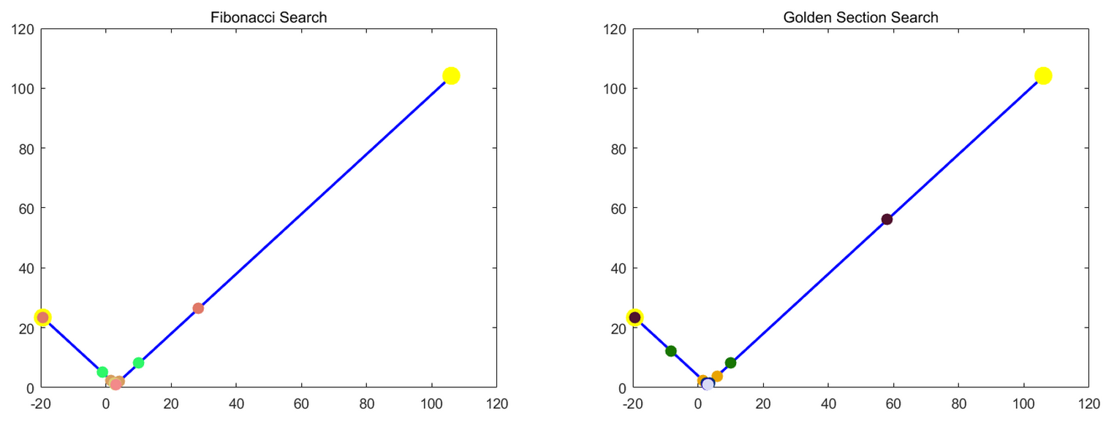

- Performance

|  |  |  |  |  |
| --- | --- | --- | --- | --- |
| Method | Optimal interval | Speed (sec) | Iterations | Interval/Iterations |
| Fibonacci search | 6.39 * 10^-4 | 0.463756 | 25 | 2.56 * 10^-5 |
| Golden section search | 4.62 * 10^-4 | 0.480452 | 26 | 1.78 * 10^-5 |

- Discussion

a. It seems that Fibonacci search converges a little faster than Golden section search, but in terms of ratio with interval/iteration, Golden section search is better. (same result as problem 1)

**Problem 3) Find local minimum of f(x) = abs(x + 50) - 3**

- The local minimum of f(x) is -3 when x = -50

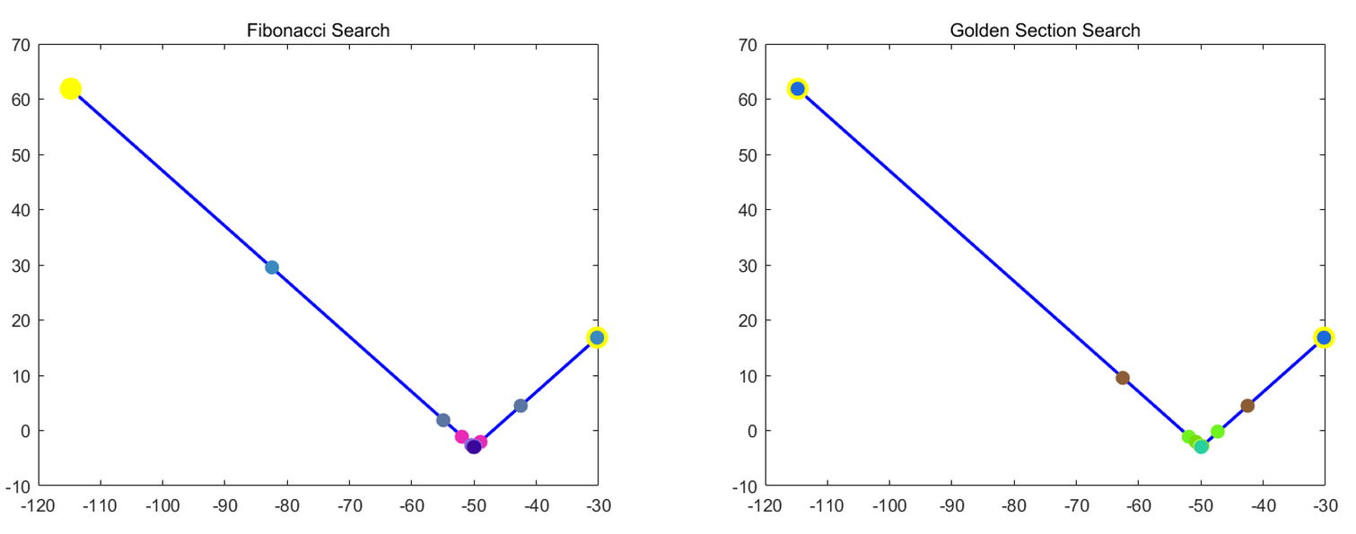

- Performance

|  |  |  |  |  |
| --- | --- | --- | --- | --- |
| Method | Optimal interval | Speed (sec) | Iterations | Interval/Iterations |
| Fibonacci search | 6.97 * 10^-4 | 0.438175 | 24 | 2.90 * 10^-5 |
| Golden section search | 5.04 * 10^-4 | 0.501500 | 25 | 2.02 * 10^-5 |

- Discussion

a. It seems that Fibonacci search converges a little faster than Golden section search, but in terms of ratio with interval/iteration, Golden section search is better. (same result as problem 1)

**Problem 4) Find local minimum of f(x) = 3*x^4 + 32*x^3 + 30*x^2 - 600*x + 24**

- The local minimum of f(x) is -752 when x = 2

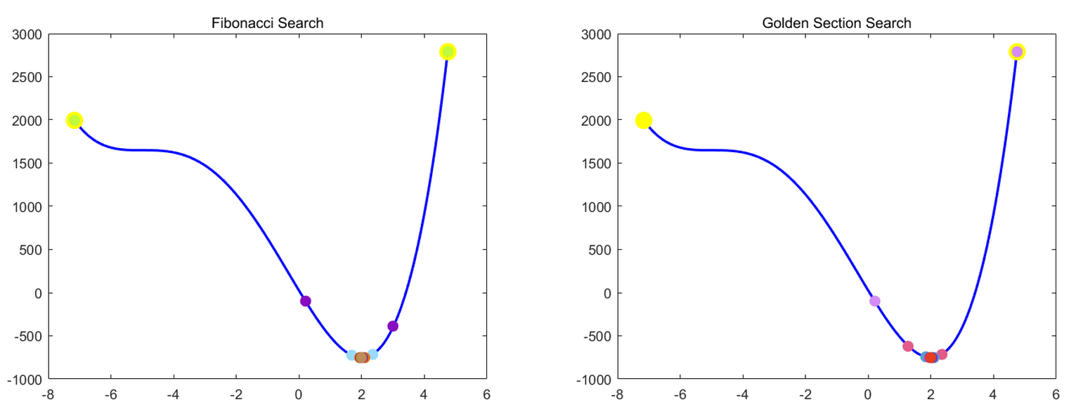

- Performance

|  |  |  |  |  |
| --- | --- | --- | --- | --- |
| Method | Optimal interval | Speed (sec) | Iterations | Interval/Iterations |
| Fibonacci search | 6.72 * 10^-4 | 0.377071 | 20 | 3.36 * 10^-5 |
| Golden section search | 4.86 * 10^-4 | 0.382552 | 21 | 2.31 * 10^-5 |

- Discussion

a. It seems that Fibonacci search converges a little faster than Golden section search, but in terms of ratio with interval/iteration, Golden section search is better. (same result as problem 1)

b. In this case, there is a unimodal point at x = 2 and inflection point at x = -5

**Problem 5) Find local minimum of f(x) = 3*x^4 + 4*x^3 - 96*x^2 + 240*x + 3**

- The local minimum of f(x) is -2222 when x = -5

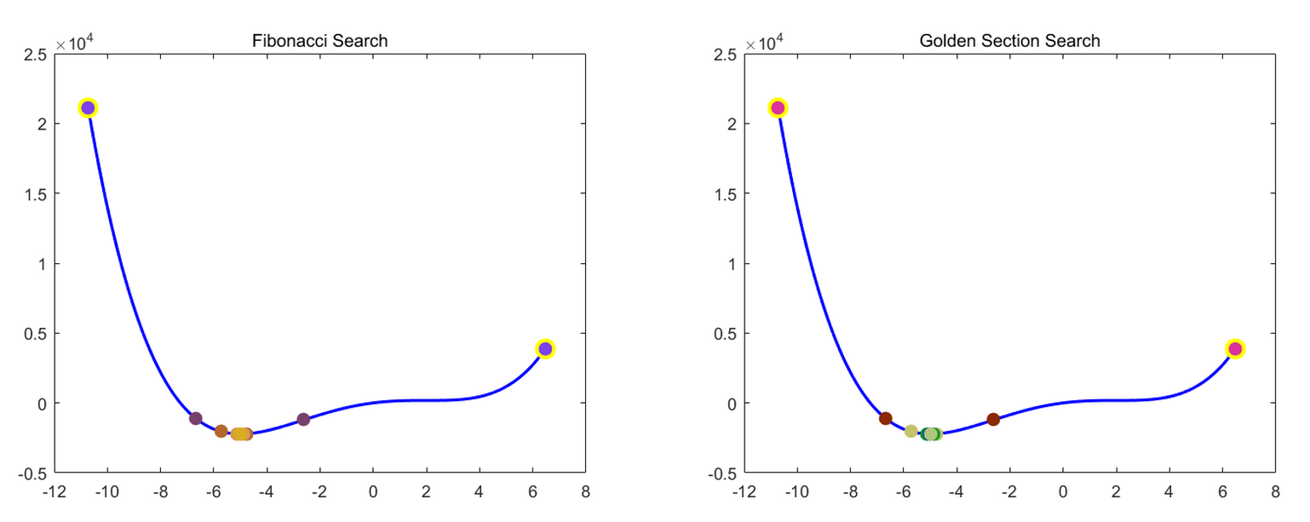

- Performance

|  |  |  |  |  |
| --- | --- | --- | --- | --- |
| Method | Optimal interval | Speed (sec) | Iterations | Interval/Iterations |
| Fibonacci search | 9.71 * 10^-4 | 0.373819 | 20 | 4.86 * 10^-5 |
| Golden section search | 4.34 * 10^-4 | 0.411195 | 22 | 1.97 * 10^-5 |

- Discussion

a. It seems that Fibonacci search converges a little faster than Golden section search, but in terms of ratio with interval/iteration, Golden section search is better. (same result as problem 1)

b. In this case, there is a unimodal point at x = -5 and inflection point at x = 2