**Numerical Optimization Homework #4**

**20161216 HAN SANGJUN**

**장세현, 원경호 조교님**

**Nelder Mead method**

- Termination condition: The average of three vertex lengths of triangular <= epsilon

- alpha = 1, beta = 2, and gamma = 0.5

**Powell’s method**

- Termination condition: The distance of point x(N) - x(N-1) <= epsilon

- For find gamma, Golden section search was used with seeking unimodal bound.

- Depending on initial values, the unimodal bound sometimes cannot be found

**Problem 1) Find local minimum of f(x, y) = 2*x^2 + 5*y^2**

- The local minimum of f(x, y) is 0 when (x, y) = (0, 0)

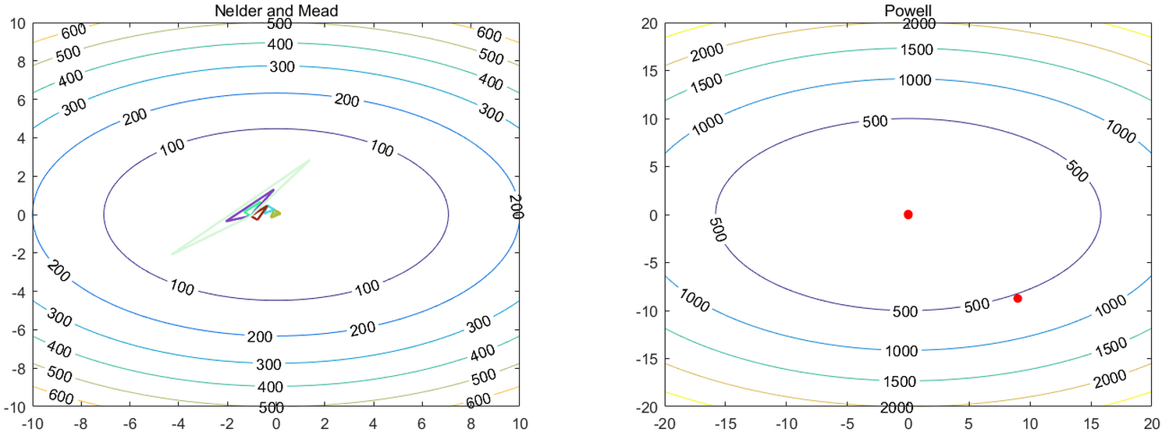

*\* The code of figure can be slightly changed upon the range*

*\* The figures were captured at each iteration which satisfies (iter mod 2 == 0)*

- Performance

|  |  |  |  |  |
| --- | --- | --- | --- | --- |
| Method | Optimal point | Speed (sec) | Iterations | Speed / Iterations |
| Nelder and Mead method | 0.000543 | 0.595820 | 20 | 2.97 * 10^-2 |
| Powell’s method | 0.000002 | 0.247033 | 2 | 1.24 * 10^-1 |

- Discussion

a. Powell’s method is faster to converge than Nelder and Mead method in terms of speed per one iteration.

b. Powell’s method is faster to converge than Nelder and Mead method in terms of total time.

c. However, if the function is not unimodal along directional vectors, other search algorithm needed.

d. Nelder and Mead method is known for slow convergence, and I found it needs many iterations.

**Problem 2) Find local minimum of**

**f(x, y) = (1.5 - x + x*y)^2 + (2.25 - x + x*y^2)^2 + (2.625 - x + x*y^3)^2**

- The local minimum of f(x, y) is 0 when (x, y) = (3, 0.5)

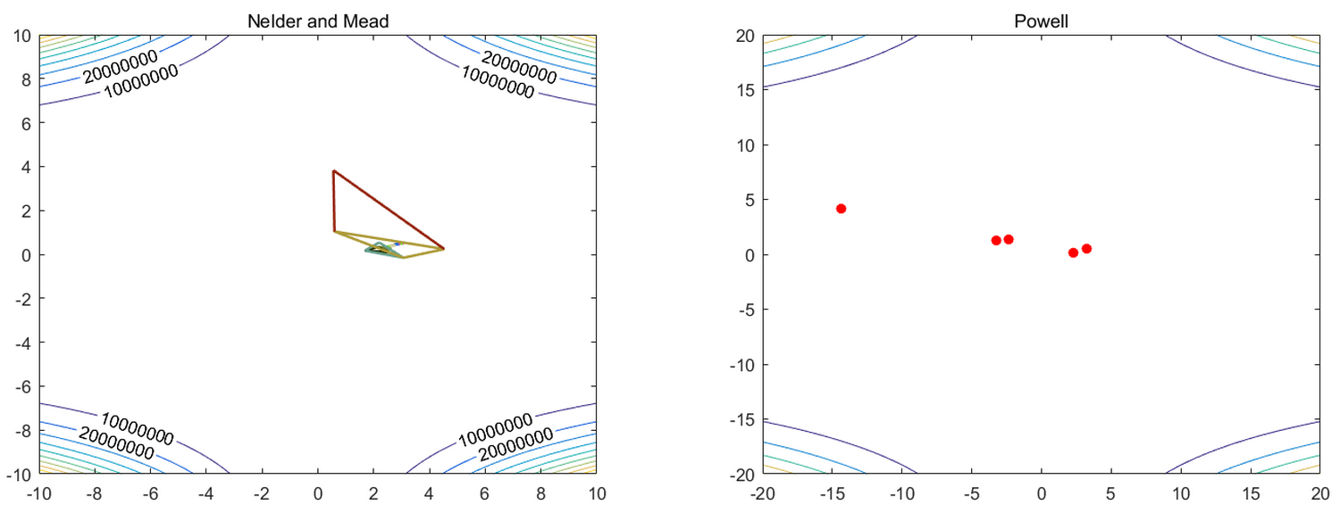

- Performance

|  |  |  |  |  |
| --- | --- | --- | --- | --- |
| Method | Optimal point | Speed (sec) | Iterations | Speed / Iterations |
| Nelder and Mead method | 0.000040 | 0.863023 | 29 | 2.98 * 10^-2 |
| Powell’s method | 0.006600 | 0.218815 | 5 | 4.38 * 10^-2 |

- Discussion

a. Same result with Problem 1)

**Problem 3) Find local minimum of f(x, y) = 100 * (y - x^2)^2 + 3 * (1 - x)^2**

- The local minimum of f(x, y) is 0 when (x, y) = (1, 1)

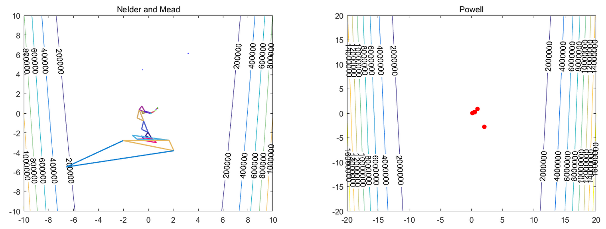

- Performance

|  |  |  |  |  |
| --- | --- | --- | --- | --- |
| Method | Optimal point | Speed (sec) | Iterations | Speed / Iterations |
| Nelder and Mead method | 0.186826 | 1.111830 | 39 | 2.85 * 10^-2 |
| Powell’s method | 0.016632 | 0.294614 | 5 | 5.89 * 10^-2 |

- Discussion

a. Same result with Problem 1), 2)