**Numerical Optimization Homework #6**

**20161216 HAN SANGJUN**

장세현, 원경호 조교님

**Problem 1)** Find local minimum of f(x, y) = 2*x^2 + 5*y^2

- The global minimum of f(x, y) is 0 when (x, y) = (0, 0)

**Problem 2)** Find local minimum of

f(x, y) = (1.5 - x + x*y)^2 + (2.25 - x + x*y^2)^2 + (2.625 - x + x*y^3)^2

- The global minimum of f(x, y) is 0 when (x, y) = (3, 0.5)

**Problem 3)** Find local minimum of f(x, y) = 100 * (y - x^2)^2 + 3 * (1 - x)^2

- The global minimum of f(x, y) is 0 when (x, y) = (1, 1)

**1. When initial point (x, y) = (-1, 1)**

Problem 1) Find local minimum of f(x, y) = 2*x^2 + 5*y^2

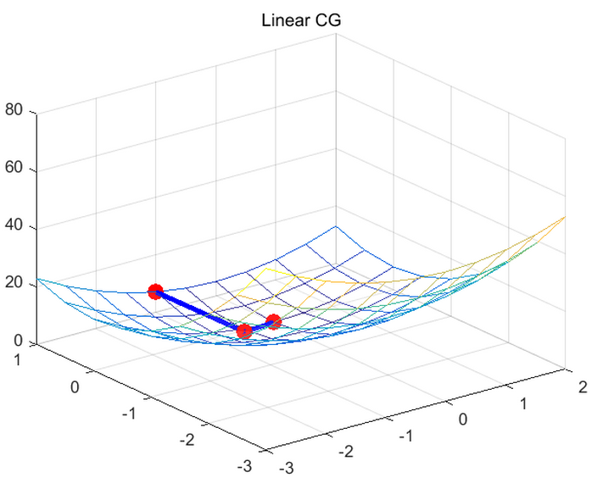

- Performance

|  |  |  |  |  |
| --- | --- | --- | --- | --- |
| Method | Optimal value | Time (sec) | Iterations | Time / Iterations |
| Linear CG | 0 | 0.052 | 3 | 0.017 |

- Discussion

a. It converges within finite iterations

b. It converges faster than gradient descent, Newton’s method, Quasi-SR1, and Quasi-BFGS in HW5

Problem 2) Find local minimum of

f(x, y) = (1.5 - x + x*y)^2 + (2.25 - x + x*y^2)^2 + (2.625 - x + x*y^3)^2



- Performance

|  |  |  |  |  |
| --- | --- | --- | --- | --- |
| Method | Optimal value | Time (sec) | Iterations | Time / Iterations |
| Nonlinear CG | 0.552 | 8.456 | 27 | 0.313 |

- Discussion

a. It needs restart strategies, setting beta = 0 when two gradients are far from orthogonal

b. When wrong direction was estimated, the restarting strategy switch the direction to local minimum

c. Because of the strategy, it converges slower than HW5 methods

d. For nonlinear CG, the function was approximated by Talyor expansion

Problem 3) Find local minimum of Find local minimum of f(x, y) = 100 * (y - x^2)^2 + 3 * (1 - x)^2



- Performance

|  |  |  |  |  |
| --- | --- | --- | --- | --- |
| Method | Optimal value | Time (sec) | Iterations | Time / Iterations |
| Nonlinear CG | 0.046 | 3.471 | 13 | 0.267 |

- Discussion

a. The restarting strategy was used

**2. Initial point near global minimum**

Problem 1) Find local minimum of f(x, y) = 2*x^2 + 5*y^2 (initial point = (1, 1))



- Performance

|  |  |  |  |  |
| --- | --- | --- | --- | --- |
| Method | Optimal value | Time (sec) | Iterations | Time / Iterations |
| Linear CG | 0 | 0.054 | 3 | 0.018 |

- Discussion

a. It performs as much as Newton’s method in HW5

Problem 2) Find local minimum of

f(x, y) = (1.5 - x + x*y)^2 + (2.25 - x + x*y^2)^2 + (2.625 - x + x*y^3)^2 (initial point = (3.2, 1))



- Performance

|  |  |  |  |  |
| --- | --- | --- | --- | --- |
| Method | Optimal value | Time (sec) | Iterations | Time / Iterations |
| Nonlinear CG | 0.005 | 1.821 | 8 | 0.228 |

- Discussion

a. It seems that nonlinear conjugate gradient method converges slower than linear conjugate because of gradient calculation and the restarting strategy

b. It converges slower than HW5 methods.

Problem 3) Find local minimum of Find local minimum of f(x, y) = 100 * (y - x^2)^2 + 3 * (1 - x)^2 (initial point = (2, 0.5))

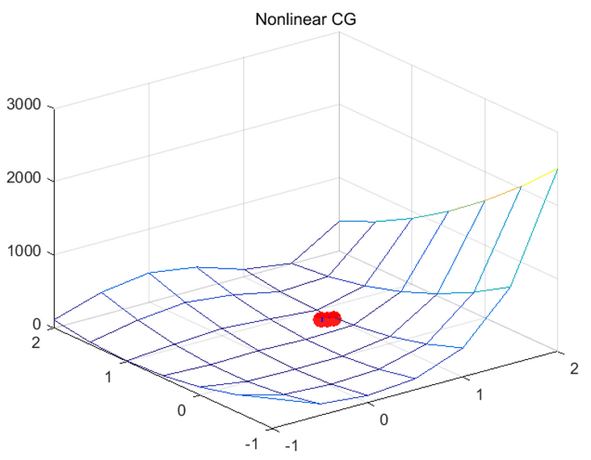

- Performance

|  |  |  |  |  |
| --- | --- | --- | --- | --- |
| Method | Optimal value | Time (sec) | Iterations | Time / Iterations |
| Nonlinear CG | 0.040 | 1.833 | 6 | 0.306 |

- Discussion

a. It seems that nonlinear conjugate gradient method converges slower than linear conjugate because of gradient calculation and the restarting strategy

b. It converges slower than HW5 methods.

**3. Random initial point**

Problem 1) Find local minimum of f(x, y) = 2*x^2 + 5*y^2 (initial point = (2.7, 9.0))

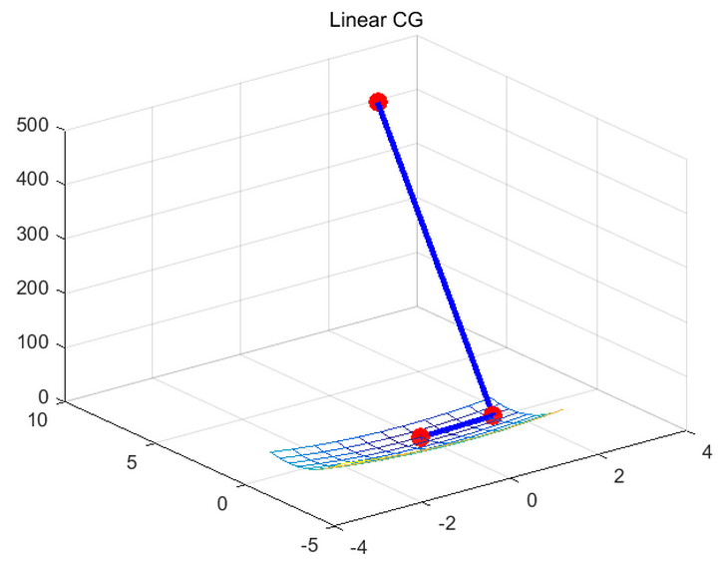

- Performance

|  |  |  |  |  |
| --- | --- | --- | --- | --- |
| Method | Optimal value | Time (sec) | Iterations | Time / Iterations |
| Linear CG | 0 | 0.054 | 3 | 0.018 |

- Discussion

a. It performs as much as Newton’s method in HW5

Problem 2) Find local minimum of (initial point = (-0.8, -0.1))

f(x, y) = (1.5 - x + x*y)^2 + (2.25 - x + x*y^2)^2 + (2.625 - x + x*y^3)^2



- Performance

|  |  |  |  |  |
| --- | --- | --- | --- | --- |
| Method | Optimal value | Time (sec) | Iterations | Time / Iterations |
| Nonlinear CG | 0.011 | 4.138 | 24 | 0.172 |

- Discussion

a. When wrong direction was estimated, the restarting strategy switch the direction to local minimum

Problem 3) Find local minimum of Find local minimum of f(x, y) = 100 * (y - x^2)^2 + 3 * (1 - x)^2

(initial point = (6.4, -0.3))



- Performance

|  |  |  |  |  |
| --- | --- | --- | --- | --- |
| Method | Optimal value | Time (sec) | Iterations | Time / Iterations |
| Nonlinear CG | 0.124 | 4.907 | 19 | 0.258 |

- Discussion

a. When wrong direction was estimated, the restarting strategy switch the direction to local minimum