**Numerical Optimization Homework #7**

**20161216 HAN SANGJUN**

**장세현, 원경호 조교님**

**Model 1) ax + by + cz +d**

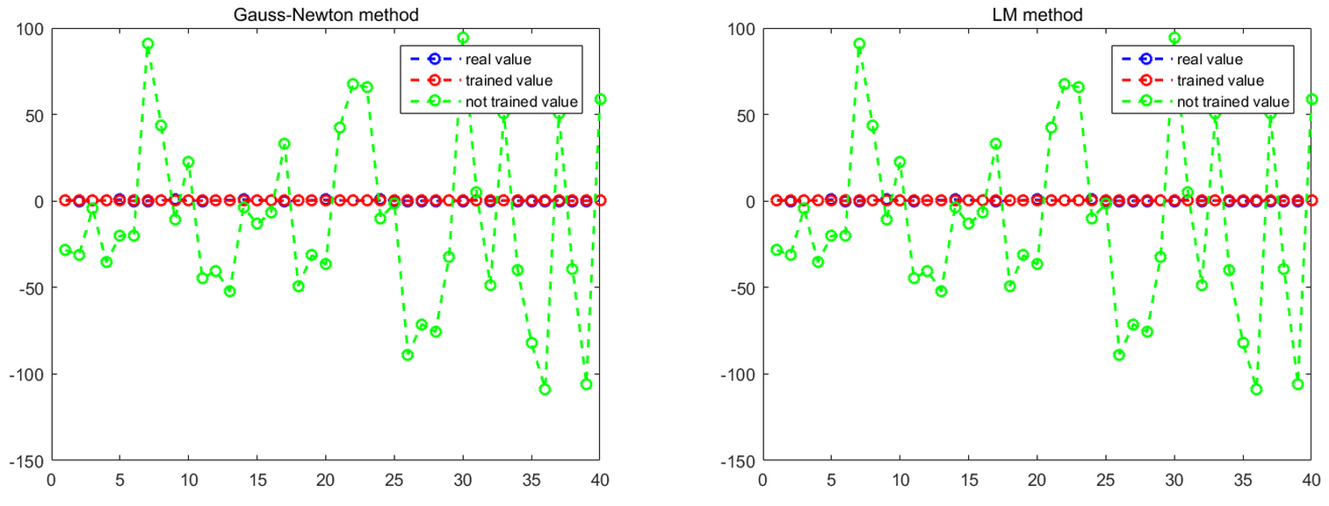

- Performance

|  |  |  |  |  |
| --- | --- | --- | --- | --- |
| Method | Loss | time (sec) | Iterations | time / Iterations |
| Gauss-Newton method | 1.673 | 1.56 | 3 | 0.52 |
| LM method | 1.673 | 1.91 | 3 | 0.64 |

*\* Loss = (1/2) * (sum of square of residual)*

- Discussion

a. Model 1 is too simple to represent data distribution, so the loss cannot be reduced less than 1.67

b. LM method needs computation time of lambda, so it is a little slower than Gauss-Newton method

**Model 2) exp(-[(x-a)^2 + (y-b)^2 + (z-c)^2] / d^2)**

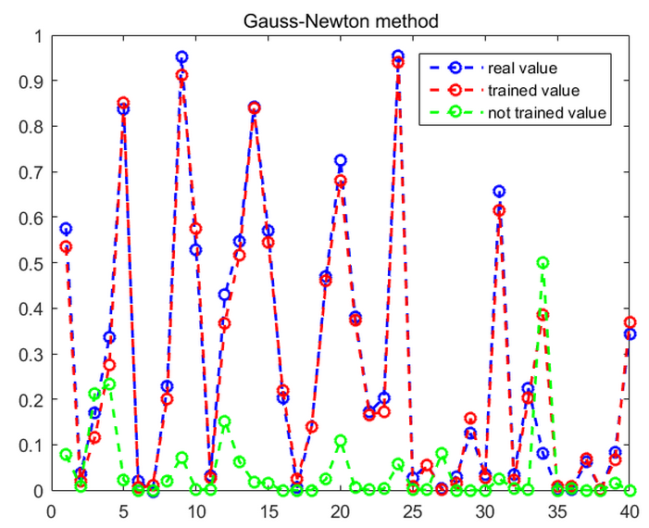 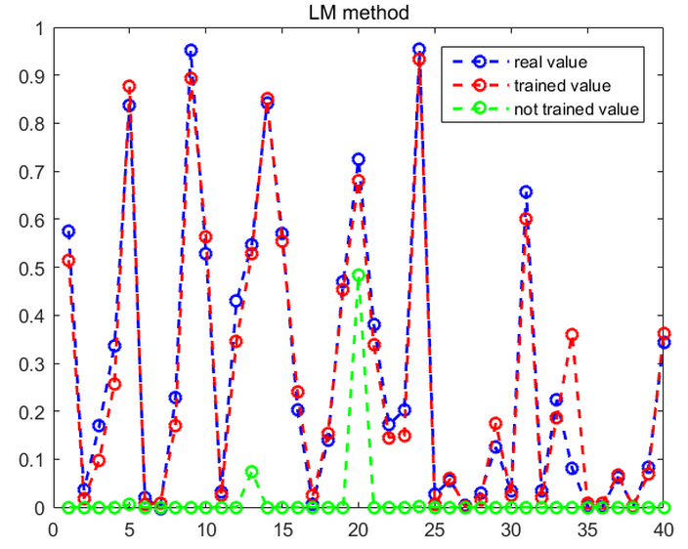

- Performance

|  |  |  |  |  |
| --- | --- | --- | --- | --- |
| Method | Loss | Speed (sec) | Iterations | Speed / Iterations |
| Gauss-Newton method | 0.066 | 2.52 | 4 | 0.63 |
| LM method | 0.064 | 4.53 | 6 | 0.76 |

- Discussion

a. Model 2 is more complex than Model 1, so the loss is reduced up to 0.066

b. LM method needs computation time of lambda, so it is a little slower than Gauss-Newton method

c. LM method functions more sophisticatedly than Gauss-Newton method in than loss is reduced up to 0.064