**HW1 Figure – Machine Learning**

**20161216 HAN, SANGJUN**

**1) Compare Dimension**

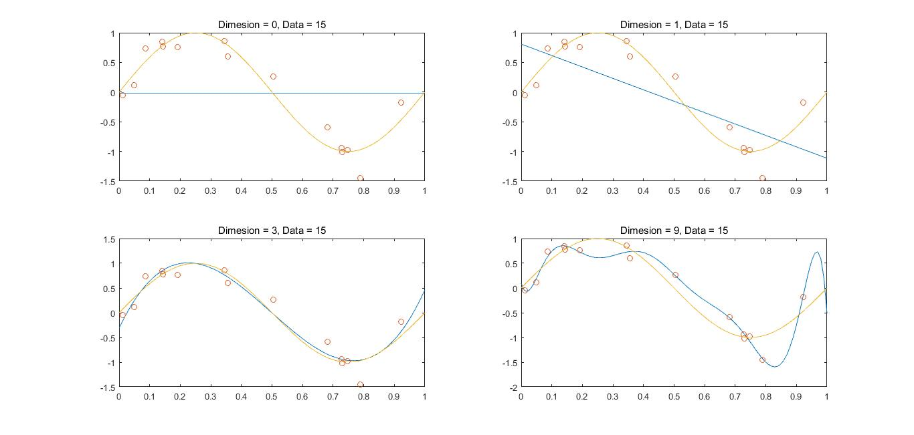

**2) Compare Dimension with RMS**

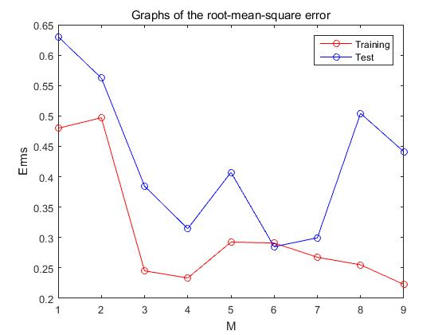

**3) Can more data prevent overfitting?**

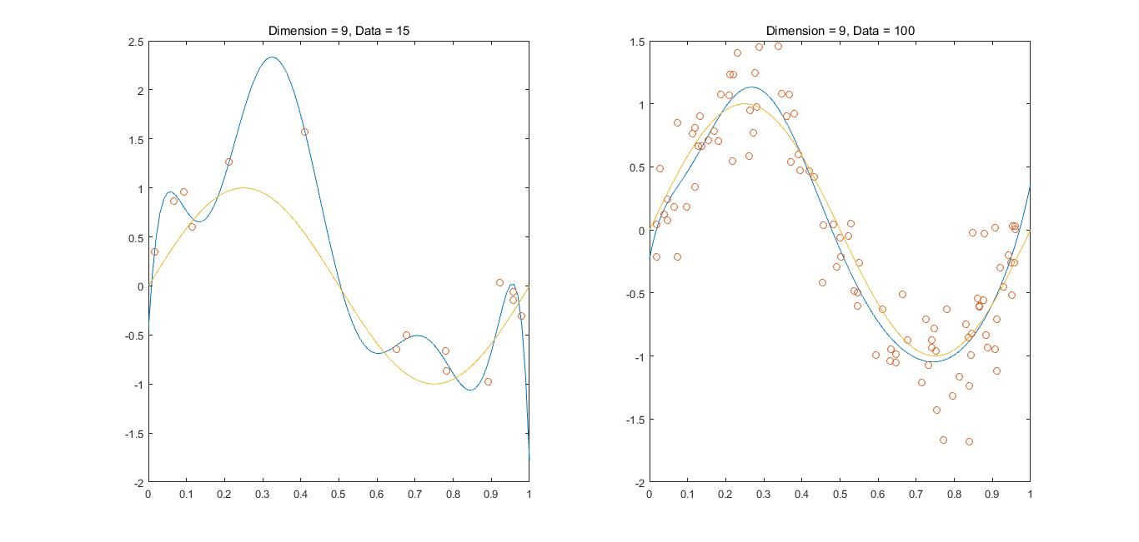

**4) Can regularization prevent overfitting?**

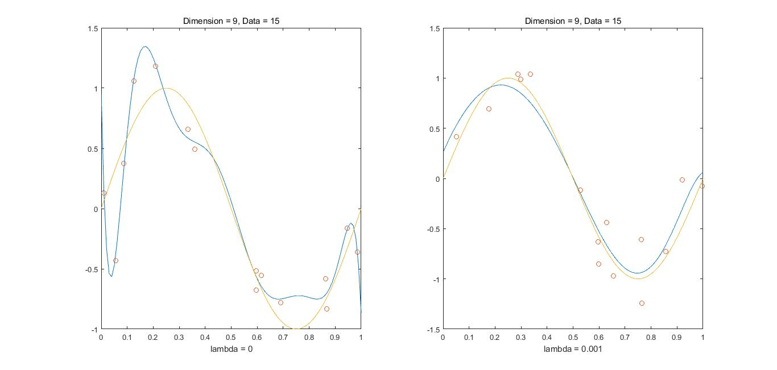

**5) Graph of root-mean-square for lambda value changes**

