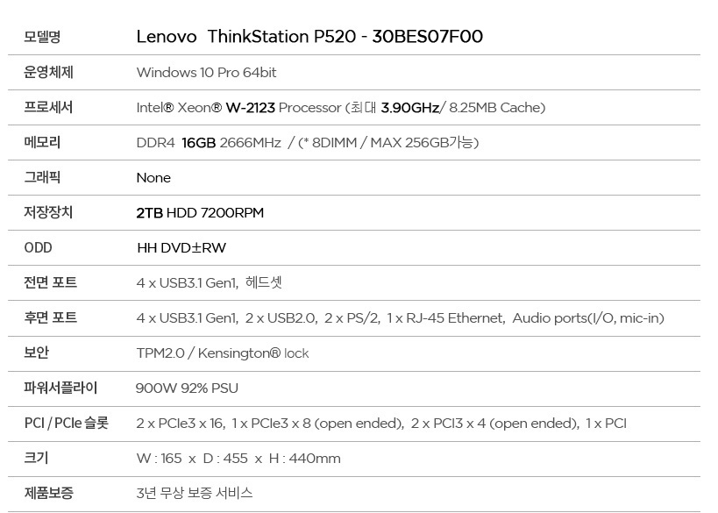

http://www.g9.co.kr/Display/VIP/Index/1513555521?jaehuid=200007334&NaPm=ct%3Djr1lxucw%7Cci%3Df69818b76218101cf1397c0b9ae93f0f530780a1%7Ctr%3Dslsl%7Csn%3D280455%7Chk%3Dccbe538a7d5d5ce582691cc39e2790538223d654

1,890,000원

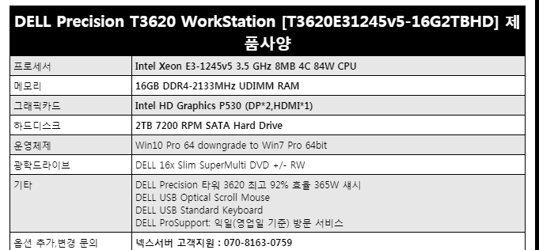

http://www.11st.co.kr/product/SellerProductDetail.tmall?method=getSellerProductDetail&prdNo=1713400192&utm_term=&utm_campaign=%B4%D9%B3%AA%BF%CDpc_%B0%A1%B0%DD%BA%F1%B1%B3%B1%E2%BA%BB&utm_source=%B4%D9%B3%AA%BF%CD_PC_PCS&utm_medium=%B0%A1%B0%DD%BA%F1%B1%B3

1,986,340

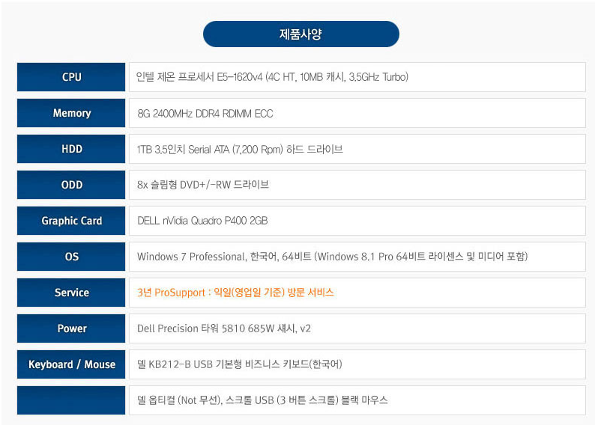

http://item.gmarket.co.kr/DetailView/Item.asp?goodscode=1488493151&GoodsSale=Y&jaehuid=200002657

1,757,000