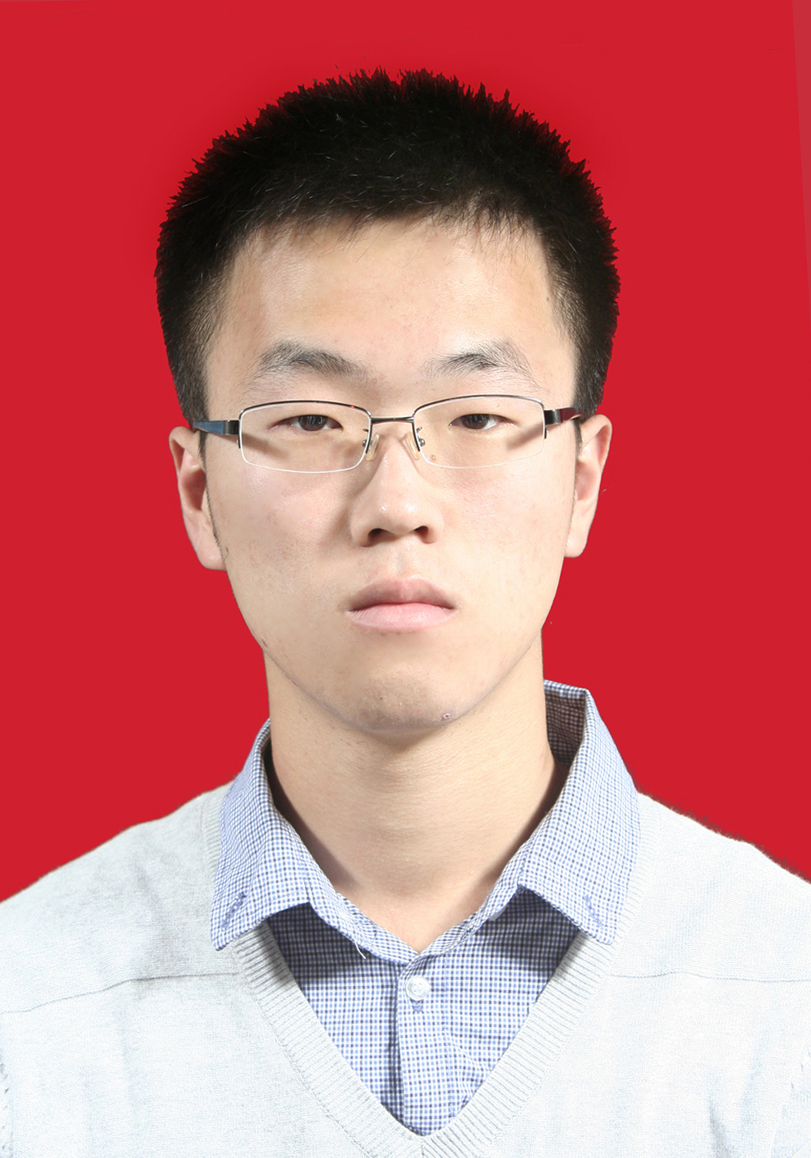
RESUME

PERSONAL
Name: Han Youyang
Gender: Male
GPA&Rank 87.11/100, 10/106
Email: hanyy@shanghaitech.edu.cn

OBJECTIVE
- Apply job of non-technical position.

EDUCATION
- 2011-2015 Bachelor degree of Agriculture, Northwest University of Agriculture and Forestry
- 2015-Now Master program of Bioinformatics, Institute of Plant Physiology & Ecolgy, SIBS, CAS

WORKING EXPERIENCE
- 2015.9 – Now Teaching Assistant of Bioinformatics
- 2014.3-2014.6 Research Assistant of Anaerobic Fermentation, Inorganic Chemistry Experiment
- 2014.12-2015.3 Research Assistant of Molecular Biology, Genotyping

KNOWLEDGE BACKGROUND
- Biology
——System studied The Botany, The Microbiology, The Biochemistry , The Plant Physiology
- Bioinformatics
——Familliar with programming language R, Perl,
——Familiar with knowledge of highthroughput sequencing
- Language
——IEST test 6.0
Fluent and proficient communication in both spoken and written English
- Speciality
——System studied the courses such as The Statistics, The Linear Algebra, The Calculus,
The Introduction of SAS,

VOLUNTEER
- Social survey with report awarded the second honor of university
- Regional Planning team organizer

