Multislot save system for Fungus
This asset expands the capabilities of the standart Fungus save system, like Ren’py save system.
Fungus is a tool for easily making Visual Novel, Interactive Fiction, RPG, Point & Click & eLearning games.

Features:
1. Manage to create up to 9 save/load slots or more
2. Saves are made with a thumbnail picture and date
3. Asset supports autosave for which a separate slot is allocated
4. Easy to show the save menu by pressing Esc or UI button
5. Possibility to delete save data to facilitate testing
6. Possibility to customize the save/load menu view
7. The demo scene is included in the asset
8. Easy to use asset
Demo video:
https://youtu.be/2efTp6O-LTY
How to use it
1. Install Fungus https://assetstore.unity.com/packages/templates/systems/fungus-34184
2. Create flowchart object (Tools – Fungus – Create – Flowchart)
3. Add SaveMenu and SaveData on the Scene
https://www.youtube.com/watch?v=Bd4RDcCc0lE
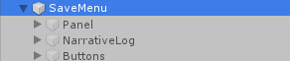
Disable native Panel, NarrativeLog and Buttons, but keep SaveMenu active (They are already disabled in the asset example scene).
4. Create flowchart blocks (or use flowchart prefab). It is important that each block starts with SavePoint command. The first block should be no “Game Started” event, but “It Start Point” must be enabled. «Fire Event» and “Resume On Load” must be true on each block.
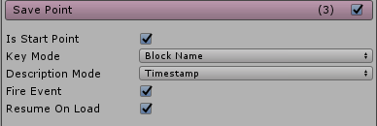
5. Import our asset
6. These variables in the script SaveMenu.cs ( Assets/Fungus/Scripts/Components/ ), should look like this:
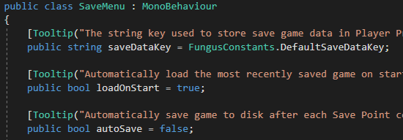
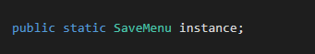
They must be public.
7. Add objects to the scene from the folder Prefabs:
- GameMenu
- MainCamera
- secondaryCam
If your scene already contains a Main Camera, delete it first.

8. Asset menu is called by pressing the Esc button.
You must disable the skip text activation in the Say Dialog settings
(Tools – Fungus – Create – Say Dialog).
As shown on the screenshot:

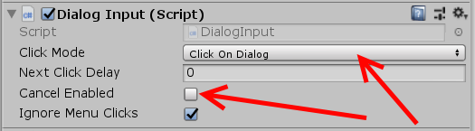

9. For correct work need to uncheck:
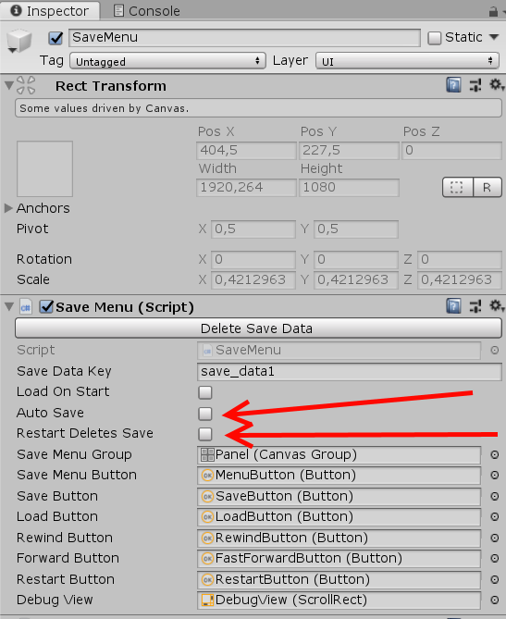
10. Add methods to object buttons at SaveMenu
As shown in the screenshots.
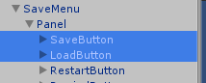

SaveButton
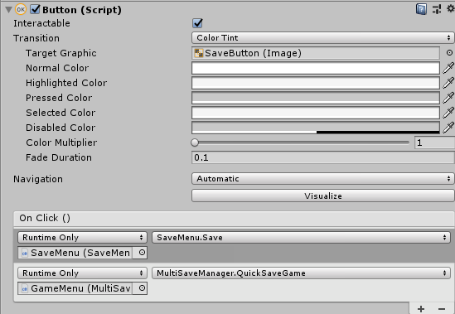
LoadButton
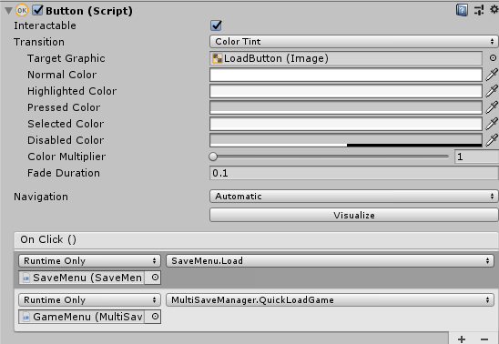

11. configure Stage Canvas like this:

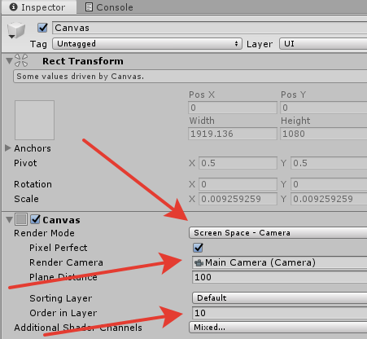
Сharacter sprites will not be visible on the saves thumbnails if you do not do this.

12. (optional) If you want to remain the Say dialogue on the saves thumbnails, then set the following settings to the dialogue in the inspector.

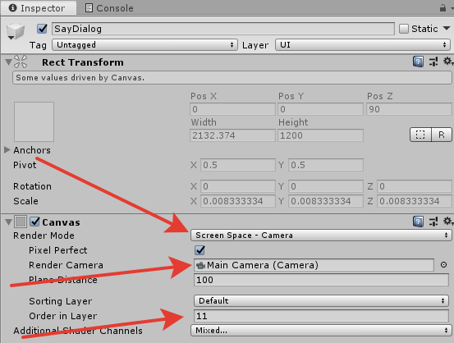
13. (optional) Editing the appearance of the asset menu is done by changing the Сanvas of the object GameMenu/menu_panel

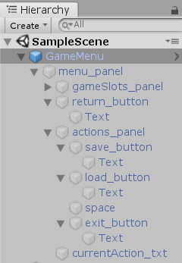
Notes:
1. Asset menu called by pressing Esc (by default) and by method on the button.

2. Аsset options help:
Action Type String_save \ Action Type String_load - the names of the tabs in the menu, it is convenient to use to localize the project in other languages.
Slot Name - name to be given to the save slots.
Autosave Slot Name - the name to be given to the autosave slot.
Add Slot Id To Name - slots will be numbered by ID.
Empty Slot Name - name of an empty save slot.
Empty Slot Icon - you can specify a default picture for save slots.
Menu By Esc - enabled by default. If it false: asset menu will not be called up by pressing Esc, only by the method on the button.
Delete Save Data - asset allows you to easily delete saves through the editor in the play mode by pressing the corresponding button “Delete Save Data”. This makes testing easier.
Locked To Open Menu Blocks - allows you to specify the names of the blocks in which the save menu will not be called by Esc (like Intro or Menu of the game)
Locked To Save Blocks - blocks in which autosave will not work (like Intro or Menu of the game)

3. We recommend to keep these default settings:
Slots Max (9) - number of slots for saving. You can use more than 9, but you will need to change SaveMenu UI and _slotsMax on MultiSaveManager.cs :
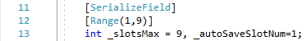

Auto Save Slot Num (1) - number of slot for automatic saving at the start of the scene.

Screen Scale Compress (5) - control the compression ratio of the saves thumbnails.
Valid values are 1-5. If you want to get less compressed images set 1.

Block Menu Time (1) - value of seconds to block the call to the asset menu.

Autosave Delay Time (1) - autosave delay seconds.
4. It's recommended to use a clean project to avoid errors.
If you have a flowchart that was carried over from several past versions, we recommend that you do the following:
- Create a clean Flowchart (or use asset example scene)
- Copy the blocks from my old Flowchart to the new one
- Readjust the corresponding links between blocks in the new Flowchart
- Remove the old Flowchart and save the changes

5. If in the editor, when you restart the game, the save disappears, this is normal. In a real build, everything will work. Create a build of your game, make save and restart the game.

Beta features:
You can use a separate button in the interface of your game to call the menu of the asset.
Then you need to assign a method to the button as shown in the screenshot:

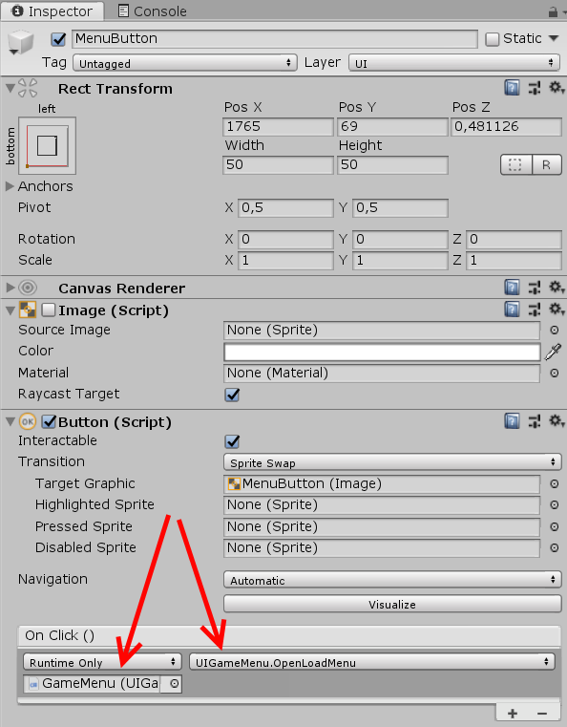

or you can use UIGameMenu.OpenSaveMenu for open SaveMenu on “Save” tab.
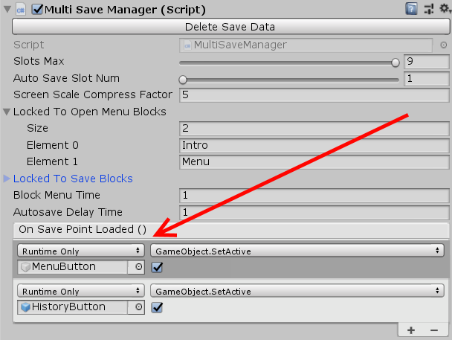
Also you can use the narrative log.
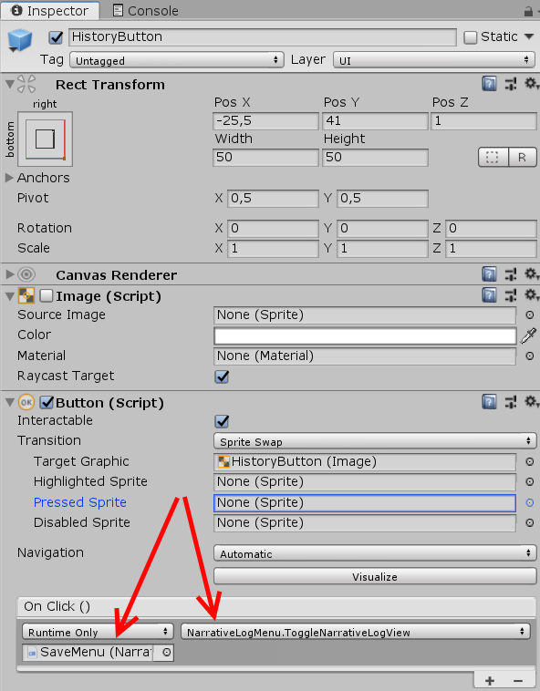
To do this, you need to configure as shown in the screenshot.

FAQ:
1. How can I make a only load button in my start beginning will load the previous save if I already did?
- Create a scene and canvas in which there will be only a load button.
- Use the prefab and delete the save button for this.
- Create a button and add the UIGameMenu.OpenLoadMenu method to the OnClick event to call the gamemenu Canvas.
2. How can I use the save system if I have more than one scene?
- Easily. Here is a video demonstrating this.
https://youtu.be/u6kiJSlJhn4

3. Can I change the Save system menu view? It looks gloomy and unsightly, and my game is not like that.
- Of course, this is only a prefab, you can change the save system menu for your project. It's ordinary Unity UI Canvas
4. A completely different block of Flowchart is loaded when loading a save. Not at all what I need.
- Look at what information the Unity console gives out. If it says that the block is null then make sure that each block is set true on «Fire Event» and “Resume On Load”.

5. The save button disappeared from the asset menu on asset installation.
- Most likely you are installing an asset on an existing project. Make sure that all steps of the tutorial are completed correctly. And also look at Note #4 of this guide. If that didn’t work, then try changing the version of Unity and Fungus https://github.com/snozbot/fungus/releases .

6. When I make the build and start it in menu I see all saves that I made in play mode in Unity when tested the game. But all slots must be empty when I start play first time. What I need to do for this?
- Before starting to make build, delete the saves using the button Delete Save Data at the asset settings in the play mode.

If our asset was useful to you, please write us a review, this inspires us to new updates.
https://assetstore.unity.com/packages/templates/systems/multislot-save-system-for-fungus-141890

You can send your suggestions for improving the functionality of the asset on email: thedreambucket@gmail.com

Email for support requests:
thedreambucket@gmail.com
thedreambucket@gmail.com

