**Flex Navbar**

For this assignment we will use our newly formed flexbox skills to recreate the following images.  Download the dojo icon [here](https://s3.amazonaws.com/General_V88/boomyeah2015/codingdojo/curriculum/content/chapter/dojo-icon.png) and fork the project using the below link.

<https://github.com/TheCodingDojo/webFun_css_flex_navbar>

**Part I**



<div class="center-box">

<div class="center-item"></div>

</div>

copy

**Part II**

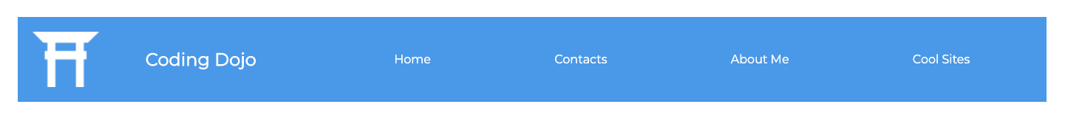

<div>

    <img src="dojo-icon.png" alt="dojo-icon">

    <h1>Coding Dojo</h1>

    <ul>

        <li><a href="#">Home</a></li>

        <li><a href="#">Contacts</a></li>

        <li><a href="#">About Me</a></li>

        <li><a href="#">Cool Sites</a></li>

    </ul>

</div>

•  Use the supplied HTML code snippets to recreate the images using flex.

•  (optional) Use google font Montserrat