Wetland nutrient flux and inundation regime project proposal
Wetlands are often restored or constructed for services like wastewater treatment, flood abatement, habitat, and nutrient removal within a landscape (Fisher & Acreman, 2004; Mitsch et al., 2015). Nutrients like nitrogen and phosphorus are typically stored within the sediment and vegetation of newly constructed wetlands, preventing their excess runoff into freshwater bodies (Fennessy et al., 2008). Variations in water level and topography can be a control on the biogeochemical cycling taking place between the sediment and surface water in wetlands, which controls how much nitrogen or phosphorus could be retained. In some cases, inundated and reducing conditions can promote denitrification, driving nitrogen removal from the sediment (Martínez-Espinosa et al., 2021), however there is potential for phosphorus release through dissolution of iron oxides (Steinman et al., 2012). Understanding how inundation regimes influence nutrient cycling in constructed wetlands will become increasingly crucial due to the changing global climatic and hydrologic conditions (Steinman et al., 2012, 2014). My main research question is how sediment-nutrient flux changes along an inundation gradient at the Trumbull Creek Wetland and if connectivity to constructed wetlands pools should be enhanced for nutrient retention. To address this, I propose connecting in-situ sediment characteristic data, ex-situ sediment-surface water nutrient flux data, and wetland inundation/hydroperiod spatial data as part of my dissertation.
Understanding nutrient flux and its relation to wetland design and inundation regime is essential for monitoring and improving water quality. For my first dissertation chapter, I plan to examine how wetland release and retention of nitrogen and phosphorus could be affected by variable water level to better inform future wetland design and management. This project will become streamlined, reproducible, and more easily interpreted by using R as a GIS. Currently, my data is being interpreted by mainly qualitative observations of wetness at Trumbull Creek, which makes it difficult to fully interpret and understand the story my data is telling. I am also incorporating work and tools Dr. Eileen Acosta created during her Postdoc at Kent State University, which are currently between many platforms such as python, ArcGIS Pro, and R. It would be a clear way to combine digital elevation models, drone imagery, bathymetric data, and tabular data in one space and conduct statistical and spatial analyses with it.
There should be a few expected outcomes from this project that build off each other. In the end, I hope to have certain “zones” in Trumbull Creek categorized by hydroperiod or length of time that area is inundated throughout the year and how those zones align with where I have sampled for sediment and water nutrient flux. Some intermediate outcomes I expect are transferring the work Dr. Acosta has done in ArcGIS Pro to R, finishing her spatial inundation analysis and creating hydroperiods, connecting my tabular data to that spatial data, and then some form of statistical analysis between those zones of inundation and measured nutrient flux.
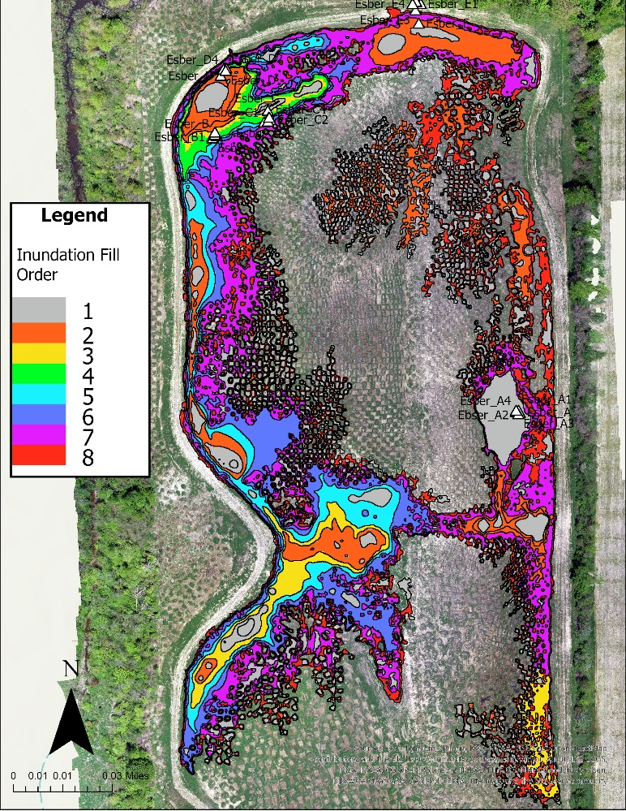
I have already conducted an intact sediment core incubation with sediment cores from Trumbull Creek and have analyzed the core water for ammonium, nitrate+nitrite, and orthophosphate. I also will have the results from my dissolved gas in water samples and the in-situ sediment characteristics within the next few weeks to include in my project. At this point, I have an inundation fill order that used different spatial data from Trumbull Creek that may need some transformations before it can be classified into hydroperiods. I have attached a sample of that map below along with a preliminary bar plot showing the fluxes of phosphate at the five different sampling locations I had.
Figure 1: Aerial drone image showing Trumbull Creek Wetland in northeast Ohio overlayed with layers of inundation fill order and sampling locations. Inundation fill order shown in the legend was completed by Dr. Eileen Acosta and the sampling locations are denoted by white outlined triangles within different constructed pools of this wetland. Fill order 1 would fill first with precipitation and fill order 8 would fill last (least connected areas).

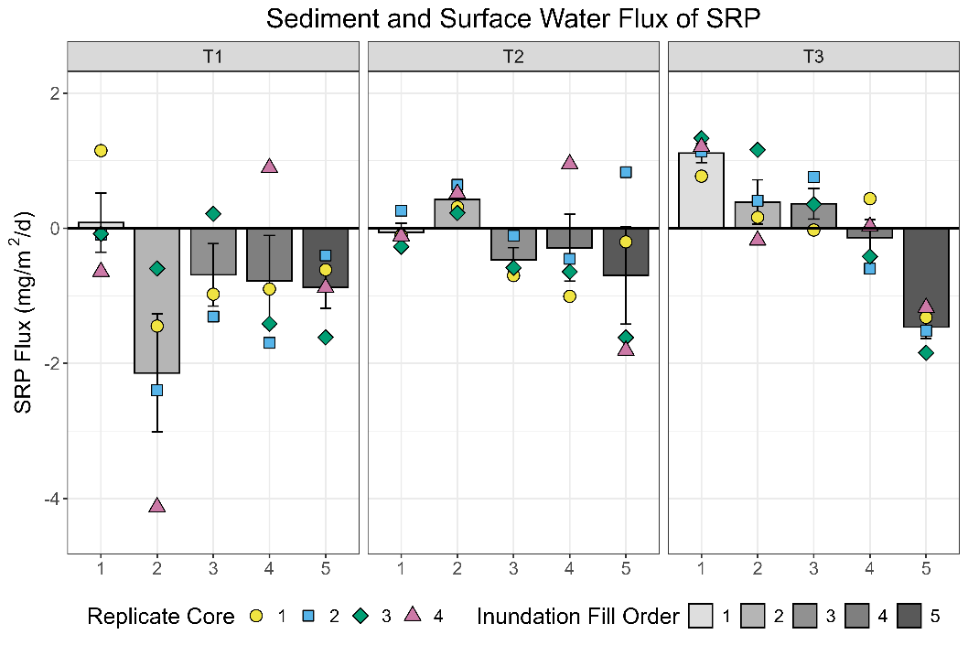
Figure 2: Multipaneled figure displaying soluble reactive phosphorus nutrient flux rates from intact sediment cores over three time periods, classified by inundation fill order (shade of grey) and replicate core number (colored shapes).
References
Fennessy, M. S., Rokosch, A., & Mack, J. J. (2008). Patterns of plant decomposition and nutrient cycling in natural and created wetlands. Wetlands, 28(2), 300–310. https://doi.org/10.1672/06-97.1
Fisher, J., & Acreman, M. C. (2004). Wetland nutrient removal: A review of the evidence. Hydrology and Earth System Sciences, 8(4), 673–685. https://doi.org/10.5194/hess-8-673-2004
Martínez-Espinosa, C., Sauvage, S., Al Bitar, A., Green, P. A., Vörösmarty, C. J., & Sánchez-Pérez, J. M. (2021). Denitrification in wetlands: A review towards a quantification at global scale. Science of The Total Environment, 754, 142398. https://doi.org/10.1016/j.scitotenv.2020.142398
Mitsch, W. J., Bernal, B., & Hernandez, M. E. (2015). Ecosystem services of wetlands. International Journal of Biodiversity Science, Ecosystem Services & Management, 11(1), 1–4. https://doi.org/10.1080/21513732.2015.1006250
Steinman, A. D., Ogdahl, M. E., Weinert, M., Thompson, K., Cooper, M. J., & Uzarski, D. G. (2012). Water level fluctuation and sediment–water nutrient exchange in Great Lakes coastal wetlands. Journal of Great Lakes Research, 38(4), 766–775. https://doi.org/10.1016/j.jglr.2012.09.020
Steinman, A. D., Ogdahl, M. E., Weinert, M., & Uzarski, D. G. (2014). Influence of water-level fluctuation duration and magnitude on sediment–water nutrient exchange in coastal wetlands. Aquatic Ecology, 48(2), 143–159. https://doi.org/10.1007/s10452-014-9472-5

