**Name:** Hana Yasser Amgad

**ID:** 18P5007

**Group:** 2

**Section:** 2

**Practical Task Examination**

**Jira task**

**Part 1:**

**Project description:**

The product will be a desktop software for university that facilitates management of services concerned with doctors and student affairs. This system interacts with students’ Moodle. Doctor and student affairs have the accessibility to login to the system, where doctors can confirm registration from the students and assign grades of the courses to the students, and student affairs can confirm the admission from of the requesting students, he is to set the schedule of the staff, exam and student.

**Stakeholders:**

|  |  |  |  |  |
| --- | --- | --- | --- | --- |
| **Name** | **Role** | **Availability** | **Influence** | **Engagement** |
| Zeina | Scrum master | High | High | Actively engaged |
| Laila | Product owner | High | High | Actively engaged |
| Customer | Stakeholder | low | High | Keep satisfied |
| Youssef | Project manager | High | Medium | Keep informed |
| Seif | Development team member | medium | medium | Keep informed |
| End user | stakeholder | low | Medium | Keep satisfied |

**Near vision of the project:**

* User can login using its ID and password saved on the database.
* System should be able to compare entered data and validate it.
* System should be able to show each user pages that he has accessibility to it. And give him easy navigation between pages.

**Sprints:**

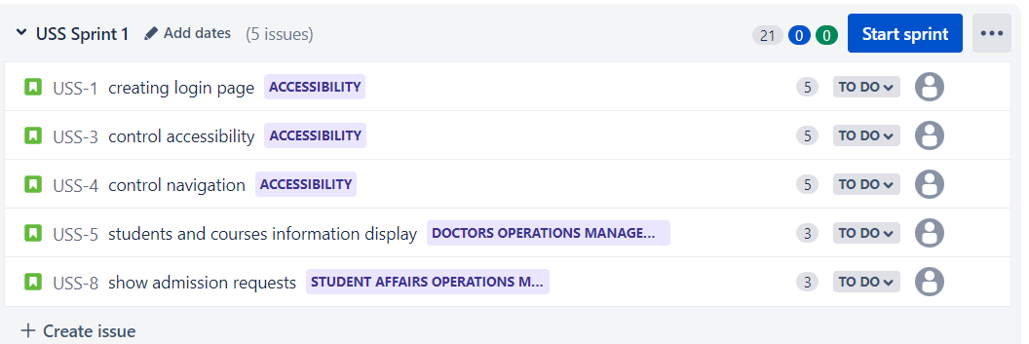

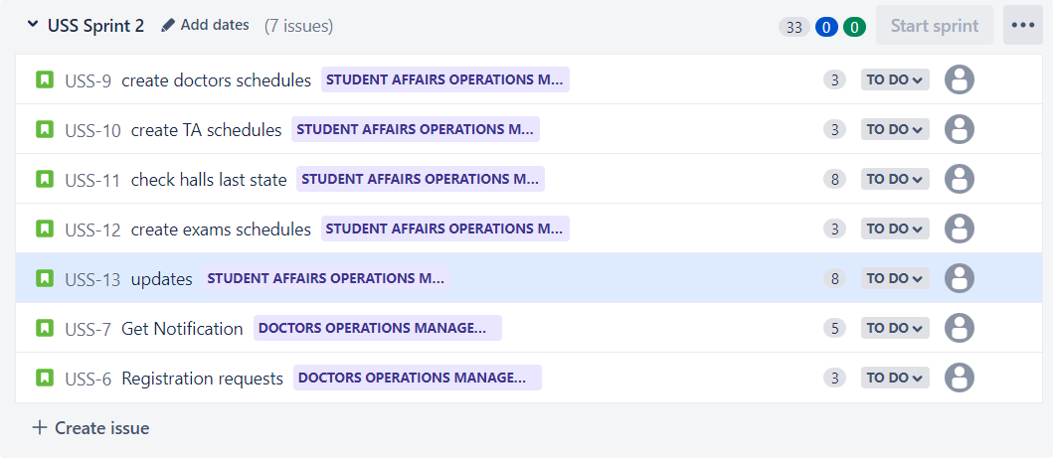

Stories are ordered based on the flow of working on the system putting into consideration business value of each story as user should login first to start working on the system which will also help while testing other stories like accessibility and building them like navigation.

**Stories description:**

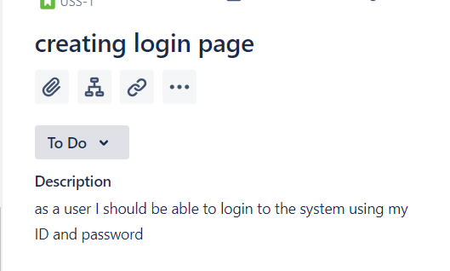

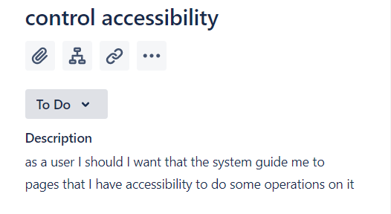



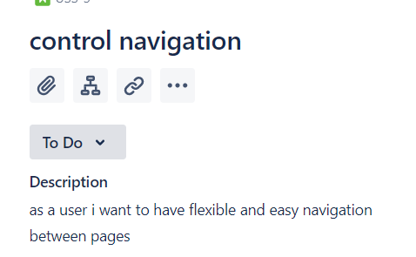

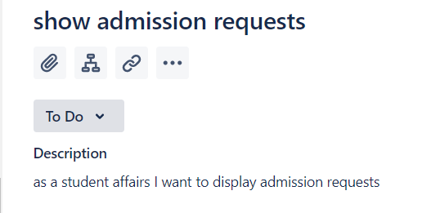

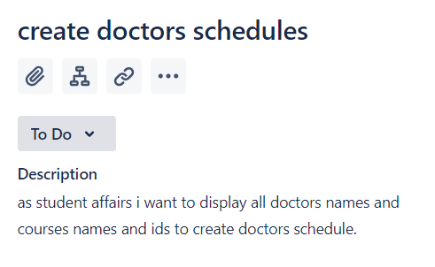

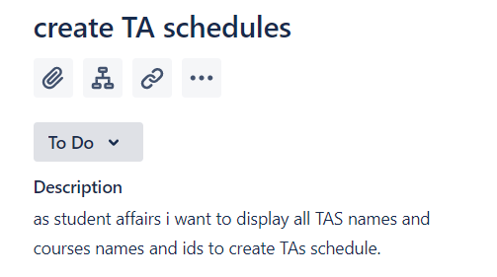

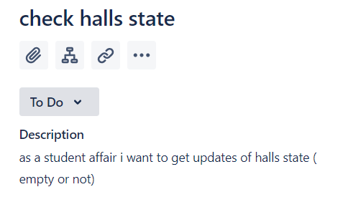

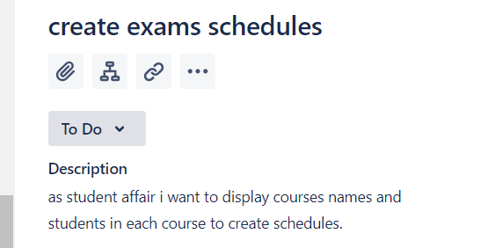

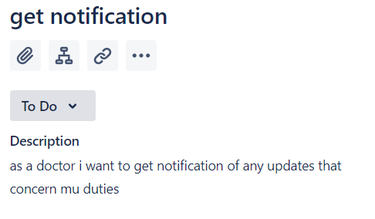

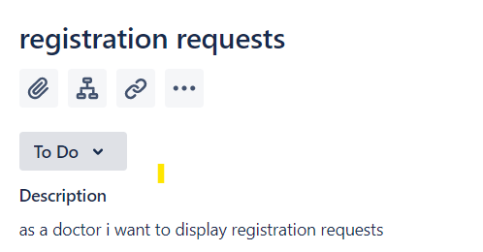

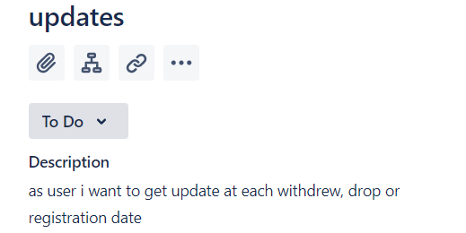

**Epics Description:**

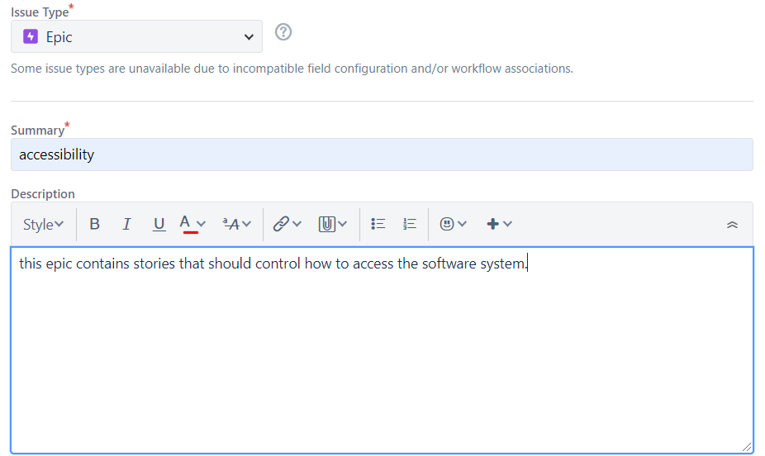

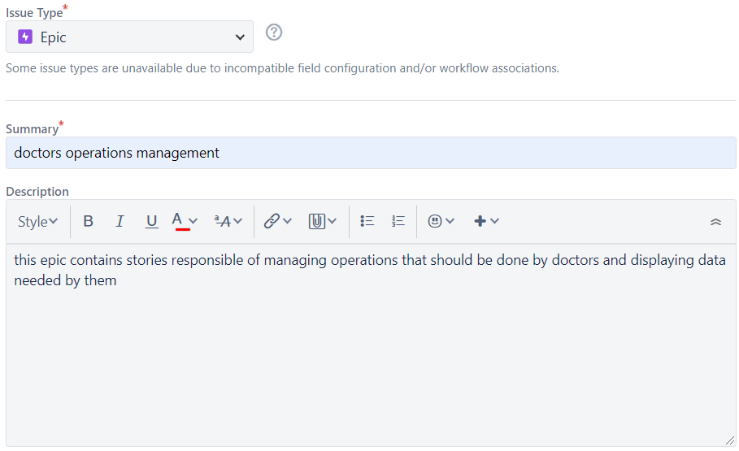



**Part 2:**

1. **How many story points my team can achieve per sprint:**

* Using the modified Fibonacci sequence scale for story point estimation.
* Suppose that the epic has maximum 100 story points.
* Largest stories were in sprint 2 with 8 story points, as their complexity is based on that the system should be aware of specific updates at a specific time.
* Stories with minimum complexity in sprint 1 and 2 with 3 story points and medium complexity with 5 story points.

1. **2 examples of daily scrum document:**

**Sprint 1:**

|  |  |  |  |
| --- | --- | --- | --- |
| Team | Question | Monday | Tuesday |
| Backend team | What did you do yesterday? | Building backend of login page | Start working on backend of admission requests page |
|  | What will you work on today? | Start working on backend of courses and students information display page | Start working on accessibility control |
|  | Do you have any obstacles? | No | No |
| Front end team | What did you do yesterday? | Preparing login GUI | Preparing login GUI |
|  | What will you work on today? | working on courses and student information design | Working on admission registration design |
|  | Do you have any obstacles? | No | No |
|  | What did you do yesterday? | Testing users data validation while logging in | Testing accessibility |
| Testing team | What will you work on today? | Continue Testing accessibility | Continue Testing accessibility |
|  | Do you have any obstacles? | No | No |

**Sprint 2:**

|  |  |  |  |
| --- | --- | --- | --- |
| team | Question | Monday | Tuesday |
| Backend team | What did you do yesterday? | Start working on creating doctors schedule backend end page | Finish working on creating doctors schedule backend end page |
|  | What will you work on today? | Start working on creating TAs schedule backend end page | Finish working on creating TAs schedule backend end page |
|  | Do you have any obstacles? | No | No |
| Front end team | What did you do yesterday? | Start working on creating TAs schedule front end page | Start working on creating doctors schedule front end page |
|  | What will you work on today? | Finish working on creating TAs schedule front end page | Finish working on creating doctors schedule front end page |
|  | Do you have any obstacles? | No | No |
| Testing team | What did you do yesterday? | Security testing | Checking on bugs |
|  | What will you work on today? | Continue security testing | Continue checking on bugs |
|  | Do you have any obstacles? | No | No |

1. **Example of sprint document:**

By the end of sprint 1:

* User can login using its ID and password saved on the database.
* System should be able to compare entered data and validate it.
* User can navigate within pages
* Accessibility is controlled

At sprint 2:

We will start working on pages were doctors and student affair can access to display needed data to work based on it.

1. **Workflow:**

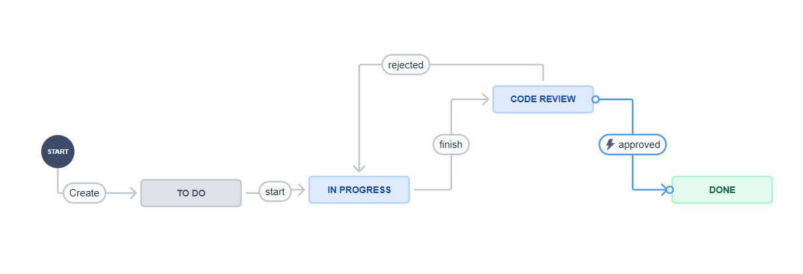Rule1:

To achieve done state system should be went through testing.

Rule2:

Code should be approved by testers based on product owner specifications.

1. **Sprints:**





1. **Put the sprint tasks onto a Kanban board:**

**Sprint 1:**

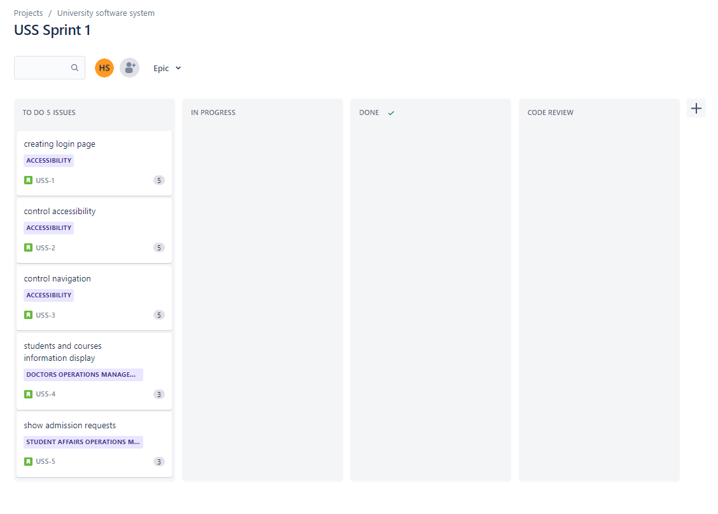

**Sprint 2:**

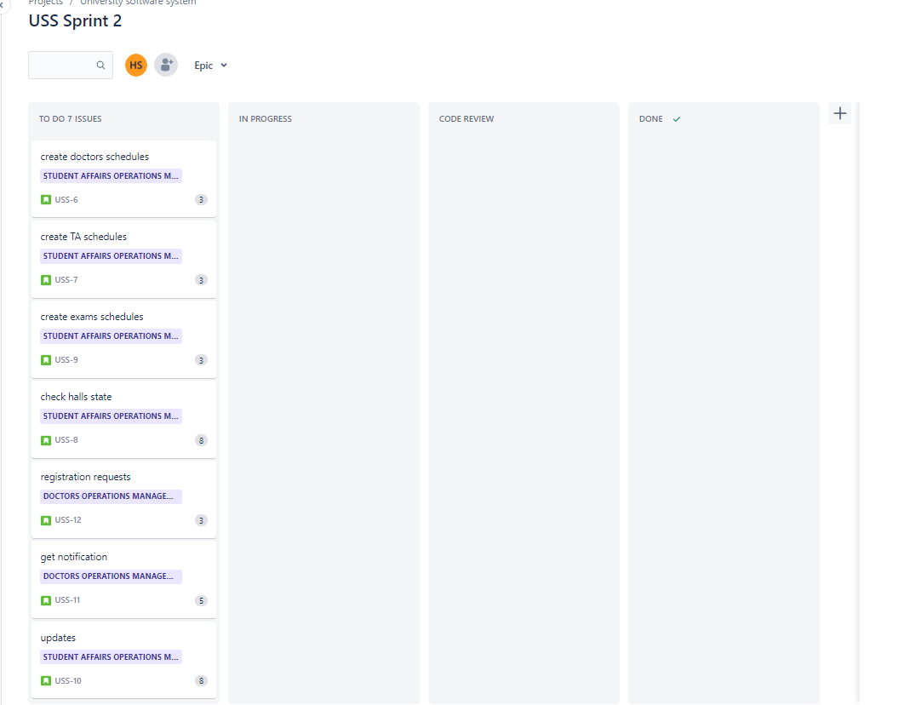

1. **Provide screenshots of what the Kanban chart would look like on 3,5,8,12 day**

**Sprint1:**

Each 3 days:

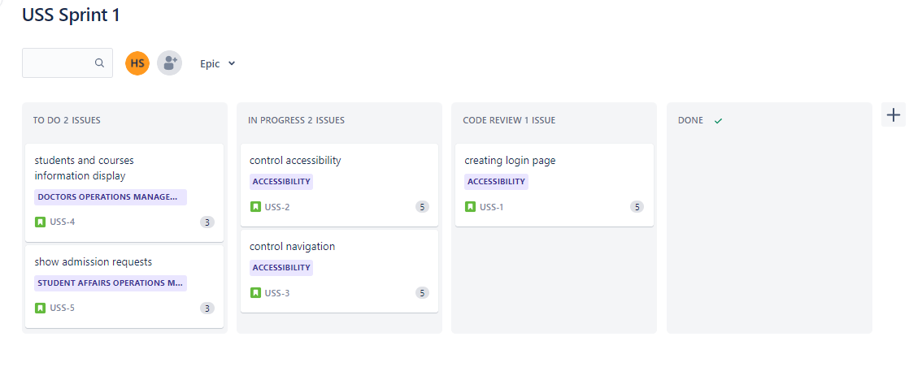

5days:

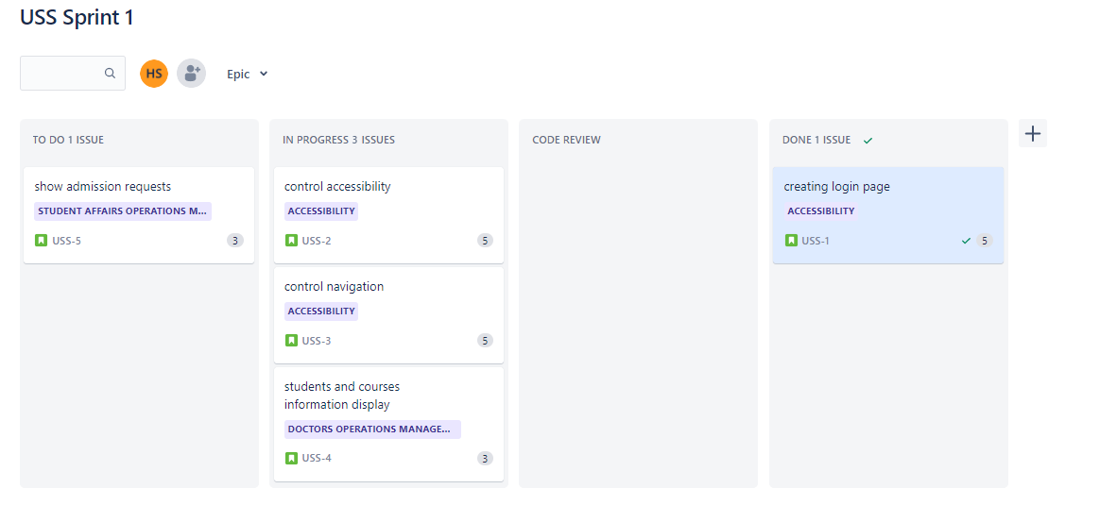

8days:

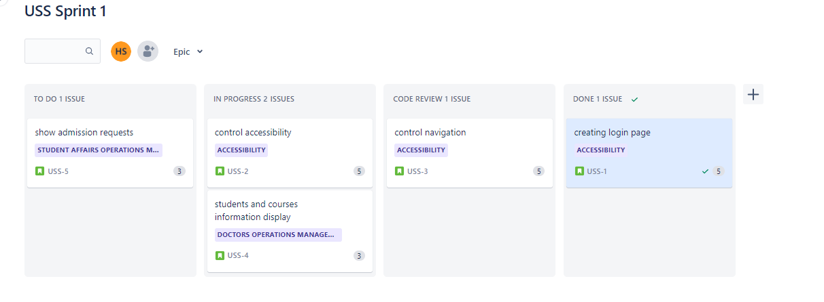

12 days:

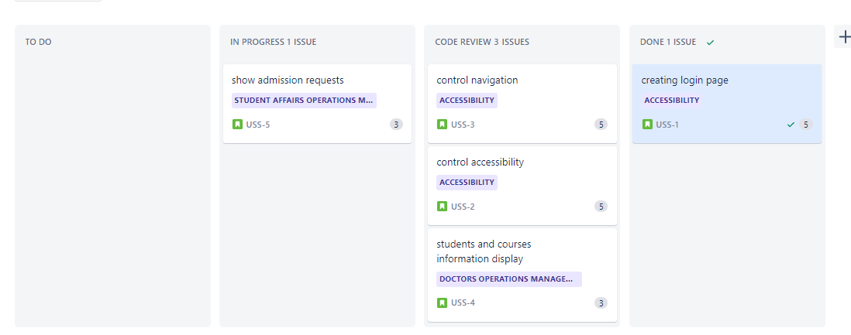

**Sprint 2:**

3 days:

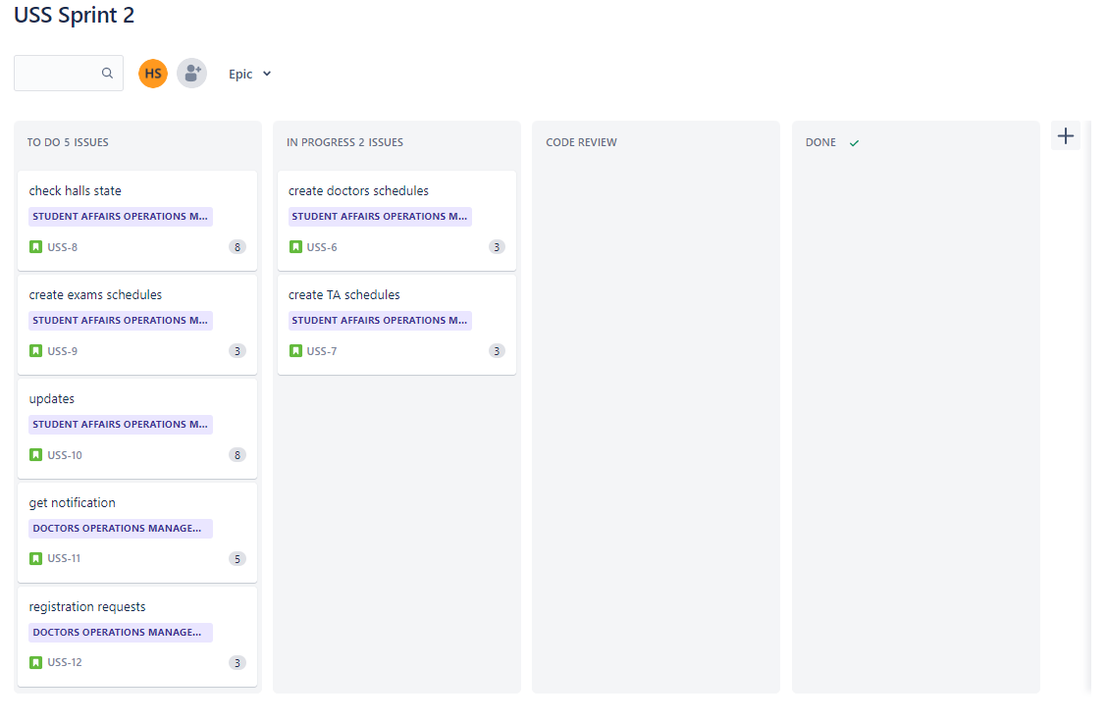

5 days:

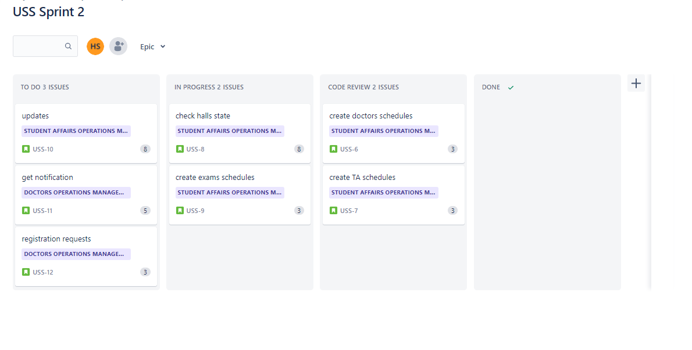

8 days:

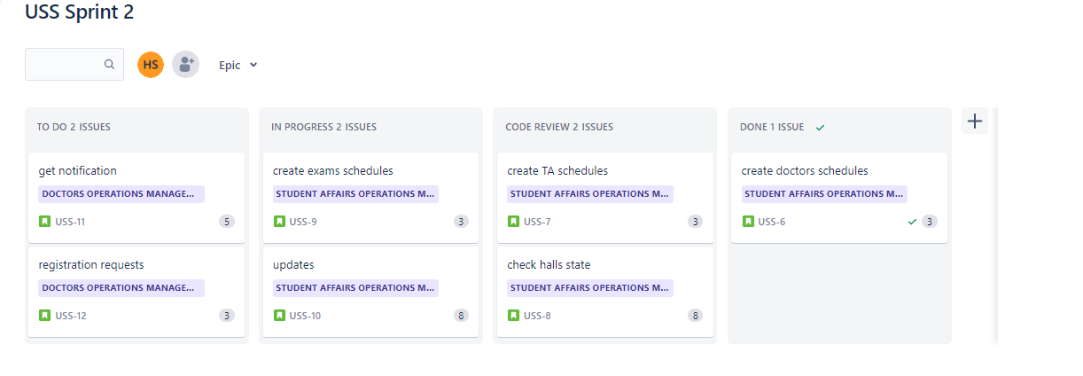

12 days:

