

**Software testing**

**Assignment1**

**Name: Hana Yasser Amgad.**

**ID: 18p5007**

**Group: 2**

**Section: 2**

**Hospital management system.**

1. Testable features.
2. Check if patients are added to the system **(Add patients).**
3. Check if each patient is given an ID **(Assign ID).**
4. Check if patent is assigned to the appropriate ward **( Assign Ward).**
5. Check if the system is able to determine bed availability and assign patients to the waiting list **(Assign to WaitingList).**
6. Check if the system is able to assign doctors to a given patient in the ward **(Assign** **Doctor).**
7. Check if the system is able to assign nurse to a given patient in the ward **(Assign Nurse).**
8. Check if the system is able to inform doctors of new patients **(Inform Doctors).**
9. Check if the system is able to inform nurses of new patients **(Inform Nurses).**
10. Check if the system can act in an emergency case( assign an emergency room , doctors and nurses to the patients immediately) **(Emergency case)**
11. Check that there is no conflict in assigning surgery room, surgeon and nurses to the patient. **(surgery case)**
12. Patient is informed whenever there is an available bed.**(inform patient)**
13. Check that the time needed by the system to generate patient’s situation doesn’t exceed 2 hours. **(Generate Report (normal))**
14. Check that the time needed by the system to generate patient’s situation doesn’t exceed half hour. **(Generate Report(Severe))**
15. Patient’s treatment procedure should be recorded by the system **(Record procedure)**
16. Patient’s ID should be deleted by the administrator after the patient checks out **(Delete Patient ID)**
17. Evacuated beds should be added in beds available list by the administrator of the ward **(Add to beds-availablelist)**
18. System should generate reports containing patient’s information (PHN, patient’s name, ward name, bed number and the doctor’s name every six hours. **(Patient information)**
19. the system shall generate reports on bed availability about the following information(ward name, bed number, occupied/unoccupied) every six hours.**(Bed Availability)**
20. The system shall generate reports on staff schedule about the following information (staff ID, staff name, staff type, duty shift) every six hours. **(Staff Schedule)**
21. Availability of patient’s information on the data base.**(Patient Mandatory Information)**
22. User can update patient information**(Update Patient Information)**
23. User can search for patient by using patient’s last name or ID or PHN**(Search for patient)**
24. Staff information such as (identification number, first name, last name, phone number, address, postal code, city, country, employee type, duty schedule.) should be saved on data base**(Staff Mandatory Information)**
25. User can update any of the staff’s information (Update Staff Information).
26. User can search for employee information by last name or ID number**(Employee Information)**
27. Ward is categorized into four types: Maternity, Surgical, Cancer and Cardiac**.(Ward Types)**
28. Rooms’ mandatory information such as (room number, list of beds in room, full/not full.) should be saved on data base. **(Room information).**
29. Beds information such as(bed number, occupied/unoccupied, patient PHN).should be saved on data base **(Bed information)**

**Features to test:**

# Delete patient ID:

This operation tends to delete patient ID to complete check out operation.

## Applying cause effect testing technique:

C1: patient has a valid ID

C2: deletion done by administrative staff.

E1: patient’s ID deleted

E2: error message

|  |  |  |  |
| --- | --- | --- | --- |
| # | 1 | 2 | 3 |
| C1 | 1 | 0 | X |
| C2 | 1 | X | 0 |
| E1 | 1 |  |  |
| E2 |  | 1 |  |
| E3 |  |  | 1 |

Modeling using cause effect graph:

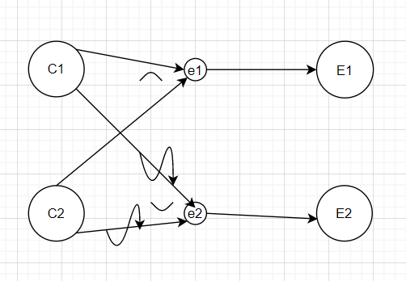

## Test requirements:

Precondition:

* Hospital assigned an ID for each patient.
* Deletion should be done by administrative staff.

Post condition:

* Patient’s ID is deleted
* Patient’s ID cannot be deleted

Patient’s ID is valid and deletion is by administrative staff.

Patient’s ID is invalid or deletion isn’t by administrative staff, Error message.

## Test case specifications:

Variables:

1. patient’s ID.
2. Administrator’s ID.

Assumptions:

1. Staff administrator should log in using his ID so that the operation can be done.
2. Patient’s ID format: 4 digits of integer numbers.
3. Administrator’s ID: 6 digits XXX-XXX of integer numbers.

|  |  |  |  |  |
| --- | --- | --- | --- | --- |
| Test case number | Inputs | Expected output | Side Effect | Actual output |
| 1 | Patient’s ID=1234  Administrator ID=123-567 | Access approved and patient is deleted. | Patient is deleted from the system and system starts to do the rest of operations needed to complete patient’s check out | # |
| 2 | Patient’s ID =3456  Administrator ID=23h-j34 | Error message appears:  -access denied | operation is denied | # |
| 3 | Patient’s ID =khlh  Administrator ID= 123-567 | Error message appears:  -invalid patient’s ID | operation is denied | # |

# Search forPatient:

## Applying cause effect test technique:

This operation allows user to search for a patient information by last name or ID or PHN.

C1: patient has a valid ID

C2: patient has a PHN

C3: patient has a valid last name

E1: patient found

E2: error message

|  |  |  |  |  |  |  |
| --- | --- | --- | --- | --- | --- | --- |
| # | 1 | 2 | 3 | 4 | 5 | 6 |
| C1 | 1 | X | X | 0 | X | X |
| C2 | X | 1 | X | X | 0 | X |
| C3 | X | X | 1 | X | X | 0 |
| E1 | 1 | 1 | 1 |  |  |  |
| E2 |  |  |  | 1 | 1 | 1 |

Modeling using cause effect graph:

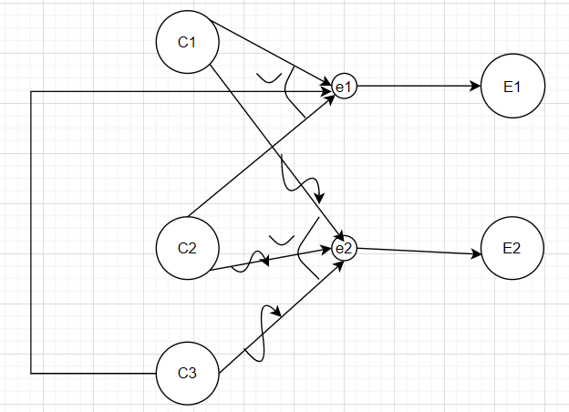

## Test requirements:

Precondition:

* Hospital assigned an ID for each patient
* Patient should have a PHN
* Patient’s last name is known( assuming that name should start with a capital letter and this name is saved on the hospital’s data base)

Post condition:

* Patient is found
* Patient is not found

Patient’s ID or Last name or PHN is valid, patient is found.

Patient’s ID or Last name or PHN is invalid, error message.

## Test case specifications:

Variables:

1. Patient’s name.
2. Patient’s ID.
3. Patient’s PHN.

Assumptions:

1. Patient’s ID format: 4 digits of integer numbers.
2. Patient’s Last name is a string that starts with a capital letter.
3. Patient’s PHN format: 3digits
4. First digit: letter P(upper case letter)
5. Last 2 digits: integer numbers

|  |  |  |  |  |
| --- | --- | --- | --- | --- |
| Test case number | Inputs | Expected output | Side Effect | Actual output |
| 1 | ID=1234  Last name= Henry  PHN=P21 | Required patient data | Process is done and system is ready to do any other operation using patient’s data | # |
| 2 | Last name= Henry | Required patient data | Process is done and system is ready to do any other operation using patient’s data | # |
| 3 | PHN=P21 | Required patient data | Process is done and system is ready to do any other operation using patient’s data | # |
| 4 | ID=fgh3 | Error message appears:  -Invalid ID | Operation denied | # |
| 5 | Last name= henry | Error message appears:  -invalid Last name | operation denied | # |
| 6 | PHN=p21 | Error message appears:  -invalid PHN | operation denied | # |

# Surgery case:

In surgery case, system allows administrative stuff to assign surgeon, nurses and surgery room to patient.

## Using pair wise test technique:

1. Surgeon:

* Available
* Not available

1. Nurse:

* Available
* Not available

1. Surgery Room:

* occupied
* Not occupied

|  |  |  |
| --- | --- | --- |
| **Surgeon** | **Nurse** | **Surgery Room** |
| available | available | Not-occupied |
| available | Not available | Not-occupied |
| Available | Not available | Occupied |
| Not available | available | Not-occupied |
| Not available | Not available | Not-occupied |
| Not available | Not available | Occupied |
| Available | Available | Occupied |
| Not available | Available | Occupied |

## Test requirements:

Precondition:

* Staff schedule should be available.
* Patient completed his registration.
* Patient is assigned to surgery ward.

Post condition:

* Surgery room, surgeon and nurses are assigned to patient.

Surgeon, nurse are available and surgery room is not occupied, surgeon nurse and surgery room are assigned to patient.

Surgeon is available but nurses are not available and surgery room is not occupied, unsuccessful operation.

Surgeon, nurse are available and surgery room is occupied, unsuccessful operation.

Surgeon is not available but nurses are available and surgery room is not occupied, unsuccessful operation.

Surgeon, nurse are not available and surgery room is not occupied, unsuccessful operation.

Surgeon and nurses are not available and surgery room is occupied, unsuccessful operation.

Surgeon is available and operation room is not occupied but nurses are not available, unsuccessful operation.

Surgeon is not available but nurses are available and room operation is occupied, unsuccessful operation.

## Test case specification:

Variables:

1. Surgeon

2. Nurse

3. Surgery Room

|  |  |  |  |  |
| --- | --- | --- | --- | --- |
| Test case number | Inputs | Expected output | Side Effect | Actual output |
| 1 | Surgeon=  Available.  Nurses=available.  Surgery room= Not-occupied | Surgeon , nurses data and Surgery room number that will be assigned to the patient | Process done successfully and system is ready to complete any procedure needed. | # |
| 2 | Surgeon=  Available.  Nurses=Not available.  Surgery room= Not-occupied | Error message:  -no available nurses  -no available Surgery room | Operation is denied | # |
| 3 | Surgeon=  Available.  Nurses=Not available.  Surgery room=occupied | Error message:  -no available nurses | Operation is denied | # |
| 4 | Surgeon=  Not available.  Nurses=available.  Surgery room= Not-occupied | Error message appears:  -no available Surgeon  -no available Surgery room | Operation is denied | # |
| 5 | Surgeon=  Not-available.  Nurses=Not-available.  Surgery room= Not-occupied | Error message appears:  -no available Surgeon  -no available Surgery room  -no available nurses | Operation is denied | # |
| 6 | Surgeon=  Not-available.  Nurses=Not-available.  Surgery room= occupied | Error message appears:  -no available Surgeon  -no available nurses | Operation is denied | # |
| 7 | Surgeon=  available.  Nurses=available.  Surgery room= occupied | Error message appears:  -no available  Surgery room | Operation is denied | # |
| 8 | Surgeon=  Not-available.  Nurses=available.  Surgery room= occupied | Error message appears:  -no available Surgery room  -no available Surgeon | Operation is denied | # |

# Assign to WaitingList:

System checks on bed availability and based on patient is assigned to waiting list or a doctor is assigned to patient.

## Using cause effect test technique:

C1: patient has a valid PHN

C2: patient is assigned to a ward

C3: beds occupied

E1: assign patient to waiting list

E2: error message

E3: assign patient to doctor

|  |  |  |  |  |
| --- | --- | --- | --- | --- |
| # | 1 | 2 | 3 | 4 |
| C1 | 1 | 0 | X | 1 |
| C2 | 1 | X | 0 | 1 |
| C3 | 1 | X | X | 0 |
| E1 | 1 |  |  |  |
| E2 |  | 1 | 1 |  |
| E3 |  |  |  | 1 |

Modeling using cause effect graph:

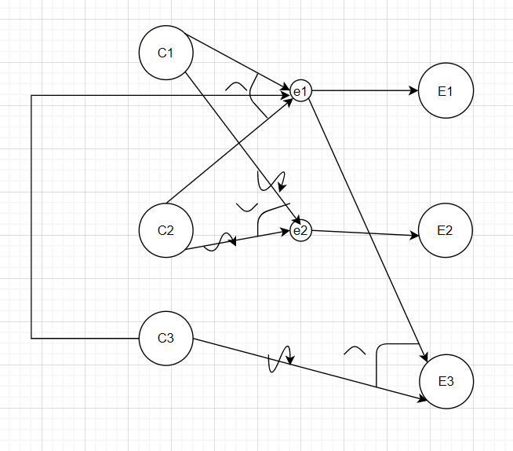

## Test requirements:

Precondition:

* Patient has a PHN
* Patient is assigned to ward
* Wards contain beds

Post condition:

* Assign patient to waiting list
* Assign patient to doctor

Patient has a valid PHN and assigned to a ward and all beds in the ward are occupied, patient assigned to waiting list.

Patient doesn’t have a valid PHN or isn’t assigned to ward, error condition.

Patient has a valid PHN and assigned to ward and a bed is available, patient is assigned to doctor.

## Test case specifications:

Assumption:

1. Patient’s PHN format: 3digits
2. First digit: letter P (upper case letter)
3. Last 2 digits: integer numbers
4. Ward types: Maternity, Surgical, Cancer and Cardiac
5. User should enter the correct PHN and the correct ward to which patient is assigned.
6. To test this feature, we assumed that patient’s PHN: P34 and he is assigned to cardiac ward.
7. If input data are valid system will show the list of beds’ state to show if here are available beds or not.
8. Bed’s state: occupied/unoccupied.

|  |  |  |  |  |
| --- | --- | --- | --- | --- |
| Test case number | Inputs | Expected output | Side Effect | Actual output |
| 1 | PHN=P34  Ward=Cardiac | Beds ‘state list | System checks if there are available beds then patient is assigned to doctor, if not then patient is put on the waiting list. | # |
| 2 | PHN=p37  Ward=cardiac | Error message appears:  -invalid PHN | Operation is denied | # |
| 3 | PHN=P34  Ward=Cancer | Error message appears:  -register patient | Operation is denied | # |

# Employee Information

System allows user to search for an employee by using his last name or ID.

## Using decision table technique:

|  |  |  |  |  |
| --- | --- | --- | --- | --- |
| Condition | 1 | 2 | 3 | 4 |
| Employee last Name | True | False | False | True |
| Employee ID | False | True | False | True |
| Output(F/NF) | F | F | NF | F |

## Test requirements:

Precondition:

* User should enter correct name or correct ID

Post Condition:

* Found: if employee is found
* Not Found: if employee is not found

To find an employee user should enter either a right Last name or a right ID.

Scenario 1: user enters right name and false Id so the employee is found.

Scenario 2: user enters false name and right Id so the employee is found.

Scenario 3: user enters false name and false Id so the employee is not found.

Scenario 4: user enters right name and right Id so the employee is found.

## Test case specification:

Variables:

1. Employee last name.
2. Employee ID.

Assumptions:

* Name format: starts with a capital letter.
* Employee ID format: 6 digits of integer numbers XXX-XXX

|  |  |  |  |  |
| --- | --- | --- | --- | --- |
| Test case number | Inputs | Expected output | Side Effect | Actual output |
| 1 | Name=Ahmed | Employee information | Process is done and system is ready to do any other operation on employee information | # |
| 2 | Name= ahmed | Error message appears:  -invalid name | Process is denied | # |
| 3 | ID=234-127 | Employee information | Process is done and system is ready to do any other operation on employee information | # |
| 4 | ID=hj7-789 | Error message appears:  -invalid ID | Process is denied | # |

# Emergency case:

In emergency case a doctor, nurses and emergency room are assigned to patient.

## Applying pair wise testing technique:

|  |  |  |
| --- | --- | --- |
| **Doctor** | **Nurse** | **Emergency Room** |
| available | available | Not-occupied |
| available | Not available | Not-occupied |
| Available | Not available | Occupied |
| Not available | available | Not-occupied |
| Not available | Not available | Not-occupied |
| Not available | Not available | Occupied |
| Available | Available | Occupied |
| Not available | Available | Occupied |

## Test requirements:

Precondition:

* Staff schedule should be available.

Post condition:

* Doctor, nurse and emergency room are assigned to patient immediately.

Doctor and nurses are available and emergency room is not occupied, doctor, nurses and emergency room are assigned to patient immediately.

Doctor is available and emergency room is not occupied but nurses are not available, unsuccessful operation.

Doctor is available but nurses are not available and emergency room is occupied, unsuccessful operation.

Doctor is not available bur nurses are available and emergency room is not occupied, unsuccessful operation.

Doctor and nurses are not available but emergency room is not occupied, unsuccessful operation.

Doctor and nurses are not available and emergency room is occupied, unsuccessful operation.

Doctor and nurses are available but emergency room is not occupied, unsuccessful operation.

Doctor is not available and emergency room is occupied but nurses are available, unsuccessful operation.

## Test case specifications:

Variables:

1. Doctor
2. Nurses
3. Emergency room

|  |  |  |  |  |
| --- | --- | --- | --- | --- |
| Test case number | Inputs | Expected output | Side Effect | Actual output |
| 1 | Doctor=  available.  Nurses=available.  Emergency room= Not-occupied | Doctor , nurses data and Emergency room number that will be assigned to the patient | Process done successfully and system is ready to complete any procedure needed. | # |
| 2 | Doctor=  available.  Nurses=Not available.  Emergency room= Not-occupied | Error message:  -no available nurses  -no available emergency room | Operation is denied | # |
| 3 | Doctor=  available.  Nurses=Not available.  Emergency room=occupied | Error message:  -no available nurses | Operation is denied | # |
| 4 | Doctor=  Not available.  Nurses=available.  Emergency room= Not-occupied | Error message appears:  -no available doctor  -no available emergency room | Operation is denied | # |
| 5 | Doctor=  Not-available.  Nurses=Not-available.  Emergency room= Not-occupied | Error message appears:  -no available doctor  -no available emergency room  -no available nurses | Operation is denied | # |
| 6 | Doctor=  Not-available.  Nurses=Not-available.  Emergency room= occupied | Error message appears:  -no available doctor  -no available nurses | Operation is denied | # |
| 7 | Doctor=  available.  Nurses=available.  Emergency room= occupied | Error message appears:  -no available emergency room | Operation is denied | # |
| 8 | Doctor=  Not-available.  Nurses=available.  Emergency room= occupied | Error message appears:  -no available emergency room  -no available doctor | Operation is denied | # |

# Inform Patient:

System informs patient on the waiting list that a bed became available.

Assumption:

* Bed state: (occupied/unoccupied)

## Using decision table test technique:

|  |  |  |  |  |
| --- | --- | --- | --- | --- |
| condition | 1 | 2 | 3 | 4 |
| Patient on waiting list | True | True | False | False |
| Available bed | True | False | False | True |
| Output(Inform/Denied) | Inform | Denied | Denied | Denied |

## Test requirements:

Precondition:

* Waiting list exist.
* Ward contains beds.
* Beds’ state is valid.

Post condition:

* Inform patient that a bed is available

Scenario 1: patient on the waiting list and bed is available so the system will inform user that a bed is available.

Scenrio2: patient on the waiting list but no available beds so operation is denied.

Scenario3: No patients on the waiting list and all beds are occupied so operation is denied.

Scenario 4: no patients on the waiting list and there exist available beds so operation is denied.

## Test case specifications:

Assumptions:

1. Considering any of patient’s (ID, PHN, name) is required to find the patient to be informed.
2. By entering the ward name system shows the user beds ‘state.
3. Patient’s ID format: 4 digits of integer numbers (XXXX)
4. Ward types: Maternity, Surgical, Cancer and Cardiac
5. To test this feature, we assumed that patient’s ID: 8960 and he is assigned to Cancer ward.

|  |  |  |  |  |
| --- | --- | --- | --- | --- |
| Test case number | Inputs | Expected output | Side Effect | Actual output |
| 1 | ID=8960  Ward=Cancer | Beds ‘state list | System continue the process by checking bed availability and assuring that patient is on the waiting list to take an action | # |
| 2 | ID=erh4  Ward= Cancer | Error message appears:  -invalid ID | operation is denied | # |
| 3 | ID=8960  Ward=Cardiac | Error message appears:  -register patient | operation is denied | # |

# ADD to beds available list:

Evacuated beds are added to beds available list.

## Applying cause effect test technique:

C1: valid ward name

C2: valid bed number

C3: bed evacuated

E1: add to available list

E2: bed still occupied

E3: error message

|  |  |  |  |  |
| --- | --- | --- | --- | --- |
| # | 1 | 2 | 3 | 4 |
| C1 | 1 | 1 | 0 | X |
| C2 | 1 | 1 | X | 0 |
| C3 | 1 | 0 | X | X |
| E1 | 1 |  |  |  |
| E2 |  | 1 |  |  |
| E3 |  |  | 1 | 1 |

Modeling using cause effect graph:

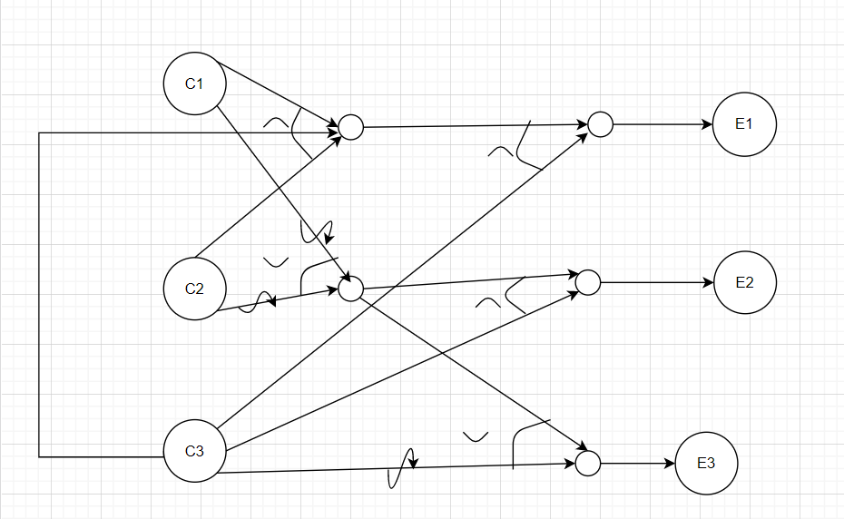

## Test requirements:

Precondition:

* Ward contains beds
* Ward name exists
* Each bed has a number

Post condition:

* Bed is added to available list

Ward name and bed number are valid and bed is evacuated, bed is added to available list

Ward name and bed number are valid and beds are occupied, error message

Ward name or bed number is invalid, error message

## Test case specification:

Assumptions:

1. Bed’s list: list of numbered beds.
2. By entering ward’s name, system shows user beds’ list.
3. Search in that list is done by entering bed’s number to show its state.
4. Wards: Cancer, Cardiac, Maternity, Surgery
5. Bed number is an integer number from 1 to 100

|  |  |  |  |  |
| --- | --- | --- | --- | --- |
| Test case number | Input | Expected output | Side effect | Actual output |
| 1 | Ward Name= Maternity  Bed number=10 | Bed’s state list | System continue the operation by checking evacuated beds to add it on beds available list or to deny the operation | # |
| 2 | Ward Name= Maternity  Bed number=500 | Error message:  -invalid bed number | Operation denied | # |
| 3 | Ward Name= Orthopedic  Bed number=100 | Error message:  -invalid ward | Error message | # |

# Patient Mandatory information:

Every patient should have his information saved on data base:

## Using equivalence partitioning:

Assumptions:

1. First name format: should start with a capital letter.
2. Last name format: should start with a capital letter.
3. Phone number:+20 XXX-XXXXXXXX
4. Personal health number format: XX-XXX of integer numbers
5. Address format: building number, street name, city name, apartment number.
6. City: should start with a capital letter.
7. Country: should start with a capital letter.
8. Patient identification number format: 4 digits of integer numbers.
9. Assuming that the box where data is entered will be highlighted in green if data format is valid, else it will be highlighted in red with an error message.

Equivalence classes:

|  |  |  |  |
| --- | --- | --- | --- |
| # | Input | Valid equivalence | Invalid equivalence |
| 1 | First name such as: Henry | A string that doesn’t take numbers and that starts with a capital letter: [Henry, Ahmed,…] | * henry * H12r * 14H * 4567 |
| 2 | First name such as: Henry | A string that doesn’t take numbers and that starts with a capital letter: [Henry, Ahmed,…] | * henry * H12r * 14H * 4567 |
| 3 | Phone number:  +20 XXX-XXXXXXXX | +20 013-65006091 | * 2001365006091 * +20 hr5-6500k091 |
| 4 | Personal health number: XX-XXX of integer numbers | 12-345 | * 12345 * He-1243 * 12 * 12-hg5 |
| 5 | Address format: building number-street name(starts with a capital letter)-city name(starts with a capital letter)- apartment number. | 10-Hassan Khalifa-Nasr city-1456 | * 10Hassan KhalifaNasr city1456 * Hassan Khalifa-10-Nasr city-1456 * 10-1456-Nasr city-Hassan Khalifa * 1456-10- Nasr city - Hassan Khalifa * 10-345-2345-1456 * 10- hassan khalifa- nasr city -1456 |
| 6 | City: should start with a capital letter. | Nasr city | * nasr city |
| 7 | Country: should start with a capital letter. | Cairo  Alexandria | * cairo * alexandria |
| 8 | Patient identification number format: 4 digits of integer numbers. | 1234 | * Hjsgd * 12hgr * 12 * Hgr5 |

## Test requirements:

Precondition:

* Patient should have all his information available.

Post condition:

* Patient’s data are saved on data base.

If user entered data in the right format, the box where data is entered will be highlighted in green.

If user entered any of the data in the wrong format, the box where data is entered will be highlighted in red and error message appears.

## Test case specification:

|  |  |  |  |  |
| --- | --- | --- | --- | --- |
| Test case number | Input | Expected output | Side effect | Actual output |
| 1 | First name=Henry | The box where data is entered will be highlighted in green | Data will be saved on data base | # |
| 2 | Last name=Hany | The box where data is entered will be highlighted in green | Data will be saved on data base | # |
| 3 | Phone number=+20 013-65006091 | The box where data is entered will be highlighted in green. | Data will be saved on data base | # |
| 4 | Personal health number= 12-345 | The box where data is entered will be highlighted in green. | Data will be saved on data base | # |
| 5 | Address= 10-Hassan Khalifa-Nasr city-1456 | The box where data is entered will be highlighted in green. | Data will be saved on data base | # |
| 6 | City= Nasr city | The box where data is entered will be highlighted in green. | Data will be saved on data base | # |
| 7 | Country=Cairo | The box where data is entered will be highlighted in green. | Data will be saved on data base | # |
| 8 | ID=1234 | The box where data is entered will be highlighted in green. | Data will be saved on data base | # |
| 9 | First name=henry | The box where data is entered will be highlighted in red.  Error message: invalid first name | Operation denied and system cannot proceed unless this error is corrected | # |
| 10 | Last name=hany | The box where data is entered will be highlighted in red.  Error message: invalid last name | Operation denied and system cannot proceed unless this error is corrected | # |
| 11 | Phone number=2001365006091 | The box where data is entered will be highlighted in red.  Error message: invalid phone number | Operation denied and system cannot proceed unless this error is corrected | # |
| 12 | Personal health number=he-345 | The box where data is entered will be highlighted in red.  Error message: invalid personal health number | Operation denied and system cannot proceed unless this error is corrected | # |
| 13 | Address= Hassan Khalifa-10-Nasr city-1456 | The box where data is entered will be highlighted in red.  Error message: invalid address | Operation denied and system cannot proceed unless this error is corrected | # |
| 14 | City= Nasr city | The box where data is entered will be highlighted in red.  Error message: invalid city name | Operation denied and system cannot proceed unless this error is corrected | # |
| 15 | Country=Cairo | The box where data is entered will be highlighted in red. Error message: invalid country name | Operation denied and system cannot proceed unless this error is corrected | # |
| 16 | ID=12hf | The box where data is entered will be highlighted in red. Error message: invalid ID | Operation denied and system cannot proceed unless this error is corrected | # |

# Assign ward:

Patient is assigned to ward based on its medical condition. Available Ward types are: Maternity, Cancer, Surgery and Cardiac.

## Using AD HOC test technique:

Try assigning patient to a ward that doesn’t exist in this hospital.

## Test requirements:

Precondition:

* Register patient.
* Patient have a valid PHN.
* Assigning patient to an invalid ward.

Post condition:

* Patient cannot be assigned patient to ward.

Assign patient to any ward except (Cardiac, Cancer, Maternity or Surgery), unsuccessful operation.

## Test case specifications:

Variable:

1. Ward name.

|  |  |  |  |  |
| --- | --- | --- | --- | --- |
| Test case number | Input | Expected output | Side effect | Actual output |
| 1 | Ward Name= orthopedic | Error message: invalid ward | System cannot continue operation. | # |