**HANA FLIGHT PREDICTOR**

**Code Installation Guide**

**Carnegie Mellon University – Silicon Valley**

*Jia Zhang*

*Edward Akoto*

*Lydian Lee*

*Madhok Shivaratre*

*Rashmi Devarahalli*

*Vidya Pissaye*

*Fall, 2012*

This iPad application is developed in a client-server pattern. So the code installation comprises two parts.

#### Server Side Installation:

1. Install the play MVC framework from: <http://www.playframework.org/>.
2. Clone the project repository from GitHub ***git clone:***

[***https://github.com/HanaApp/HANA-Flight-Predictor.git***](https://github.com/HanaApp/HANA-Flight-Predictor.git)

1. In the local downloaded folder, run: ***play run.***
2. Open a web browser, visit:

<http://localhost:9000/>

**Client Side Installation:**

1. Clone the repository from GitHub ***git clone:***

[*https://github.com/HanaApp/HANA-Flight-Predictor.git*](https://github.com/HanaApp/HANA-Flight-Predictor.git)

1. Open XCode and choose “Open Other” (as shown below), then browse to the location of your cloned repository.

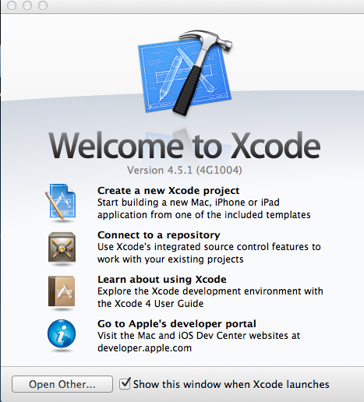

1. To install and run the application in your iPad device, note that you will have to register your device by following the instructions at <https://developer.apple.com/programs/ios/>.