**Theoretical description**

**Project: Smart Parking System with Ultrasonic Sensors**

**Components**:

* **NEXYS A7 50T Board**

FPGA development platform designed by Digilent. It includes Axtix-7 FPGA which provides a balance of processing power and I/O capabilities. Board contains several built-in peripherals, including an accelerometer, temperature sensor, MEMs digital microphone, a speaker amplifier, and several I/O devices allow the Nexys A7 to be used for a wide range of designs without needing any other components.

Ports:

* + - * Power jack
      * Powe switch
      * USB host connector
      * VGA connector
      * Audio connector
      * UART
      * Ethernet connector

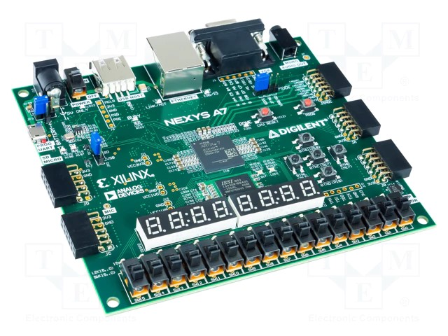

* **HC­SR04 Ultrasonic Sensor**

The HC-SR04 is distance measuring sensor module that uses ultrasonic waves to measure distance by sending out a sound pulse and timing how long it takes for the pulse to bounce back after hitting an object.

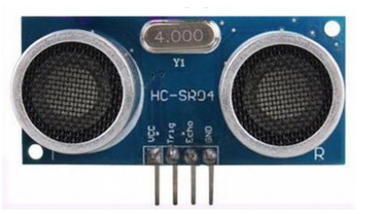 Ports:

* + - * VCC = 5V
      * Trig = Trigger input of Sensor
      * Echo = Echo output of Sensor
      * GND = GND

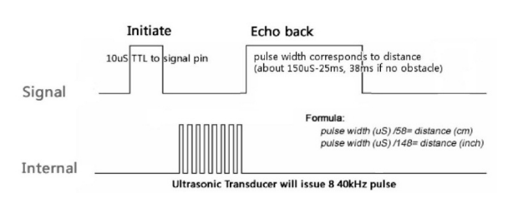

To start measurement, Trig of SRO4 must receive pulse of high (5V).