**Theoretical description**

**Project: Smart Parking System with Ultrasonic Sensors**

**Components**:

* **NEXYS A7 50T Board**

FPGA development platform designed by Digilent. It includes Axtix-7 FPGA which provides a balance of processing power and I/O capabilities. Board contains several built-in peripherals, including an accelerometer, temperature sensor, MEMs digital microphone, a speaker amplifier, and several I/O devices allow the Nexys A7 to be used for a wide range of designs without needing any other components.

Ports:

* + - * Power jack
      * Powe switch
      * USB host connector
      * VGA connector
      * Audio connector
      * UART
      * Ethernet connector

All Nexys A7 power supplies can be turned on and off by a single logic-level power switch (SW16). An external power supply can be used by plugging into to the power jack (J13) and setting jumper JP3 to “WALL”.

Thanks to its features and performance, A7-50T is a suitable also in the development and testing of digital systems.

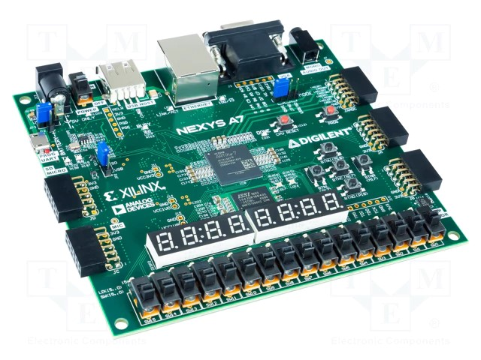

* **HC­SR04 Ultrasonic Sensor**

The HC-SR04 is distance measuring sensor module that uses ultrasonic waves to measure distance by sending out a sound pulse and timing how long it takes for the pulse to bounce back after hitting an object.

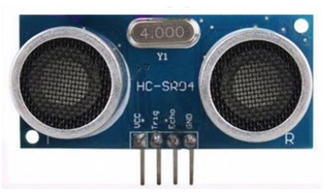 Ports:

VCC = 5V

Trig = Trigger input of Sensor

Echo = Echo output of Sensor

GND = GND

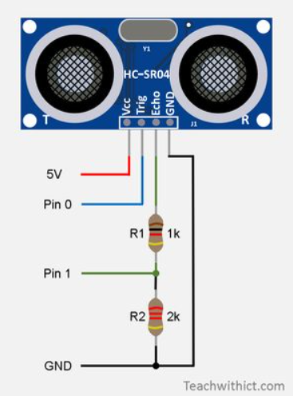

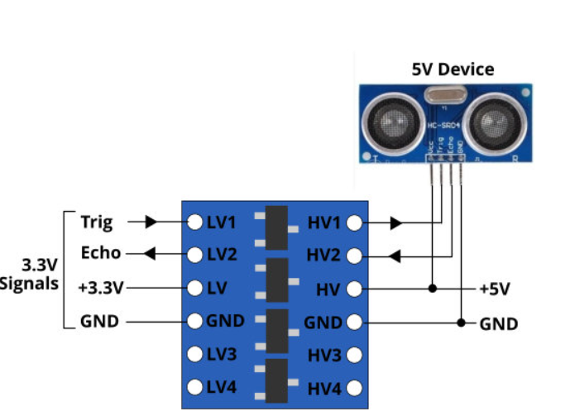

*connection*

*Internal structure*

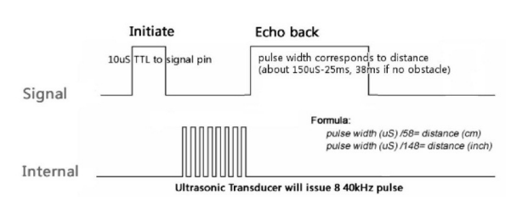

To start measurement, Trig of SRO4 must receive pulse of high (5V). for at least 10us, this will initiate the sensor will transmit out 8 cycle of ultrasonic burst at 40kHz and wait for the reflected ultrasonic burst. When the sensor detected ultrasonic from receiver, it will set the Echo pin to high (5V) and delay for a period (width) which proportion to distance. To obtain the distance, measure the width (Ton) of Echo pin.

**Time** = Width of Echo pulse, in uS (micro second)

* Distance in centimeters = Time / 58
* Distance in inches = Time / 148
* Or you can utilize the speed of sound, which is 340m/s

**FSM -** abstract machine that can be in exactly one of a finite number of *states* at any given time. In this project we use Moore machine which output depends only on state.

Machine is

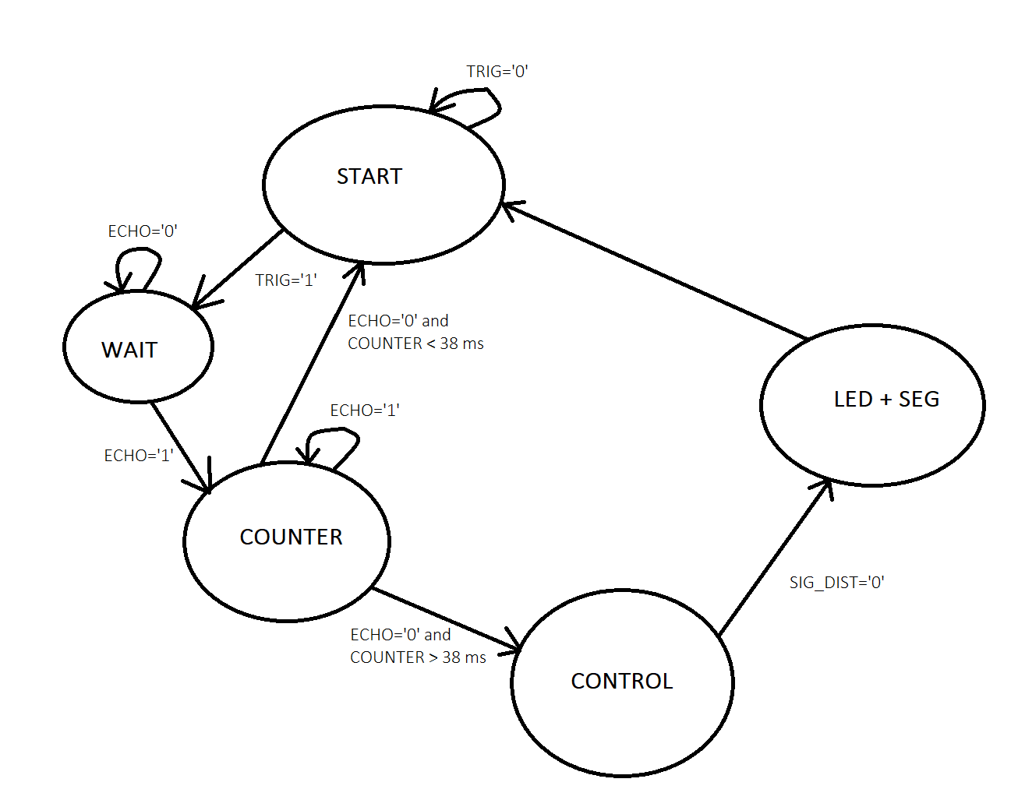

**Resources:**

* <https://digilent.com/reference/_media/reference/programmable-logic/nexys-a7/nexys-a7_rm.pdf>
* <https://web.eece.maine.edu/~zhu/book/lab/HC-SR04%20User%20Manual.pdf>