Cell Universe Config Generator

Introduction

This tool helps create configuration files for Cell Universe. It functions by comparing the cell information on two separate frames in a video.

GUI

The graphical user interface (GUI) of Cell Universe Config Generator contains five sections, which are Canvas 1, Canvas 2, Information Panel, Synthetic Cell Preview, and Data Form. In the figure below, each section is identified by a red box together with its name.

Usage

To generate a configuration file, the following input fields need to be completed.

In Info panel section:

* + Min cell length
  + Max cell length
  + Min cell length
  + Max cell length

In Synthetic Cell Preview section:

* + Diffusion sigma
  + Diffusion strength
  + Diffusion truncate

In Data Form section:

* + Frame# of left
  + Frame# of right
  + Max speed
  + Max spin
  + Max growth
  + Cell color
  + Background color
  + Cell count (Left) - Currently don’t need to be filled
  + Cell count (Right) - Currently don’t need to be filled

After all fields been completed, click the Generate Button in the Data Form Section to generate the configuration file.

**Follow the instructions below to ensure that all fields are completed correctly.**

**Step 1: Load image to canvas 1.**

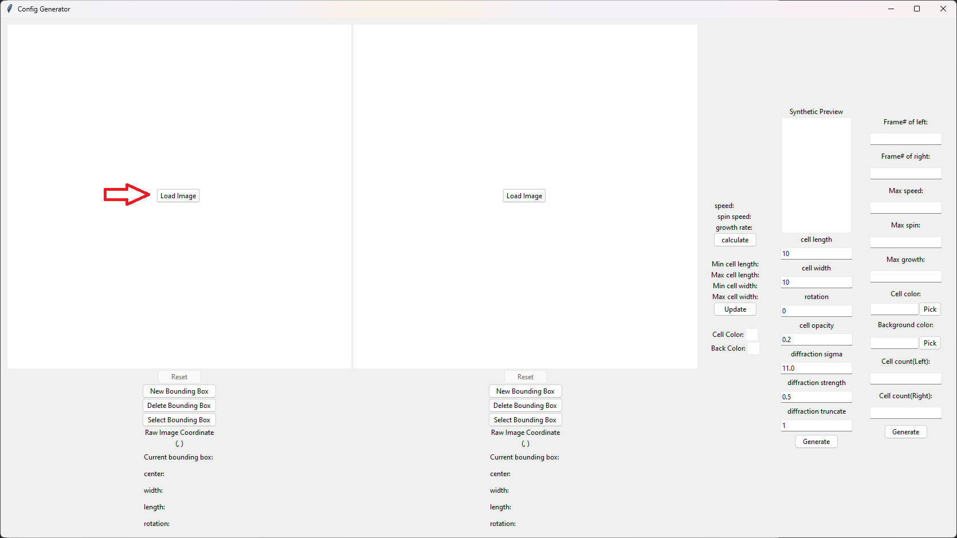

Select the image in the pop-up window.

Enter the frame number of this image and click confirm.

**Step 2: Load image to canvas 2.**

Repeat the process of step 1.

If you are uncertain which image to load, please refer to the following guidelines:

For Canvas 1, please choose Frame 0.

For Canvas 2, it’s depending on how the cells change. You should select a frame where you can observe noticeable changes in cell size and location.

**Step 3: Draw bounding boxes & click update button.**

For both canvases, draw bounding boxes to label the cells. After finishing the drawing, click the update button in the info panel. The program will show the max/min cell length and width according to the cells that you have drawn.

You don't need to draw for all cells, but make sure to draw the cells that you think has highest/lowest length or width.

To draw a bounding box:

First, click the new bounding box button under the canvas.

Second, left click on one corner of the cell and move along the longer side of the cell until you reach the opposite side.

Third, right click and move the cursor to adjust the width of the bounding box. Release the right mouse button if the bounding box correctly encloses the cell.

**Step 3: Determine Max speed/spin/growth.**

This tool can help you measure the speed/spin/growth between two cells, but the max speed/spin/growth needs to be manually input by the user.

To calculate the speed/spin speed and growth rate of a cell:

* 1. click the select bounding box button under the canvas.
  2. click on one bounding box in the canvas.
  3. repeat the previous steps for the other canvas. (The two selected cells need to be the same cell)
  4. Click the calculate button in the info panel.
  5. The speed/spin speed/growth rate now appears in the info panel.

Manually enter the result into the data form. For each value, add some tolerance value to account for potential errors. For example, if the speed is 0.283, you should type 0.3 or maybe 0.35 for max speed.

**Step 4: Determine Cell/Background Color.**

1. Click the pick button on the right of input box.
2. Select a rectangular area on either of the canvas.
3. The average grey scale color should have automatically been placed in the input box.

**Step 5: Determine diffraction parameters.**

Use the synthetic preview section to find the optimal diffraction parameters. The goal is to create a closest synthetic cell image compared to the real image. Make sure you have finished step 4 before press the generate button in the synthetic preview section.

**Step 6: Input the cell count of both canvases.**

Currently not required.

**Step 7: Generate the configuration.**

Click the generate button in the data form.

Select the desired location of generated config file.

Finished.