<https://github.com/HanaStanojkovic>

Github is a form of version control and it is a hosting service. It was created in 2007 but launched in 2008 by Tom Preston-Werner, Chris Wanstrath, and PJ Hyett. Bitbucket is a similar platform, however it is private. I prefer github because github promotes open source projects.

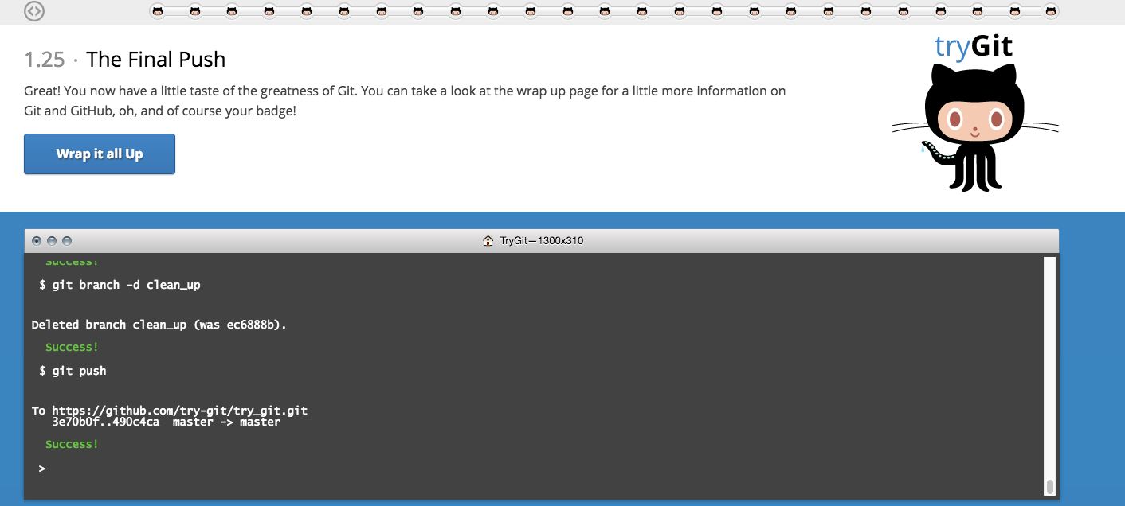

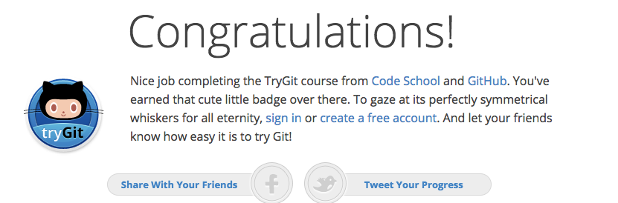

* Repository – a repository is a place where all folders, files, etc. are stored
* Commit – a git commit will record any changes that are done to the repository
* Push – a git push is when all the changes are pushed onto github for anyone to use
* Branch – a branch, master is the default but any branch can be created, for code in different stages to be worked on before getting pushed
* Fork – a fork is just a copy of a repository
* Merge – a git merge is when code is combined together from different branches once all the differences are resolved
* Clone – a git clone copies the git repository you want to clone
* Pull – git pull obtains the most recent version of the code
* Pull request - a pull request allows other team members to review changes before it is used

<https://github.com/HanaStanojkovic/CS3892017.git>

For the final part of the exercise, I went to <https://github.com/paceuniversity/courses>, into the README file and edited my information on github itself.