0-Sphere Model Primer (Volume 3)
Background knowledge for reading Paper #19: “Spin as a Real Vector from Internal Photon-Sphere Motion”
Source paper: Paper #19 (published). Full title: Spin as a Real Vector from Internal Photon-Sphere Motion: Geometric Origin of U(1) Gauge and SU(2) Periodicity
Purpose of this primer: This book explains the claims of Paper #19 so that first- and second-year undergraduates can follow them. It assumes the content of Volume 1 (Paper #65), but repeats the necessary parts within this book.
Date prepared: 13 November 2026
Notation convention: Standard facts of mathematics and physics are labelled “standard”. Interpretations and proposals of the 0-Sphere Model are labelled “0SM reading”. The results of checking the paper’s equations in this book are summarised in Chapter 8 and Appendix B.
Caution | What to know before reading
The argument of Paper #19 requires attention in three places. The first is its discussion of Thomas precession, the second is the units of the angular-velocity equation, and the third is the reclassification of spin. Chapters 8 and 9 treat these in detail.
This book aims to convey the paper’s claims accurately. It does not present the paper’s conclusions as having been verified by the author of this book.

Contents
Part | Chapters | Content | What the reader gains
Summary | — | The paper’s claims and this book’s review findings, stated first | An overview of the whole
Part I | Ch. 1–2 | What spin is. Premises of the 0-Sphere Model | How the question is posed, and what the terms mean
Part II | Ch. 3–7 | Internal motion, the 4π period, Thomas precession, SU(2) and U(1), the paper’s applications | The flow of the paper’s argument
Part III | Ch. 8–10 | Checking equations and units, checking the logic, the relation to experiment | What can and cannot be claimed
Part IV | Ch. 11–12 | Open questions, connections to other papers, how to read | The next step
Appendices | A–H | Glossary, checklist, exercises, list of figures and tables, correspondence with the source, summary card, mathematical toolbox, quiz | Review and re-checking
Source: structure of this book

Summary
Paper #19 proposes treating the electron’s spin not as an abstract pseudovector but as a real vector that changes in time and arises from the back-and-forth motion of an internal photon sphere.
Key point | The paper’s claim
The internal angular velocity oscillates in time along the z direction, in the form Ω(t) = −(1/4c²) sin(2ωt) e_z (the paper’s equation).
This oscillation has period π, because of sin(2ωt). The paper argues from this that the 4π (720°) periodicity characteristic of spin-1/2 particles emerges.
From this, the paper claims that spin is not a probabilistic quantum quantity but a deterministic quantity determined by internal phase.
The paper further proposes that the SU(2) symmetry can be understood as a “geometric unfolding” of a single U(1) phase.
Caution | What this book’s review found
Thomas precession: The paper states that for a one-dimensional harmonic oscillation, if velocity and acceleration are parallel, their cross product is zero. It then states that the angular velocity arises from Thomas precession. In standard theory, Thomas precession is proportional to the cross product of acceleration and velocity, so it vanishes when they are parallel. The paper’s argument is inconsistent on this point (Chapter 8).
Units of the angular velocity: The coefficient 1/(4c²) has units of s²/m² in SI. Since Ω should have units of 1/s, the equation holds only in natural units. The paper calls this a “dimensional correction”, but in SI units the correction is not complete (Chapter 8).
Reclassification as a real vector: The paper states that spin should be regarded as a real vector rather than a pseudovector. However, the argument for this reclassification rests on definitions and assumptions made within the paper. To change the treatment of pseudovectors within standard theory requires further argument (Chapter 9).
Open | Open issues
Zitterbewegung of a free electron has not been observed directly. The experiments the paper cites are simulations in cold-atom and optical systems, not observations of the electron itself (Chapter 10).
The paper’s proposal that parity violation may be a consequence of projection is not tested within the paper (Chapter 11).

Part I: Question and Premises

Chapter 1: What Spin Is
Reader’s question: Why does an electron’s spin return to its original state only after a 720° rotation?
An electron has an orientation like a magnet. This property is called spin. It might look as if the electron is spinning on its axis, but that picture does not match the observations, because the speed at the electron’s surface would exceed the speed of light (standard). For this reason, spin has been treated as a quantity specific to quantum mechanics rather than classical rotation.
Spin-1/2 particles have a special rotational property. Rotating one by 2π about an axis reverses the sign of the wavefunction. Rotating it by 4π returns it to the original state (standard). When first encountered, this property can seem strange.
A familiar example is a twisted belt. Fix one end and turn the other end through 360°, and the belt becomes twisted. Turn it through another 360°, and the twist can be undone. The outcome of this operation can be described as a rotation of 720° followed by a return to the start (standard). The belt example helps build an intuition for the 4π periodicity of spin-1/2.
The question posed by Paper #19 is this: should the 4π periodicity of spin be given as an axiom of abstract mathematics, or does it arise from a physical quantity moving inside the particle? The paper aims at the latter answer.
Table 1-1: The standard understanding of spin and the paper’s proposal
Item | Standard understanding | Proposal of Paper #19
Nature of spin | Pseudovector (axial vector). Expressed with generators of SU(2) | A real vector that changes in time
Origin of the 4π period | Given as an axiom, because SU(2) is the double cover of SO(3) | Derived from the back-and-forth motion of the internal photon sphere
Measurement | Projection onto eigenstates, with probabilistic outcomes | Deterministic projection determined by internal phase
Source: Paper #19’s introduction and comparison table, organised by this book

Chapter 2: Premises of the 0-Sphere Model
Reader’s question: What do the “photon sphere” and the “two nuclei” in the paper refer to?
In the 0-Sphere Model (0SM), the electron is described as a system of two nuclei, A and B, and a photon sphere that carries energy between them (0SM reading). The energy is divided into three parts by the internal phase θ = ωt. Paper #19 uses the following equation as its premise.
E₀ = E₀ [ cos⁴(ωt/2) + sin⁴(ωt/2) + (1/2) sin²(ωt) ]
The two terms on the left are the thermal potential energies of nucleus A and nucleus B. The term on the right is the kinetic energy of the photon sphere. The three terms always add up to E₀ (this can be verified with standard algebra).
This equation is the same identity treated in Volume 1. There, we used the fact that the sum of cos⁴ and sin⁴ equals 1 − (1/2) sin²(2θ) (a standard trigonometric calculation). In this book, the identity is called the “three-way division of energy”.
Table 2-1: Symbols used in this book
Symbol | Meaning | Role in the paper
ω | Angular frequency of the internal oscillation | Sets the phase of internal time
t | Proper time in the particle’s rest frame | Sets the rate at which the internal phase advances
v(t), a(t) | Internal velocity and acceleration of the photon sphere (normalised values) | Serve as the ingredients of Ω
Ω(t) | Internal angular-velocity vector | Sets the direction of spin
e_z | Unit vector in the z direction | Added by the correction to give a direction
c | Speed of light in vacuum | Link to SI units
Source: the notation section of Paper #19
Key point | Key points for reading
Some equations in the paper are written in natural units (ℏ = c = 1). When reading the equations in SI units, check the units one by one (Chapter 8).
The paper’s “internal velocity” is not the speed measured by an external observer. It is the speed that the internal photon sphere has in its own rest frame (the paper’s definition).

How to Read This Book
This book is written to help you follow the paper’s argument. It does not aim to restate the whole paper. Part II follows the paper’s argument in order. Part III checks the equations and the logic. The calculations are shown so that readers can verify them for themselves.

Part II: The Paper’s Argument

Chapter 3: Internal Motion and Angular Velocity
Reader’s question: How does the angular velocity arise from the motion of the photon sphere?
The paper treats the internal motion of the photon sphere as a one-dimensional harmonic oscillation. The normalised velocity and acceleration are written as follows (the paper’s description).
v(t) = cos(ωt), a(t) = −sin(ωt)
Velocity and acceleration point along the same line. Their sign alternates between positive and negative over time. This is what “one-dimensional” means here.
The paper writes the angular velocity as follows. In the earlier paper, the left-hand side of this equation was a vector and the right-hand side a scalar, so the dimensions did not match. The paper corrects this by adding the unit vector e_z. The corrected equation is (the paper’s equation).
Ω(t) = −(1/4c²) sin(2ωt) e_z
The meaning of this equation is that the angular velocity along z oscillates while changing sign over time. The z component of spin alternates between up and down. The paper states that this oscillation is determined by the “deterministic internal phase”.

Chapter 4: The 2π and 4π Periods
Reader’s question: Why does the velocity return after 2π, while spin returns only after 4π?
Figure 4-1 shows how three quantities vary with the phase ωt. The velocity cos(ωt) and the acceleration −sin(ωt) both repeat with period 2π. The z component of the angular velocity, −sin(2ωt), repeats with period π.
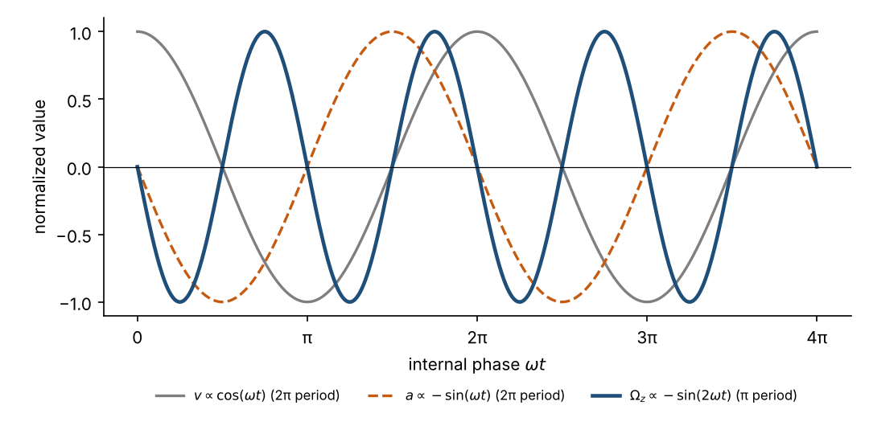
Figure 4-1: prepared by this book from the paper’s equations (normalised values). Source: Paper #19’s equation for Ω(t), and this book’s calculations
In the paper’s description of the figure, the cross product of velocity and acceleration is said to oscillate with period π. The product of components, cos(ωt) × (−sin(ωt)), equals −(1/2) sin(2ωt), and this calculation itself is correct. However, for one-dimensional motion the actual value of the cross product is zero. This point is treated in Chapter 8.
From here, the paper draws the following conclusion. To complete one cycle of the internal back-and-forth motion takes an internal phase of 4π. The paper states that this corresponds to the 720° periodicity of spin-1/2.
Caution | Parts of the paper not verified within the paper
That the period of sin(2ωt) is π is a fact of mathematics. However, the statement that “one full back-and-forth cycle requires an internal phase of 4π” is an interpretation. The paper presents it as a way of viewing the motion, but does not give a mathematical definition of a cycle.
The 720° periodicity of spin arises from the mathematical structure of the double cover of SU(2). The paper proposes that this structure can be derived from internal motion, but it does not show the correspondence step by step.

Chapter 5: Thomas Precession and the “Real Vector”
Reader’s question: Why does the coordinate axis of an accelerating electron rotate?
Thomas precession is the effect by which coordinate axes rotate inside an accelerating frame. In standard theory, for a particle with velocity v and acceleration a, its angular velocity is written as follows (standard).
ω_T = [γ² / (γ + 1)] (a × v) / c²
Here γ is the Lorentz factor. At low speeds, this can be approximated as ω_T ≈ (a × v) / (2c²). The important feature of this equation is that it is proportional to the cross product a × v. If a and v lie on the same line, the cross product is zero and so is the Thomas precession (standard calculation).
The paper applies this Thomas precession to the internal motion of the photon sphere. The paper treats Ω(t) as a “physically real angular velocity” because it originates from Thomas precession. According to the paper, Thomas precession is not an apparent effect of a coordinate change but a real angular velocity arising from internal motion (the paper’s claim).
The flow of the paper’s argument can be summarised as follows.
- In one-dimensional harmonic motion, velocity and acceleration are parallel, so their cross product is zero (the paper’s description).
- However, when the internal motion reaches relativistic speeds, Thomas precession appears and an angular velocity arises (the paper’s claim).
- Therefore, spin arises from a relativistic correction rather than from the orbital angular momentum of circular motion (the paper’s claim).
The first two steps of this argument are inconsistent within the paper. Chapter 8 explains why.

Chapter 6: SU(2) and U(1)
Reader’s question: Are SU(2) and U(1) separate symmetries?
SU(2) is the group that describes the symmetry of spin-1/2. Its representation changes sign under a 2π rotation and returns to its original state under 4π. This is the structure known as the double cover of SO(3) (standard). U(1) is the group describing rotations of phase, and its period is 2π (standard).
The paper regards these two groups as two manifestations of one internal phase θ = ωt. The paper states that the internal phase has period 2π, while the observed angular momentum has period 4π. From this contrast, the paper reads SU(2) and U(1) as two expressions of a single phase.
This proposal is called a “geometric unfolding” in the paper. However, the paper does not show that the SU(2) × U(1) gauge group of standard theory can be derived from this proposal. This book treats that part as the paper’s proposal.

Chapter 7: Applications Claimed by the Paper
Reader’s question: How far does the paper claim applications?
The paper lists several applications. Their status is not the same, and Table 7-1 sorts them out.
Table 7-1: Applications listed in the paper and their status
Application | Claim of the paper | This book’s assessment
Anomalous magnetic moment (deviation from g = 2) | Explained as a relativistic effect inside the particle | Must be read together with the earlier paper. Detailed calculations are not shown in this paper
Zeeman-type behaviour without an external field | Interpreted as an internal magnetic field produced by internal motion | A proposal only. No calculation is shown
Parity violation in weak interactions | May be reinterpreted as a result of projection | Untested proposal. The paper itself says so
Internal electron velocity of about 0.04c | Given as a theoretical prediction | Consistent with β in #62 and #65. However, the placement problem remains in #62 (Chapter 9)
Source: comparison table and conclusions of Paper #19, organised by this book

Part III: Review

Chapter 8: Checking Equations and Units
Reader’s question: Can the paper’s equations be read correctly in SI units?

8.1 Units of the angular velocity
We check the units of the coefficient 1/(4c²) in the paper’s equation Ω(t) = −(1/4c²) sin(2ωt) e_z. c is a speed, with units of m/s. Therefore c² has units of m²/s², and its reciprocal has units of s²/m². sin(2ωt) is dimensionless. Hence Ω has units of s²/m².
In standard theory, angular velocity has units of 1/s. In this book’s calculation, 1/(4c²) is about 2.78 × 10⁻¹⁸ s²/m². Even if this coefficient is multiplied by ω (units of 1/s), the result does not have units of 1/s. Therefore the paper’s equation does not hold as an angular-velocity equation in SI units.
Caution | On the unit correction
The paper states that the purpose of the correction is to “preserve dimensional consistency”. However, the corrected equation also fails to match dimensions in SI units.
The equation holds only in natural units (ℏ = c = 1). Even then, the meaning of the factor 1/4 and the reason for including c² are not explained in the paper.

8.2 Thomas precession and parallel velocity and acceleration
As seen in Chapter 5, Thomas precession is proportional to a × v. In the paper’s one-dimensional argument, v = cos(ωt) and a = −sin(ωt) are components along the same line. Computing the cross product gives zero (this book’s calculation).
The paper accepts that this cross product is zero, and then states that “a relativistic effect produces Thomas precession”. However, Thomas precession itself is a quantity proportional to the cross product. If the cross product is zero, Thomas precession is also zero. Therefore the paper’s argument is inconsistent on this point.
Caution | Logical inconsistency (the most important point)
In the paper’s one-dimensional argument, velocity and acceleration are parallel, so their cross product is zero. Thomas precession is proportional to that cross product. Therefore, the one-dimensional argument of the paper does not yield an angular velocity from Thomas precession.
The later argument in the paper (Chapter 5) derives the angular velocity from Thomas precession, but this does not resolve the inconsistency.
Later papers (#52, #62) use helical motion in which velocity and acceleration are orthogonal. When they are orthogonal, the cross product is not zero and Thomas precession appears. The one-dimensional argument of #19 uses a different geometry from the helical motion of the later papers.

8.3 The value of the ZB velocity
The paper states that the internal velocity of the electron is about 0.04c. In the earlier paper, β is 0.040472, and this book’s calculation reproduces that value (the equation uses the standard form from #62). However, #62 states that the placement of the factor 1/√2 in the equation giving this value (whether it enters at the acceleration stage or the velocity stage) is still unresolved. Therefore the “0.04c” of Paper #19 inherits that unresolved problem (Chapter 9).

Chapter 9: Checking the Logic
Reader’s question: How far is the paper’s conclusion supported logically?
We examine the paper’s conclusions by dividing them into four claims.
Table 9-1: The paper’s claims and this book’s judgement
Claim | Status in the paper | This book’s judgement
The equation for Ω(t) gives the z component of spin | Stated as established (the paper’s wording) | The units do not match in SI. It should be read as a proposal in natural units
Thomas precession gives the angular velocity | Stated as established (the paper’s wording) | Inconsistent for parallel velocity and acceleration. The consistency problem remains
Spin is a real vector, not a pseudovector | Reclassification (the paper’s proposal) | Depends on the paper’s definitions. Overturning standard theory requires further argument
Measurement probabilities arise from the unobservability of internal phase | Interpretation (the paper’s proposal) | No calculation is shown. The paper itself says so
Source: each section of Paper #19, judged by this book
Open | Criteria for this book’s judgements
“Established” means the paper shows the calculation and this book could reproduce it.
“Proposal” means the paper states it as a logical claim without yet having computational or experimental support.

Chapter 10: Relation to Experiment
Reader’s question: Has Zitterbewegung, the basis of the paper, actually been observed?
Zitterbewegung is a rapid oscillation of the electron that emerges from the Dirac equation. In standard theory, this oscillation appears as interference between positive- and negative-energy solutions (standard). Zitterbewegung itself has not been observed directly for a free electron (the paper’s description).
The paper cites two simulation experiments. One is an oscillation seen in a Bose–Einstein condensate with spin–orbit coupling, in a cooled-atom system (LeBlanc et al., 2013). The other is a report of an oscillation resembling Zitterbewegung, observed for light in a semiconductor microcavity (Zhang et al., 2023). Both are observations of systems with similar mathematics, not of the electron itself.
The paper states that these observations “support the physical reality of the internal oscillatory structure”. However, simulation experiments are not direct evidence about the electron’s internal structure. This book keeps this distinction clear.

Part IV: Open Questions and Next Steps

Chapter 11: The Paper’s Open Questions
Reader’s question: What does the paper itself leave unresolved?
The concluding part of the paper states its open questions explicitly. Organised by this book, they are as follows.
- Rewrite the equation for the internal angular velocity correctly in SI units.
- Resolve the contradiction between Thomas precession in the one-dimensional argument and the vanishing of the cross product.
- Show how the SU(2) × U(1) unification connects to the gauge structure of standard theory.
- Show whether parity violation can be explained as a projection effect.
- Show by calculation that measurement probabilities arise from the unobservability of internal phase.

Chapter 12: Connections to Other Papers and How to Read
Reader’s question: How does this paper connect to other papers?
Paper #19 connects to the following papers.
- Paper #62 (bridge form): deals with the value 0.04c for the ZB velocity and the position of the factor 1/√2. The commentary on #62 helps in understanding the numbers in #19.
- Paper #46 (zero-point energy): deals with the lower bound E₀/2 of the energy identity. It helps in understanding the relation between internal phase and the three-way division of energy.
- Paper #52 (weak equivalence principle): uses the geometry of helical motion with orthogonal velocity and acceleration. It points toward resolving the inconsistency in the one-dimensional argument of #19.
As a reading order, first confirm the premises in Volume 1 (#65), then read #19, and finally read #52 and #62. This makes the flow of the papers easier to follow.

Overall flow (figure)
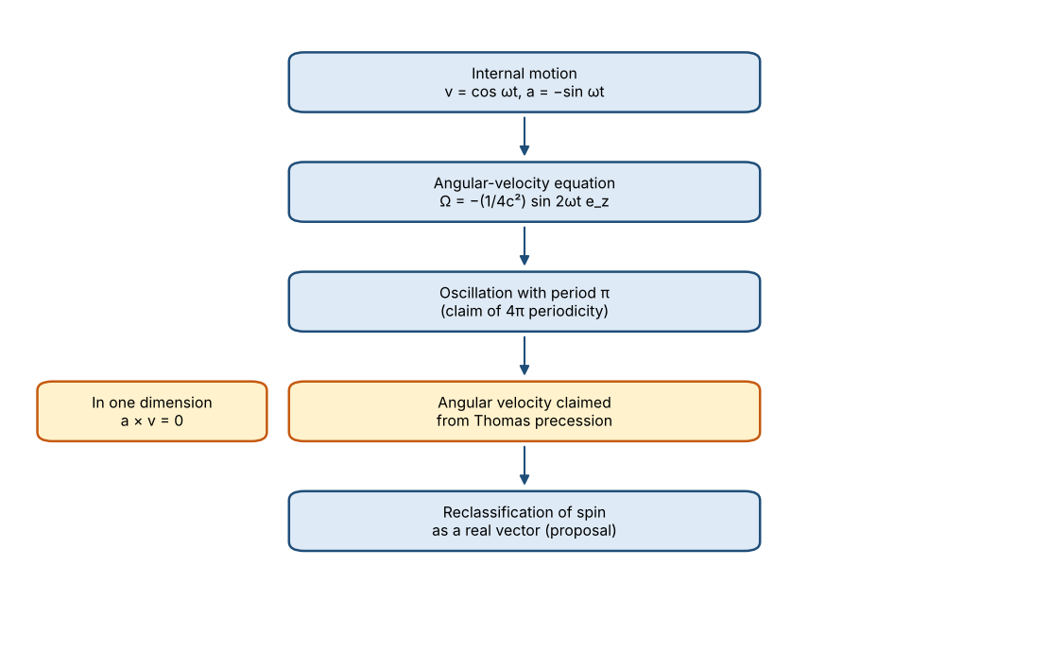
Figure 12-1: the paper’s argument, organised by this book

Appendices

Appendix A Glossary
Term | Meaning
Spin | Angular momentum of particles such as electrons, specific to quantum mechanics. It cannot be explained by classical rotation
Pseudovector (axial vector) | A vector that does not change sign under reflection. In standard theory, spin is treated this way
Real vector (polar vector) | A vector that changes sign under reflection. The paper proposes classifying spin this way
Zitterbewegung | A rapid oscillation of the electron that emerges from the Dirac equation
Thomas precession | The rotation of coordinate axes in an accelerating frame. Proportional to the cross product of velocity and acceleration
SU(2) | The group describing the symmetry of spin-1/2. The double cover of SO(3)
U(1) | The group describing rotations of phase. Its period is 2π
Photon sphere | In 0SM, the element that carries energy between the two nuclei
Nuclei A and B | In 0SM, the two elements holding thermal potential energy
Natural units | A way of writing equations by setting quantities such as ℏ = c = 1, so that units are omitted
Double cover | The structure in which SU(2) corresponds 2-to-1 to the rotation group SO(3)
Parity | Behaviour under spatial reflection. Known to be violated in weak interactions
Source: definitions of terms in this book

Appendix B Checklist
The items checked by calculation in this book are summarised in the following table.
Item | Statement in the paper | Check in this book | Judgement
Units of 1/(4c²) | States that a dimensional correction was made | s²/m² (SI), not 1/s | Caution (holds only in natural units)
Cross product of parallel v and a | States it is zero | Confirmed to be 0 | Correct
Thomas precession for parallel motion | States that it arises even for parallel motion | Thomas precession is proportional to a × v and so vanishes | Inconsistent
Period of sin(2ωt) | States it is π | Confirmed to be π | Correct
ZB velocity about 0.04c | States 0.04c | β = 0.040472 (standard form from #62) | Correct (placement unresolved)
Source: this book’s checks. Calculations use the paper’s equations and standard formulas

Appendix C Exercises
Three exercises to test the content of this book are given below. Answers follow each question.
Exercise 1: The twisted belt
Question: Fix one end of a belt and turn the other end through 360°. What happens to the belt? If you then turn it through another 360°, for a total of 720°, what happens?
Answer: After 360°, the belt is twisted once and cannot be untwisted as it is. After a further 360°, for a total of 720°, the twist can be undone by passing your hand through the loop of the belt. This example intuitively shows the property that a spin-1/2 system changes sign under 2π and returns to its original state under 4π.
Exercise 2: The cross product of parallel velocity and acceleration
Question: Find the cross product of v = (1, 0, 0) and a = (−1, 0, 0). What does the result mean for Thomas precession?
Answer: The cross product is (0, 0, 0). Thomas precession is proportional to a × v, so in this case the Thomas precession is zero. Therefore the one-dimensional argument does not produce an angular velocity from Thomas precession.
Exercise 3: Units of the angular velocity
Question: Find the units of 1/(4c²). When it is multiplied by ω, do the resulting units match those of angular velocity?
Answer: The units of 1/(4c²) are s²/m². Multiplying by ω gives units of s/m², which does not match the units of angular velocity, 1/s. To make them match, a different coefficient is needed. (In natural units this problem is hidden.)

Appendix D List of Figures and Tables
Number | Content | Source
Figure 4-1 | Phase dependence of velocity, acceleration and angular velocity (normalised) | Prepared by this book from the paper’s equations
Table 1-1 | The standard understanding of spin and the paper’s proposal | Paper’s introduction and comparison table
Table 2-1 | Symbols used in this book | Paper’s notation section
Table 7-1 | Applications listed in the paper and this book’s assessment | Paper’s comparison table and conclusions
Table 9-1 | The paper’s claims and this book’s judgements | This book’s judgements

Appendix E Correspondence with the Source
Section of Paper #19 | Chapter of this book
Introduction | Chapters 1, 2
Motivation and notation | Chapters 2, 3
Geometric relation between SU(2) and U(1) (Discussion) | Chapter 6
Dimensional correction of the angular velocity | Chapters 3, 8
Argument that spin is a real vector (Thomas precession) | Chapters 5, 8
Energy distribution and geometric interpretation | Chapters 2, 4
Comparison table and conceptual differences | Chapters 1, 9
Zitterbewegung and experiment | Chapter 10
Conclusion | Chapter 11

Appendix F Summary Card
Key point | Summary card
The paper’s aim is to derive the 4π periodicity of spin-1/2 from internal motion.
From Ω(t) ∝ sin(2ωt), the paper derives a period of π, and from this argues for the 4π periodicity.
Thomas precession is proportional to the cross product of velocity and acceleration. In the one-dimensional argument, that cross product is zero. The paper’s argument is inconsistent at this point.
The coefficient 1/(4c²) does not match dimensions in SI. It can be read only in natural units.
There is no direct observation of Zitterbewegung. The experiments the paper cites are simulations.
The next papers to read are #62 (bridge form) and #52 (weak equivalence principle).

Appendix G Mathematical Toolbox
The standard tools used in this book are collected here. Readers who already know them may skip this section.
Tool | Content
Periods of trigonometric functions | The periods of sin x and cos x are 2π. The period of sin(2x) is π (standard).
Cross product | The magnitude of the cross product of two vectors is |a||b| sinφ. When φ is 0 or π (parallel), the cross product is zero (standard).
Spinors and 2π rotation | The wavefunction of spin-1/2 changes sign under a 2π rotation and returns to its original state under 4π (standard).
Thomas precession | For a particle with velocity v and acceleration a, Thomas precession can be written as ω_T = [γ²/(γ+1)](a×v)/c² (standard). At low speeds, ω_T ≈ (a×v)/(2c²).
Lorentz factor | γ = 1/√(1 − v²/c²) (standard).
How to check units | Break each term of an equation into base units (m, s, kg) and compare. 1/(4c²) has units of s²/m².
Source: content of standard textbooks, organised by this book

Appendix H Quiz (with answers)
Questions to test the content of this book. Answers are given in the right-hand column.
No. | Question | Answer
1 | What is the period of sin(2ωt)? | π (expressed in the phase ωt).
2 | What is the cross product of v = (0, 1, 0) and a = (0, 2, 0)? | (0, 0, 0). The two are parallel, so the cross product is zero.
3 | What are the SI units of 1/(4c²)? | s²/m². They do not match the units of Ω, which are 1/s.
4 | Which part of the argument in Paper #19 contradicts the one-dimensional argument? | The statement that an angular velocity arises from Thomas precession. Thomas precession is proportional to a × v and vanishes for parallel motion.
5 | From the period of which quantity does the paper derive the 4π periodicity of spin-1/2? | The period π of the z component sin(2ωt) of the angular velocity. However, counting one cycle as 4π is an interpretation.
Source: prepared from the content of this book

