0-Sphere Model Primer (Volume 4)
Background knowledge for reading Paper #46: “Geometric Origin of the One-Half Factor”
Source paper: Paper #46 (published). Full title: Geometric Origin of the One-Half Factor: Thermal Potential Energy Floor and Zero-Point Energy in the 0-Sphere Model
Purpose of this primer: This book explains the claims of Paper #46 so that first- and second-year undergraduates can follow them. It addresses the origin of the zero-point energy ½ℏω and the relation between that energy and the geometric floor of the 0-Sphere Model. It assumes the content of Volume 1 (Paper #65).
Date prepared: 13 November 2026
Notation convention: Mathematical facts (such as the arithmetic–geometric mean inequality) are labelled “standard”. Interpretations and proposals of the 0-Sphere Model are labelled “0SM reading”. The numerical checks made in this book are summarised in Chapter 8 and Appendix B.
Caution | What to know before reading
The paper’s central result (Theorem 1) is correct and can be proved with the arithmetic–geometric mean inequality. Chapter 3 checks it step by step.
On the other hand, the paper’s “correspondence with zero-point energy” depends on an assumption that the paper itself calls “phase matching”. In addition, some of the paper’s numerical values do not survive checking (Chapter 8).

Contents
Part | Chapters | Content | What the reader gains
Summary | — | The paper’s conclusions and this book’s review findings, stated first | An overview of the whole
Part I | Ch. 1–2 | What zero-point energy is. The energy identity of the 0-Sphere Model | The question and its premises
Part II | Ch. 3–7 | Proof of the theorem, ceiling and stationary points, why the fourth power, correspondence with zero-point energy, bridge to the ZB frequency | The flow of the paper’s argument
Part III | Ch. 8–10 | Checking the numbers, checking the logic, the treatment of the “remaining 96%” | What can and cannot be claimed
Part IV | Ch. 11–12 | Open questions, relation to the earlier paper, how to read | The next step
Appendices | A–H | Glossary, checklist, exercises, list of figures and tables, correspondence with the source, summary card, mathematical toolbox, quiz | Review and re-checking
Source: structure of this book

Summary
Paper #46 shows that the energy identity of the 0-Sphere Model contains a geometric lower bound that had not been stated explicitly before. The paper states that this bound has the value ½, the same factor that appears in zero-point energy.
Key point | The paper’s conclusions
Theorem 1: The sum of the thermal potential energies of the kernels (nuclei) is at least E₀/2 for every phase θ. Equality holds only at θ = π/4 + nπ/2 (the paper’s theorem).
This bound is a property of the identity that follows from the arithmetic–geometric mean inequality. It has a different origin from the uncertainty relation of quantum mechanics (the paper’s claim).
The paper reads this bound as the geometric counterpart of the zero-point energy ½ℏω. To do so, it uses E₀ = ℏω. This identification is an assumption that the paper calls “phase matching”.
Caution | What this book’s review found
Theorem 1 is correct: The lower bound 1/2 follows rigorously from the arithmetic–geometric mean inequality (this book’s check and Chapter 3).
An error in ν: The paper gives the Dirac zero-point frequency as ν ≈ 3.93 × 10²⁰ Hz. However, computing ν = ω/2π from the paper’s own expression ω = 2mc²/ℏ gives ν ≈ 2.47 × 10²⁰ Hz (Chapter 8).
An error in the ratio: The paper states that the 0SM frequency is “∼78 times smaller” than the Dirac value. The calculation gives about 49 times smaller. This agrees with 2/β ≈ 49.4, which appears elsewhere in the paper (Chapter 8).
The identification is an assumption: E₀ = ℏω is what the paper calls a “phase-matching” assumption. It is not derived (Chapter 9).
Open | Open issues
To derive E₀ = ℏω from the equations of motion of 0SM (the paper’s next task).
Whether the generalised virial theorem holds for oscillators in 0SM.
How the Casimir effect is explained in an ontology without field modes.

Part I: Question and Premises

Chapter 1: What Zero-Point Energy Is
Reader’s question: Why can a quantum oscillator never come to rest?
The energy of the ground state of a harmonic oscillator is not zero. Its value is ½ℏω (standard). This is called zero-point energy. If the oscillation came to a complete stop, position and momentum would both be exactly zero at the same time. However, the uncertainty relation Δx·Δp ≥ ℏ/2 does not allow this (standard).
This zero-point energy has been confirmed experimentally. The Casimir force, the rate of spontaneous emission, and the Lamb shift are representative examples (standard). The paper also takes this fact as its starting point.
The question posed by the paper is this. The 0-Sphere Model has no operators. So where does the factor ½ in zero-point energy come from? The paper tries to answer this question from the geometry of the energy identity.
Table 1-1: Two origins of zero-point energy
Item | Zero-point energy in quantum mechanics | Proposal of Paper #46
Origin of the factor ½ | Non-commutativity of operators (uncertainty relation) | Arithmetic–geometric mean inequality (from the fourth-power structure)
Minimum energy | ½ℏω | E₀/2 (when E₀ = ℏω is identified)
Premises | Operator algebra and canonical commutation relations | The energy identity and the fourth-power form of the thermal kernels
Source: introduction and correspondence section of Paper #46, organised by this book

Chapter 2: The Energy Identity of the 0-Sphere Model
Reader’s question: What form does the energy identity used in the paper take?
In the 0-Sphere Model, the rest energy E₀ of the electron is divided into three parts according to the internal phase θ (0SM reading). Paper #46 uses the following equation.
E₀ = cos⁴θ + sin⁴θ + (1/2) sin²(2θ) (normalised so that E₀ = 1)
The first two terms are the thermal potential energies Te₁ and Te₂ of the two kernels. The last term is the kinetic energy T_ph of the photon sphere. Papers #19 and #62 write the kernel phase as θ/2. This book uses the notation of Paper #46, that is, θ as it is.
This identity can be checked algebraically. Set u = cos²θ and v = sin²θ. Then u + v = 1. Also cos⁴θ + sin⁴θ = u² + v² = 1 − 2uv. Since sin²(2θ) = 4uv, we have (1/2) sin²(2θ) = 2uv, and the sum is 1 (standard algebra).
Table 2-1: Symbols used in this book
Symbol | Meaning | Role in the paper
θ | Internal phase (notation of the kernels) | Sets the distribution of energy
Te₁, Te₂ | Thermal potential energies of kernels A and B | Objects of the lower bound
T_ph | Kinetic energy of the photon sphere | Object of the ceiling (the paper’s system)
E₀ | Rest energy of the electron (normalised to 1) | Unit of the total energy
ℏω | Energy of one quantum | Used for comparison with zero-point energy
Source: notation section of Paper #46
Key point | Key points for reading
The paper’s bound holds for every value of θ. It is not a property of a particular time or a particular state.
At θ = 0 and π, the energy of the photon sphere is 0 and the kernel energy is E₀. At θ = π/4 and 3π/4, the energy is split evenly into halves.

Part II: The Paper’s Argument

Chapter 3: Proof of the Theorem
Reader’s question: Why can the sum of the kernel energies not fall below 1/2?
Theorem 1 of the paper states the following. For all θ, Te₁ + Te₂ = cos⁴θ + sin⁴θ ≥ 1/2. Equality holds only at θ = π/4 + nπ/2.
The key to the proof is the arithmetic–geometric mean inequality. For two non-negative numbers u and v, (u + v)/2 ≥ √(uv) holds (standard). Equality holds only when u = v.
Since u + v = 1, the arithmetic–geometric mean gives uv ≤ (1/2)² = 1/4. Therefore u² + v² = 1 − 2uv ≥ 1 − 1/2 = 1/2. This establishes the theorem (standard algebra).
Table 3-1: The stages of the proof
Stage | Expression | Basis
1 | u = cos²θ, v = sin²θ, u + v = 1 | Basic trigonometric identity
2 | cos⁴θ + sin⁴θ = u² + v² = 1 − 2uv | Algebra
3 | uv ≤ 1/4 | Arithmetic–geometric mean inequality (equality when u = v)
4 | u² + v² ≥ 1/2 | Combination of stages 2 and 3
5 | Equality when u = v, that is, θ = π/4 + nπ/2 | Equality condition of the arithmetic–geometric mean
Source: proof in Paper #46, divided into stages by this book
Established | Confirmation of Theorem 1
Numerical calculation in this book also gave a minimum of 0.5 for Te₁ + Te₂ over the whole range of θ (review in Appendix B).
The equality positions were also confirmed at θ = π/4, 3π/4 and so on.

Chapter 4: Ceiling and Stationary Points
Reader’s question: What does the lower bound imply for the energy of the photon sphere?
From the energy identity, Te₁ + Te₂ + T_ph = E₀. Therefore Te₁ + Te₂ ≥ E₀/2 is the same statement as T_ph ≤ E₀/2. The paper calls this the “ceiling”. The lower bound on the kernels and the ceiling on the photon sphere express the same geometric constraint from two sides.
The paper points out that at θ = 0 and π the energy of the photon sphere is 0. In that case the kernel energy is E₀. The lower bound is therefore satisfied with room to spare. At θ = π/4 and 3π/4, on the other hand, the energy is divided into E₀/2 each. At these points the lower bound is tightest.
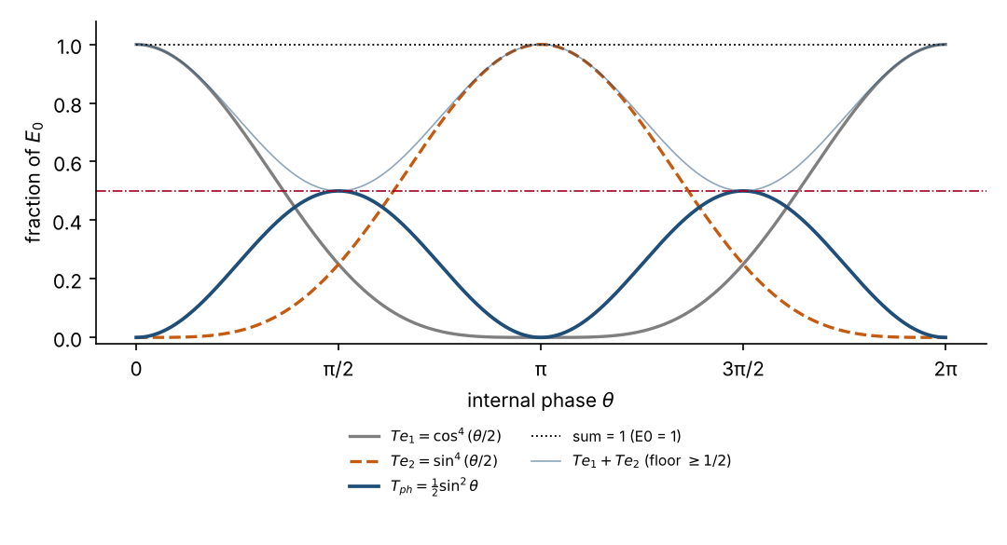
Figure 4-1: prepared by this book from the paper’s equations (normalised to E₀ = 1). Source: identity and Theorem 1 of Paper #46
Figure 4-1 shows that the sum Te₁ + Te₂ never falls below the dashed line at 1/2. The kinetic energy of the photon sphere reaches exactly 1/2 at θ = π/4 and 3π/4.

Chapter 5: Why the Fourth Power
Reader’s question: Why the fourth power and not the square?
The paper traces the fourth-power form of the kernel energies to the Stefan–Boltzmann law. The power radiated by a black body is proportional to the fourth power of its temperature (standard). By regarding the kernels as perfect black bodies, the paper derives this fourth-power form (0SM reading).
To test the role of the exponent, we replace it with a general 2n. Set Te₁ = cos^{2n}θ and Te₂ = sin^{2n}θ. The minimum of the sum occurs at θ = π/4 and equals 2 × (1/√2)^{2n} = 2^{1−n} (this book’s calculation).
Table 5-1: Relation between the exponent and the bound
Exponent 2n | n | Bound 2^{1−n} | Meaning
2 (square) | 1 | 1 | The sum is fixed at 1. The photon sphere has zero energy. The bound is trivial
4 (fourth power) | 2 | 1/2 | The paper’s case. Matches the ½ of zero-point energy
6 (sixth power) | 3 | 1/4 | The bound becomes 1/4
Source: calculation in this book of the generalisation in Paper #46
Caution | On the square case
In the square case, Te₁ + Te₂ = 1, so the photon sphere carries no kinetic energy. In this model the back-and-forth motion described by the paper does not occur. In that sense, the choice of the fourth power is a central premise of the paper’s argument.
The paper claims that the fourth power is “necessary”, but this rests on an analogy with black-body radiation. Whether the interpretation of thermal kernels is correct must be checked outside the paper.

Chapter 6: Correspondence with Zero-Point Energy
Reader’s question: Why does the paper regard E₀/2 as the same quantity as ½ℏω?
For a quantum harmonic oscillator, the ground-state energy is ½ℏω, and half of it is potential energy and half kinetic energy (the virial theorem, standard). The paper builds the correspondence as follows.
- The sum of the kernel potential energies, Te₁ + Te₂, corresponds to the potential energy of the harmonic oscillator (the paper’s correspondence).
- Its lower bound E₀/2 corresponds to the zero-point potential energy ¼ℏω (the paper’s correspondence).
- The kinetic energy T_ph of the photon sphere is also bounded from above by E₀/2. This corresponds to zero-point kinetic energy (the paper’s correspondence).
Care is needed here. The paper writes the zero-point potential energy as ¼ℏω and the total zero-point energy as ½ℏω. The use of these two values is somewhat ambiguous within the paper (this book’s reading). The paper reads the total E₀/2 = ½ℏω as “the minimum energy that cannot be extracted” (the paper’s description).

Chapter 7: The Bridge to the ZB Frequency
Reader’s question: On what basis does the paper regard E₀ and ℏω as the same quantity?
The paper writes the angular frequency of the Zitterbewegung (ZB) of Dirac theory as ω = 2mc²/ℏ (standard). This is the frequency arising from the interference between positive- and negative-energy solutions.
In 0SM, the same phenomenon is read as an internal energy transport. Its frequency is written as ν₀ₛ = βc/λ_C using the β of Paper #62 (0SM reading). Here λ_C = h/(mc) is the Compton wavelength of the electron, about 2.43 × 10⁻¹² m.
Table 7-1: Comparison of the two frequencies
Item | Dirac theory | 0SM (Paper #46)
Speed of the oscillation | Speed of light c | About 0.04047c (β c)
Angular frequency ω | 2mc²/ℏ ≈ 1.55 × 10²¹ rad/s | 2πν₀ₛ ≈ 3.14 × 10¹⁹ rad/s
Frequency ν (the paper’s notation) | ω/2π ≈ 2.47 × 10²⁰ Hz | ν₀ₛ ≈ 5.00 × 10¹⁸ Hz
Energy quantum | 2mc² ≈ 1022 keV | E₀ = hν₀ₛ ≈ 20.7 keV
Source: standard formulas and the paper’s equations, calculated by this book (see Appendix B)
The paper writes E₀ = hν₀ₛ = β m_e c² ≈ 20.7 keV. This is about 1/24.7 of the electron’s rest energy of 511 keV (this book’s calculation agrees). From this identification, the paper uses E₀ = ℏω to derive E_min = E₀/2 = ½ℏω.
Caution | Status of the identification
The paper calls this identification “phenomenological matching” and states that it is an assumption, not a derivation.
The paper argues that the identification has physical content on the premise that the internal oscillation is real. That premise is unconfirmed, because the Zitterbewegung of a free electron has not been observed directly.

Part III: Review

Chapter 8: Checking the Numbers
Reader’s question: Can the paper’s numbers be reproduced in this book?
We recalculated the paper’s numbers from standard constants (CODATA values) and the paper’s equations. The results are summarised in Table 8-1.
Table 8-1: Numerical checks
Item | Value in the paper | Recalculated in this book | Judgement
β (standard form from Paper #62) | 0.04047 | 0.040472 | Agrees
ν₀ₛ = βc/λ_C | 5.007 × 10¹⁸ Hz | 5.0007 × 10¹⁸ Hz | Minor rounding difference (about 0.1%)
ω₀ₛ = 2πν₀ₛ | 3.15 × 10¹⁹ rad/s | 3.14 × 10¹⁹ rad/s | Minor rounding difference
Dirac ν = ω/2π | 3.93 × 10²⁰ Hz | 2.47 × 10²⁰ Hz | Error (does not match the paper’s equation)
Dirac / 0SM frequency ratio | ∼78 | 49.4 | Error (agrees with 2/β = 49.4 stated elsewhere in the paper)
E₀ = hν₀ₛ | 20.7 keV | 20.68 keV | Agrees
mc²/E₀ | About 24.7 | 24.71 | Agrees
Minimum in Theorem 1 | 1/2 | 0.5 (numerical calculation) | Agrees
Source: this book’s checks. Constants are CODATA values; the method is given in Appendix B
Caution | Handling of the errors
The Dirac frequency of 3.93 × 10²⁰ Hz does not match the paper’s equation ω = 2mc²/ℏ. The value that follows from the calculation is 2.47 × 10²⁰ Hz.
The ratio ∼78 also does not match the value 49.4 that follows from the paper’s equations. The body of the paper contains a passage that reads as 49.4, so which value is correct must be confirmed with the paper’s author.
The conclusions of this book do not depend on these errors. However, the explanation “78 times slower than Dirac” is not correct.

Chapter 9: Checking the Logic
Reader’s question: Where in the paper does the argument depend on assumptions?
We examine the paper’s conclusions in four stages.
Table 9-1: The paper’s stages and this book’s judgement
Stage | Claim of the paper | This book’s judgement
Theorem 1 (lower bound E₀/2) | Derived from the identity | Correct. Can be proved rigorously with the arithmetic–geometric mean
Ceiling (T_ph ≤ E₀/2) | Another expression of the same constraint as the lower bound | Correct (follows directly from Theorem 1)
Choice of the fourth power | Follows from the Stefan–Boltzmann law for black-body radiation | Rests on an analogy. It is a question of interpretation of 0SM and does not follow from mathematics
E₀ = ℏω | Identification by phase matching | Assumption. Not derived (the paper also acknowledges this)
Source: each section of Paper #46, judged by this book
The paper’s argument for the fourth power has one further point to note. The paper states that the correspondence between the zero-point ½ and the exponent n = 2 is “necessary”. However, as Table 5-1 shows, the lower bound 1/2 for n = 2 is only one value among those obtained by varying the exponent. Why n = 2 is chosen depends on reasons outside the paper.

Chapter 10: The Treatment of the Remaining 96%
Reader’s question: If E₀ is 20.7 keV, where did the rest of the electron’s 511 keV go?
The paper accepts that E₀ is about 1/24.7 of the electron’s rest energy. For the remaining roughly 96%, it states that “this paper does not treat it, and it is an open problem”.
The paper further argues that this difference is not a defect of the 0SM framework. Dirac theory takes the internal speed to be c, while 0SM takes it to be βc. The paper reads the difference in the two theories’ numerical values as arising from this difference (the paper’s claim). This claim shows a difference in assumptions about the internal speed in the two theories.
Open | The problem of the remaining energy
The paper’s conclusion treats E₀ = βm_e c² as the total energy of the internal oscillation. In that sense, the paper says there is no “shortfall”.
However, how the total rest energy of the electron is distributed is not shown concretely in the paper. This point is one of the paper’s open questions.

Part IV: Open Questions and Next Steps

Chapter 11: The Paper’s Open Questions
Reader’s question: Which questions does the paper itself leave open?
The paper’s conclusion lists three open questions.
- Derive E₀ = ℏω from the equations of motion of 0SM (the paper’s first task).
- Show whether the generalised virial theorem holds for the lower bound E₀/2 (the paper’s second task).
- Show how the Casimir effect is treated in an ontology without field modes (the paper’s third task).
The paper also raises the question of whether the photon sphere contributes to the 511 keV mass of the electron. This book also treats that question as open.

Chapter 12: Relation to the Earlier Paper and How to Read
Reader’s question: How does this paper connect to the earlier paper?
Paper #46 complements the conclusions of an earlier paper. The earlier paper (corresponding to Paper #32, “Resolution of the vacuum energy problem”) argued that by not treating local field modes as independent physical degrees of freedom, the divergence of the cosmological constant is resolved. Paper #46 takes that resolution as a premise and then tries to explain the remaining factor ½ from the geometry of the energy identity (the paper’s description).
As a reading order, first confirm the premises in Volume 1 (#65), then check the identity and the theorem in Chapters 2 and 3 of this book, and finally look at the numerical and logical checks in Chapters 8 and 9.
- Paper #62 (bridge form): deals with the origin of the ZB speed β. It helps in understanding the numbers in Chapter 7 of this book.
- Paper #19 (spin as a real vector): deals with the relation between internal phase and the distribution of energy.
- Paper #52 (weak equivalence principle): deals with the geometry of the ZB axis.

Overall flow (figure)
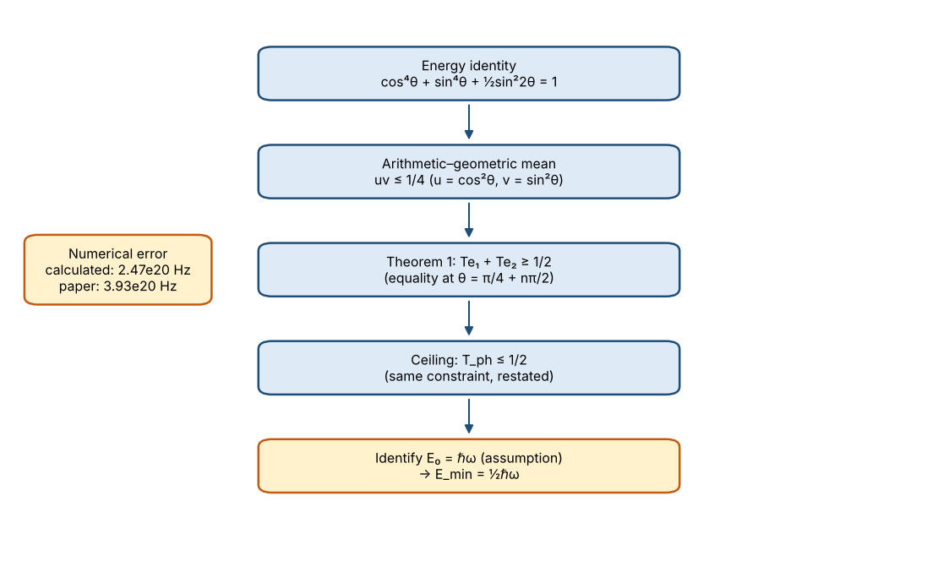
Figure 12-1: the paper’s argument, organised by this book

Appendices

Appendix A Glossary
Term | Meaning
Zero-point energy | Energy of the ground state of a quantum system. For a harmonic oscillator, ½ℏω
Uncertainty relation | The relation that the product of the spreads of position and momentum cannot be smaller than ℏ/2
Arithmetic–geometric mean inequality | The inequality stating that the arithmetic mean of two non-negative numbers is at least their geometric mean
Stefan–Boltzmann law | The law that the power radiated by a black body is proportional to the fourth power of its temperature
Virial theorem | For a harmonic oscillator, the time-averaged kinetic and potential energies are equal
Casimir effect | The force between conducting plates, explained by the change in zero-point energy
Zitterbewegung (ZB) | The rapid oscillation of the electron that emerges from the Dirac equation
Kernel | In 0SM, one of the two elements holding thermal potential energy
Photon sphere | In 0SM, the element that carries energy between the two kernels
Phase matching | The assumption used in the paper that identifies a physical quantity with a mathematical one
Source: definitions of terms in this book

Appendix B Checklist
The items checked by calculation in this book are summarised in the following table.
Item | Statement in the paper | Check in this book | Judgement
Identity cos⁴θ + sin⁴θ + ½sin²(2θ) = 1 | Holds | Confirmed to be 1 by numerical evaluation over θ | Correct
Lower bound of Theorem 1 | 1/2 | Numerical minimum 0.5 | Correct
Dirac ν | 3.93 × 10²⁰ Hz | 2.47 × 10²⁰ Hz | Error
Dirac / 0SM ratio | ∼78 | 49.4 | Error
E₀ = hν₀ₛ | 20.7 keV | 20.68 keV | Correct
mc²/E₀ | About 24.7 | 24.71 | Correct
Bound 2^{1−n} for general exponent n | Stated in the paper | Confirmed for n = 1, 2, 3 | Correct
Source: this book’s checks. Calculations use standard constants

Appendix C Exercises
Exercise 1: Confirming the bound
Question: Set u = cos²θ and v = sin²θ. Find the maximum of uv. Using this value, find the minimum of cos⁴θ + sin⁴θ.
Answer: uv = cos²θ sin²θ = (1/4) sin²(2θ), whose maximum is 1/4 (at θ = π/4). Therefore the minimum of cos⁴θ + sin⁴θ = 1 − 2uv is 1 − 2 × 1/4 = 1/2.
Exercise 2: Changing the exponent
Question: Take Te₁ = cos⁸θ and Te₂ = sin⁸θ. Find the bound in this case.
Answer: The exponent is 2n = 8, so n = 4. The bound is 2^{1−4} = 1/8.
Exercise 3: Ratio of the frequencies
Question: Find the ratio of ω_D = 2mc²/ℏ to ω₀ₛ = 2πβc/λ_C. Take β = 0.04047.
Answer: The ratio is (2mc²/ℏ) ÷ (2πβc/λ_C). Substituting λ_C = h/(mc) = 2πℏ/(mc), the factors of c, ℏ and π cancel, and the ratio becomes 2/β. For β = 0.04047 this is about 49.4. The paper’s “∼78” does not agree with this calculation.

Appendix D List of Figures and Tables
Number | Content | Source
Figure 4-1 | Three-way division of energy and the lower bound (E₀ = 1) | Prepared by this book from the paper’s equations
Table 1-1 | Two origins of zero-point energy | Introduction and correspondence section of the paper
Table 2-1 | Symbols used in this book | Notation section of the paper
Table 3-1 | Stages of the proof of Theorem 1 | Proof in the paper
Table 5-1 | Relation between the exponent and the bound | Calculation in this book
Table 7-1 | Comparison of the two frequencies | Standard formulas and the paper’s equations
Table 8-1 | Numerical checks | Checks in this book
Table 9-1 | The paper’s stages and this book’s judgements | Judgements of this book

Appendix E Correspondence with the Source
Section of Paper #46 | Chapter of this book
Introduction | Chapters 1, 2
Energy identity and geometric lower bound (Theorem 1) | Chapters 2, 3
Ceiling and stationary points (Symmetry character) | Chapter 4
Role of the fourth power (Why the fourth-power structure is essential) | Chapter 5
Relation to zero-point energy (Relation to Zero-Point Energy) | Chapter 6
Bridge to the ZB frequency (The bridge) | Chapter 7
Relation of the vacuum energy to the earlier paper | Chapter 12
Discussion and open questions (Discussion, Open questions) | Chapters 10, 11

Appendix F Summary Card
Key point | Summary card
Theorem 1: cos⁴θ + sin⁴θ ≥ 1/2. It can be shown with the arithmetic–geometric mean inequality. Equality holds at θ = π/4 + nπ/2.
The kinetic energy of the photon sphere is bounded from above by E₀/2 under the same constraint.
With exponent n = 2, the bound is 1/2. This is the same value as the ½ of zero-point energy.
The identification E₀ = ℏω is an assumption of the paper. It has not yet been derived.
The paper’s ν = 3.93 × 10²⁰ Hz and ∼78 do not match its equations. The calculated values are 2.47 × 10²⁰ Hz and about 49.
The next paper to read is #62 (bridge form).

Appendix G Mathematical Toolbox
The standard tools used in this book are collected here. Readers who already know them may skip this section.
Tool | Content
Arithmetic–geometric mean inequality | For non-negative numbers u and v, (u + v)/2 ≥ √(uv). Equality holds only when u = v (standard).
Double-angle formulas | sin 2θ = 2 sinθ cosθ, and cos²θ + sin²θ = 1 (standard).
Zero-point energy | The ground-state energy of a harmonic oscillator is ½ℏω (standard).
Stefan–Boltzmann law | The power radiated by a black body is proportional to the fourth power of its temperature T (standard).
Compton wavelength | λC = h/(mc) ≈ 2.43 × 10⁻¹² m. The reduced Compton wavelength is ℏ/(mc), which is smaller by a factor 2π (standard).
Energy and frequency | E = hν. 1 eV = 1.602 × 10⁻¹⁹ J, h = 6.626 × 10⁻³⁴ J·s (standard).
Source: content of standard textbooks, organised by this book

Appendix H Quiz (with answers)
Questions to test the content of this book. Answers are given in the right-hand column.
No. | Question | Answer
1 | With u = 0.3 and v = 0.7, what are uv and cos⁴θ + sin⁴θ? | uv = 0.21, and the sum = 1 − 2 × 0.21 = 0.58. This satisfies the lower bound 0.5.
2 | For exponent 2n = 6, what is the bound? | 2^{1−n} = 2^{−2} = 1/4 (n = 3).
3 | For E₀ = 20.68 keV, what is the frequency ν = E/h? | About 5.0 × 10¹⁸ Hz.
4 | What is the ratio of the Dirac ω to the 0SM ω₀ₛ? | About 49 (= 2/β). The paper’s “∼78” does not agree.
5 | How is the identification E₀ = ℏω positioned in the paper? | As an assumption by phase matching, not a derivation. The paper itself says so.
Source: prepared from the content of this book

