0-Sphere Model Primer (Volume 5)
Background knowledge for reading Paper #62: “The Bridge Equation γ = 1 + a from First Principles”
Source paper: Paper #62 (published). Full title: The Bridge Equation γ = 1 + a from First Principles: Representation Duality of the Anomalous Moment and the Geometric Origin of the Root-Mean-Square Factor in the 0-Sphere Model
Purpose of this primer: This book explains the claims of Paper #62 so that first- and second-year undergraduates can follow them. It addresses the “bridge equation” that links the anomalous magnetic moment a and the internal speed of the electron (the ZB speed). It assumes the content of Volume 1 (Paper #65).
Date prepared: 13 November 2026
Notation convention: Standard facts of mathematics and physics are labelled “standard”. Interpretations and proposals of the 0-Sphere Model are labelled “0SM reading”. Where the paper itself states that a point is unresolved, this book also treats it as unresolved.
Caution | What to know before reading
Paper #62 tries to derive, from an identity, the origin of the factor 1/√2 that appears in the form of the bridge equation that fixes the speed.
The paper itself limits the status of its result. What it derives is a “ratio at the speed stage”. Whether that ratio agrees with the “placement at the a stage” remains an open problem stated in the paper (Chapter 8). This book follows the same limitation.

Contents
Part | Chapters | Content | What the reader gains
Summary | — | The paper’s conclusions and this book’s review findings, stated first | An overview of the whole
Part I | Ch. 1–2 | What the bridge equation is. Reading the anomalous moment from two sides | The question and its premises
Part II | Ch. 3–7 | The momentum term and 1/√2, the pulsating-radius helix, winding number of the unit, three routes, limits of interpretation | The flow of the paper’s argument
Part III | Ch. 8–10 | The placement problem, numerical checks, logical checks | What can and cannot be claimed
Part IV | Ch. 11–12 | Open problems, relation to the earlier volumes, how to read | The next step
Appendices | A–H | Glossary, checklist, exercises, list of figures and tables, correspondence with the source, summary card, mathematical toolbox, quiz | Review and re-checking
Source: structure of this book

Summary
Paper #62 attempts to ground, from first principles, the bridge equation that links the electron’s anomalous magnetic moment a_e with the internal speed of the Zitterbewegung (ZB).
Key point | The paper’s conclusions
The bridge equation has two forms. The form that fixes the mass is γ = 1 + |a|, and the form that fixes the speed is γ_v = 1 + |a|/√2 (the paper’s equations).
The factor 1/√2 emerges from the identity as the square root of the ratio between the time average and the maximum of the momentum term ½ sin²θ. This is the paper’s main result (checked in Appendix B).
The same 1/√2 also appears in the maximum radius of a helix with a pulsating radius and in the projection of the winding unit. The paper presents these as three views of one origin.
However, the value derived is a “ratio at the speed stage”. The paper itself states that correspondence with the normal form, which places 1/√2 on the a side, is unresolved (a discrepancy of 2^{1/4}).
Caution | What this book’s review found
The numbers are correct: the normal-form β = 0.040472, the maximum speed 0.04812c, and the speed-stage value 0.03402c can be reproduced by this book’s calculations (Chapter 9).
The discrepancy is as the paper states: the ratio between the normal-form value and the speed-stage value is 2^{1/4} ≈ 1.19. This matches the paper’s description.
Limits of “necessity”: because the radius is defined as the square root of the momentum term, a maximum radius of 1/√2 follows from the definition. It is not an independent check (Chapter 10).
A small approximation: where the contraction of the internal arc is written as a_e, strictly it should be a/(1+a), a first-order approximation in a (Chapter 8).
Open | Open issues
Why the ratio 1/√2 should be placed on the a stage (an open problem stated in the paper).
Whether the helix with a pulsating radius follows from the geometry of rotation, or is a chosen construction.

Part I: Question and Premises

Chapter 1: What the Bridge Equation Is
Reader’s question: Can the internal speed of the electron be known from its anomalous magnetic moment?
The electron behaves like a magnet, and its magnetic moment deviates slightly from the value g = 2. This deviation is called the anomalous magnetic moment a_e. Its measured value is about 1.16 × 10⁻³, and it has been measured with very high precision (standard).
In the 0-Sphere Model, this a_e is linked to the speed of the internal Zitterbewegung. The bridge equation assumed by Paper #62 takes the following form (the paper’s equation).
√(1 − v²/c²) = 1 / (1 + a_e / √2)
Solving this equation gives v/c ≈ 0.04047. This book’s calculation also reproduces 0.040472 (see Appendix B).
Table 1-1: The two forms of the bridge equation
Form | Equation | What it fixes | Position in the paper
Form that fixes the mass | γ = 1 + |a| | Scale of the internal mass (peak value) | The equation on which the paper builds
Form that fixes the speed | γ_v = 1 + |a| / √2 | Internal speed (representative value over a period) | The paper’s subject: grounding the origin of 1/√2
Source: introduction and discussion of Paper #62, organised by this book
Key point | Key points for reading
The only difference between the “mass form” and the “speed form” is the presence of 1/√2. The paper states that this difference comes from the difference between the “maximum value” and the “representative value” within a cycle.
The paper states that the bridge equation can be read within the scope of special relativity. It does not include gravitational effects (the paper’s description).

Chapter 2: Reading the Anomalous Moment from Two Sides
Reader’s question: Can the same a_e be read both from external measurement and from internal geometry?
The paper regards a_e as an invariant that does not depend on the frame. This invariant appears from two sides.
- External description: measurement in a Penning trap. a_e is expressed as the ratio of the cyclotron period T_c to the anomalous period T_a (standard). The equation is a_e = T_c / T_a.
- Internal description: in the 0SM reading, a_e is expressed as the contraction of an internal arc length. It is written as a_e = (L₀ − L) / L₀ (0SM reading).
The paper uses γ_L = 1 + a_e as the translating factor that links the two. This has a structure similar to the way one Lorentz transformation in special relativity stretches time and contracts length (the paper’s analogy).
Table 2-1: The two descriptions
Aspect | External description (Penning trap) | Internal description (0SM reading)
Kind of quantity | Ratio of times (ratio of periods) | Ratio of lengths (contraction of arc)
Operation | Measure two frequencies | Compare internal arc lengths
Orders of magnitude of the periods | T_c ≈ 6.8 × 10⁻¹² s, T_a ≈ 5.9 × 10⁻⁹ s | T_ZB ≈ 2.0 × 10⁻¹⁹ s
Dependence on the magnetic field B | Depends | Does not depend
Source: sections of Paper #62. The orders of magnitude of the periods are back-calculated from a_e and T_ZB by this book (see Appendix B)
Caution | The paper’s own limitation
The paper states explicitly that, because a_e does not depend on the magnetic field, one cannot conclude that its origin is internal geometry. Standard quantum electrodynamics also computes a_e as a vertex correction in the absence of a field, so independence from the field does not choose between the two explanations.
What the paper claims is a weak statement: the kinematic description of the interior is consistent with a_e. It does not claim that the internal description is privileged.

Part II: The Paper’s Argument

Chapter 3: The Momentum Term and 1/√2
Reader’s question: Why does the representative speed carry exactly the factor 1/√2?
The paper reads the identity as a relation between relativistic energy and momentum. The two terms of the identity correspond as follows (the paper’s reading).
- Mass part: cos⁴(θ/2) + sin⁴(θ/2) = 1 − ½ sin²θ. This corresponds to (mc²/E)² (the paper’s reading).
- Momentum part: γ*_KE = ½ sin²θ. This corresponds to (pc/E)² (the paper’s reading).
The sum of the two is 1 for every θ. The speed is given by the square root of the momentum fraction (using the standard relation v/c = pc/E).
v/c = √(γ*_KE) = (1/√2) |sinθ|
The momentum term reaches its maximum value 1/2 at θ = π/2. Its average over a period is (standard integral).
⟨γ*_KE⟩ = (1/2π) ∫₀^{2π} ½ sin²θ dθ = 1/4
The value of the representative speed depends on whether one averages first and then takes the square root, or takes the square root first and then averages. The paper chooses to average the conserved quantity and then take its square root. The ratio is as follows.
√(⟨γ*⟩ / max γ*) = √((1/4) / (1/2)) = 1/√2
This is the central result of the paper. The same 1/√2 appears as the coefficient of the bridge equation. The paper describes it as “a quantity intrinsic to the identity, not an analogy imported from outside”.
Key point | The paper’s central result
From the identity, 1/√2 emerges as the square root of the ratio between the representative value over a period and the maximum (verified in this book).
The paper carefully calls this ratio the “ratio at the speed stage”. Placement at the a stage is treated as a separate problem (Chapter 8).

Chapter 4: The Pulsating-Radius Helix
Reader’s question: How is the momentum term drawn as a spatial figure?
The paper describes the helical motion of the photon sphere as a helix whose radius changes with time. The square of the radius is set to agree with the momentum term (the paper’s construction).
R(θ) = (1/√2) |sinθ|, R² = γ*_KE
The radius of this helix is zero on the kernels (θ = 0, π). There, the momentum of the photon sphere is zero. The maximum radius is 1/√2 at θ = π/2. The paper states that this construction is faithful to the structure of the two kernels.
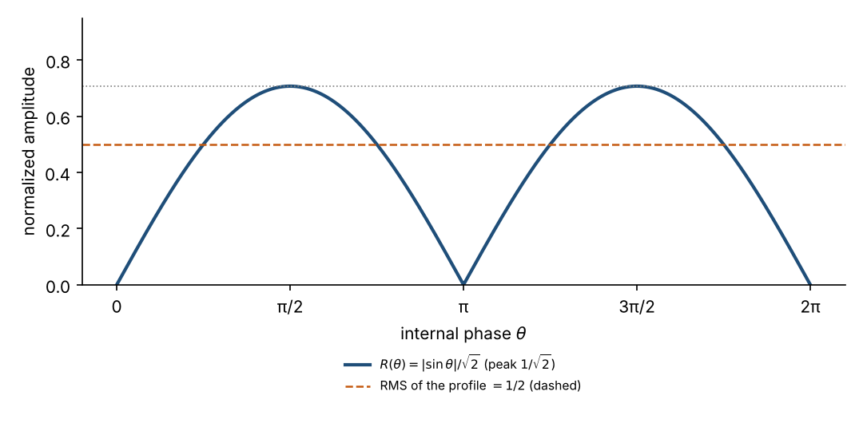
Figure 4-1: prepared by this book from the paper’s equation R(θ) = |sinθ|/√2. Source: helix section of Paper #62
Figure 4-1 shows that the square root of the period average of the radius (dashed line) is 1/2, and that its ratio to the maximum 1/√2 is 1/√2.

Chapter 5: Winding Numbers of the Unit: SU(2) and U(1)
Reader’s question: How many turns does the helix make, and how is that number determined?
The paper states that the internal phase θ appears on two scales (the paper’s reading).
- The kernel amplitudes are written as cos(θ/2) and sin(θ/2), with period 4π (720°). This corresponds to objects of SU(2) (spinors) (standard mathematics).
- Their fourth powers have period 2π (360°). The momentum term ½ sin²θ also belongs to the energy scale with period 2π. This is the scale of U(1) (standard mathematics).
Since the speed is the square root of the momentum term, it belongs to the energy scale (period 2π). The paper therefore states that it is natural to take the winding number of the speed description as 1. Using a helix with winding number 1, the ratio of the projection coincides with 1/√2.
The projection ratio is computed as follows. The x component of the helix is cosθ, and the average of the square of its derivative is 1/2. The average of the square of the total speed is 1. The ratio is therefore √(1/2) = 1/√2 (checked by this book’s calculation).

Chapter 6: Three Routes, One Origin
Reader’s question: 1/√2 appears in three different calculations. Is that a coincidence?
The paper organises the appearances of 1/√2 as follows.
Table 6-1: Three appearances of 1/√2
Route | Calculation | Result
Representative value and maximum over a period | √(⟨γ⟩ / max γ) | 1/√2
Maximum radius of the helix | √(max γ*) = √(1/2) | 1/√2
Projection of the winding-1 helix | √(⟨ẋ²⟩ / ⟨|ṙ|²⟩) | 1/√2
Source: three routes of Paper #62, organised by this book
The paper states that because all three routes come from the same momentum term, the agreement is not a coincidence. Chapter 10 examines this point.

Chapter 7: Limits of Interpretation
Reader’s question: How far does the paper claim, and where does it refrain from claiming?
The paper limits its claims in three respects.
- Scope of special relativity: the bridge equation is read within the framework of Dirac’s equation (flat spacetime). Gravitational effects are outside the paper’s scope (the paper’s description).
- Not a new prediction: the paper states that it is a re-grounding of an existing relation, not a prediction that departs from standard theory (the paper’s description).
- Placement on the a side is unresolved: the paper does not decide whether 1/√2 enters on the a side or on the speed side (Chapter 8).
This limitation shows both the strength of the paper and its boundaries. Readers need to keep these distinctions in mind.

Part III: Review

Chapter 8: The Placement Problem
Reader’s question: If 1/√2 is placed on the a side, what value results? What happens if it is placed on the speed side?
Because the bridge equation is nonlinear, the ratio cannot simply be moved from the a side to the speed side. The paper treats this point explicitly.
Since a for the electron is small, the bridge equation can be written approximately as v ≈ c√(2a) (standard expansion). Replacing a by a/√2 multiplies the speed by 2^{−1/4} ≈ 0.841. On the other hand, multiplying the speed by 1/√2 gives a factor 1/√2 ≈ 0.707. These two do not agree.
Table 8-1: Values for the two placements
Placement | Calculation | Value (in units of c)
Normal form (1/√2 on the a side) | Use 1 + |a|/√2 | 0.040472
Speed side (1/√2 applied to the maximum) | v_max / √2 | 0.034024
Maximum (no 1/√2 on the a side) | Use 1 + |a| | 0.048117
Source: this book’s calculation (see Appendix B)
Caution | The paper’s open problem
The normal-form value and the speed-side value differ only by 2^{1/4} ≈ 1.19. The paper records the origin of this difference as an “open problem”.
The paper suggests a candidate: because the helix radius is proportional to the absolute value of sin, the contraction of the arc is proportional to the transverse amplitude. However, the paper has not yet shown this proportionality from the geometry of rotation.
The importance of this problem appears in later papers. Later papers use the normal-form value 0.040472 to carry over the numerical value of the ZB speed. In other words, the later numbers depend on the normal-form placement, not on the speed-side ratio derived in Paper #62.

Chapter 9: Numerical Checks
Reader’s question: Can the paper’s numbers be reproduced in this book?
We recalculated the paper’s numbers from standard constants and the paper’s equations. The results are as follows.
Table 9-1: Numerical checks
Item | Value in the paper | Recalculated in this book | Judgement
β of the normal form | 0.04047 | 0.040472 | Agrees
Maximum speed v_max (no 1/√2) | 0.0481 c | 0.048117 c | Agrees
Speed-side value v_max / √2 | About 0.0340 c | 0.034024 c | Agrees
Ratio of the two values | 2^{1/4} ≈ 1.19 | 1.1895 | Agrees
Ratio of period average to maximum | 1/√2 | 0.70711 | Agrees
Ratio of the helix projection | 1/√2 | 0.70711 | Agrees
T_c / T_ZB | About 3.4 × 10⁷ | From T_ZB = 2.0 × 10⁻¹⁹ s, T_c ≈ 6.8 × 10⁻¹² s | Ratio agrees. The way T_c is written (10⁻¹² s) is rough in order of magnitude
Arc contraction and a_e | a_e = (L₀ − L)/L₀ | Strictly a/(1+a). First-order approximation: a | Reasonable as an approximation. The exact expression should be written
Source: this book’s checks. Constants are CODATA values; the method is given in Appendix B
Caution | Relation to the earlier volume
The earlier volume (commentary on Paper #51) used v_ZB ≈ c√(2a_e) ≈ 0.048c. This corresponds to the maximum speed of the present paper.
The β = 0.040472 of Paper #65 is the value of the normal form. Which of the two values is used must be made consistent across the volumes (see also Appendix B of Volume 1).

Chapter 10: Checking the Logic
Reader’s question: How far is the paper’s conclusion supported logically?
We examine the paper’s conclusions in four parts.
Table 10-1: The paper’s claims and this book’s judgement
Claim | Status in the paper | This book’s judgement
The factor 1/√2 is intrinsic to the identity | Derived (the paper’s wording) | Correctly derived as a ratio of representative and maximum values over a period. However, it includes the choice of how the representative value is taken
The maximum radius of the helix agrees with 1/√2 | “Not a coincidence” (the paper’s wording) | Follows from the definition R² = γ*, so it is a consequence of the definition. Not an independent check
The three routes share one origin | Three views of one momentum term (the paper’s wording) | All three come from the same γ*, so this is correct. However, their independence is limited
Placement on the a side | Unresolved (the paper’s wording) | Remains unresolved. Later numerical values depend on this placement
Source: each section of Paper #62, judged by this book
On the choice of representative value in particular, the paper compares three candidates: the square root of the average (1/√2 ≈ 0.707), the simple average (2/π ≈ 0.637), and the naive 1/2. The paper states that the square root of the average is natural as a representative value of a second-order quantity. This choice is the most important premise in the paper’s logic.
Established | What the paper states correctly
The derivation of 1/√2 from the identity is correct as a calculation.
The calculation of the helix projection agreed with this book’s numerical calculation.
The difference between the normal-form value and the speed-side value is 2^{1/4}, as the paper describes.

Part IV: Open Problems and Next Steps

Chapter 11: The Paper’s Open Problems
Reader’s question: What does the paper itself leave unresolved?
- Show why the ratio 1/√2 should be placed on the a side (the paper’s first problem).
- Explain the origin of the 2^{1/4} discrepancy (part of the paper’s first problem).
- Show whether the proportionality of the helix radius follows from the geometry of rotation (a candidate in the paper).
- Treat the behaviour of the bridge equation under gravity in a separate paper (outside the paper’s scope).

Chapter 12: How to Read and Next Steps
Reader’s question: How does this paper connect to the other papers?
Paper #62 connects to other papers as follows.
- Paper #65 (Volume 1): uses the value β = 0.040472, and assumes the a_e of the Penning trap.
- Paper #46 (Volume 4): uses β to compute the ZB frequency ν₀ₛ.
- Paper #52 (Volume 6): uses β as the coefficient of force, F = m g β.
- Paper #51: the v ≈ 0.048c treated in the earlier volume corresponds to the maximum speed of the present paper.
As a reading order, first confirm the relation between a_e and β in Volume 1 (#65), then follow the derivation of 1/√2 in Chapters 3 and 4 of this book. Keep the placement problem of Chapter 8 in mind throughout when reading the later papers.

Overall flow (figure)
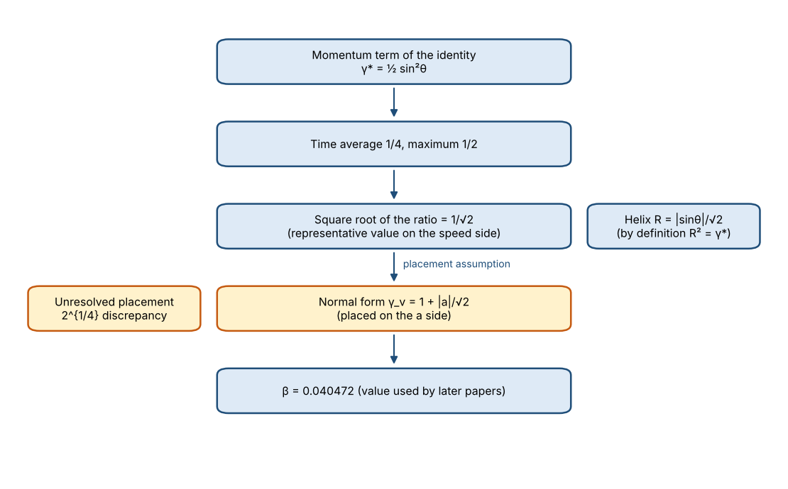
Figure 12-1: the paper’s argument, organised by this book

Appendices

Appendix A Glossary
Term | Meaning
Anomalous magnetic moment a_e | Deviation of the electron’s magnetic moment from g = 2. Measured value about 1.16 × 10⁻³
Bridge equation | The equation linking a_e and the internal speed. It has a mass form and a speed form
Penning trap | Apparatus that confines an electron with magnetic and electric fields and measures its periods
Cyclotron period T_c | Period of one circuit of the electron in the magnetic field
Anomalous period T_a | Period of the extra precession of the spin. a_e = T_c / T_a
Zitterbewegung (ZB) | The rapid oscillation of the electron that emerges from the Dirac equation
Momentum term | ½ sin²θ in the identity. Corresponds to the momentum fraction of the photon sphere (0SM reading)
Helix with a pulsating radius | Helical motion of the photon sphere whose radius changes with time (0SM reading)
Spinor | An object of SU(2) whose sign reverses under a 2π rotation
Normal form | The form γ_v = 1 + |a|/√2 that the paper uses as its standard
Translating factor γ_L | The factor linking the ratio of external times and the ratio of internal lengths (the paper’s description)
Source: definitions of terms in this book

Appendix B Checklist
Item | Statement in the paper | Check in this book | Judgement
Identity cos⁴(θ/2) + sin⁴(θ/2) = 1 − ½ sin²θ | Holds | Confirmed by numerical evaluation | Correct
⟨γ⟩ = 1/4, max γ = 1/2 | Stated in the paper | Confirmed by numerical integration (0.249999) | Correct
√(⟨γ⟩/max γ) = 1/√2 | Stated in the paper | Confirmed to be 0.707105 | Correct
β (normal form) | 0.04047 | 0.040472 | Correct
v_max (no 1/√2) | 0.0481 c | 0.048117 c | Correct
Speed-side value | 0.0340 c | 0.034024 c | Correct
Ratio of the two values | 2^{1/4} | 1.18951 (2^{1/4} = 1.18921) | Correct
Helix projection | 1/√2 | 0.70711 | Correct
Arc contraction | Written as a_e | a/(1+a) is exact | Reasonable as an approximation
T_c | ∼10⁻¹² s | About 6.8 × 10⁻¹² s (back-calculated from the ratio) | Rough in order of magnitude
Source: this book’s checks. Calculations use standard relations and the paper’s equations

Appendix C Exercises
Exercise 1: The average over a period
Question: Find the average of sin²θ over one period. Using this value, find the average of ½ sin²θ.
Answer: The average of sin²θ is 1/2 (because the averages of sin² and cos² are equal and their sum is 1). Therefore the average of ½ sin²θ is 1/4.
Exercise 2: The square root of the ratio
Question: With ⟨γ⟩ = 1/4 and max γ = 1/2, find √(⟨γ⟩ / max γ).
Answer: The ratio is (1/4)/(1/2) = 1/2. Its square root is 1/√2 ≈ 0.707.
Exercise 3: Approximating the arc contraction
Question: With γ_L = 1 + a, express (L₀ − L)/L₀ in terms of a. Compare it with the approximation a for a = 0.00116.
Answer: Since L = L₀/γ_L, (L₀ − L)/L₀ = 1 − 1/γ_L = a/(1 + a). For a = 0.00116, a/(1 + a) = 0.0011587, which differs from a = 0.00116 by about 0.1%. This is a reasonable first-order approximation.

Appendix D List of Figures and Tables
Number | Content | Source
Figure 4-1 | Helix radius, with representative and maximum values | Prepared by this book from the paper’s equation
Table 1-1 | The two forms of the bridge equation | Introduction of the paper
Table 2-1 | The two descriptions of the anomalous moment | Sections of the paper and this book’s calculation
Table 6-1 | Three appearances of 1/√2 | Three routes of the paper
Table 8-1 | Values for the two placements | This book’s calculation
Table 9-1 | Numerical checks | Checks in this book
Table 10-1 | The paper’s claims and this book’s judgements | Judgements of this book

Appendix E Correspondence with the Source
Section of Paper #62 | Chapter of this book
Introduction and the invariant a_e (Section 2) | Chapters 1, 2
Momentum term and 1/√2 (Section 3) | Chapter 3
Helix with a pulsating radius (Section 4) | Chapter 4
SU(2) amplitudes and U(1) energy (Section 5) | Chapter 5
Three routes and discussion (Discussion) | Chapters 6, 7
Placement problem (second half of Section 3) | Chapter 8
Scope of the theory (Appendix) and genealogy (Genealogy) | Chapters 7, 12

Appendix F Summary Card
Key point | Summary card
The bridge equation has two forms. The mass form is γ = 1 + |a|, and the speed form is γ_v = 1 + |a|/√2.
1/√2 emerges from the momentum term ½ sin²θ as the square root of the ratio between the representative value over a period and the maximum.
The same 1/√2 appears in the maximum radius of the helix and in the projection of the winding-1 unit. However, since the radius is √γ* by definition, this is not an independent check.
The normal form (0.040472) and the speed-side value (0.034024) differ by 2^{1/4}. This difference is an open problem stated in the paper.
The β = 0.040472 used in later papers depends on the normal form. The 0.048c treated in the earlier volume corresponds to the maximum speed.
The next papers to read are #46 (zero-point energy) and #52 (weak equivalence principle).

Appendix G Mathematical Toolbox
The standard tools used in this book are collected here. Readers who already know them may skip this section.
Tool | Content
Average over a period | The average of sin²θ over one period is 1/2. Since the sum of sin²θ and cos²θ is 1, each average is 1/2 (standard).
Mean and RMS | The root mean square (RMS) is the square root of the mean of the squares. The key point is the order of operations: average the squares first, then take the square root (standard).
Lorentz factor and length contraction | γ = 1/√(1 − v²/c²). The length along the direction of motion is L = L₀/γ (standard).
Anomalous magnetic moment | The magnetic moment of the electron is written g = 2(1 + a_e). a_e ≈ 1.16 × 10⁻³ (standard).
Penning trap | The electron is confined by magnetic and electric fields, and the frequencies of cyclotron motion and anomalous precession are measured. a_e is obtained from their ratio (standard outline).
First-order approximations | For small a, a/(1+a) ≈ a and √(1 + x) ≈ 1 + x/2 are used (standard).
Source: content of standard textbooks, organised by this book

Appendix H Quiz (with answers)
Questions to test the content of this book. Answers are given in the right-hand column.
No. | Question | Answer
1 | What is the average of sin²θ over one period? | 1/2.
2 | What is the maximum of the square root of the momentum term, whose maximum is 1/2? | 1/√2 ≈ 0.707.
3 | With a = 0.00116, what is 1 + a/√2? | About 1.00082.
4 | With β = 0.040472, what is the Lorentz factor γ? | About 1.00082. Calculate as 1/√(1 − β²).
5 | What is the ratio between the normal-form value and the speed-side value? | About 1.19 (2^{1/4}). The paper states that this ratio is unresolved.
Source: prepared from the content of this book

