A Model of An Electron Including Two Perfect Black Bodies
Satoshi Hanamura*
This paper modifies two significant points of existing theory. First, the image of a virtual photon is replaced with a real one. A bare electron captures the photon. Second, it is assumed that the bare electron is a perfect black body. To meet the constraints of charge conservation, a virtual photon must include two bare electrons. There is a temperature gradient between the two because the two particles alternate between behaving as emitters and absorbers. Presently, it is considered an electron consists of two blinking bare electrons and at least one real photon.
I. INTRODUCTION
In spite of significant experimental efforts, a perfect black body [1] has not yet been found in nature [2]. This study not only proves that an electron is a perfect black body but assumes that this is the case and build upon this assumption to contribute to a flourishing branch of physics. It is natural to think that an electron is not a perfect black body; nevertheless, remaking our view of the electron allows us to imagine this elementary particle as consisting of oscillators.
I begin by discussing virtual photons and fluid dynamics, upon which the proposed model is based. Then, the structure of the Sun is discussed and it is assumed that an electron has similarities in terms of being a perfect fluid (a concept that comes from astrophysics and fluid dynamics). These fields of knowledge form the center of the proposed model.
On the contrary, this electron model also suggests a structure for the electron. It is assumed that an electron consists of two bare electrons with both being black bodies. This reorganization constitutes a new image of the electron.
These two bare electrons exchange heat energy in the form of radiation through virtual photons. This is possible because those two bare electrons are inside of the virtual photon. The two black bodies exchange heat energy through the virtual photon as a real photon.
While the two black bodies emit and absorb heat energy, they do not do so in an equal proportion because of a margin cosine and sine powered four. The total energy does not change because this model uses an isolated system. To ensure that energy is conserved, the rest of amount shall be transported by the virtual photon in the form kinetic energy.
It will be shown that the virtual photon moves in space with its velocity changing from zero to maximum in a manner similar to a harmonic oscillator. The velocity comes from energy released {2.1 [JP] 英単語・語句のご確認をお願いします。} by the velocity potential. The temperature gradient forms this potential. This gradient, in turn, arises from the energy difference between the two bare electrons.
For reference, this model concerns electrons moving significantly below the speed of light; thus, relativistic effects are not considered.
II. MODELING
A. Modification of a Virtual Photon
Image a free electron. For the purposes of this electron model, change the concept of a virtual photon into a real one; in this paper, the term “virtual photon” shall be used to describe a real photon captured by a bare electron with coupling constant of α.
To clarify our image of a captured virtual photon, we use the concept of “hydrostatic equilibrium” from fluid mechanics.
Gravity is balanced by a pressure-gradient force in the Sun. The inner structure of an electron is comparable with the balancing of the Sun as a self-gravitating gas sphere.

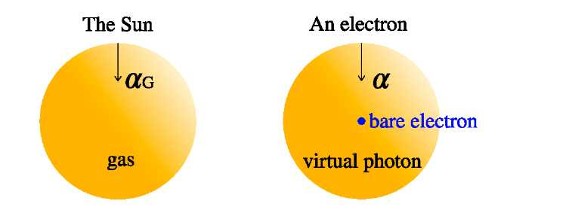
FIG. 1. Two spheres and the central force
Gravity points toward {2.1 [JP] 英単語・語句のご確認をお願いします。} the center of the Sun. Equivalently, the electromagnetic force points toward the center of an electron.
A means of determining the internal structures of stars is well established. First, calculate the stellar radius using the hydrostatic equilibrium equation [5] from fluid dynamics:

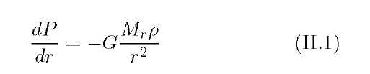
This equation yields the Lane–Emden equation, Eq. (II.2):

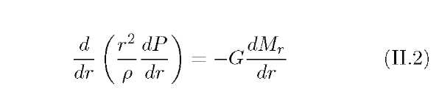
The pressure P is related to the density as P:

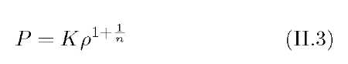
This is known as the polytropic equation, where K is constant. The last two equations belong to the field of astrophysics.
Polytropes are one type of fluid. Using the polytropic equation, such polytropes can be regarded as perfect fluids. Let us apply this fact to the virtual photon in this model.
However, referencing Coulomb potential V = (−e2)/(4neor), the spherically symmetric potential energy depends only upon the distance, r. In a similar manner, let us hypothesize that the shape of the virtual photon is spherical.
To simplify the model, we assume the following.
Assumption: A virtual photon is a perfect fluid and captured by the central force of a bare electron.
Therefore, the virtual photon captured by the electromagnetic force does not emit any electromagnetic radiation and has no oscillation at this moment. By this logic, a virtual photon can be replaced by a real photon spread over a certain length. Yet a bare electron has a radius <1018 m.
Thus, let us modify the term “virtual photon” to refer to a real photon captured by the bare electron, which exists all the time.
Assumption: Reinterpret a virtual photon as a real photon captured by the potential energy of a bare electron.
To clarify this free-electron model, I explain that only the bare electron has potential energy in a subsequent section. That is, the virtual photon has all kinetic energy and the bare electron has all potential energy.
B. An Electron Contains Black Bodies
In this subsection, I interpret the bare electron as a black body. To push the model forward, let us make another assumption.
Assumption: A bare electron is a perfect blackbody and radiates its energy harmonically through time-dependent oscillation.
This bare electron has a bare mass, and we handle its mass by temperature, T. We postulate that this black body oscillates time dependently according to an arbitrarily chosen cosine function:

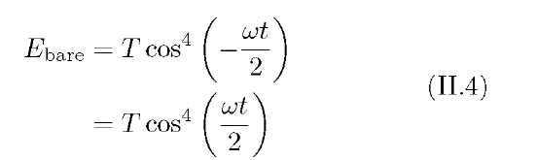
There is no element cos(kx) in the above equation, because we assumed the bare electron to have a fixed position and not to oscillate back and forth in space. This immovability is shown using the delta function:

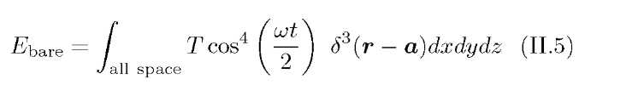
To simplify the model, assume one-dimensional coordinates and set the center of the bare electron at (x = 0). The change of energy of the bare electron with respect to time is shown in Fig. 2.

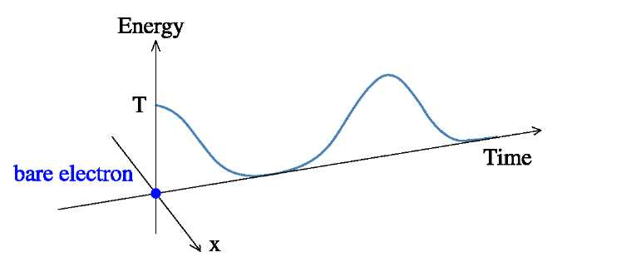
FIG. 2. Plots of Tcos4 (%r), which is the change in the energy waveform with a bare electron at location x = 0.
Figure 2 shows that the bare electron black body has two phases. One is absorbing and the other is emitting.
Using 8 instead of Lot, cos4(|) is classified into two phases by reference to Fig. 3. As a bare electron is a spinor, the same curve is observed when plotting f(8) = cos4(|) or Tcos4 (^*) with T = 1.
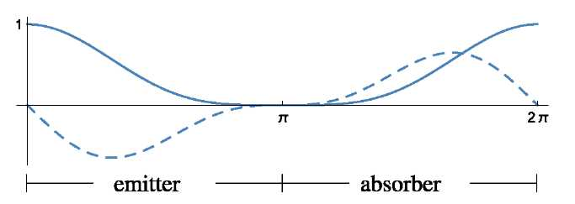
Fig.

3. Plots of of f(θ) = cos4 and f′(θ) = −2cos3 sin

Except stationary points on f(θ) = cos4, if f′(θ) = −2cos3 sin were minus, while 0 < < π in Fig. 3, the energy of the black body is decreasing. This is the emittance phase. On the other hand, if f′(8) = −2cos3(f) sin(f) were positive, the energy of the one {1.2 [JP] 文意が不明瞭です。意味を明確にして下さい。} is increasing due to energy absorption.
C. The Necessity of the Paring Oscillator
According to Figs 2 and 3, the bare electron energy is zero when 8 = n. If the bare electron vanished at 8 = n, this would allow a virtual photon without a bare electron to exist, contradicting {2.1 [JP] 英単語・語句のご確認をお願いします。}charge conservation, since photons cannot carry an electric charge.
To maintain charge conservation, we take in another bare electron. These two electrons act as both emitters and absorbers in turn.
To meet the requirements for simultaneous emission and absorption, assign different phases to each. Set the two electrons as paired oscillators with Te1 = Te cos4(f) and Te2 = Te sin4(f). Plug 1 into Te, and take a look at Fig. 4.

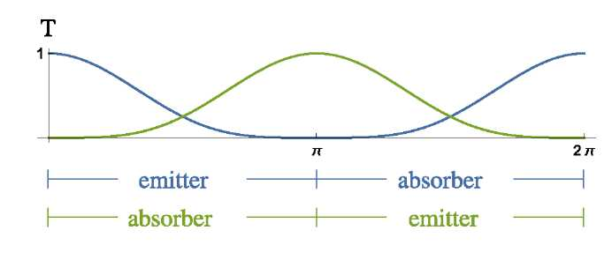
FIG. 4. Plots of Te1 = cos4(f) (blue) and Te2 = sin4(f) (green).
While 0 < f < n in Fig. 4, one of the bare electrons, Te1, is in the emitter phase. On the other hand, Te2 is in the absorber phase. Te1 emits energy by radiation, which is in turn absorbed by Te2.
Moreover, these radiation exchanges can occur within the virtual photon. Radiated energy propagates via electromagnetic waves, thereby reinforcing these exchanges.
D. The Interval between the Two Bare Electrons
Another bare electron would emerge in the vicinity of the virtual photon, because the two bare electrons exert repulsive forces. Both of the two bare electrons consist of an electron {2.1 [JP] 英単語・語句のご確認をお願いします。}.
To simplify the model, regard the virtual photon as a sphere. Furthermore, restrict the bare electrons, which are condensed matter of heat energy, to appear and disappear at the same point.
Assumption: Another pair of bare electrons will emerge on the sphere at the virtual photon's surface.
This assumption works to maintain the “principle of locality.” Another pair of electrons would not emerge abruptly, for example, on the far side of the moon. This postulation implies that the information of the two bare electrons is shared within the virtual photon.
To investigate the relationship between the photon and the two bare electrons, divide the bare electron Te in Eq. (II.5) into Eq. (II.6), with initial value x = +a,

and Eq. (II.7), with initial value x = −a:

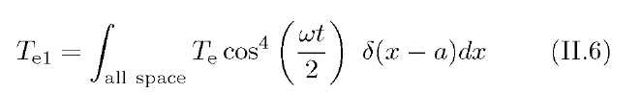
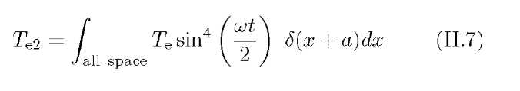
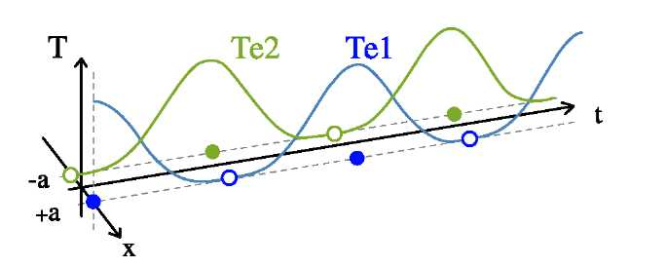
FIG. 5. Plots of the bare electrons apart from one another.
Figure 5 is a three-dimensional perspective based on Fig. 4. The light green circle at x = −a indicates the outer frame. That means that the paring oscillator, Te2, does not have any heat energy at t = 0. Te1 has all heat energy in the system at t = 0.
E. Applying the First Law of Thermodynamics
We use the first law of thermodynamics as a special case for considering internal energy: “An isolated system does not allow for passage of matter or energy into or out of the system” [3].
Let us focus our attention on an electron model composed of one virtual photon and two spinors of bare electrons as an “isolated system.” That is, the electron does not allow the spinors to leave or to pass energy outside of the photon.
The first law
is expressed using the total amounts of work, w, and heat, q:

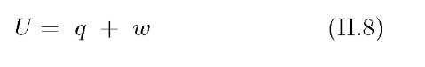
“If energy cannot move in or out, then the total energy U of the system does not change” [3]. This isolated system is “adiabatic” with respect to the surroundings. However, the inside is not adiabatic, because two differential-phase spinors are present. In this situation, q = 0. Let us apply the isolated system assumption to this electron model. Heat, q, is equal to Te1 + Te2, giving us

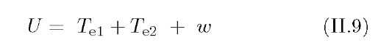
However, this model does not deal with pair production from two-photon interaction. The virtual photon does not vanish with the passage of time. Moreover, the bare electron does not have kinetic energy, but heat energy.
In these requirements, making the roles of these particles separately {2.1 [JP] 英単語・語句のご確認をお願いします。}. Bare electrons absorb heat energy, whereas the photon carries kinetic energy. Let us apply these roles to Eq. (II.8); as the kinetic energy of the virtual photon, we have
7k.e^

For an isolated system, AU = 0,

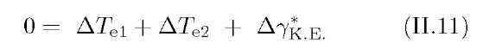
Hence,

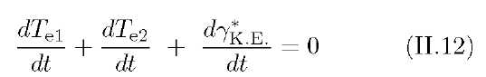
which shows that energy is conserved in this model of the electron.
F. Fourier's Law
In this section, we examine how the virtual photon is captured by the bare electron to move and work in the isolated system. Our expected image is that of a simple harmonic oscillator.
Before looking into the motion by phase, let us check the two fixed states of the positional relationship between the virtual photon and a pair of two oscillators.
These two states have two phases. One comes from cos4 p = 1 and the other comes from sin4 (^) = 1. For cos4 (^2r) = 1, for example, at t = 0, the center of the virtual photon stays at x = a in Fig. 6.
Using Fourier's law as a rule of thumb, the heat flux density (units of W • m−2), q, the material conductivity (units of W • m−1 • K−1), k, and the temperature gradient (units of K • m−1), T, are related as

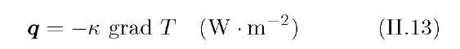
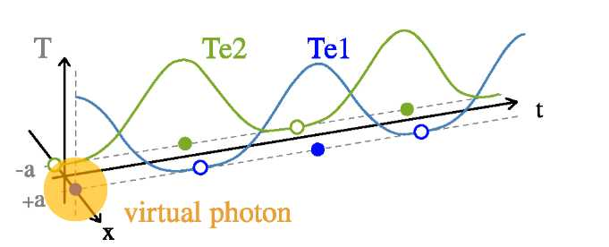
FIG. 6. The position of the virtual photon at t = 0. Bare electrons at two points, −a and a, are separated by a distance of 2a.
The temperature gradient between the two bare electrons is calculated as

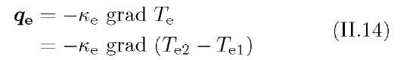
Replace Te1 and Te2 in Eq. (II.14) with the harmonic oscillators shown below:

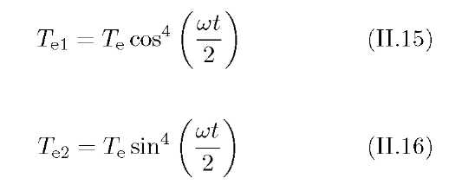
grad Te1 and grad Te2 include only time-derivative terms; their space derivatives are zero, because the bare electrons do not change in position with time. That is,

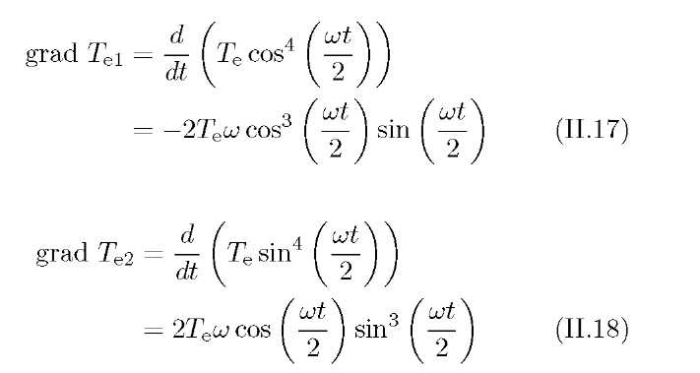
So

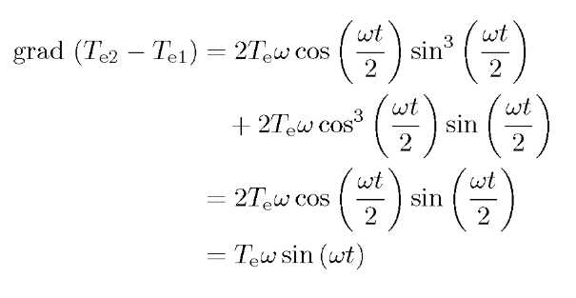
Therefore, put the above conclusion into Eq. (II.14) and calculate qe below:

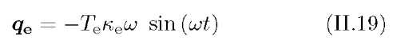
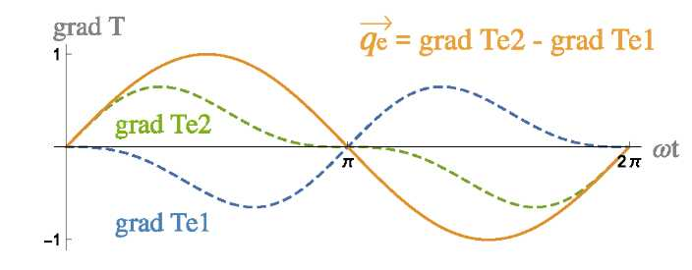
FIG. 7. Plots of qe and two temperature gradients of the spinors, replacing Teui in Eqs (II.17) and (II.18) with 1 and Teneus in Eq. (II.19) with 1.
G. Velocity Potential and the Virtual Photon
Let us focus on the virtual photon. To this end, we return to our assumption of hydrostatic equilibrium.
To advance this model, try to put the virtual photon on a velocity potential {2.1 [JP] 英単語・語句のご確認をお願いします。}. Two conditions should be satisfied to use the velocity potential. First, the flow of the fluid should be irrotational. Second, the fluid should be a perfect fluid.
Let us check the first condition; the virtual photon moves along the x-axis, so

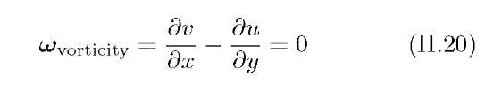
or
meaning that a specific velocity potential exists because of the vorticity being zero.
Let us now check the second condition. Previously, the virtual photon has been regarded as a polytrope. Thus, it can be treated as a perfect fluid.
Thus, there is a room to put the virtual photon into the temperature gradient between Te1 and Te2.
Previously, the bare electron has been discussed in terms of heat conduction. Henceforth, the virtual photon will be modeled in terms of velocity potential.
As the flow met the two conditions, ready for setting new velocity potential for the virtual photon {2.1 [JP] 英単語・語句のご確認をお願いします。}. Let us generate a new constant, ky* (units of m • s−1 • K−1), satisfying the below condition:

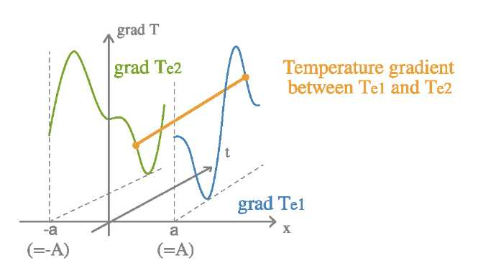
FIG. 8. Relationship between the temperature gradients and the bare electrons in three dimensions.

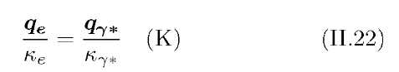
The heat flux, qe (units of W • m−1), arises from the temperature gradient, and the speed of a running fluid qY* (units of m • s−1) is based on the velocity potential. Ke is the material's conductivity (units of W • m−1 • K−1) for bare electrons. That is the reason why two different constants, Ke and ky*, are generated.
A governing equation rules Eq. (II.22), which is to say that Poisson's equation (kV$ = −q) provides the fundamentals for describing both qe and
q^*. The scalar field, $, of both the two fluxes is temperature. The source is the bare emitter electron, which is a perfect black body.
Assume that the virtual photon moves along with the vector field qY*. In other words, the central force arising from the two bare electrons moves along with the velocity potential. Using Eqs (II.19) and (II.22), we obtain

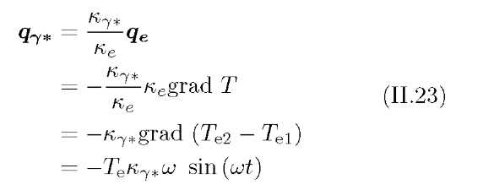
Here, we add a new assumption.
Assumption: The central force belonging to the two bare electrons moves along with the temperature gradient.
On the basis of the above principle, the virtual photon captured by the central force of the electron moves along with the temperature gradient as well.
Equation (II.23) shows that the temperature gradient between grad Te1 and grad Te2 produces a force F. The force drives the velocity of the virtual photon along with simple harmonic motion. On the basis of the principle mentioned
above, the virtual photon swings back and force spatially between the two bare electrons.
Meanwhile, by replacing TeKY* with spatial amplitude A, Eq. (II.23) is
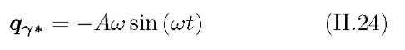
Integrating the function Eq. (II.24) with respect to time, we obtain

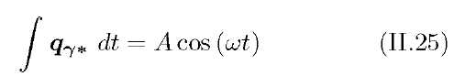
Assuming that the virtual photon moves along with the temperature gradient yields the behavior of the photon.
Equation (II.25) implies that the displacement of the photon is a wave moving continuously along the x-axis. Compared with the motion of the bare electron itself, its energy spot moves discretely from +a to −a.
Take a look at Fig. 9. This is added the motion of virtual photon along with Eq. (II.25) and rewrote the Figs 5 and 6 {2.1 [JP] 英単語・語句のご確認をお願いします。}. The radius of the virtual photon can be imagined as being double the width of the spatial amplitude, 2A. This length is equal to 2a on the x-axis.

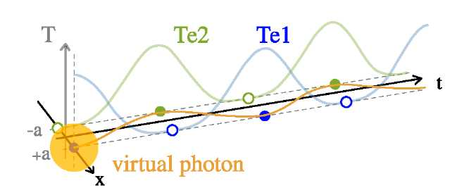
FIG. 9. Behavior of the virtual photon as a spatial simple harmonic oscillator while the two bare electrons act as emitters and absorbers.
Remarkably, two vectors, qe and qY*, can be recovered from the same scalar field. qe shows the temperature gradient consisting of the two bare electrons, and qY* indicates the velocity and spatial value of the virtual photon.
III. DISCUSSIONS
A. Value of Emissivity
In the previous section, it was assumed that a bare electron acts as a perfect black body. Because of this principle, virtual photons behave like spatial simple harmonic oscillators (Figs 7–9). What happens if its emissivity is less than 1? The temperature of the bare electron decreases with each repeated absorption C. Consider there are two emittance and absorption cycles per 2n, with frequency f

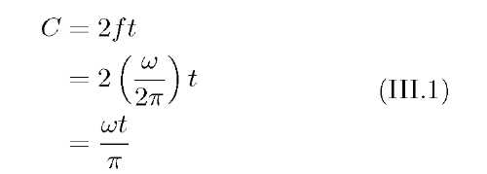
C is the number of times radiation is emitted from a black body. However, let us set the emissivity of the bare electron, e. When 0 < e < 1, the energy of T1 can be calculated as

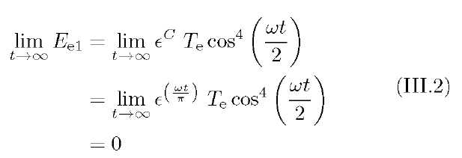
This equation means that the energy of the bare electron decreases with every single absorption in proportion to the value of the emissivity e. The energy of T2 is derived same as above:

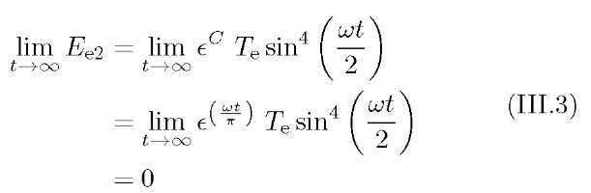
These two equations show that the two oscillators behave as if they are damped, as well as that the masses of the two bare electrons will decrease by and by {2.1 [JP] 英単語・語句のご確認をお願いします。}, eventually reaching zero. Considering the isolated system, the total energy of the whole electron, Ee, is unchangeable:

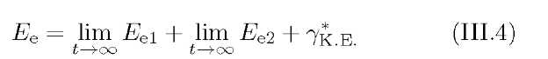
so

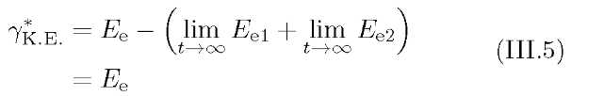
Equation (III.5) indicates that the final outcome is only going to be a photon, because the total energy of the virtual photon, yK e, ultimately occupies the total energy of the electron Ee. In other words, the phenomenon whereby two oscillators vanish without any positrons and change the electron's full mass-energy into a real photon conflicts with charge conservation. Consequently, the emissivity has to be 1 for charge conservation to be maintained.
B. The Virtual Photon as Perfect Fluid
This electron model regards the virtual photon as a perfect fluid, with reference to the
hydrostatic equilibrium and the polytropic equation.
If the virtual photon of the electron had viscosity, the electron could not exist continuously because of damped oscillation. As far as the moving behavior, this condition is equal to the under-damped spring-mass system with Z < 1, where Z is the damping ratio.
For example, suppose

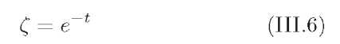
then the oscillation of the virtual photon is

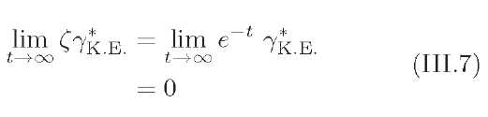
Were the photon composed of viscous fluid, it would cause viscous flow, changing its kinetic energy into the heat energy. Finally, the photon would cease to oscillate.
In this paper, the category “perfect fluid” comprises all fluids that lack viscosity. That is, both compressible and incompressible fluids can be perfect. Were we to treat only incompressible fluids, this would lead to an inconsistency.
Interaction between heat and kinetic energy is essential in this electron model, because the interaction between the two kinds of energy drives the virtual photon along with the harmonic oscillator. This condition that the harmonics cease to oscillate would be able to exist and need a future study {2.1 [JP] 英単語・語句のご確認をお願いします。}.
Moreover, no conditions on the pressure of the virtual photon could be shown in this paper. For an incompressible fluid, the pressure of the virtual photon pY* in thermodynamics (p = p(p,T)) is

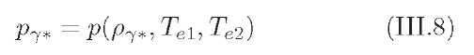
Also, no equations describing the hydrostatic equilibrium of the electron are shown here; this too is left to future work.
C. Interpretation and Adjustment of the Amplitude
In this model, the amplitude and the radius of the virtual photon are related by the equations that I have determined. One of the ambiguous points in this paper is the interpretation and definition of the amplitudes. There are two amplitudes in here, appearing in qe and qY*. We shall interpret them cautiously.
In this subsection, there cannot be a certain conclusion at that point {2.2 [JP] 主語が不明確です。}. Instead, some possibilities for choosing oscillations when making the model are shown. How the one is chosen and laid aside the others {2.1 [JP] 英単語・語句のご確認をお願いします。}.
Eventually, two possibilities appeared in the scene of taking the harmonics equation in mathematically {2.1 [JP] 英単語・語句のご確認をお願いします。}. There are the two scenarios. As a first scenario, set each oscillator as Eqs (III.9a) and (III.9b), which leads to Eqs (III.9c) and (III.9d)

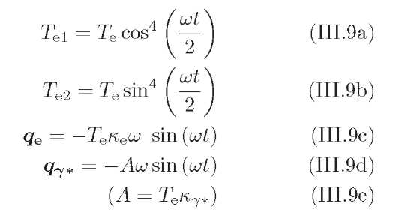
By the second scenario, set the oscillators as Eqs (III.10a) and (III.10b), and then we obtain Eqs (III.10c) and (III.10d):
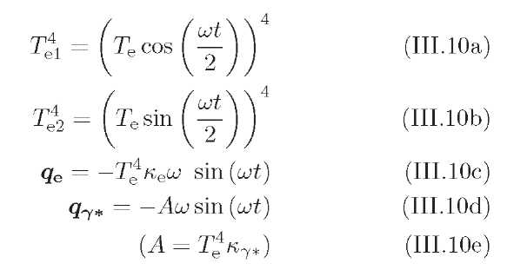
Whichever scenario we chose, the virtual photon oscillates along with the sine function, qY*,
Eqs (III.9d) and (III.10d).
The total power per unit area in units of W/m² is proportional to the fourth power of the absolute temperature with the proportionality between them given by the Stefan–Boltzmann constant, <rSB,

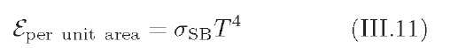
Thus, this second scenario is useful for thinking about black body radiation, Q = aSBT4, as well as the effective radiation between two things, Q = <tsb(T4 − T24), through unifying concept of quadruple T.
According to this model, heat is transferred between the two bare electrons by radiation, which is possible because those two are within the virtual photon, which works as a medium.
One major difference comes from the way of viewing the temperature gradient: for example, the way of setting amplitude A. That difference generates a variation of Eqs (III.9d) and (III.10d).
“For conduction and convection, energy transfer between two objects depends approximately on the temperature difference between them. For natural (free) convection, or when variable property effects are included,
the energy transferred can be a function of the difference between (T1)n and (T2)n, where the power n may be slightly larger than one, and can reach two. Thermal radiation transfer that takes place between two distant bodies depends on the difference between the fourth power of their absolute temperatures (n = 4)” [4].

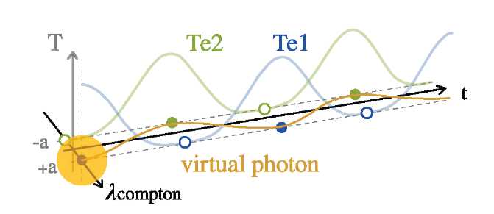
FIG. 10. The third scenario. The x-axis has been changed into λCompton for consistency because of the use of k'y* instead of ky*. The constant value ky* is adjusted by multiplying the Compton wavelength.
This paper had picked up scenario one as Eqs (III.9a) and (III.9b) the first time. The modeling is moving forward on the scenario {2.1 [JP] 英単語・語句のご確認をお願いします。}. This is because energy transfer between the bare electrons by the virtual photon should be considered by heat conduction rather than radiation. It is certain that a real photon carries energy as electromagnetic waves, but the virtual photon does not move between the black bodies at the speed of light. The velocity of a real photon captured is variable; however, energy transfer by radiation travels at the speed of light. There is room for applying the concept of heat conduction, but not radiation, to this model.
However, both scenarios involve a collision case. The higher the virtual photon's energy, the wider its radius due to increasing Te. That is conflict the fact of behavior of the electron.
An alternative approach is to somehow put the Compton wavelength λCompton into Eq. (III.9a). The
Compton wavelength is given by

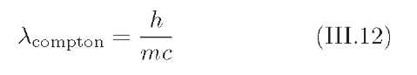
so
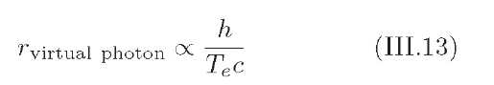
It would be preferable for this model on the point of determination of radius of the virtual photon. The higher the electron's energy, the shorter the virtual photon's radius would be. That is, the amplitude A should be defined as the reciprocal of temperature T.
The third scenario is to set the oscillators as Eqs (III.14a) and (III.14b). These are the same as in the first scenario; however, the value of k7#! is remarkably changed into as follows, reflecting the Compton wavelength.

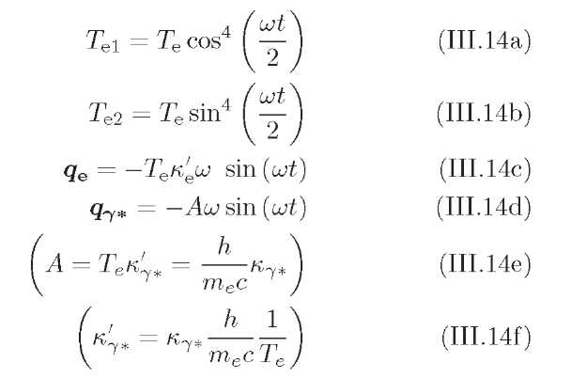
Then, Eqs (III.14c) and (III.14d) can be obtained; see Fig.
10 for further information about the change from the x-axis to λCompton. In addition, 1/Te in the Eq (III.14f) exists only to cancel Te.
Finding relationship between the amplitude and the radius of the virtual photon for keeping consistency is a challenging task that remains to be solved.

[1] M. Planck, The Theory of Heat Radiation; Dover Publication, Inc.: New York, (1912)
[2] Zu-Po Yang et al, Nano letters 8, 446-451 (2008).
[3] David W. Ball, Physical Chemistry 2E, Wadsworth Cen-
gage Learning, (2015) [4] John R. Howell, Thermal Radiation Heat Transfer 6E,
CRC Press, (2016)
[5] Bradley W. Carroll and Dale A. Ostlie, An Introduction to Modern Astrophysics 2E, Cambridge University Press,
(2017)

