|  |  |
| --- | --- |
|  | **[Year]** |
|  | [Type the company name]  pc |





|  |
| --- |
|  |
|  |

**Ministry of Social Development**

**Up Skilling program ICTC5-Web Development**

**Supervisors:**

**Dr.Jalal Kiswani**

**Ms.Hana Alrasheed**

**Dr.William Smairat**

**Ms. Jacquelyn.Brown**

**Sep.28th, 2020**

**By Dana Alsawalha**

Table of Contents

**Introduction**3

**Project details**3

Technologies3

Requirements4

Design4

Development6

Testing6

Deployment6

**Screen Shoots7**

**Source Code**7

**Conclusion**7

# Introduction

### Preamble

# Ministry of Social Development project is a website that contains main categories and a service that helps the user to know most of the information he wants about the ministry, in addition to providing him with most of the services he needs, and there are electronic services that facilitate the completion of transactions in the easiest and best possible way. For each category there are a lot of things such as; About the ministry, Services, Initiatives, Media Center, call us.

### Project Motivation

The reasons to create this website is my motivation to help the largest possible number of people to access reliable information from the official authority in an orderly and orderly manner and being able to achieve easy and easy-to-use electronic services, saving time and effort.

# Project Details

There are many variations of passages of Lorem Ipsum available, but the majority have suffered alteration in some form, by injected humour, or randomised words which don't look even slightly believable. If you are going to use a passage of Lorem Ipsum, you need to be sure there isn't anything embarrassing hidden in the middle of text. All the Lorem Ipsum generators on the Internet tend to repeat predefined chunks as necessary, making this the first true generator on the Internet. It uses a dictionary of over 200 Latin words, combined with a handful of model sentence structures, to generate Lorem Ipsum which looks reasonable. The generated Lorem Ipsum is therefore always free from repetition, injected humour, or non-characteristic words etc.

## Technologies

## There are many variations of passages of Lorem Ipsum available, but the majority have suffered alteration in some form, by injected humour, or randomised words which don't look even slightly believable. If you are going to use a passage of Lorem Ipsum, you need to be sure there isn't anything embarrassing hidden in the middle of text. All the Lorem Ipsum generators on the Internet tend to repeat predefined chunks as necessary, making this the first true generator on the Internet. It uses a dictionary of over 200 Latin words, combined with a handful of model sentence structures, to generate Lorem Ipsum which looks reasonable. The generated Lorem Ipsum is therefore always free from repetition, injected humour, or non-characteristic words etc.

## Requirements

There are many variations of passages of Lorem Ipsum available, but the majority have suffered alteration in some form, by injected humour, or randomised words which don't look even slightly believable. If you are going to use a passage of Lorem Ipsum, you need to be sure there isn't anything embarrassing hidden in the middle of text. All the Lorem Ipsum generators on the Internet tend to repeat predefined chunks as necessary, making this the first true generator on the Internet. It uses a dictionary of over 200 Latin words, combined with a handful of model sentence structures, to generate Lorem Ipsum which looks reasonable. The generated Lorem Ipsum is therefore always free from repetition, injected humour, or non-characteristic words etc.

## Design

There are many variations of passages of Lorem Ipsum available, but the majority have suffered alteration in some form, by injected humour, or randomised words which don't look even slightly believable. If you are going to use a passage of Lorem Ipsum, you need to be sure there isn't anything embarrassing hidden in the middle of text. All the Lorem Ipsum generators on the Internet tend to repeat predefined chunks as necessary, making this the first true generator on the Internet. It uses a dictionary of over 200 Latin words, combined with a handful of model sentence structures, to generate Lorem Ipsum which looks reasonable. The generated Lorem Ipsum is therefore always free from repetition, injected humour, or non-characteristic words etc.

### 2.3.1 SiteMap

### 2.3.2 WireFrame

### Mockup

### Prototype

### ERD

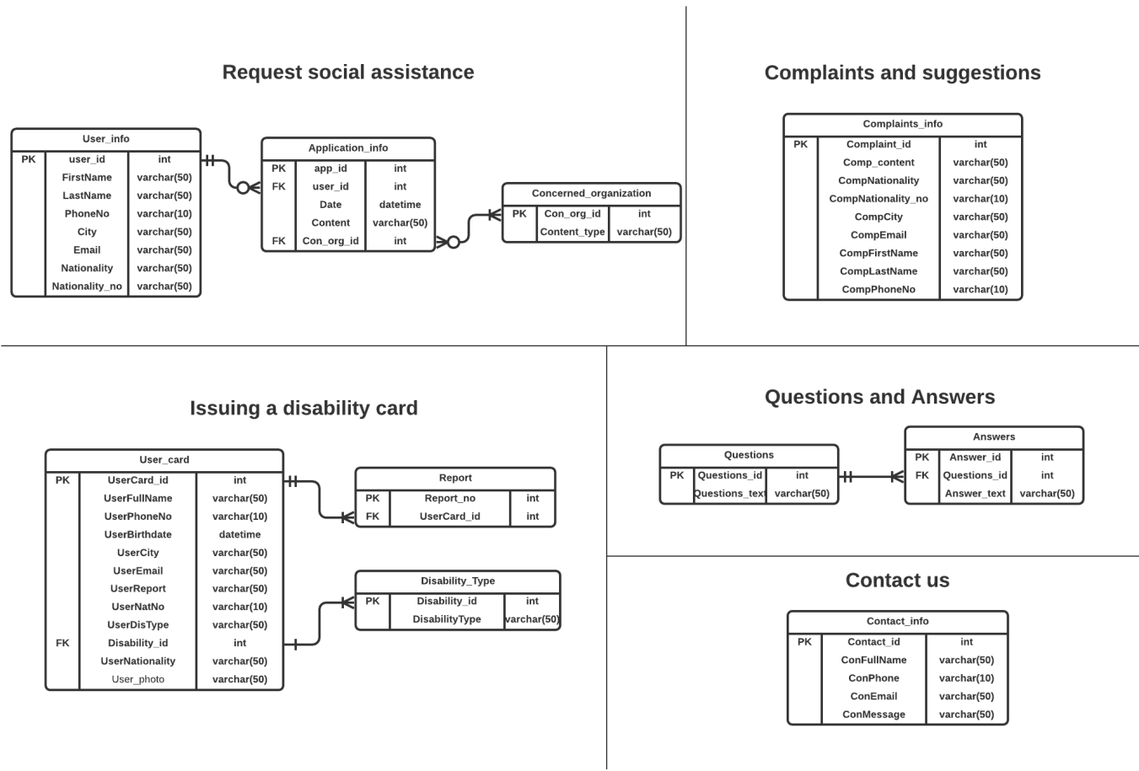

## 2.4 Development

## There are many variations of passages of Lorem Ipsum available, but the majority have suffered alteration in some form, by injected humour, or randomised words which don't look even slightly believable. If you are going to use a passage of Lorem Ipsum, you need to be sure there isn't anything embarrassing hidden in the middle of text. All the Lorem Ipsum generators on the Internet tend to repeat predefined chunks as necessary, making this the first true generator on the Internet. It uses a dictionary of over 200 Latin words, combined with a handful of model sentence structures, to generate Lorem Ipsum which looks reasonable. The generated Lorem Ipsum is therefore always free from repetition, injected humour, or non-characteristic words etc.

## 2.5 Testing

## There are many variations of passages of Lorem Ipsum available, but the majority have suffered alteration in some form, by injected humour, or randomised words which don't look even slightly believable. If you are going to use a passage of Lorem Ipsum, you need to be sure there isn't anything embarrassing hidden in the middle of text. All the Lorem Ipsum generators on the Internet tend to repeat predefined chunks as necessary, making this the first true generator on the Internet. It uses a dictionary of over 200 Latin words, combined with a handful of model sentence structures, to generate Lorem Ipsum which looks reasonable. The generated Lorem Ipsum is therefore always free from repetition, injected humour, or non-characteristic words etc.

## 2.6 Deployment

## There are many variations of passages of Lorem Ipsum available, but the majority have suffered alteration in some form, by injected humour, or randomised words which don't look even slightly believable. If you are going to use a passage of Lorem Ipsum, you need to be sure there isn't anything embarrassing hidden in the middle of text. All the Lorem Ipsum generators on the Internet tend to repeat predefined chunks as necessary, making this the first true generator on the Internet. It uses a dictionary of over 200 Latin words, combined with a handful of model sentence structures, to generate Lorem Ipsum which looks reasonable. The generated Lorem Ipsum is therefore always free from repetition, injected humour, or non-characteristic words etc.

## 3. Screen Shots

## There are many variations of passages of Lorem Ipsum available, but the majority have suffered alteration in some form, by injected humour, or randomised words which don't look even slightly believable. If you are going to use a passage of Lorem Ipsum, you need to be sure there isn't anything embarrassing hidden in the middle of text. All the Lorem Ipsum generators on the Internet tend to repeat predefined chunks as necessary, making this the first true generator on the Internet. It uses a dictionary of over 200 Latin words, combined with a handful of model sentence structures, to generate Lorem Ipsum which looks reasonable. The generated Lorem Ipsum is therefore always free from repetition, injected humour, or non-characteristic words etc.

## Source Code

## There are many variations of passages of Lorem Ipsum available, but the majority have suffered alteration in some form, by injected humour, or randomised words which don't look even slightly believable. If you are going to use a passage of Lorem Ipsum, you need to be sure there isn't anything embarrassing hidden in the middle of text. All the Lorem Ipsum generators on the Internet tend to repeat predefined chunks as necessary, making this the first true generator on the Internet. It uses a dictionary of over 200 Latin words, combined with a handful of model sentence structures, to generate Lorem Ipsum which looks reasonable. The generated Lorem Ipsum is therefore always free from repetition, injected humour, or non-characteristic words etc.

## Conclusion

## There are many variations of passages of Lorem Ipsum available, but the majority have suffered alteration in some form, by injected humour, or randomised words which don't look even slightly believable. If you are going to use a passage of Lorem Ipsum, you need to be sure there isn't anything embarrassing hidden in the middle of text. All the Lorem Ipsum generators on the Internet tend to repeat predefined chunks as necessary, making this the first true generator on the Internet. It uses a dictionary of over 200 Latin words, combined with a handful of model sentence structures, to generate Lorem Ipsum which looks reasonable. The generated Lorem Ipsum is therefore always free from repetition, injected humour, or non-characteristic words etc.