**Linux-intro-cli-task**

**Tasks:**

* Use Command whoami and figure out the output. You can use man to know more about whoami.

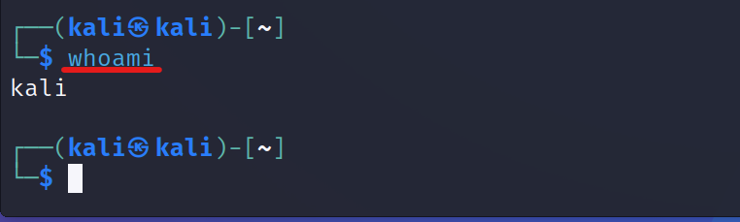

* Use Command hostname and figure out the output. You can use man to know more about hostname.

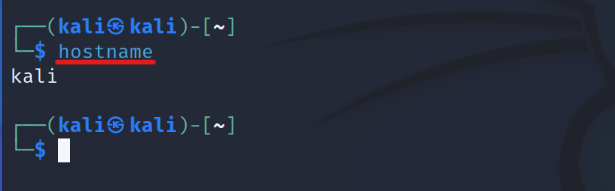

* Use history command and run one of the processes that appears in the history without re-write the command?

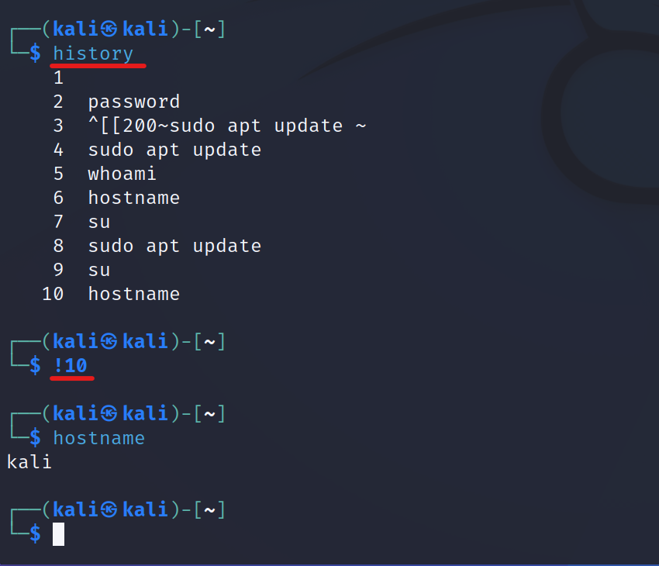

* Find since when your system was running?

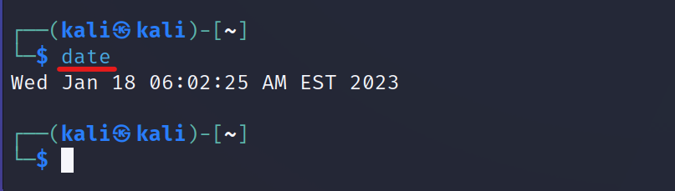

* Get the date and time in Dubai using CLI?

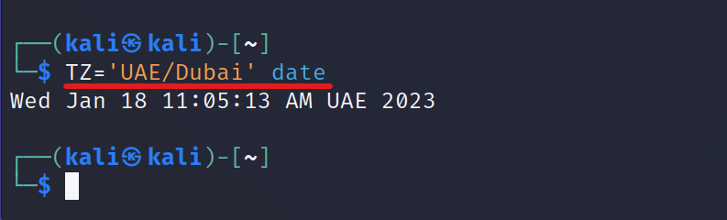

* Store calendar output to a file called calender.txt

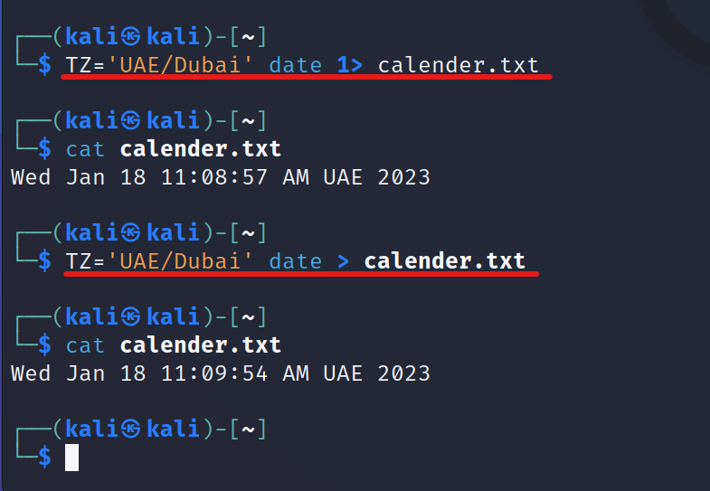

* Use this command echos “Oh there is an error” then save the error(output) if appears to file called logs.txt

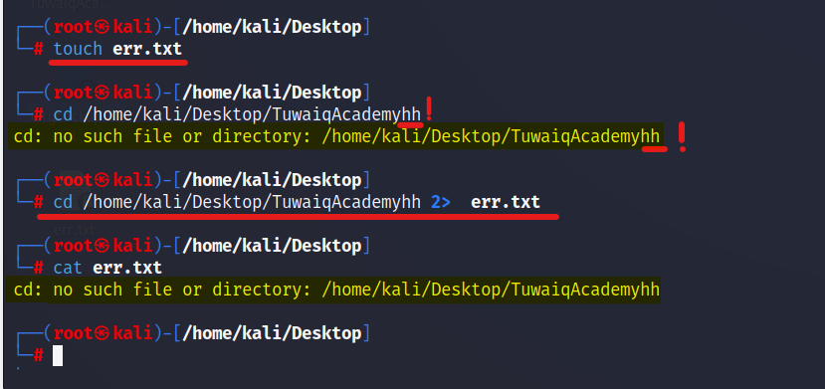

**Additional Challenge:**

* Count how many words in any file in your system?

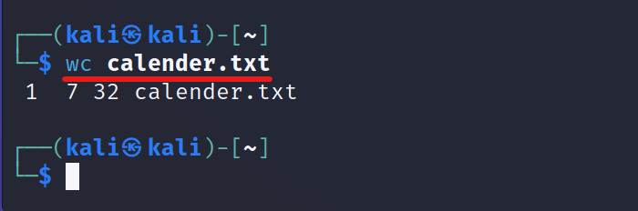

* Find the logged in users in your system?

