

CAPSTONE PROJECT REPORT
Report 5 – Software Test Documentation

Design and Development of a Warehouse and Sales Management System
for Viet Tien Company (DDWSMSVTC)

– Hanoi, August 2026 –

Table of Contents

I. Record of Changes 3
II. Testing Documentation 4
1. Scope of Testing 4
1.1 Target of Testing 4
1.1.1 Functional Features 4
1.1.2 Non-functional Features 5
1.1.2.1 External Interface 5
1.1.2.1.1 User Interface 5
1.1.2.1.2 Software Interfaces 6
1.1.2.2 Quality Attributes 6
1.1.2.2.1 Usability 6
1.1.2.2.2 Security 6
1.1.2.2.3 Performance 7
1.1.2.2.4 Maintainability 7
1.1.2.2.5 Scalability 7
1.1.2.2.6 Portability 7
1.2 Test Level 8
2. Test Strategy 9
2.1 Testing Types 9
2.2 Test Levels 10
2.3 Supporting Tools 11
3. Test Plan 11
3.1 Human Resources 11
3.2 Test Environment 12
3.3 Test Milestones 12
4. Test Cases 13
4.1 Unit Test 13
4.2 Integration Test 14
4.3 System Test 15
4.4 Acceptance Test 15
5. Test Reports 15
5.1 Unit Test 16
5.2 Integration Test 16
5.3 System Test 16
5.4 Acceptance Test 17

I. Record of Changes
Date | A*, M, D | In charge | Change Description
27/06/2026 | A | Trần Ngọc Khánh | Init document – Scope of Testing and Test Level baselined against SRS.
16/07/2026 | A | Trần Ngọc Khánh | Create Test Strategy, Test Plan and the Test Cases.
01/08/2026 | M | Trần Ngọc Khánh | Re-baseline against SRS v2.0.
03/08/2026 | A | Trần Ngọc Khánh | Create Test Reports.
*A – Added M – Modified D – Deleted

II. Testing Documentation

1. Scope of Testing

1.1 Target of Testing

1.1.1 Functional Features
The test scope of the project includes all features and functions defined in the latest Software Requirement Specification document.
Code | Feature / Requirement
FT-01 | Storefront, Registration & Order Placement – catalogue browsing and search, email verification, OTP-verified phone, delivery-address book (0 or 1 active default), persistent cart with a 24-hour server-side price snapshot, checkout, manual (walk-in) orders governed by the same rules as online orders (BR-030), VAT invoice request recording.
FT-02 | Tiered & Negotiated Pricing – quantity-tier discounts below VND 100,000,000; orders of VND 100,000,000 or more require an approved quotation version (Sales → Sales Manager → CEO) accepted by the customer; server-side price recalculation is authoritative (CLIENT_PRICE_MISMATCH); quotation chat with immutable messages.
FT-03 | Payment, Reservation & SePay Integration – QR and reference generation, webhook signature verification and exact amount matching, webhook idempotency, 15-minute SePay reservation, 35-minute COD reservation with 25 / 30-minute warning and escalation, manual confirmation restricted to Sales Manager with mandatory evidence, PAID_REVIEW_REQUIRED handling of late payments.
FT-04 | Customer Assignment & Sales Ownership – round-robin allocation with cursor wrap, referral-code resolution, one open sales-change request per customer, manager approval, historical orders keep their original Sales snapshot.
FT-05 | Warehouse Fulfilment – allocation and pick tasks, multi-pick requiring Sales Manager approval, consolidation defaulting to WH-PROD, dual handover confirmation (Warehouse and Sales must agree on the package count), goods issue posted only after handover, all-or-nothing stock deduction.
FT-06 | Purchase Order & Goods Receipt – PO draft → issue → send-to-warehouse, Excel/OCR import producing a draft only, partial receipt, accepted versus damaged quantities, posted documents immutable, receiving discrepancy resolved by the CEO.
FT-07 | Delivery & COD Collection – internal fleet of 5 vehicles × 3 shifts (Morning / Noon / Afternoon, at most one trip per vehicle per shift per day), proof of delivery (photo + customer signature + timestamp) mandatory before DELIVERED, COD collection with a DebtRecord for shortfalls, no COD on already-paid orders, escalation after 3 failed attempts.
FT-08 | Paid Cancellation, Credit & Exchange – no monetary refund; value preserved through payment reallocation and customer order credit; return / exchange request with evidence, manager approval and scheduled pickup; quality returns held in quarantine until inspection.
FT-09 | Administration, Dashboards, Alerts & Audit – role-scoped dashboards and KPI, operational alerts routed to the responsible role, versioned system configuration with no retroactive effect, immutable (INSERT-only) audit log, background-job health tracking; Admin performs technical administration and must not approve business transactions.
FT-10 | AI Marketing Assistant – AI-assisted content and image generation, mandatory approval gate by the Sales Manager (the author cannot self-approve), scheduled publishing queue (maximum 30), Facebook publishing via webhook with failures recorded and alerted, publishing never changes customer ownership.
FT-11 | Inter-Warehouse Stock Transfer – transfer between WH-PROD / WH-TRADE / WH-PE, source ≠ destination, posting decrements the source and increases in-transit, receipt clears in-transit and increases only the accepted quantity, discrepancies recorded rather than auto-balanced.
FT-12 | Stock Count, Adjustment & Low-Stock Alerts – a count session freezes an immutable theoretical snapshot, adjustments change stock only after approval and posting, adjustments above the configured threshold require CEO approval, negative stock is forbidden, production material issue requires recipient + document number + signed photo, low-stock alerts per inventory line.
Table 1: Functional Features in Scope
The following items are out of scope for this test cycle:
- Cost Component Model / COGS calculator and Payroll & HR management – removed from scope in SRS v2.0.
- Electronic VAT invoice issuance to the tax authority – the system only records the invoice request.
- Native iOS / Android applications – only a responsive web application is delivered in version 1.
- Third-party courier API integration – delivery uses the internal fleet only.
- Automatic financial refund to customer bank accounts – value is preserved through reallocation and credit, which is itself tested under FT-08.
- Internal logic of third-party services (SePay settlement engine, Facebook Graph, AI image model, SMS gateway) – only the integration contract is tested; vendor internals are stubbed with WireMock.Net.
- Full penetration testing – security testing is limited to an OWASP Top 10 scan plus targeted manual checks.

1.1.2 Non-functional Features

1.1.2.1 External Interface

1.1.2.1.1 User Interface
- All user-facing text, currency and date formats are in Vietnamese.
- A loading indicator is displayed whenever an action requires server communication, so the user is never left guessing whether the system is responding.
- Server errors are surfaced as clear, understandable Vietnamese messages, never as raw exception text.
- The interface keeps a consistent visual style – fonts, colours and layout – across all seven role portals (Guest, Customer, Sales Staff, Sales Manager, Warehouse Staff, CEO, Admin).
- Buttons and icons carry labels or tooltips so their function is understandable without training.
- The web interface is compatible with Google Chrome and Microsoft Edge, and the layout remains usable from a width of 375 px upwards with no horizontal scrolling.
- A standard checkout is completed in at most four clicks or pages.

1.1.2.1.2 Software Interfaces
The software interfaces the system interacts with during operation:
- Microsoft SQL Server 2022 – primary relational database, accessed through Entity Framework Core 8 with code-first migrations.
- SePay payment gateway – QR generation and payment webhook callback with signature verification and exact amount matching.
- eSMS gateway – outbound SMS for phone OTP verification.
- SMTP mail service – outbound email for account verification, OTP and order confirmation.
- Make.com webhook → Facebook Graph – publishing of approved marketing posts and the publishing result callback.
- AI Image / content generation API – AI-assisted marketing content, called asynchronously with a status endpoint.
- Cloudinary – media storage for product images, delivery evidence photos and marketing attachments.
- SignalR hubs (Sales, Warehouse, Quotation chat) – real-time push of order, payment and negotiation status changes.
- Hangfire (SQL Server-backed) – background jobs for reservation expiry, COD SLA, webhook retry, low-stock alerts, quotation expiry and marketing scheduling.

1.1.2.2 Quality Attributes

1.1.2.2.1 Usability
- The interface is intuitive for non-technical warehouse and sales staff; a new user can complete a basic task without extensive training.
- The experience is consistent across every screen of the seven role portals.
- The storefront and the Sales delivery screens remain usable at a width of 375 px with no horizontal scroll, because sales staff record deliveries on a phone.
- All user-facing text, currency and date formats are Vietnamese.
- A standard checkout takes at most four clicks or pages.
- During UAT the participant operates the system unaided; needing to be shown how to proceed is recorded as a usability failure even when the function itself works.

1.1.2.2.2 Security
- All traffic runs over HTTPS / TLS 1.2 or higher with automatic redirection from HTTP and the standard security headers present.
- Passwords are stored as salted BCrypt hashes; refresh tokens are rotated on every use, can be revoked, and are never written to a log.
- Role-based access control is enforced by JWT on every endpoint across the seven roles; an unauthorised call returns HTTP 403.
- OTP values are stored hashed, are single-use, and are subject to a 5-minute expiry, a 60-second resend interval and attempt / daily limits.
- The SePay webhook signature is validated and a replayed event is processed at most once.
- Personal data (phone number, tax code) is masked in logs and restricted in API responses.
- File uploads are restricted by type and size and are stored privately.
- The audit log is immutable and INSERT-only, enforced at database level.
- Sensitive actions – role changes, quotation approval, manual payment confirmation, stock adjustment, configuration changes – are recorded in the audit log with the actor, the IP address and the before / after values.

1.1.2.2.3 Performance
Code | Target | Verified at
NFR-P01 | Catalogue and homepage p95 < 500 ms. | L3 (JMeter)
NFR-P02 | Product search and filter p95 < 800 ms. | L3 (JMeter)
NFR-P03 | Cart recalculation with tiered pricing p95 < 1 s. | L3 (JMeter)
NFR-P04 | Quotation chat message delivered end-to-end < 2 s. | L3 (SignalR client)
NFR-P05 | SePay webhook acknowledgement < 3 s, heavy work deferred to the background. | L3 · L2
NFR-P06 | Role dashboard p95 < 3 s for day / week / month ranges. | L3 (JMeter)
NFR-P07 | AI marketing generation returns a first response < 1 s with a status endpoint. | L3 (JMeter)
NFR-S01 | 100 concurrent users with at most 20 % degradation from the baseline and an error rate below 1 %. | L3 (JMeter stress)
NFR-S02 | Operational report queries < 3 s over approximately 1 million records. | L3
Table 2: Performance and Scalability Targets

1.1.2.2.4 Maintainability
- Backend line coverage of at least 80 % for the critical services namespace, measured with Coverlet and reported per namespace rather than as an assembly total.
- A layered architecture (Controller → Service → EF Core → SQL Server) with a domain error-code list (CLIENT_PRICE_MISMATCH, PRICE_SNAPSHOT_EXPIRED, INSUFFICIENT_AVAILABLE, …) so that a failure is identified by code rather than by message text.
- Background-job health is observable, and a job that has never run is never reported as healthy.
- The database schema is built exclusively from EF Core migrations; a test asserts that no pending model change exists, so the schema cannot drift from the code.
- Complete documentation: SRS v2.0, TDS v1.0, RTW traceability workbook, API documentation through Swagger, and this test documentation.

1.1.2.2.5 Scalability
- Stateless JWT authentication without server-side session storage lets the API layer scale horizontally behind a reverse proxy.
- Long-running work (webhook processing, marketing publishing, report generation) is deferred to Hangfire background jobs so it never blocks the request lifecycle.
- SQL Server indexing is applied to foreign keys, lookup fields and the status / time-range fields used by high-traffic queries.
- Optimistic concurrency (RowVersion) on Order and Inventory guarantees that concurrent operations on the same stock or payment resolve exactly once.

1.1.2.2.6 Portability
- The backend and the database run on Windows Server or Linux (Ubuntu 22.04 LTS); staging uses Ubuntu.
- Docker images are provided for the API, the database and the reverse proxy, so the whole stack can be recreated from configuration.
- The Level 2 test suite provisions its own SQL Server container through Testcontainers, so it runs on any developer machine or CI runner with Docker and does not depend on staging.
- The architecture is cloud-ready for deployment on a standard VPS or on a managed cloud provider.

1.2 Test Level
Testing is organised into four levels: unit test, integration test, system test and acceptance test.
No | Test Level | In charge | Time | Focus | Acceptance Criteria
1 | Unit Test (L1) | Developers | Per commit, locally and on CI | Method-level service logic (backend) and services, contexts and components (frontend) in complete isolation; all dependencies mocked, time controlled by a mocked clock. | All P1 cases pass; no open P1 defect; line coverage ≥ 80 % for critical services.
2 | Integration Test (L2) | Developers | On every pull request, before merge | API plus a real SQL Server 2022: transaction boundaries, atomicity, webhook idempotency, concurrency on shared stock, background-job boundaries. | All P1 flows pass; idempotency and atomic rollback proved; concurrency resolves exactly once with no negative stock.
3 | System Test (L3) | Developers | Pre-release, against staging | The full stack over HTTP: API contract and business error codes, multi-step API flows, performance under load, OWASP Top 10 with emphasis on access control. | All P1 API cases return the correct status and error code; NFR-P and NFR-S thresholds met with an error rate below 1 %; access-control cases all return 401 or 403.
4 | Acceptance Test (AT / UAT) | Product Owner and Viet Tien representative | Before the stakeholder demonstration and before go-live | Business scenario validation SC-01…SC-06 with realistic Vietnamese data, plus usability confirmation. | All six scenarios executed and signed off by the Product Owner; no critical business-process blocker; written sign-off recorded.
Table 3: Test Level Description

2. Test Strategy

2.1 Testing Types
The following testing types are applied in this project:
- Unit Testing
- Integration Testing
- API / System Testing
- E2E (GUI) Testing
- Non-functional Testing – performance and security
- User Acceptance Testing
Type | Objective | Technique | Completion Criteria
Unit Testing | Verify that every business rule behaves according to the SRS AC-xx / NAC-xx specification, with method-level logic exercised in complete isolation and every numeric and temporal constraint pinned by a boundary test. | White-box techniques: equivalence partitioning, boundary value analysis, branch and condition coverage, state transition on the four order enums, plus a dedicated RegressionFixes sheet that pins every defect fixed in the patch series. | All P1 unit cases pass; every AC-xx of an implemented feature has at least one test and every NAC-xx at least one negative test; line coverage ≥ 80 % for critical services (NFR-M02).
Integration Testing | Verify that the API, a real SQL Server database and the external integrations work together: transaction boundaries, atomicity, idempotency and concurrency. | xUnit with WebApplicationFactory<Program> driving the real HTTP pipeline over SQL Server 2022 started per run by Testcontainers, Respawn resetting the database between tests, WireMock.Net stubbing external services and a mail-sink container capturing SMTP. | All P1 flows pass; idempotency confirmed for the webhook endpoint and every posting operation; atomic rollback confirmed for order, goods issue, goods receipt and stock transfer; no negative stock under concurrent load.
API / System Testing | Verify the running system end to end over real HTTP: the API contract and business error codes of every endpoint, multi-step API flows, and the OWASP Top 10 with emphasis on broken access control across the seven roles. | xUnit with WebApplicationFactory for the contract cases and Postman / Newman for the checks that must run against a deployed instance; direct SQL probes for database-level invariants that no API can prove. | All P1 API cases return the correct status and business error code; all access-control cases return 401 or 403; no Critical or High security finding left unrecorded.
E2E (GUI) Testing | Confirm that a real user can achieve their goal through a real browser with nothing mocked, that role boundaries hold in the user interface, that sessions expire safely and that the layout is usable on a 375 px viewport. | Playwright (TypeScript) driving Chromium against the running stack, with two viewports (1280×800 desktop and 375×812 mobile); permission checks type the protected URL directly and also call the API with the same role, so a merely hidden button is not mistaken for an enforced rule. | Critical paths pass after every deployment; all P1 user-journey cases pass before release; a case whose screen or endpoint does not exist is recorded as Blocked, never as Pass.
Non-functional Testing | Confirm that the system meets the NFR-P, NFR-S and NFR-SEC targets defined in the SRS. | Apache JMeter for NFR-P01…P07 and NFR-S01/S02; Microsoft.AspNetCore.SignalR.Client for the WebSocket latency target; Newman, direct SQL probes and an OWASP Top 10 checklist for the security cases. | Every NFR-P and NFR-S threshold met with an error rate below 1 %; all security spot-checks recorded with a defect raised for each failure.
User Acceptance Testing | Confirm that the system meets real business needs through the six business scenarios SC-01…SC-06 executed by the Product Owner and a Viet Tien representative. | Script-based UAT written in Vietnamese business language, each scenario with a main flow and an exception flow, followed by exploratory testing; the participant operates the system unaided. | All six scenarios executed and signed off; no critical business-process blocker; written sign-off recorded on each scenario sheet.
Table 4: Testing Types Description

2.2 Test Levels
Type of Tests | Unit (L1) | Integration (L2) | System (L3) | Acceptance (AT)
Functional Testing | X | X | X | X
Integration Testing |  | X
API Testing |  | X | X
GUI Testing |  |  | X | X
Performance Testing |  |  | X
Security Testing |  |  | X
User Acceptance Testing |  |  |  | X
Table 5: Test Levels Description

2.3 Supporting Tools
Purpose | Tool | Vendor / In-house | Version
Create test plan and test documentation | Microsoft Word / Google Docs | Microsoft / Google | Online
Create and manage test cases and reports | Microsoft Excel | Microsoft | 365
Unit testing (backend) | xUnit | .NET Foundation | 2.9.2
Unit testing (frontend) | Vitest | Vitest | 4.1.9
Performance testing | Apache JMeter | Apache Software Foundation | 5.6.3
Security testing | Newman / Postman + direct SQL probes (OWASP ZAP planned) | Postman / OSS | Latest
E2E automation | Playwright (TypeScript) + Chromium | Microsoft (OSS) | 1.62.1
Container platform | Docker | Docker Inc. | 29.6.2
Table 6: Supporting Tools Description

3. Test Plan

3.1 Human Resources
Worker / Doer | Role | Specific Responsibilities / Comments
Trần Ngọc Khánh | Member | Create and maintain the test plan and this test documentation; design the test cases for all levels; execute Level 1 to Level 3; consolidate the test reports; review defects.
Nguyễn Xuân Tiến | Member | Implement the unit and integration test suites for the backend services; fix defects raised at Level 1 and Level 2; maintain the Testcontainers and Respawn infrastructure.
Nguyễn Quang Huy | Leader | Review test cases; execute the API contract cases; log and track defects.
Hà Minh Tân | Member | Implement and execute the Playwright end-to-end suite; capture evidence (trace, video, screenshot) for every failure.
Đặng Văn Dũng | Member | Prepare the staging environment and the seed data; execute the performance and security runs; log defects.
Table 7: Human Resources Description

3.2 Test Environment
Purpose | Tool / Component | Provider
Backend Hosting | Azure App Service | Microsoft Azure
Frontend Hosting | Azure Static Web Apps | Microsoft Azure
Database Server | Azure SQL Database | Microsoft Azure
Source Code Version Control | Git + GitHub | GitHub (Microsoft)
Run Level 1 | Visual Studio 2022 / VS Code | Microsoft
Level 2 infrastructure | Docker + Testcontainers.MsSql + Respawn + WireMock.Net | OSS
Level 3 infrastructure | Staging instance with an idempotent seed script + Postman + JMeter + Playwright | OSS
Browsers for E2E | Chromium (Playwright), Google Chrome, Microsoft Edge | Google / Microsoft
Table 8: Test Environment Description

3.3 Test Milestones
Milestone Task |  | Start Date | End Date
Project Initiating | Create a test plan | 27/06/2026 | 29/06/2026
Iteration 1 | Review and update the test plan | 16/07/2026 | 24/07/2026
 | Create test cases
 | Execute unit test
 | Create a unit test report
Iteration 2 | Create unit test cases and integration test cases | 25/07/2026 | 29/07/2026
 | Execute unit test & integration test
 | Create an integration test report and update the unit test report
 | Create test cases for UT, IT, and ST
 | Execute unit test & integration test & system test
Iteration 3 | Create a system test report and update the UT and IT reports | 30/07/2026 | 12/08/2026
 | Create test cases for ST, and UAT
 | Execute unit test & integration test & system test & acceptance test
 | Create and update the test report & document
Table 9: Test Milestones Description

4. Test Cases
Test cases are maintained in separate Excel workbooks, one per test level. Every workbook follows the standard template with a Cover sheet, a test case index, a statistics sheet and one sheet per method, feature or workflow.

4.1 Unit Test
Functional testing will be done on the server development side by the backend developer.
Development teams use unit testing to achieve the following advantages:
- Detect errors as early as possible, and develop and test faster.
- Save development time: detecting errors early means fewer late changes and easier-to-detect problems than when done at a later stage.
- Reduce the level of errors in production code.
- Documentation can be easily generated from tests.
- Make code changes and refactoring easier by improving code design.
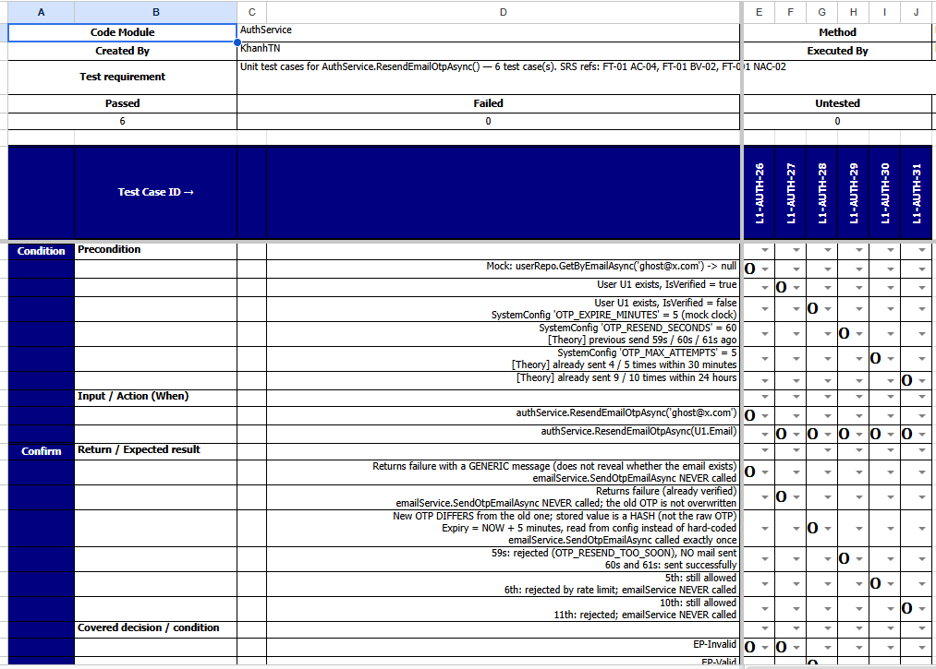
Figure 1: Unit Test Example

4.2 Integration Test
- Integration testing exercises the API together with a real SQL Server 2022 database provisioned per run by Testcontainers, with Respawn resetting the database between tests.
- The focus is on what a unit test cannot prove: transaction boundaries and atomic rollback, webhook idempotency, concurrency on shared stock, background-job boundaries and the immutability of the audit log at database level.
- Any failure is logged as a defect in the Defect Register and tracked until the development team resolves it.
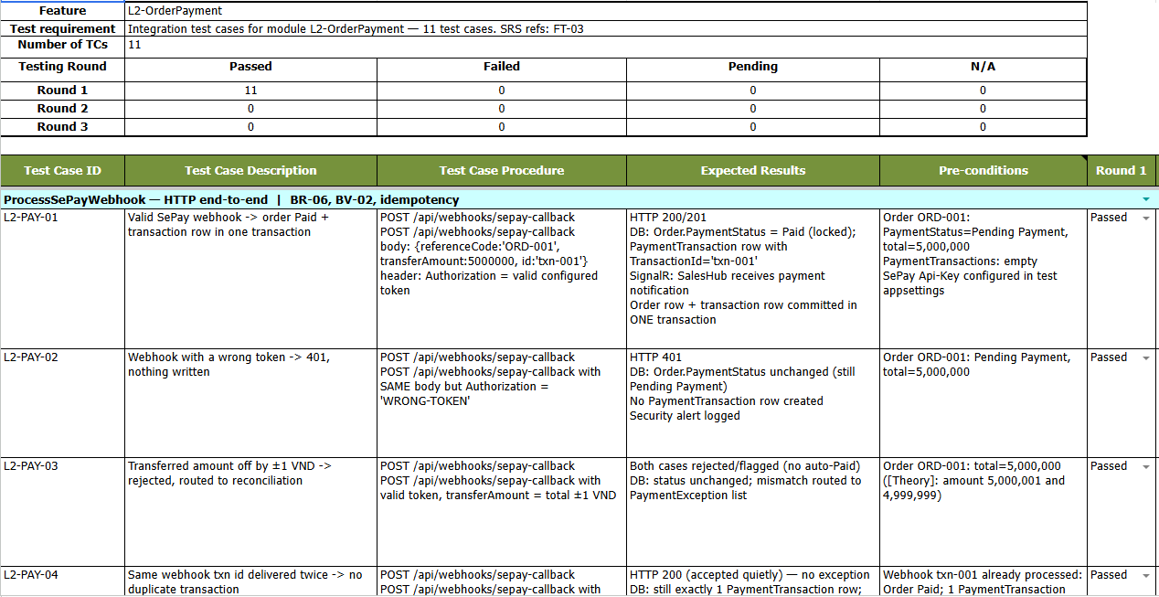
Figure 2: Integration Test Example

4.3 System Test
- System testing starts once the features described in the requirements are fully implemented, and runs against the deployed staging instance as a black box.
- Test cases cover five areas: the API contract of every endpoint, multi-step API flows, security spot-checks against the OWASP Top 10, performance and stress test and end-to-end browser tests.
- A case whose screen or endpoint does not exist yet is recorded as Pending, never as Passed, so that a missing feature is not misreported as a defect.
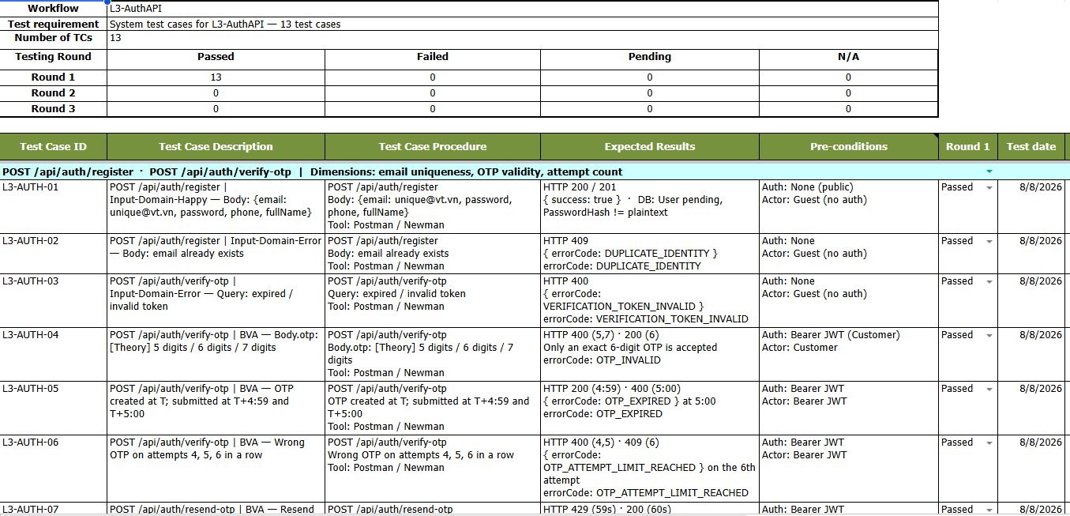

4.4 Acceptance Test
- Acceptance testing determines whether the system meets the business requirements of Viet Tien Company and is acceptable for delivery. That determines if a system meets the requirements for acceptance. The purpose of this test is to evaluate the system’s compliance with the business requirements and assess whether it is acceptable for delivery.

5. Test Reports

5.1 Unit Test
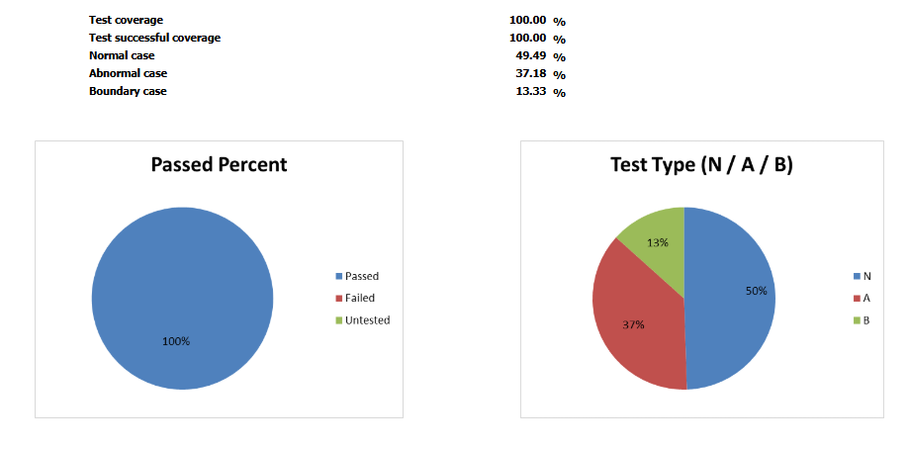
Figure 3: Unit Test Report
The detailed report of the unit test procedure shows details via: UnitTest

5.2 Integration Test
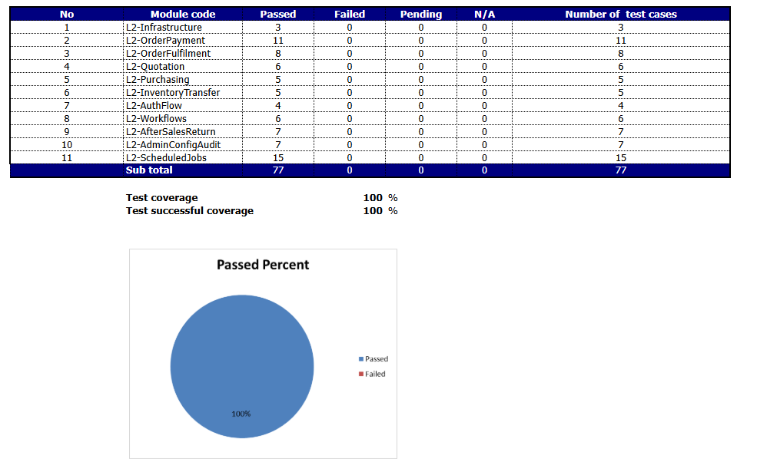Figure 4: Integration Test Report
The detailed report of the integration test procedure shows details via: IntegrationTest

5.3 System Test
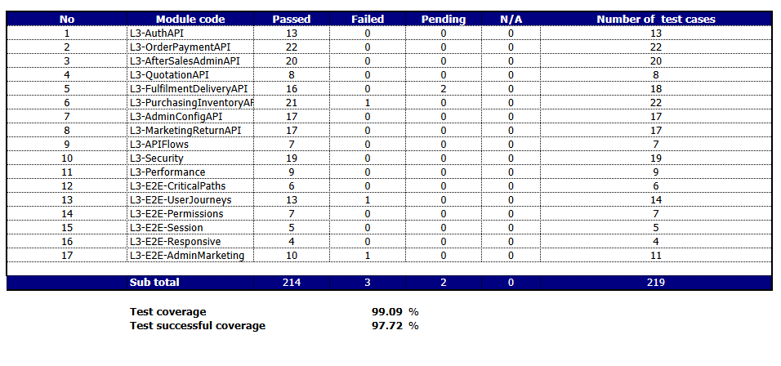Figure 5: System Test Report
The detailed report of the system test procedure shows details via: SystemTest

