Name:-hanamant malagond

Task:- 4th evaluation

Date:-19/04/2025

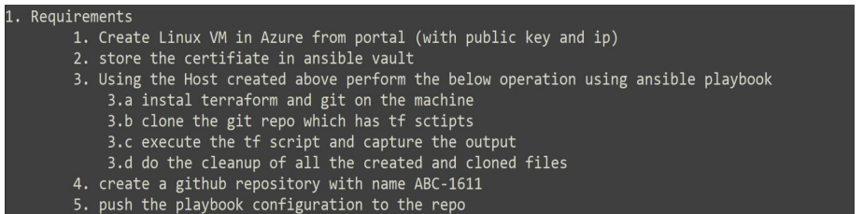

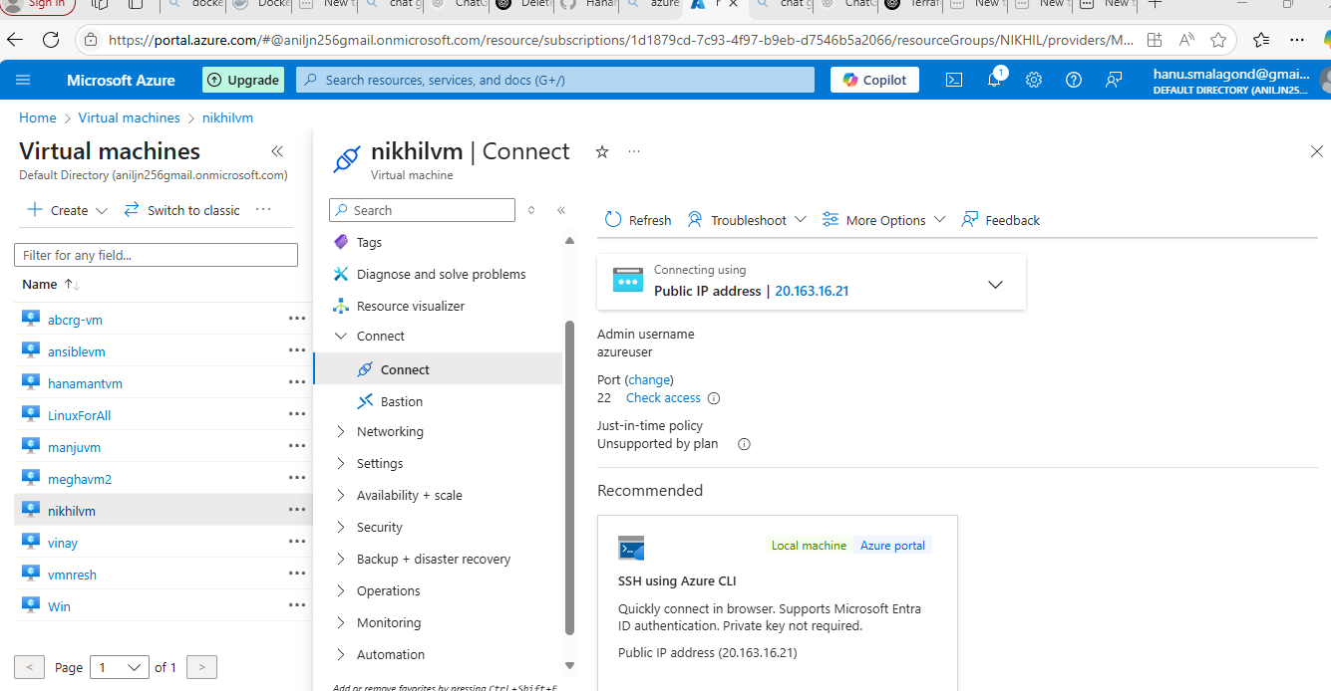

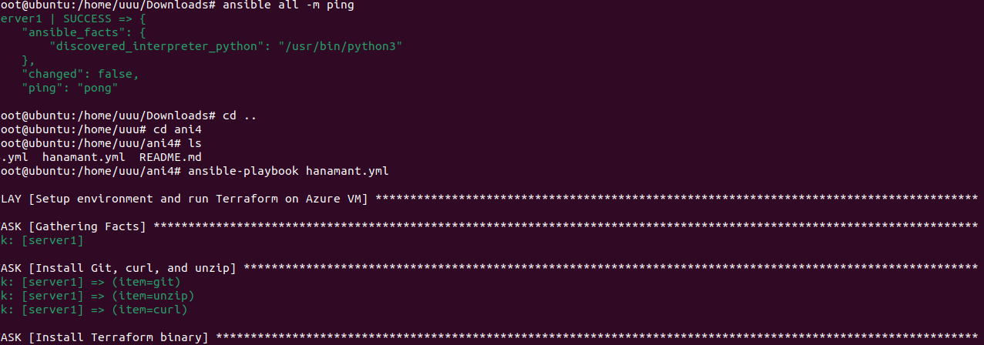

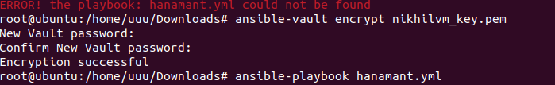

- name: Setup environment and run Terraform on Azure VM

hosts: all

become: true

tasks:

- name: Install Git, curl, and unzip

apt:

name: "{{ item }}"

state: present

update_cache: true

loop:

- git

- unzip

- curl

- name: Install Terraform binary

shell: |

curl -fsSL https://apt.releases.hashicorp.com/gpg | apt-key add -

apt-add-repository -y "deb [arch=amd64] https://apt.releases.hashicorp.com $(lsb_release -cs) main"

apt-get update && apt-get install -y terraform

args:

warn: false

- name: Delete existing /Terraformev if it exists

file:

path: /Terraformev

state: absent

- name: Ensure destination directory exists

file:

path: /Terraformev

state: directory

mode: '0755'

- name: Clone Git repository into /Terraformev

git:

repo: 'https://github.com/Hanamant001/Terraformev.git'

dest: /Terraformev

force: yes

- name: List contents to verify clone success

shell: ls -l /Terraformev

register: ls_output

- name: Show cloned directory structure

debug:

var: ls_output.stdout_lines

- name: Execute Terraform script

shell: |

terraform init

terraform apply -auto-approve

args:

chdir: /Terraformev

register: tf_output

- name: Show Terraform apply output

debug:

var: tf_output.stdout_lines

- name: Capture Terraform output

shell: terraform output

register: output_result

changed_when: false

args:

chdir: /Terraformev

- name: Display Terraform output

debug:

var: output_result.stdout

- name: Cleanup cloned files

file:

path: /Terraformev

state: absent

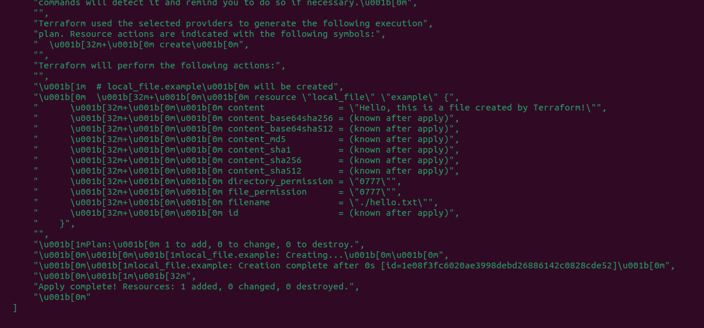

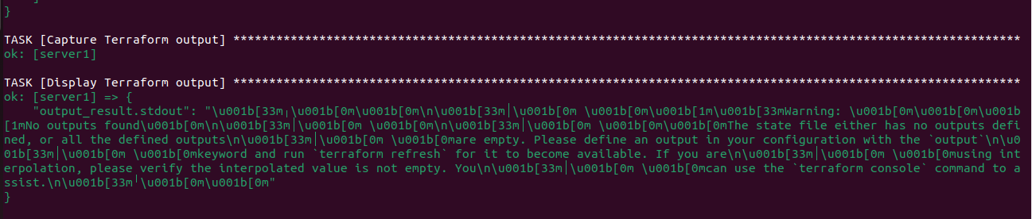

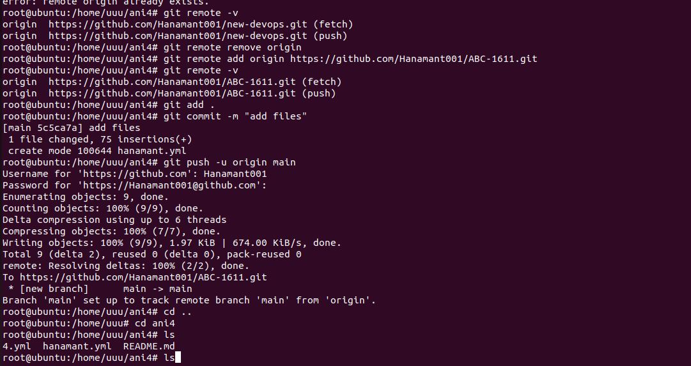

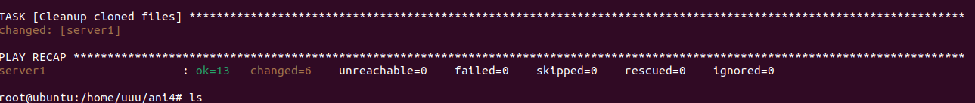

Host machine

